|  |
| --- |
| College LaSalle |
| Project - Oriented Object Programming User and Technical Manual |
|  |
| Presented to: Mihai Maftei. |

|  |
| --- |
| Your name: Bernadette Nicole Fernando  4/4/2023  Version: 2.0 |

1. **Start by adding a short description of your project, and the languages (technologies) used:**
2. Language: C#
3. Tools (IDE):

* Microsoft Visual Studio Community 2022 Version 17.5.2
* Microsoft .NET Framework Version 4.8.09032
* Installed Version: Community

1. **Present the print screens of yours forms, and have a detailed description of the functionalities (step by step).**

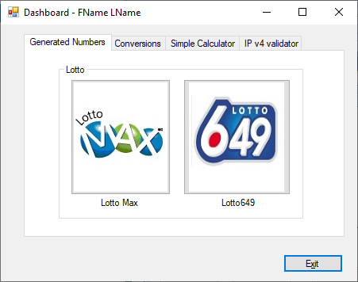

1. If you click on tab…
2. If you click on tab…
3. …
4. If you click on the Exit button, …
5. **Present the code of your application (forms).**

… your code goes here

1. **Present the classes and/or methods that you create or you did use in the project.**

|  |  |
| --- | --- |
| **Class/Method Name** | **Description** |
| 1. Class1 | Enter a short description of the class or of the method ………………. |
| 1. Class2 | Enter a short description of the class or of the method ……………….. |
| 1. void Method(int total) | Enter a short description of the class or of the method ……….. |
|  |  |
| 1. Constructor() | Enter a short description of the class or of the method ………… |

1. **Present the difficulties that you have, what was the hardest and the easiest part of your project.**

For me, I took the most time building the calculator. The hardest part in doing it was making it work like an actual calculator. I started by creating a code that would handle operations for two numbers but it got more complicated as I try to handle all possible scenarios like performing multiple operations on multiple numbers. However, the rest of the forms in the project went smoothly. I opted to create separate classes for the forms because I found it more convenient and it made my code look cleaner and simpler to understand.