Project 1 – Fun with Boxes

Release: 28 Sep 2017 (Thu, week 6)

Due: 14 Oct 2017 (Sat, week 8) 23:30 hrs.

Warning:
- We view plagiarism very seriously. You MUST acknowledge all 3rd-party code used, reference sources or assistance obtained in your code submission. Include the acknowledgement at the end of your video presentation (if any). Detected plagiarism cases will be documented with the School’s General Office.
- You may get assistance with your programming (debugging, “how-tos” etc.).

Instructions:
- There is one question in this assignment to be completed individually. A second optional question is provided.
- Your team ID is your name (i.e. you are the only member in your team).
- You need to submit code for this assignment at the Submission Server, as well as a video clip uploaded to YouTube. No written submission is required.
- Edit p1.rb that is given to you, zip it up to <any_name>.zip and submit the zip file to the Submission Server.
- You can submit your solutions to the Submission Server as many times as you wish, but the final submission on the deadline will be taken as your final submission.
- The submission server will only start accepting submissions from 30th Sep (Sat, week 7).

Question 1: The Grandfather’s Story…

The recent Amazon launch in Singapore has generated significant interest. But Amazon has a problem and is willing to pay a fortune for your help. They need to pack as many items as possible into a single box for delivery to Singapore, in order to reduce the number of boxes that they need to ship over. Given a list of items with their respective dimensions, and the dimensions of a box, your task is to come up with an algorithm to determine which items should be packed into that box, in order to maximize the number of items that can go in.
You can assume that all items and boxes are rectangular and have the same height (this changes a 3D problem into a more manageable 2D problem).

Here is how a 2X5 box looks like (remember that we will not be considering height):
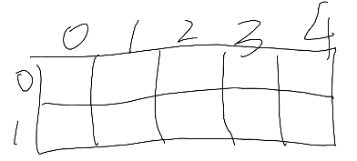
It has 2 rows (rows 0 and 1) and 5 columns (0 thru 4). The left uppermost cell is always [0][0], and for this box, the right lowermost cell is [1][4].

Assuming you are given a list with four items (IDs 0 thru 3), with the following dimensions:
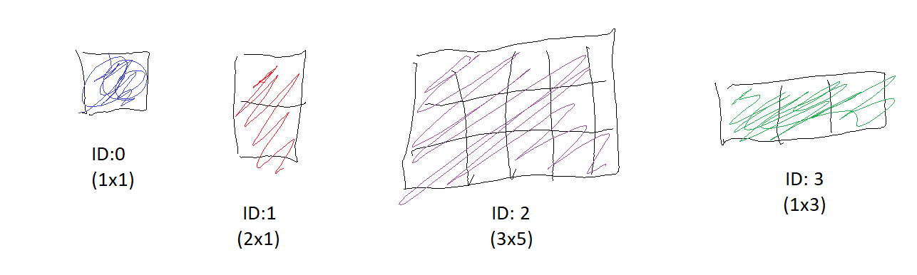

These four items can be represented as a 2D array: [[1, 1], [2, 1], [3, 5], [1, 3]]
Obviously, item 2 cannot fit in. This is one possible way to pack the remaining three items into the box, and is a “correct” solution:
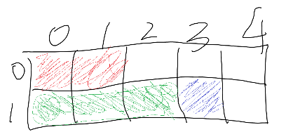
To indicate the position of each item in the box, you can specify the coordinates of its upper-left cell (r1, c1), and the lower-right cell (r2, c2). This can be represented as an array in this format:
[item ID, r1, c1, r2, c2]

The layout recommended by this solution:
- Item 0 is at (1,3)-(1,3) (area = 1 unit²)
- Item 1 is at (0,0)-(0,1) (area = 2 unit²)
- Item 3 is at (1,0)-(1,2) (area = 3 unit²)
can hence be represented in an array like this:
[0, 1, 3, 1, 3], [1, 0, 0, 0, 1], [3, 1, 0, 1, 2]

This is another possible way to pack the three items into the box (i.e. another “correct” solution):
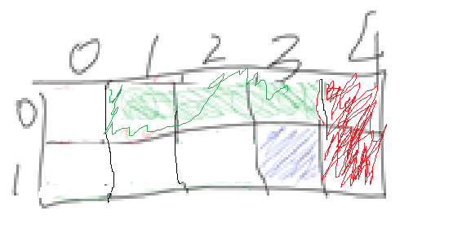
- Item 0 is at (1,3)-(1,3) (area = 1 unit²)
- Item 1 is at (0,4)-(1,4) (area = 2 unit²)
- Item 3 is at (0,1)-(0,3) (area = 3 unit²)
which - in array form - looks like this:
[0, 1, 3, 1, 3], [1, 0, 4, 1, 4], [3, 0, 1, 0, 3]

Some rules here:
- You may choose which items in the list to place into your box; the objective here is to have as many items in your box as possible, regardless of which items you choose, or their sizes.
- You may rotate your items (e.g. see how item 1 was placed into the box for both “correct” answers above.)
- Obviously, items cannot overlap in the box. Nor jut out of the box.
- All items must be either horizontally or vertically positioned in the box. The following is not allowed even if geometrically possible:
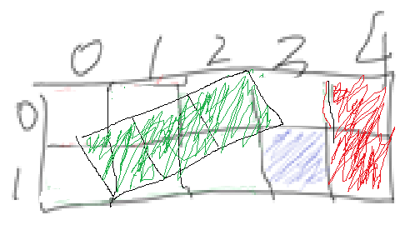

You are given the following file(s) for this assignment:
File name | Description | Comments
p1.rb | Contains the box method that you will write. | You need to modify and submit this file. This is the only file that you may submit. Do not modify the file name or the method signature in the file.
p1_main.rb | Loads p1.rb and calls the box method. | Do not submit this file; use it to check if your box method in p1.rb works before submitting it to the Submission Server.
p1_utility.rb | Contains methods used by p1_main.rb. | Do not submit this file; all the methods in p1_utility are available on the server.
Several dataX.csv files | Contains test cases | Do not submit these files.

Requirements:

- Write a method called box that takes in 3 arguments:
box(box_no_of_rows, box_no_of_col, items)
where
box_no_of_rows is the number of rows for your box,
box_no_of_col is the number of columns for your box, and
items is an array of items with dimensions.
This method can be called like this to pass in four items and a 2x5 box:
box(2, 5, [[1, 1], [2, 1], [3, 5], [1, 3]])

- box returns your proposed layout of selected items in your box as a 2D array following this format:
[[item ID, r1, c1, r2, c2], [item ID, r1, c1, r2, c2]...]
For example, this is one of the many “correct” answers that can be returned by box.
[[0, 1, 3, 1, 3], [1, 0, 0, 0, 1], [3, 1, 0, 1, 2]]
The item IDs do not have to be in any particular order in your returned array, but the following conditions must be fulfilled in your returned layout:
  - r1 <= r2 and c1 <= c2 for each item
  - the coordinates of each item must match the dimensions of each item
  - there shouldn’t be any overlapping of items in the box,
  - items should not protrude out of the box.

- Edit p1.rb provided to meet the requirements.
- Your method should complete within a certain time limit on the Submission Server (this limit will be listed under “news” on the home page at the server).

Utility Methods that You May Use:

You are given certain methods that may be used to validate your solution. They are found in p1_utility.rb. You may write your own “utility methods” in p1.rb.
- item_dimensions_correct?
- overlapping_items?
- print_layout_items_space_usage
- print_layout_items

- Check if your items fit your layout.
The layout returned by your box method contains all the items that you want packed into the box together with the upper-left position and lower-right position of each item.
This method checks if the coordinates in your layout match the dimensions of each item, and if any item is “jutting” out of the box. The method returns true if all items in your layout fit within the box, and are of the correct dimensions.
Example:
>> load "p1_utility.rb"
>> box_no_of_rows = 2
>> box_no_of_col = 5
>> items = [[1, 1], [2, 1], [3, 5], [1, 3]]
>> layout = [[0, 1, 3, 1, 3], [1, 0, 0, 0, 1], [3, 1, 0, 1, 2]]
>> item_dimensions_correct?(box_no_of_rows, box_no_of_col, items, layout)
=> true

Let’s try an incorrect layout. layout is changed so that item 1’s lower-right corner is incorrect:
>> layout = [[0, 1, 3, 1, 3], [1, 0, 0, 0, 2], [3, 1, 0, 1, 2]]
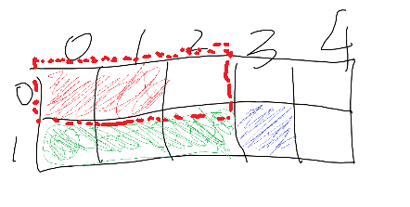
>> item_dimensions_correct?(box_no_of_rows, box_no_of_col, items, layout)
=> "Error: item 1 --> Item dimensions don't match coordinates. Item dimensions = 2 by 1. Rectangle dimensions = 3 by 1"
Here, the method returns a string (error message) instead of true. The message explains that item 1 is 2x1, but the coordinates specified in your layout fit a 3x1 space.

Let’s try another incorrect layout. box_no_of_col is changed so that the box is smaller:
>> box_no_of_col = 3
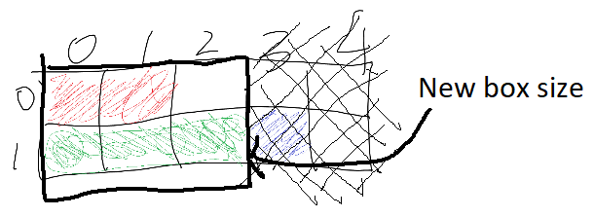
>> layout = [[0, 1, 3, 1, 3], [1, 0, 0, 0, 1], [3, 1, 0, 1, 2]]
>> item_dimensions_correct?(box_no_of_rows, box_no_of_col, items, layout)
=> "Error: item 0 --> jutting out of box"
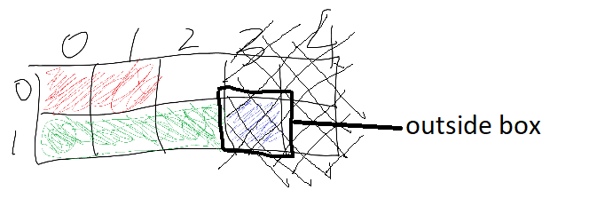

- Check if items are overlapping.
Use no_overlapping_items? to check if the items in your layout overlap (they should not). The method returns true if none of the items overlap, or an error message (string) if any overlaps are detected.
Example:
>> box_no_of_rows = 2
>> box_no_of_col = 5
>> layout = [[0, 1, 3, 1, 3], [1, 0, 0, 0, 1], [3, 1, 0, 1, 2]]
>> no_overlapping_items?(box_no_of_rows, box_no_of_col, layout)
=> true

Let’s try an overlaying layout that looks like this:
>> layout = [[0, 1, 3, 1, 3], [1, 1, 1, 1, 2], [3, 1, 0, 1, 2]]
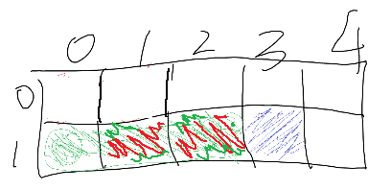
>> no_overlapping_items?(box_no_of_rows, box_no_of_col, layout)
=> "Overlapping items detected in layout!"

(c) Print the layout showing space usage
If there are overlapping items in your layout, you can use print_layout_space_usage to visually see where the overlaps are.
Example:
>> box_no_of_rows = 2
>> box_no_of_col = 5
>> layout = [[0, 1, 3, 1, 3], [1, 1, 1, 1, 2], [3, 1, 0, 1, 2]]
>> print_layout_space_usage(box_no_of_rows, box_no_of_col, layout)
0 0 0 0 0
1 2 2 1 0

The method prints out the 2x5 box with a integer counter at each cell. The counter shows the number of “item parts” that are filling up that cell. The graphical equivalent looks like this:
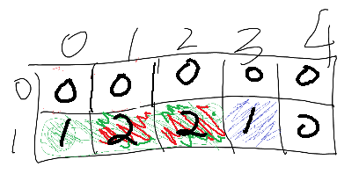
From the diagram, you can see that there are overlaps at cells [1][1] and [1][2]. If there is no overlap, all counters should show either 0s or 1s. You can use this method to get a visual representation of your layout.

(d) Print the layout showing item IDs
Like print_layout_space_usage, the print_layout method gives you a visual representation of your layout, except that the latter shows the item IDs at each cell in the box.

Example:
>> box_no_of_rows = 2
>> box_no_of_col = 5
>> layout = [[0, 1, 3, 1, 3], [1, 0, 0, 0, 1], [3, 1, 0, 1, 2]]
>> print_layout(box_no_of_rows, box_no_of_col, layout)
1 1 . . .
3 3 3 0 .

This method prints out the box with the item IDs of occupied cells. Empty cells are represented by a dot:
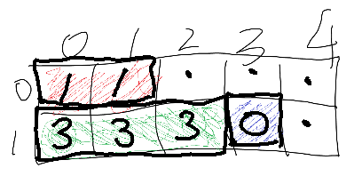
It may be difficult to detect overlaps using this method; use print_layout_space_usage instead to detect overlaps.

How to Run Your Code on Your Laptop:

Open data0.csv using a text editor:
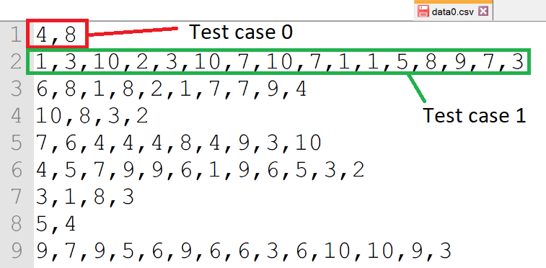
Each row in this file represents a test case.; there are 10 test cases in data0.csv. The format for each row is:
side1_{item0}, side2_{item0}, side1_{item1}, side2_{item1}, side1_{item2}, side2_{item2}…
Test case 0 (the first line in the CSV file) represents only 1 item with dimensions of 4x8 units.
Test case 1 represents eight items with dimensions 1x3, 10x2, 3x10… 7x3.

Study p1_main.rb which will read test cases from one of the CSV files, and call your box method using these values. Each test case will be prepared as a 1D array like this:
[[4, 8]]
All 10 test cases will then be inserted into a 2D array called test_cases.
test_cases = []
test_cases[0] = [[4, 8]]
test_cases[1] = [[1, 3], [10, 2], [3, 10], [7, 10], [7, 1], [1, 5], [8, 9], [7, 3]]
...

For each test case, your box method will be called like this (where i is a running counter):
box(box_no_of_rows, box_no_of_col, test_cases[i])
The layout returned by box will be stored in answers.

answers is later checked using item_dimensions_correct? and no_overlapping_items? to determine if they are “correct”. The quality score for a “correct” answer will simply be the number of items in your layout. The higher the quality score (i.e. the more items you managed to pack correctly into your box), the better.

If either item_dimensions_correct? or no_overlapping_items? returns an error, you should be able to isolate the test case that caused the error and obtain the item dimensions from the correct row in the relevant CSV file. You can troubleshoot your code by focusing only on this problematic test case. Make sure that your box method passes all test cases before submitting your code to the server; if it doesn’t run on your laptop, it will definitely not run on the server.

About the Test Cases Provided:

You are given the following CSV files in the data folder. Each test case (row) in these files contains 100 items:
- data1.csv: items are all small (1x1 to 10x10), approx avg area: 5.4
- data2.csv: items are small to middle-sized (1x1 to 20x20) approx avg area: 10.2
- data3.csv: items are all middle-sized (1x10 to 20x20) approx avg area: 12.5
- data4.csv: items are middle-sized to large (1x10 to 30x30) approx avg area: 16.7
- data5.csv: items are large (1x20 to 30x30) approx avg area: 19.6
- data6.csv: items are mixed (1x1 to 30x30) approx avg area: 16.1
A good algorithm should be able to return high quality layouts for a wide range of item sizes.

To submit:
- p1.rb (at submission server).
Edit the comments at the top of your Ruby file to indicate your name and section.
- Video explanation.
Prepare a video to briefly explain your adopted algorithm and determine its time complexity. Upload it to YouTube, ensure that it is publicly viewable and post the URL to your video to eLearn Dropbox. Your video MUST NOT exceed 1.5 minutes, and must clearly state your name and section when it starts.

Assessment:
- For code submission:
- Correctness
- Each item in the returned list must be of the correct dimensions (i.e. the returned coordinates must match the item’s width & length)
- All items in the returned list should not overlap in your proposed layout.
- All items in the returned list are within the box’s dimensions and not jutting out.
- Time taken by method.
- Quality (determined by the number of items in your layout. Your quality score is simply calculated as the number of items you have managed to include in your layout.)
Correctness is the most important factor – if your code is not correct, the server cannot compute the time taken and quality. Do make sure that you have a “correct” solution before focusing on improving the other aspects of your algorithm.
- For video explanation:
  - You will be assessed on the (i) clarity and (ii) accuracy of your explanation.
  - You do not need to spend time “jazzing” up your video with fanciful animation; a simple phone recorded video of an explanation using a marker and whiteboard will be good enough. Focus on the content instead of the “bells and whistles”.

- Late submissions:
The server will automatically stop accepting code submissions at 11:30pm sharp on the deadline. Manual submissions via email after the deadline must be sent to hnmok@smu.edu.sg with 24 hours from the deadline - a penalty of 20% will be imposed. Submissions later than 24 hours will not be accepted.

- This assignment is worth 10% of your final grade. Score breakdown:
Item | Marks | Comments
Code: quality | 6
Code: time taken | 2
Video explanation | 2
Late submission |  | -20% for up to 24 hours late  -100% for >24 hours late.

OPTIONAL Question 2

This question is OPTIONAL, but you may want to attempt this because you can’t get enough of algorithms! Students will NOT be awarded additional marks for attempting it, but students with good solutions for this question may be given an opportunity to showcase their solution as a “Show-and-Tell” (read: participation marks!)

Q2 is an extension of Q1. For Q1, you are only given one box to pack your items, and you select which items to include in your box. For this question, you are given as many boxes as you need – all these boxes have the same dimensions (we call this a “standard box”). You need to come up with an algorithm to pack ALL items into any number of standard boxes. The objective is to use as few standard boxes as possible.

Unlike Q1, for this question, you can assume that the biggest item in the item list can fit into the standard box.

Requirements:

- Write a method called pack that takes in 3 arguments:
pack(box_no_of_rows, box_no_of_col, items)
where
box_no_of_rows is the number of rows for a standard box,
box_no_of_col is the number of columns for a standard box, and
items is an array of items with dimensions.
This method can be called like this to pass in five items and the dimensions of a “standard box” (3x5):
pack(3, 5, [[1, 1], [2, 1], [3, 5], [1, 3], [3, 3]])

- pack returns the proposed layout of all items in your boxes as a 3D array following this format:
[[box0], [box1], [box2]...]
Where [boxX] is a 2D array of this format:
[[item ID, r1, c1, r2, c2], [item ID, r1, c1, r2, c2]...]

For example, this method call:
pack(3, 5, [[1, 1], [2, 1], [3, 5], [1, 3], [3, 3]])
may return the following “correct” answer (with a quality score of 3):
box0 = [[2, 0, 0, 2, 4]]
box1 = [[4, 0, 0, 2, 2],[0, 0, 3, 0, 3]]
box2 = [[1, 0, 0, 0, 1],[3, 0, 2, 0, 4]]
answer = [box0, box1, box2]
The proposed layout looks like this:
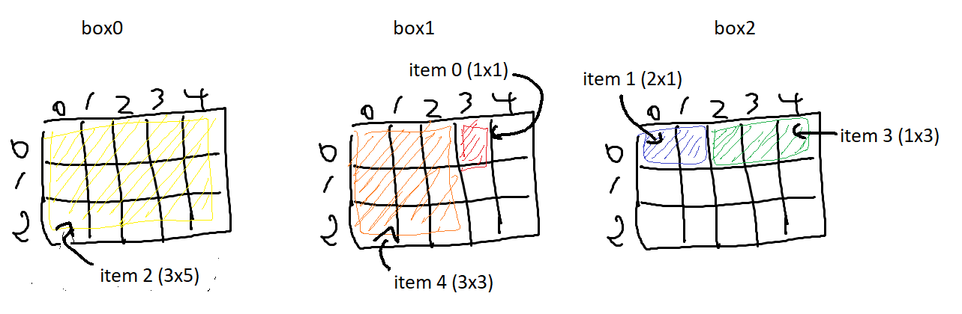
This is not the best solution; it is possible to pack these five items into only two standard boxes (quality score of 2). Can you work it out?

Write your method in p1q2.rb. Use p1q2_main.rb to test your solution before uploading it to the server. There is no need to provide a video explanation for this question.

You are given several test cases in the files: dataA.csv, dataB.csv etc. Unlike Q1, only the last line in each CSV file will be used (i.e. only 1 test case per CSV file). When p1q2_main.rb runs, it only reads the last line of your selected CSV file.

Assessment:
- For code submission:
- Correctness
- Each item in the returned list must be of the correct dimensions (i.e. the returned coordinates must match the item’s width & length)
- All items in the returned list should not overlap in your proposed layout for each box.
- All items are packed into one of the boxes only once.
- Time taken by method.
- Quality (determined by the number of boxes you need. Your quality score is simply calculated as the number of boxes in your solution.) For this question, the LOWER the quality score (i.e. the fewer boxes you need), the better it is.

~ End

