- Everything worked as intended and I was able to control all stack functions.

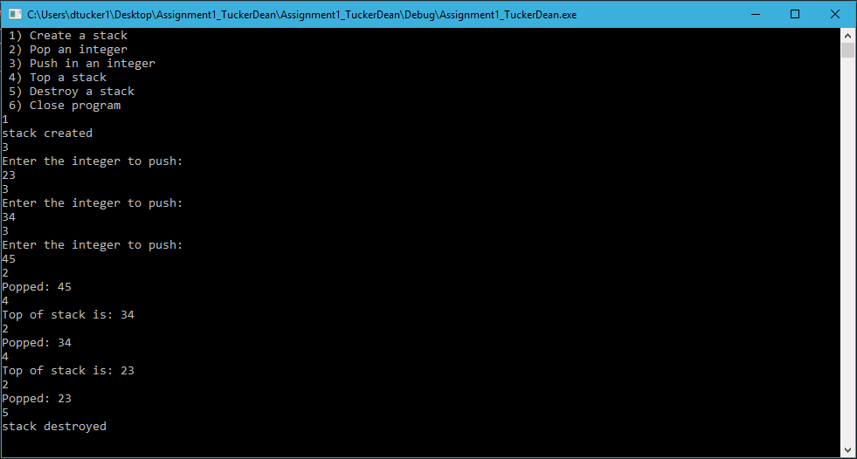

- Filled stack from array grabbed from a file and outputted it in reverse using stack functions
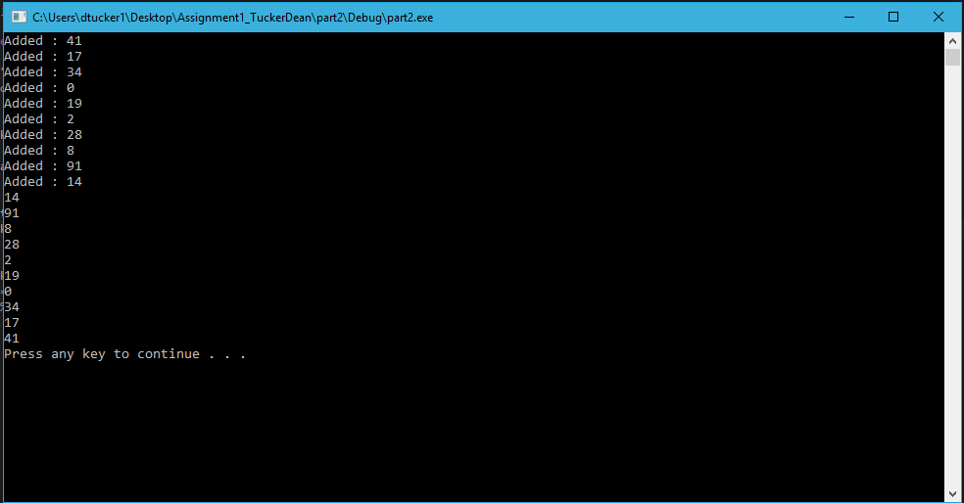
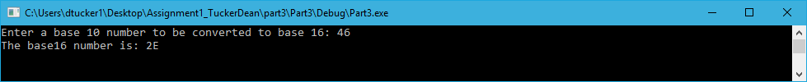
- Converted a base 10 number into base 16 using stack functions to pass the reminder into a stack until it is empty. Converts character to the hex character by adding the corresponding asci code to relate to the proper value.
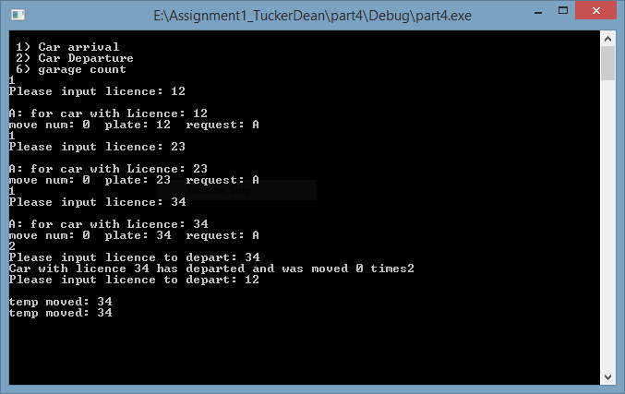
- Works for arrival and departing the top of the stack

