Getting Started

Software Setup

1. Download the libserialport library

The instructions for downloading this library can be found at
http://sigrok.org/wiki/Libserialport

The library should be placed in the \Armeda\libs folder

2. Install the USB RS485 Converter

The instructions for setting up the rs485 converter can be found on Waveshare’s website at
https://www.waveshare.com/wiki/USB_TO_RS485

3. Example Projects

Under the examples folder there are projects that were written in QT Creator 9.0.2 as well as Microsoft Visual Studio 2022

Hardware Setup

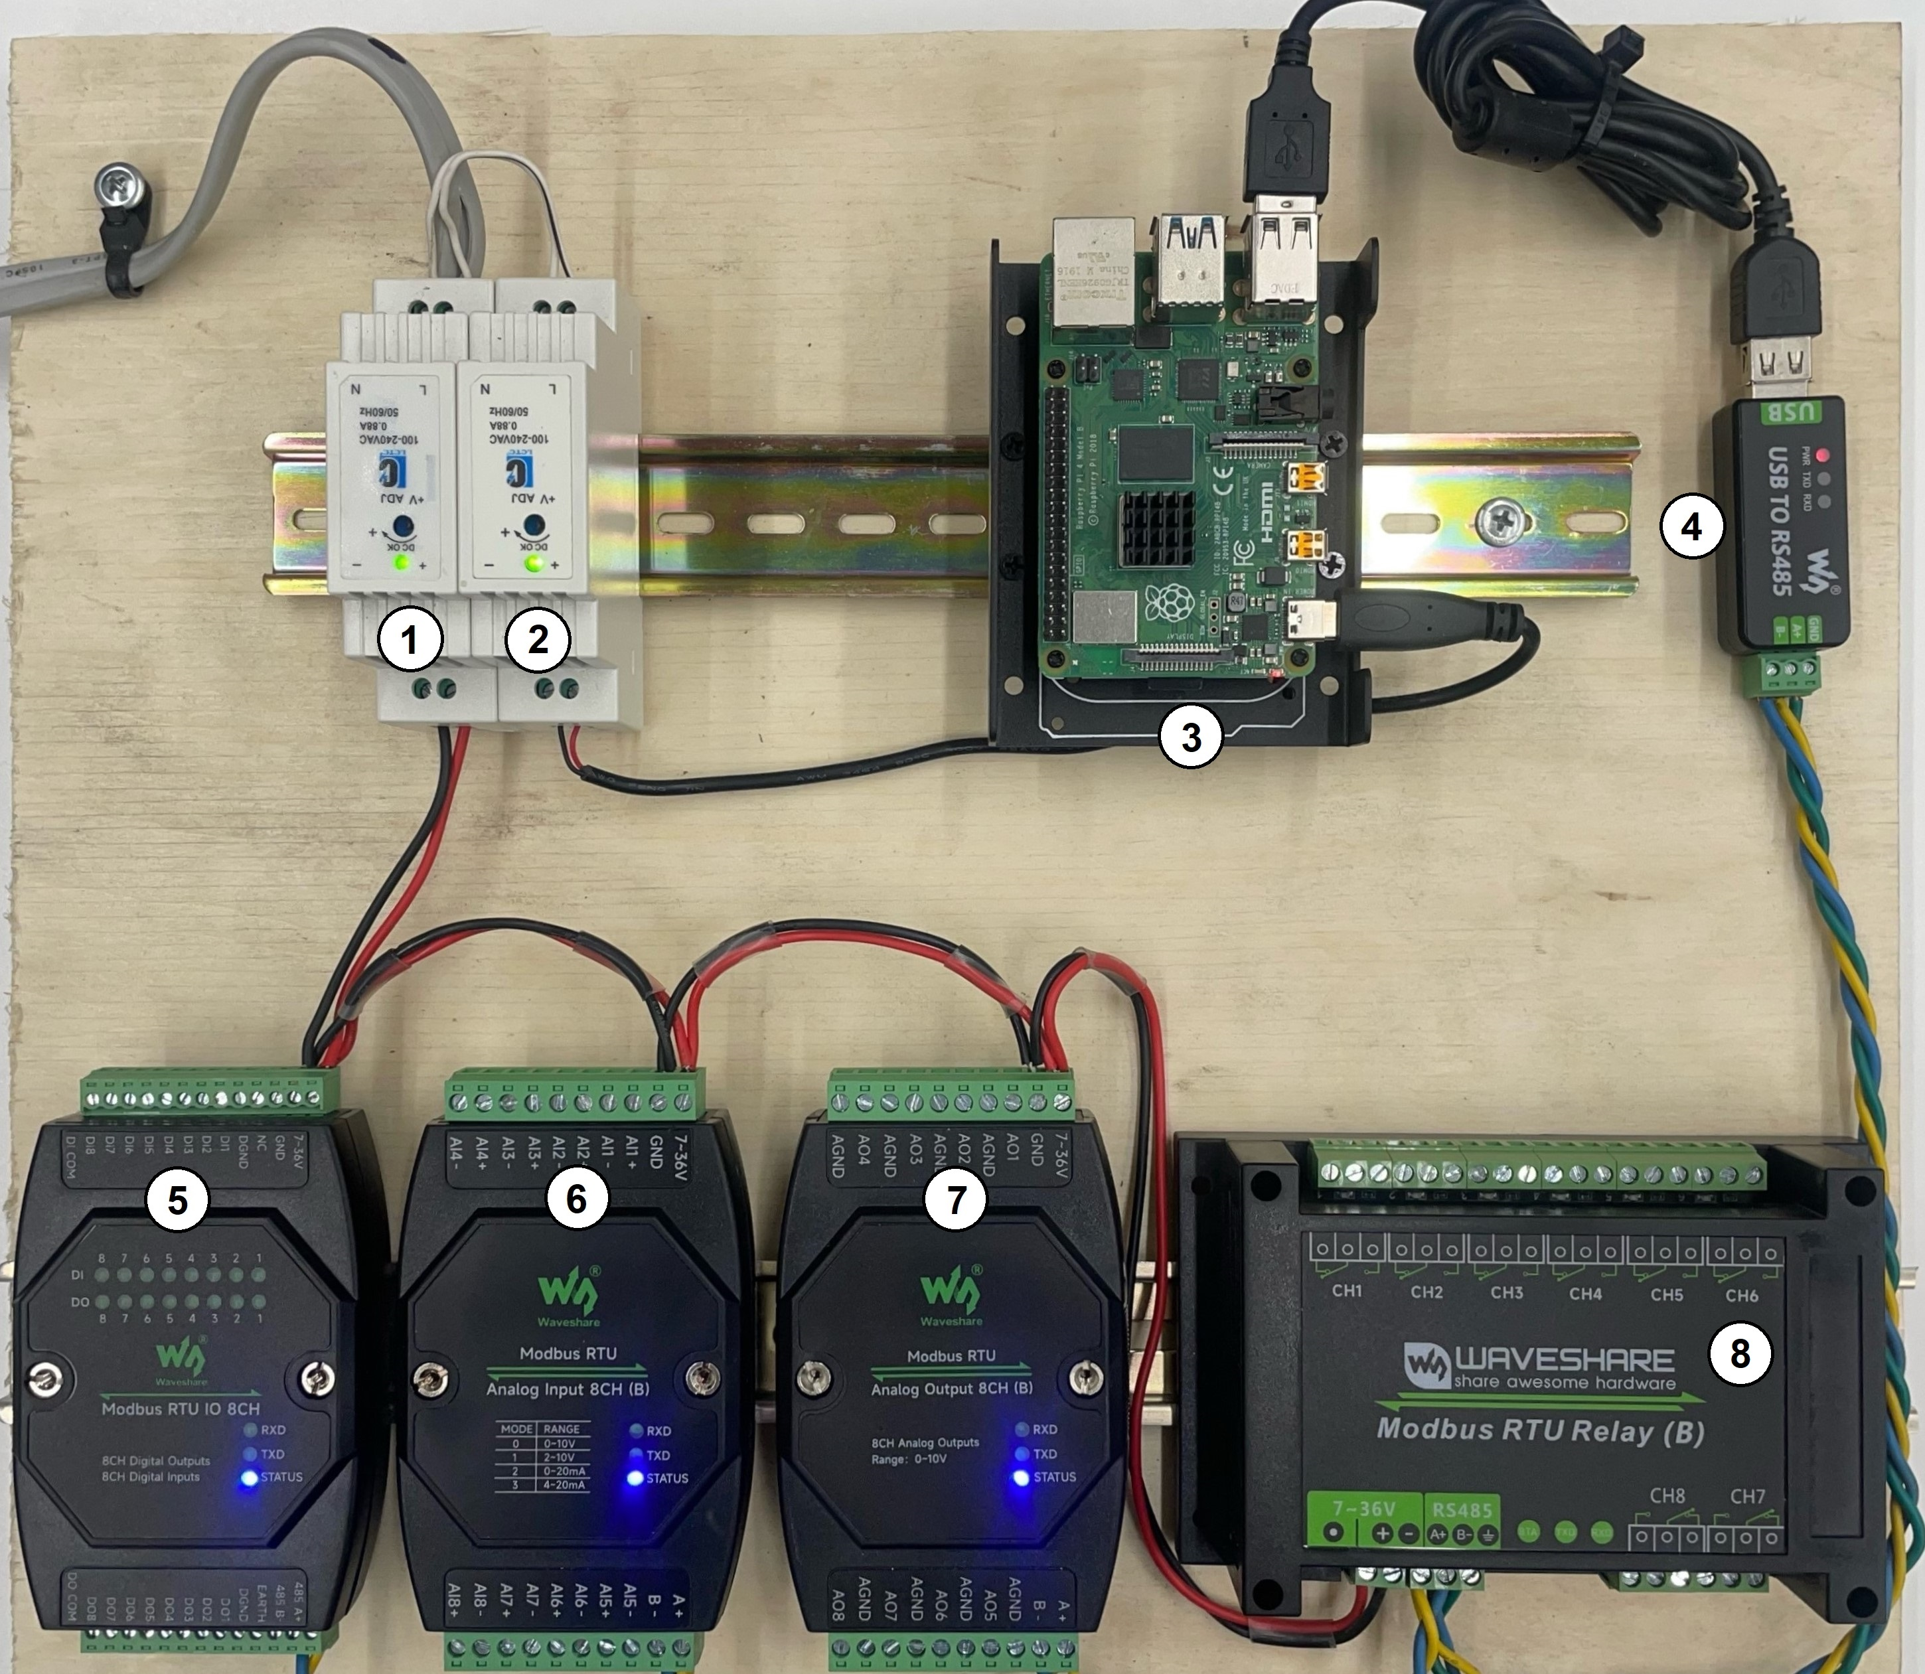
Devices
1 | 12 V Power Supply
2 | 5 V Power Supply
3 | Raspberry PI 4
4 | USB to RS485 Converter | https://www.waveshare.com/usb-to-rs485.htm
5 | Digital IO 8 Channel | https://www.waveshare.com/modbus-rtu-io-8ch.htm
6 | Analog Input 8 Channel | https://www.waveshare.com/modbus-rtu-analog-input-8ch.htm
7 | Analog Output 8 Channel | https://www.waveshare.com/modbus-rtu-analog-output-8ch.htm
8 | Relay board 8 Channel | https://www.waveshare.com/modbus-rtu-relay.htm

The devices can be powered from any DC power supply between 7-36V

Connect the A+ and B+ terminals from the devices to the respective terminals on the RS485 converter. The wires should be twisted to reduce noise.

Hardware Configuration
The configuration tool in Armeda\examples\QTCreator\Device_Config\Debug can be used to change device ID’s as well as baud rate/parity options. The tool currently only works on Raspberry PI. Waveshare also has a configuration tool that can do the same thing on there website.

To have more than one device connected to the rs485 network you must give them each unique device IDs. To add a second device connect it to the network by itself and click Read Device Address. It should show up as Device 1. Then click Update Address and assign it a unique address between 1 and 255

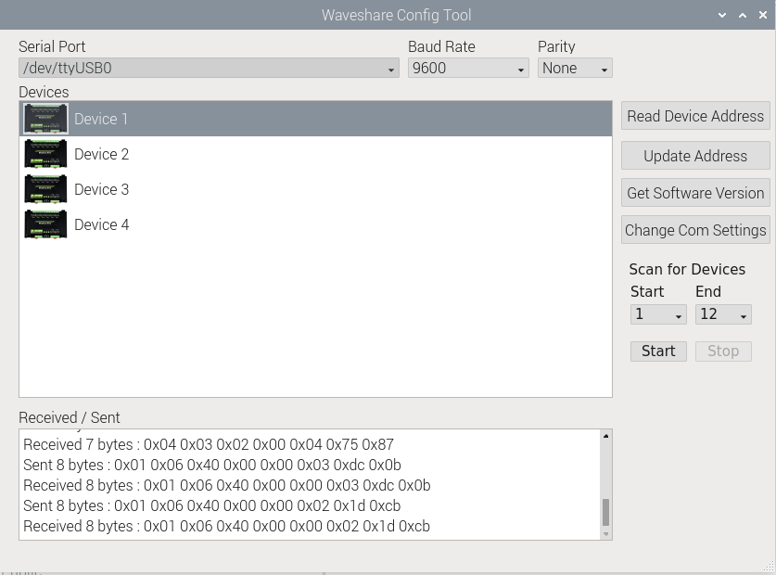

Contact
Email : dean@deanwilde.com
Project Link : https://github.com/dtwilde/Armeda

