

“An Analysis of Attitudes Towards the Social and Ethical Impact of the Singularity”

Daniel J. Tydeman

2013-14

“Research Dissertation”

School of Computer Science and Mathematics

# Statement of Original Authorship

This dissertation is submitted to the University of Chester in fulfilment of the requirement for the Degree of Bachelor of Science in Computer Science.

This work is original and has not been previously submitted in support of any other course or qualification at this University or at any other establishment, except where acknowledgment is made.

Signature…………………………………………………………………

Daniel Tydeman

Date………………………………………………….

# Abstract

This dissertation is focused on determining the public’s opinion regarding the advancement of technology to the point of the Technological Singularity. In particular, this work focuses on the advancement of technology in four key areas; Business, Education, Medicine and Military. This dissertation includes information about technology in these particular areas and research regarding information about the Technological Singularity. A study was performed involving the use of a questionnaire to determine not only the public’s collective opinion regarding the coming Technological Singularity but also if there are any factors that may have affected individuals’ opinions regarding the questions provided. The outcome of this study did not support the hypothesis, giving evidence to show that the collective opinion of the public is in favour of the advancements in technology towards the Technological Singularity. The study also highlighted certain factors that may have had some impact on the participants’ opinions and that although there is a general positive view regarding advancements in technology, people appear to have a more negative view with regard to some areas, such as Medicine, than others, such as Military. The conclusion of this dissertation is that although it appears that collective opinion is in favour of the coming Technological Singularity, the varied limitations of the study require further investigation to help verify the outcome of the study. Additional investigation could also help to provide further information regarding influential factors and if other areas receive the same opinion as those included in this work.

# Acknowledgements

I’d like to acknowledge the education and support received from the University of Chester and the Computer Science Department over the last three years. In particular I’d like to thank my dissertation tutor, John Kerins, for his continual support and guidance through the study and the writing of this dissertation as well as his interest in my work over the period of writing this dissertation.

I would also like to thank each of the participants of the questionnaire, who provided the data for this study, and Fluid Surveys for providing the facilities to create and deploy the questionnaire used for the study. As well as this, I’d like to thank the Singularity Chronicle, where the questionnaire was posted online and increased the potential for participants of the study.

I would also like to thank Briony Smith, Rhys Venables and Kayleigh Wilkins for taking the time to read this work and provide their own feedback and support during the writing of this dissertation.

Contents

Statement of Original Authorship 1

Abstract 2

Acknowledgements 3

Figure Table 5

Introduction and Background 6

Hypothesis 7

Ethical Statement 7

Literature Review 8

The Singularity 8

Current Technology 10

Methodology 13

Statistical Tests 13

Designing the Questionnaire 13

Evaluation of Results 16

Conclusion 22

Glossary 23

Bibliography 25

Appendices 28

# Figure Table

Figure 1: Calculations of Opinion Distribution 15

Figure 2: Graph and Table of Figures for Opinions Regarding Creating and Removing Memories 16

Figure 3: Graph Regarding Gender and Opinions Regarding Creating and Removing Memories 17

Figure 4: Graph and Table of Figures of Opinions Regarding Intelligent Profiling for Job Applications 17

Figure 5: Graph and Table of Figures of Opinions Regarding use of Cloud Computing over Intermediate Communication Methods 18

Figure 6: Graph for Employment Area and Opinions Regarding use of Cloud Computing over Intermediate Communication Methods 18

Figure 7: Global Map Showing Location of Participants of the Questionnaire 20

# Introduction and Background

This dissertation examines the Singularity and the potential impact it could have on various global sectors. The focus of this dissertation will be based on the aims of the Singularity and what impact these will have regarding social, moral and ethical areas. It will have information pertaining to the Singularity collected from a variety of sources and present this information to the public in order to gain a general consensus on the public’s view of the Singularity and its effect regarding certain global sectors.

The Singularity is an idea postulated by Vernor Vinge, in which he states

*“Within thirty years, we will have the technological means to create   
superhuman intelligence.”* (Vinge. 1993)

This idea involves various advancements in technology and artificial intelligence (hereafter referred to as AI) that may lead to the technological counterpart to the human brain. This can include, but is not limited to; computers becoming self-aware, Human-Computer interfaces ( hereafter referred to as HCI) becoming so advanced that it triggers a technological evolution of the human species and biological science advancements coming to the point that human intelligence can be physically and programmatically engineered (Strickland. 2008). If AI were to advance to the point of the Singularity, it would mean incredible benefits to society in a variety of areas; however it would also cause a large number of issues as well. This must be taken into account when considering the Singularity as the negative impact of these issues could be exceedingly detrimental.

The idea that a technological, superhuman intelligence is almost inevitable comes from Moore’s Law. Moore’s Law dictates that every 18 months, the number of components on a microchip will double which in turn leads to computers having twice the processing power every 18 months (Moore. 2005). Moore’s Law is not a governed rule but a self-fulfilling prediction; whilst semiconductor manufacturers are not pushed to keep up with Moore’s law they still aim to keep pace with the law and due to the decreasing price of the technology required to create components the price of a microchip with double the processing power of the previous model may cost the same. Not only this, but due to new technologies constantly becoming available, new methods of applying more and smaller microchips and components is becoming frequently more used.

How the Singularity will affect various global sectors will be addressed in order to specify the public’s views with a more specific scope. For instance, in the business sector a technological intelligence with the capacity to replicate human intelligence could be invaluable for calculating profitable moves in the stock market. Meanwhile in regards to military applications, it could allow for Unmanned Aerial Vehicles (UAVs) such as certain drones to use the same intuition as a human regarding strategy and tactics in the field. Alternatively if the technological Singularity leads to advancement in HCI the medical sector could advance incredibly as new methods of diagnosis and administration of medicines or medical procedures could arise. Another example involves the education sector, where the use of programmatically, or even physically, engineering human or animal intelligence can provide more in depth education regarding behaviour. These are a few examples that will be investigated and explained to the public in more detail in order to allow an educated response.

A simple project based on the Singularity is the OpenWorm project, this is an open source project which involves various scientists working together to design a simulated worm that operates with all the basic principles of life (Madrigal. 2013). Currently the OpenWorm project has managed to create a moving simulation of *Caenorhabditis elegans*, a Nematode Worm. Whilst it may not seem like much in order to get the virtual worm to move, the coding required includes generating signals from nerve cells to cause muscle cells to contract and relax to simulate the movement of the worm. Currently this is the most advanced example of executable biology, and the further plans for the OpenWorm project involve developing the behaviour of the worm so that it is capable of detecting and avoiding predation and threats, identifying other worms and mating, locating food and feeding as well as other simple biological functions. If the OpenWorm project should be completed then it would have created the first artificial life that can accurately model a biological creature’s behavioural patterns.

However when the OpenWorm project is completed it will bring about its own list of ethical issues, such as will the virtual worm be ‘alive’? Questions such as these will also be applicable to the Singularity in certain circumstances, as well as other issues. These can include the lack of Asimov’s “Three Laws of Robotics” (Asimov. 1950), theological issues regarding the ‘Soul’ and even ethical issues relating to technologically forced evolution. These are some of the largest issues regarding the Singularity project, and as such will most likely provoke responses from the public. However, what these responses will entail will differ depending on each individual person. For example, those whom believe in a religion may take issue with the Singularity as it could be seen as an attempt to recreate life. Meanwhile those with a fear that they could easily be replaced in the workplace by automated machinery would be unsettled by the idea of technological equipment with the capacity for human thought. These are only a couple of the examples of the issues that can be caused by the Singularity.

## Hypothesis

The hypothesis put forward is that: “People are afraid of the coming Technological Singularity.” In order to examine this hypothesis, anonymous questionnaires utilising close-ended questions will be used to provide quantitative data. The quantitative data collected from these questionnaires will be statistically analysed in order to determine if there is a particular factor that affects people’s views on the Singularity (i.e. Age, Gender, Employment Status, etc.). After this, another statistical test will be performed to see if there is a discernible collective opinion regarding advanced technology. If there is evidence that there is a discernible collective opinion, then the actual responses will be reviewed to determine what this collective opinion is. If there are a higher number of negative responses than positive responses, then the hypothesis will be accepted as correct. Alternatively, if there are more positive responses than negative responses, then there will not be any support for the hypothesis.

## Ethical Statement

During this study information was collected from willing participants. They each took part knowing that by doing so they were voluntarily providing their own, informed consent and that their provided responses would be kept anonymous. Further information regarding the ethical considerations is mentioned in the ethics form (See Appendix A) and at the beginning of the questionnaire (See Appendix B).

# Literature Review

## The Singularity

The Technological Singularity falls down to the development of computers until they reach a point of independent intelligence and self-awareness. The idea of the Singularity came from John von Neumann in the mid-1950’s, he stated:

“*ever accelerating progress of technology and changes in the mode of  
 human life, which gives the appearance of approaching some essential  
 Singularity in the history of the race beyond which human affairs, as we know   
them, could not continue*” (Ulam. 1958)

Though it was not until science fiction writer Vernon Vinge postulated this idea in the early 1990’s that it became well known. However, when Vinge offered his thoughts on the Singularity he only looked at it from an inevitable and negative view point. The title of the paper he wrote was titled ‘How to Survive in the Post-Human Era’ (Vinge. 1993) which provides a very negative outlook and an impending sense of doom regarding the increase in AI. The paper went on to mention how the best that mankind can hope for is the potential of controlling the Singularity in the early days in order to induce technological evolution to ensure that humanity can adapt to civilisation filled with super-intelligent computers. Other areas of science fiction have also looked at the possibility of the advancement of intelligent computers, most namely Isaac Asimov who wrote a collection of short stories regarding intelligent robots that live amongst humans. The most famous of which being ‘I, Robot’, containing the story ‘Run Around’ (Asimov. 1950). However, whilst the point of intelligent computers taking part in civilisation made as a good selling point for science fiction books, it also caused more reason for worry regarding the potential for the Singularity. However, whilst science fiction has had a tendency to look to the Singularity as means of an apocalyptic end for Humanity, reality shows that the advancement of AI can be devastating too. In 2013 a report was carried out which showed that approximately 45% of all jobs in the United States of America could potentially become automated within the next 20 years (Rutkin. 2013). Dr Jonathan White has stated how he is worried that any benefits from the Singularity would be negative or would only be available for the most privileged. He also explains that the main issue with advancements in technology as we near the Technological Singularity is that humanity, as a whole, are not as wise as we may need to be to fully understand how this will affect us (Thomson, 2014).

Nevertheless, whilst there have been many negative sources for the advancement of AI and the potential of the coming Singularity there are still some positive thoughts regarding these points too. A survey carried out in 2007 asked the question ‘Who’s afraid of robots?’ as an open survey (Thorisson. 2007). The survey gathered results from over 6,000 participants took part by providing one of three answers :

1. “*Yes, I find the idea of intelligent machines frightening*”
2. “*No, I don’t find the idea of intelligent machines frightening*”
3. “*I’m not afraid of intelligent machines, I’m afraid of how humans will   
   use the technology*”

From the 6,000 participants only 16.7% said they were afraid of intelligent machines whereas 27.1% said they were not afraid of intelligent machines. Whilst this shows positive results for the advancement of AI, the fact that the remaining 56.3% of the participants said they were afraid of the use of intelligent machine shows that people are more afraid of how others will make use of advancements in AI than computers becoming self-aware and fulfilling their own agenda. Nevertheless, the fact that a total of 73% are afraid of the uses of intelligent machines is still an issue; though considering the circumstances it may be applicable. The use of intelligent machines has also been beneficial though, one example of this is ‘Watson’; an artificially intelligent machine developed at International Business Machines’ (hereafter referred to as IBM) DeepQA project that is used as a medical consultation program (Upbin. 2013). It is used as a consultation specialist for lung cancer and utilisation management in healthcare insurance, and has helped to raise accurate treatment decisions from 50% to 90% with appropriate usage. AI has also been used as an educational tool as well as consultation. Flight Simulators, such as the Military AI Works (Loones. 2006), utilise AI to help pilots develop flying skills and better understand the logic behind flight. Whilst this is a simplistic piece of artificial technology it has helped to save lives by providing the means for additional training. Other online or long distance educational tools, better known as Computer Aided Learning software, have helped to provide education in many areas and even allow some people to undergo education and earn degrees or qualifications. Raymond Kurzweil, a futurist and Director of Engineering at Google, also postulates another benefit of the Singularity. In his book ‘The Singularity is Near’ he explains a belief that when the Singularity occurs it will radiate intelligence outward from the planet via various electronic signals to saturate the universe (Kurzweil. 2005).

Whether or not the Technological Singularity could be a positive event, it is undeniable that AI has been constantly increasing and doing so at an increasing rate as time passes by. Vinge states the idea that if it is at all possible for the Singularity to happen, then it will happen (Vinge. 1993). Though looking at the Singularity from the perspective of technological evolution rather than AI, Eric Drexler thought that a great advancement in technology leading to the Singularity is inevitable as time continues due to the relationship between engineers and scientists; discovering new knowledge to create tools and using new tools to uncover further knowledge (Drexler. 1986). Both of them believe that the appearance of self-aware computers or technologically advanced humans is inevitable due to the theory of Moore’s law, which dictates that the overall processing power of computers will double every two years (Moore. 2005). This is because every two years, or more accurately every 18 months, the number of transistors on a single computer chip will double, thus allowing for twice the processing power per chip. This is further reinforced by the fact that as time goes by the price of transistors decreases and new technology allows for smaller transistors to become available, both of which allow for more to be applied to a single computer chip in order to increase processing power. This is the most well-known law pertaining to the increase in computer processing power though there have been others, an example of which is Kurzweil’s ‘Law of Accelerating Returns’, which is explained in his book ‘The Singularity is Near’ (Kurzweil. 2005). This law dictates that instead of doubling every two years, the increase in processing power will occur more frequently as time goes by and technology increases until AI and technology advances too quick for humans to comprehend almost in a single moment; the Singularity. Utilising this law, Kurzweil predicts that the Singularity will occur in 2045, as opposed to Vinge’s prediction of it occurring any time between 2005 and 2030 (Vinge. 1993).

However, while both Moore’s Law and the Law of Accelerating Returns identifies the idea that processing power and technology will rapidly increase in a small number of years, this is only theory. Paul Allen argues against Kurzweil’s idea that the Singularity will occur around 2045, believing that in order to fulfil Kurzweil’s prediction the understanding of the human brain must be absolute and that would require an incredible acceleration in the understanding of the function of the human brain (Allen. 2011). Further ideas disregarding the potential of a technological Singularity also argue against the involvement of Moore’s Law in the future. This argument was suggested by Moore himself, as he mentioned that the law will not hold true unless technology can advance to a point where transistors and other parts can be made and utilised at an atomic level in order to remove the space limitations (Moore. 2005). Though even this may not be a permanent fix and developing this technology would mean that predictions about when the Singularity will occur may need to be altered. Whilst Kurzweil predicted that it is inevitable that technology will advance to the point of the Singularity, Goertzel has suggested that corporations, or other businesses that may potentially lose out from the increase in value of intelligence over economics, may try to actively slow down or outright prevent the coming of the Singularity in order to maintain the status quo of business and intelligence (Goertzel. 2012).

From the information collected it would appear as though of those who believe it, at all, most seem to believe it is likely it will occur sometime between 2030 and 2050, many seem to believe that due to a lack of understanding of the human brain and limitations to available technology it may be quite some time later than these estimates before the Singularity will begin to emerge. Nevertheless, aside from a very small minority, there seems to be a clear view that the Singularity is inevitable. While most views appear to see the potential of the Singularity as a negative, or even dangerous, technological event some believe that this advancement in intelligence may be of great benefit to society. However, the positive views do seem to focus more on the aspect of the Singularity occurring as a form of technological evolution rather than self-aware computers exhibiting super-human intelligence.

## Current Technology

As the Technological Singularity is the future development of various technologies, information regarding current technologies in various sectors is important to consider. One of these that is most related to the coming Technological Singularity is that of current medical technologies. One example of technology in medicine is the use of neuroprosthetics, for example cochlear implants. They work by converting sounds into electrical impulses which are transported straight to the auditory nerve to allow the brain to comprehend sounds as if they were being heard normally (Merkett. 2012). Another example of a neuroprosthetic is the use of cerebral implants that act as memory storage, they had been used on mice to implant negative memories by use of optogenetics and removal of memories regarding how to complete a maze. Whilst this technology has so far been used only on mice it has potential uses in curing Alzheimer's and Dementia (Kim. 2013). A third example of technology in medicine is that of biomechatronics, which includes both animatronic prosthetic limbs and the brain-to-computer interfaces that are required to correctly utilise artificial limbs (Freudenrich. 2007). Another implementation of technology being used to enhance the human body is through the development of Electronic Skin. Electronic Skin is electronic circuits incorporated into polymer foils. This allows circuitry that is nanometres thick with the ability to detect pressure and temperature without being destroyed. There is potential for this to be used to monitor vital signs or medical implants, though this technology has not yet developed to this degree (Moon, 2013). These are just a few examples of current medical technologies that are closely related to the Technological Singularity.

Technology is advancing more than in just the medical sector, for example technology has various military applications. An example of this is the use of military drones, more commonly known as Unmanned Aerial Vehicles (UAVs) or Unmanned Ground Vehicles (UGVs), which operate without an on board pilot. Typically UAVS are controlled by ‘pilots’ from the ground at a control station, or they can be fully autonomous following a pre-programmed objective. These UAVs quickly becoming highly used within the military sector as:

*“unlike manned aircraft they can stay aloft for many hours (Zephyr a   
British drone under development has just broken the world record by flying for   
over 82 hours nonstop); they are much cheaper than military aircraft and   
they are flown remotely so there is no danger to the flight crew.”*

Meaning that they are not only safer for use, but also more cost effective than manned aircraft (Cole. Wright, J. 2010). Another example of use of technology in the military sector is that of exoskeletons which act as environmental hazard suits, ballistic amour and, in some of the more advanced designs, physiological enhancement suits. One such design is the TALOS (Tactical Assault Light Operator Suit), which is being designed by Special Operations Command within the US Military (Didymus. 2013). A third example of military technology is cyber warfare. Whilst this may not have any immediate, physical presence, cyber warfare is just as dangerous as physical warfare. Cyber warfare involves attacks regarding information an information systems, such attacks have the capability to disrupt, and even in some cases disable, official websites or networks. These attacks can even involve theft of classified data and potentially financial damage through e-commerce and online banking(Rouse. 2010). While this may not directly harm someone, the information retrieved, or damaged, in this manner can be extremely detrimental to the person, company or country that owns the data. In relation to technology use in warfare, defensive technology is adapting to compensate for the advances in offensive military technology. One such advance in defensive technology is that of Space-Based Defence Lasers. These are large, Space-Based Lasers capable of disabling the boosters of Intercontinental Ballistic Missiles (ICBMs) which will prevent the missiles from delivering their payloads to the target. The use of this technology has not yet been implemented due to difficulties in power management and space debris, though it has been under research since 1983 (Rogers. 1997).

Education is another sector that has benefitted from increases in technology in recent years. An example of this is the use of electronic learning (hereafter referred to as e-learning), which is a term used for the use of technology in education. As technology advances, the use of the term e-learning has become more broad; the use of electronic media being the primary form of e-learning though technology such as microphones will also fall under this category (Leypold, Nölting, Röser, Tavangarian. 2004). A further implementation of technology into education is the use of cloud computing. Cloud Computing is the method of sharing the use of documents, software and almost all available file types via an online connection, with all the available files stored in an online space. With regard to education will allow massively online access to courses and education materials from around the world, enabling people to undertake courses, or read specialist educational materials, from any location via almost any device with internet access (Britland. 2013). Furthermore education can potentially be affected by the advancements of technology such as neuroprosthetics. The same technology that could be used to help cure Alzheimer’s and Dementia could potentially be used to replace education altogether. Currently the technology has been used on mice to provide them with the knowledge of how to complete a maze they have not been in before, however this same technology could be used to provide students with knowledge of a course without actually having to undergo the actual course (Kim. 2013). However, this is a potential use of a future technology and may not be available for many years.

Advancements in technology are also affecting business and employment. The use of autonomous equipment has enabled factory lines to become completely automated, utilizing robotic equipment pre-programmed to perform the same task hundreds of times to mass produce products with exactly the same specifications. Removing the human component from the factory line removes the issue of human error which can cause irregularities, though by implementing an autonomous factory line the people that previously did the work are no longer needed and thus become unemployed (Rifkin. 1998). Furthermore, advancements in AI have led to the use of Intelligent Profiling in this sector. Intelligent Profiling involves an autonomous program receiving input data (including but not limited to age, gender, criminal records and education) and outputs a user profile about a person from this information. More advanced software can allow for the program to search for the individual online to increase the data collected for the user profiles. These profiles can then be used to analyse a person without them even being aware of this, and some businesses are even beginning to use this software as a ‘screening’ process for potential job applicants (Amandi , Schiaffino. 2009). Another use of technology in business is the implementation of Cloud Computing. This particular use of Cloud Computing will not only allow for instant transferral of documents but will also remove intermediate communications, such as call centres, allowing customers to receive immediate help regarding their issues (Jones. 2013). However, the implementation of Cloud Computing in businesses would remove the need for intermediate communications, such as call centres, as the customers would be able to directly contact the business and gain access to any necessary documents with ease. Another way that communication in business has been adapted due to advances in technology is the implementation of Video Conferencing. Video Conferencing allows multiple people to communicate via the internet without having to be near each other. It also allows consultations with specialists or meetings between companies in various countries, and has become more popular due to the lack of travel. This method of communication not only reduces meeting delays but has also shown to increase productivity and on some occasions shorten meeting times (Earon, n.d.).

The examples of current technologies described show a basis from which the Technological Singularity can expand. Assuming Vinge’s theory that the Technological Singularity could come about in multiple ways, there is a chance that the current technology could act as a starting point for the Singularity. This is regarding either Technological Evolution, related to the uses of exoskeletons and biomechatronics, the ‘awakening’ of superhuman intelligence in computers, related to the increase in autonomous technologies and intelligent profiling or even the advancement of technology to the point that human intelligence can be programmatically installed, regarding to the use of optogenetic techniques or increase in technology over the more traditional use of books and teachers in education (Vinge. 1993).

# Methodology

In order to test the study’s hypothesis, unique data for the study has been collected from willing participants. This was done by use of a questionnaire created specifically for the purpose of this study (See Appendix B). This questionnaire was then supplied online to potential participants via Fluid Surveys, this medium allowed the participants to remain anonymous and allowed for greater spread of the questionnaire compared to physical copies. Once done, the data was statistically tested in order to determine if the hypothesis was correct. In order to do this, statistical tests had to be chosen and implemented correctly.

## Statistical Tests

Chi Squared Goodness-of-Fit (or X2) is one choice of statistical test that can account for continuous data with one or more categories and allows comparison of observed results with expected results (Sharp. 1979). This test has been chosen because the scale of opinions used in the questionnaire for each question is a form of continuous data. Another statistical test used includes the Spearman’s Rank Correlation test, this test is used to identify correlations between two sources of data. Specifically, this test identifies if there is a positive, negative or absent correlation between the sources (Laerd. N.d.). This particular test has been used to show correlations between personal data and opinions, which helped to identify any factors that may have contributed to the participants’ opinions. For the purpose of this study, these particular statistical tests were chosen. In order to perform these statistical tests, Statistical Package for the Social Sciences (hereafter referred to as SPSS) has been used. Microsoft Excel has also been used to calculate the Expected and Observed data for the Chi Squared Goodness-of-Fit test.

Before the statistical tests could begin, the null hypothesis was developed. The null hypothesis must be rejected by the results in order to show that the hypothesis is supported. The null hypothesis acts as the default position, claiming that there are no correlations. For the purposes of these statistical tests the null hypothesis is: “There is no discernible collective opinion regarding the coming Technological Singularity in the determined areas (Business, Education, Medicine and Military).” In order to test against this hypothesis, the questionnaire was created with five distinct sections; Personal, Medicine, Military, Education and Business.

## Designing the Questionnaire

The questionnaire was designed to collect participants’ opinions regarding the Technological Singularity. However, as it is a very broad idea to collect opinions about, it was determined that it would be more efficient to collect the participants’ opinions on several key areas. In particular; Business, Education, Medicine and Military were the areas that the questionnaire focused on. These areas were chosen as they are known to be areas that regularly adapt to the incorporation of advancing technology. Not only this but these particular sectors apply to everyone there are more appropriate than other choices, such as Religion.

With the areas decided the questions for the questionnaire had to be created and sectioned. The sectioning of the questionnaire was performed to ensure that the participants did not confuse different questions of the questionnaire and potentially give erroneous answers which would then be unusable. The Personal section was added to the questionnaire to allow for further testing, to help determine if there were any particular factors that might have been influencing the participants’ decisions. This section obtained information about the participants regarding their Age, Gender, Current Level of Education and Employment. The Employment question has been split into two particular areas: ‘Employment Status’ and ‘Employment Area’. This has been done to ensure that those who are not in employment do not need to input an area that they work in. The particular employment areas that participants have to choose from were based on those defined as ‘main areas of employment’ on a website focused on employment in Falkirk, Scotland (MyFuturesInFalkirk, 2011). However, an option to select ‘Other’ was available so that participants that did not fall into any of the highlighted categories would still be included.

After the personal section, a section for each key area the Singularity could affect was created. These other four sections each contained three questions related to the particular areas that asked the participants to give their opinion on a scale, either: ‘Very Positive’, ‘Positive’, ‘Neither Positive nor Negative’, ‘Negative’ and ‘Very Negative’. Each of the questions in these four sections was preceded by a small section of information related to the question, to ensure that the participants had some knowledge of what they were being asked. Once completed, the questionnaire was then made available online through the use of Fluid Surveys.

After two weeks of the questionnaire being available online, it was disabled to prevent any further participants. When this was done the data was then statistically tested using SPSS. Multiple Descriptive Summaries were created, including a Code Book and a Case File (See Appendices D, E and F). Once these were created the data then needed to be statistically tested. This involved testing each question from the Medicine, Military, Education and Business section against each of the Personal questions to determine if there may have been any particular factors that would cause participants to answer with a particular opinion. Each of these were performed by use of a one-tailed Spearman’s Rank Correlation, which states statistically significant results with only a 5% chance of error, which helped to show if there were any correlations within the datasets which in turn would show if there were any contributing factors to the participants’ answers. Each of these tests produced an acceptance or rejection of their individual null hypotheses, and stated the direction of the correlation, regardless of how slight.

Once all of the correlations were calculated, the data collected from these correlations was then calculated in Microsoft Excel to provide the expected answers for each opinion (See Appendix G). This data showed that there was a higher number of Negative Correlations, which implies a higher number of positive responses than negative responses.

Figure 1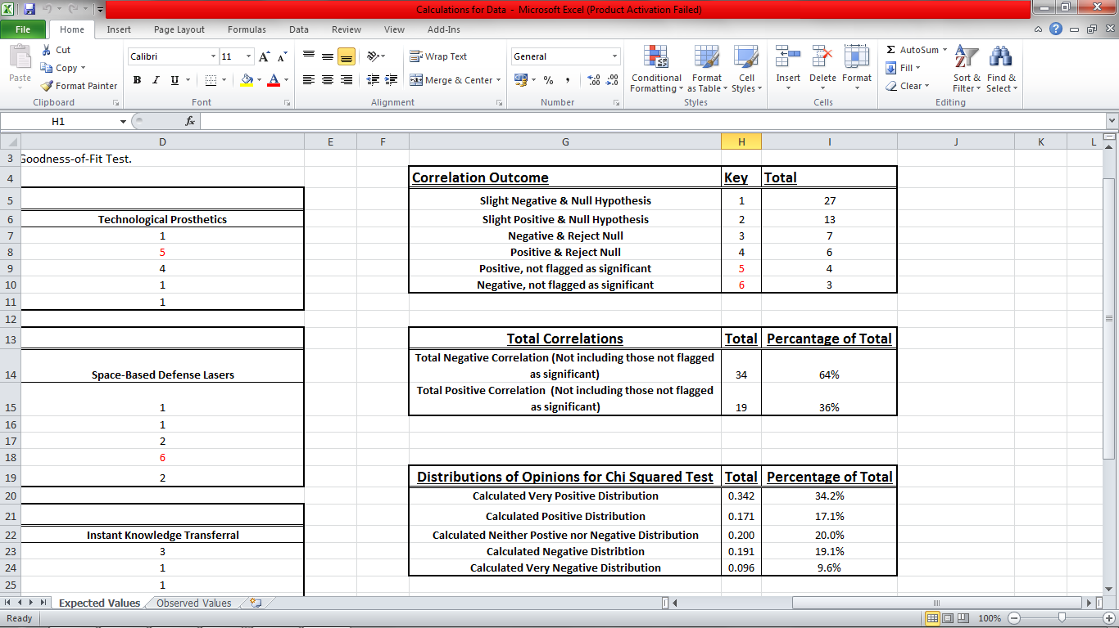

However, as the correlations did not account for the neutral option, ‘Neither Positive nor Negative’, the data from the correlations had to be appropriately calculated to determine the expected values for the Chi Squared Goodness-of-Fit test. Firstly, the totals of the Positive Correlations and Negative Correlations were split in two, so that there would be values for ‘Very Positive’, ‘Positive’, ‘Negative’ and ‘Very Negative’ respectively. Due to the higher number of negative correlations, it was determined that the totals would be split into thirds; two thirds for ‘Very Positive’ and ‘Negative’ and one third for ‘Positive’ and ‘Very Negative’ from their respective totals. This ensures that the expected data would fit appropriately within the parameters of a negative correlation. Then, in order to ensure that the neutral value was included, each of the values were divided by one fifth. The neutral value was then calculated as the difference between the total of the other values and one.

Once these values were calculated, the other values needed were the Observed values. These were extracted from the Case Book and totalled to provide the full Observed values of each opinion. With both the Observed and Expected values, the next step was simply to enter them into SPSS to perform the calculation. This provided an output with the observed and expected results to show the difference between the values as well as the test statistics. The minimum cell frequency was 153.2, showing that all the values were included in the test as they were above the minimum expected value of 5. The output also showed the assumption significance was 0.00, as this value is below 0.05 the null hypothesis was rejected, thus showing that there is in fact a discernable collective opinion regarding the coming Technological Singularity in the determined areas.

# Evaluation of Results

The results of the questionnaire do not support the null hypothesis of “There is no discernible collective opinion regarding the coming Technological Singularity in the determined areas (Business, Education, Medicine and Military)”, however this does not support the original hypothesis that “People are afraid of the coming Technological Singularity.” After evaluation of the results given in the questionnaire it is clear that the majority of the results are in fact Positive and Very Positive, which shows a collective positive opinion and thus does not support the original hypothesis.

However, further evaluation of the results shows that in the individual areas there is a difference in the collective opinion. For example, in the Medicine section, the question “How do you feel about the idea of being able to create and remove memories at will?” had 51.2% of its responses as either ‘Negative’ or ‘Very Negative’ showing a predominantly negative opinion regarding this particular possible use of technology in the future.

Figure 2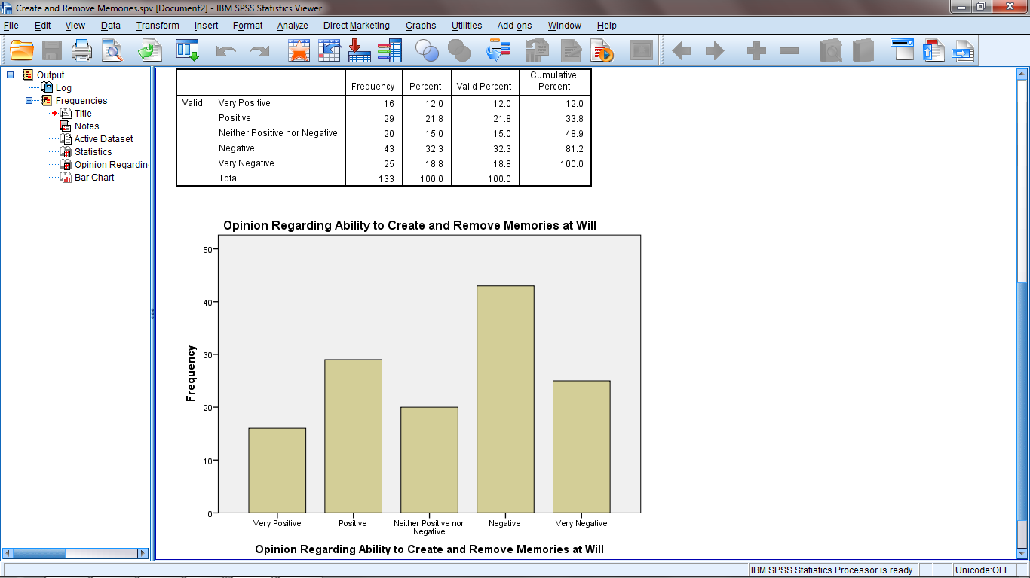

Examining the answers to this question showed that the participant’s gender may have been a large influential factor, as Females had a higher tendency to respond ‘Negative’ than other answers, whilst Males’ answers were spread more thoroughly amongst the available answers.

Figure 3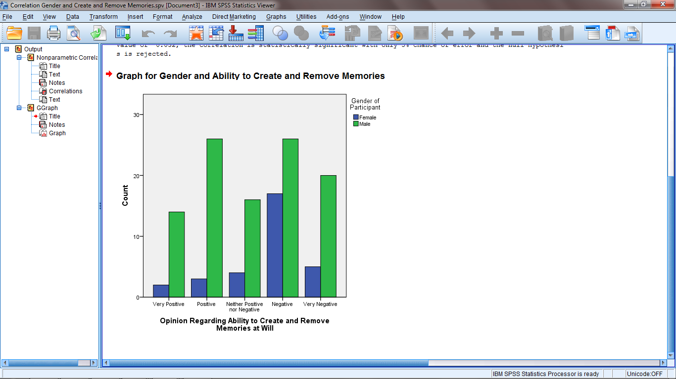

Not only this, but in the Business section, the question “How do you feel about intelligent profiling being used to determine the outcome of your jobs application to a particular business?” had 50.3% of its responses as either ‘Negative’ or ‘Very Negative’ compared to the 32.3% that responded ‘Positive’ or ‘Very Positive’, which also shows a predominantly negative opinion in this particular area of developing technology.

Figure 4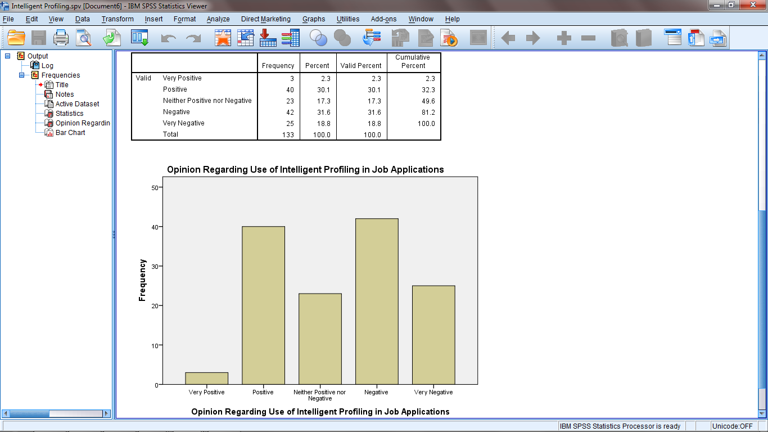

Another example regarding Business, the question “How do you feel about the use of cloud computing to remove intermediate communication between businesses and their customers?“ received 63.1% as either ‘Positive’ or ‘Very Positive’, which shows a predominantly positive opinion in this particular area.

Figure 5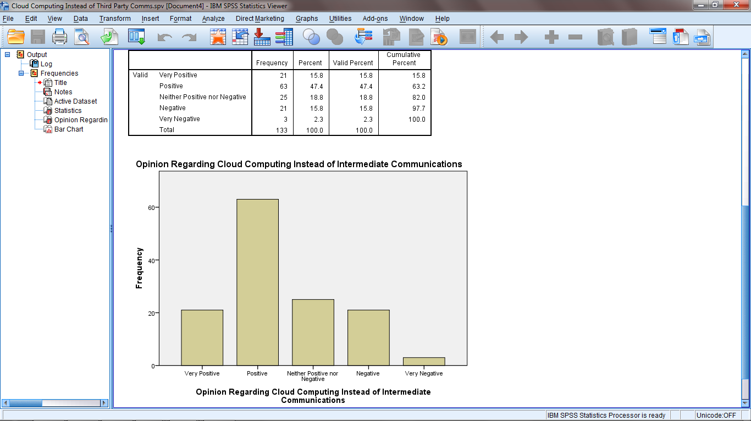

However, further focus on this particular question has shown that the participants’ employment area seems to be linked to their opinion regarding this particular question. The responses show that none of the participants that work in ‘Business or Financial Business’ had a negative opinion for the question whereas those working in other employment areas had more variety regarding their opinions to this question.

Figure 6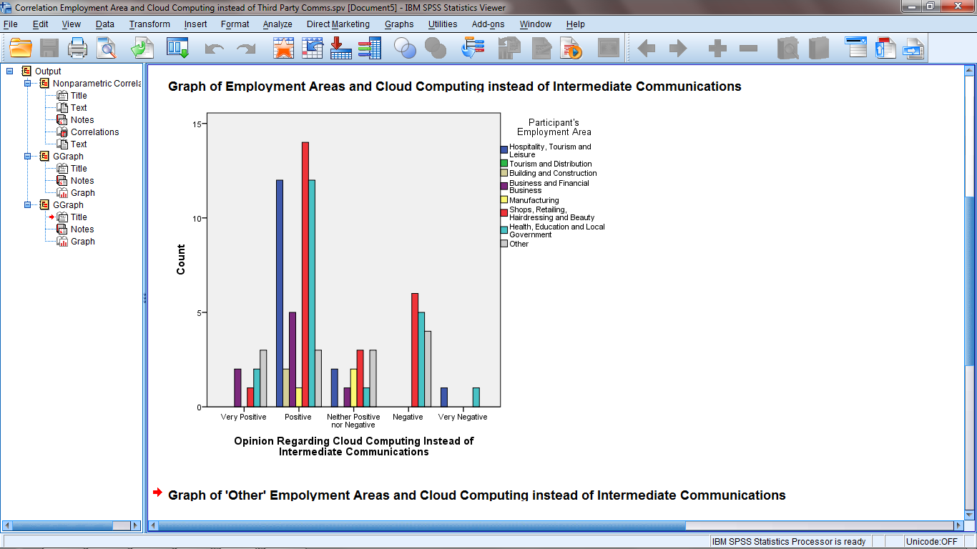

These examples provide some insight into some of the factors that may affect people’s opinions regarding the coming Technological Singularity. This information could provide the start of another study focusing solely on one particular area, such as business or medicine, which may help to further examine any particular factors that affect people’s opinions.

Whilst the outcome of the questionnaire has shown the collective view of the public regarding the coming Technological Singularity, it should be noted that these results could have been affected by multiple factors. The first of these is that as the questionnaire was only available online, the participants had no particular obligation to provide answers. However, this was somewhat unavoidable as it is not only unethical to force potential participants to take part in a questionnaire, but rather hard to force potential participants to take part in an online questionnaire without sitting beside them as they do it, which in turn would affect the results due to the presence of the researcher and lack of anonymity in the responses. Expanding on this particular point, it is possible that some of the participants did not take the time to read and consider the sections of text before each question, which means they would have made uninformed decisions and could have impacted their answers. Furthermore, as it was an online questionnaire it was impossible to moderate if people repeatedly answered the questionnaire, which would have caused the results to be more biased towards their particular answers. However, due to the medium of an online survey being used, it was impossible to prevent this from occurring.

The outcome of the study was also affected by the limited responses to the questionnaire, as due to the small sample size, as only 82 people took part in the study, the study may not show an accurate representation of the population, and as such the outcome that the hypothesis was not supported could potentially be inaccurate. However, as the questionnaire was added to a website called the ‘Singularity Chronicle’ (Available at http://paper.li/kattx78/1380549949), the potential audience was increased and as such the lack of participants could be attributed to the inability to force potential participants to answer the questionnaire. However, the fact that the website hosted the questionnaire could have been a reason for the answers being more focused towards a positive opinion, as the website was focused solely on the advancements in technology and the potential benefits, which could have caused more participants with a previous mind-set towards the Technological Singularity and advancing technologies to answer the question with their previously focused opinions. As well as this, the questions and information could have potentially influenced the participants to some degree. This is because although the information and questions were written so as to be as unbiased as possible, they were created with the hypothesis in mind, and as such there is a chance that they could potentially be slightly biased, which would affect the participants’ responses to the questions.

Another limitation of the study was that approximately a third of the participants, 34.6%, were undergraduates. This can impact the validity of the study, as the responses could be affected by the fact that the majority of the participants were undergraduates, and as such do not represent an accurate sample of the population. Not only this, but with the data collected from the online survey provider, Fluid Surveys, it was apparent that all but one of the participants of the survey were from the United Kingdom (hereafter referred to as UK), with one participant from the United States of America.

Figure 7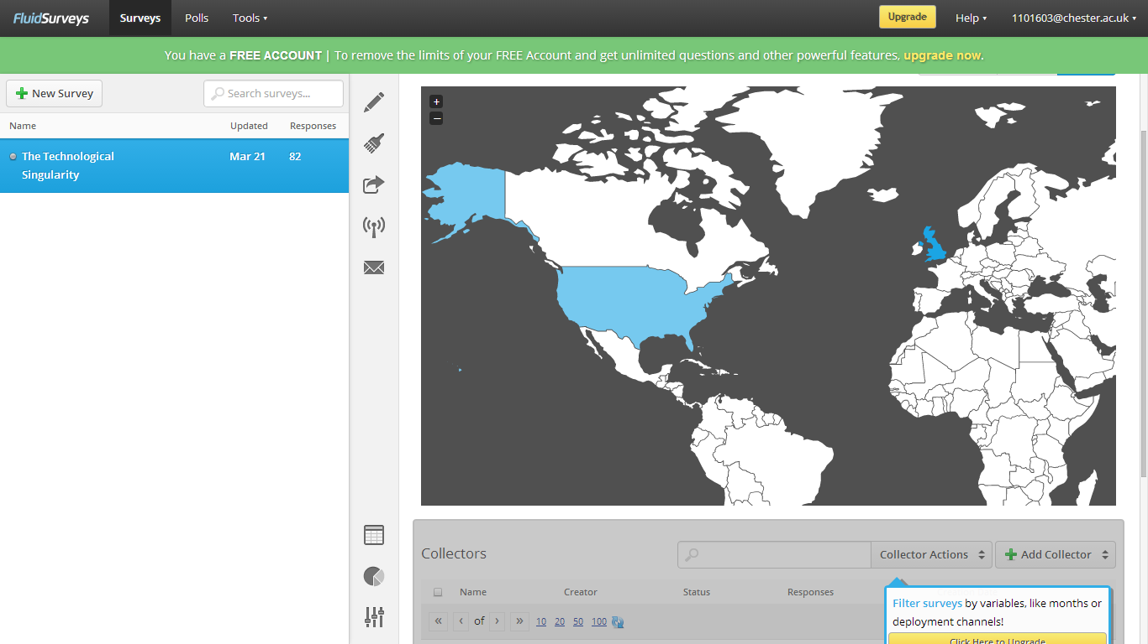

This further limits the validity of the population sample as the vast majority of the responses are all from the same region and therefore may have been influenced by the same ideals held and taught in the UK which could potentially have affected the outcome of the study. Responses from other countries could have provided insight into how alternative ideals affect the participants’ opinions. Future studies could take this into consideration.

Further limitations could include the choices of the areas focused on in the questionnaire. As the questionnaire only focused on four specific areas, it is possible that the outcome of the data was skewed due to these particular areas provoking specific responses from the participants. However, these particular areas were chosen due to the fact that they would provoke a response from the participant, so as to try and limit the number of ‘Neither Positive nor Negative’ responses that could have been chosen due to the participants’ lack of interest. Furthermore, the inclusion of additional areas could have made the questionnaire too long which may have deterred potential participants. Nevertheless, other areas could still have caused a different outcome, and as such another study focusing on alternative areas should be performed to determine if specific areas are in fact affecting the participants’ opinions.

Another potential limitation of the study could include the questions themselves. As there were only three questions to each of the four main sections, there may not have been enough questions to collect the amount of data necessary to correctly verify or disprove the hypothesis. This limitation however was brought about by the fact that if more questions were included then there may have been fewer participants as the extension to the duration of the questionnaire could have dissuaded some potential participants from taking part in the study. Another potential limitation regarding the questions is the fixed scale used in the questionnaire for obtaining the participants’ opinions. By only having five potential answers (‘Very Positive’, ‘Positive’, ‘Neither Positive nor Negative’, ‘Negative’ and ‘Very Negative’) the participants’ answers are limited to these pre-set values when their actual opinions could be more varied. The use of qualitative questions could have helped to provide further insight into the results of the survey, and would have ensured that the participants were able to provide their exact opinion regarding each question. However, this limitation did prevent the data from becoming too complex which could have caused issues regarding the statistical tests.

Whilst there have been many limiting factors to the validity of this study, the number of responses was adequate for calculating appropriate figures that were used in the statistical tests which refuted the hypothesis. Not only this, but the number of various statistical tested performed have helped to identify specific factors that may have influenced the participants’ opinions. Whilst there is the potential that other factors, not included in the study, may have also influenced the participants’ opinions the factors included cover a large selection of possible influences and have helped to provide more information regarding why the participants had their particular opinions. Also the use of an online survey ensured that the questionnaire was not only anonymous but simple to access, and as such ensured that the participants could easily take part in the study without having to worry about being questioned further about their responses. Furthermore, the inclusion of segments of information related to each question ensured that the participants had some information on which to base their opinions. This ensured that the participants had some understanding of the topics of each of the questions, so that they could provide their response as an informed opinion. The inclusion of references for each of the particular information sections also allowed participants to perform further research if they were interested.

# Conclusion

In conclusion, it is apparent that people are not afraid of the coming Technological Singularity and in fact have positive views regarding the advancement of technology in various areas. However, while this may be the overall view, it is also apparent that people have a more negative view regarding specific areas of advancements in technology. Furthermore it appears as though there are factors that influence people’s opinions regarding advances in technology in particular areas. Not only this, but the different areas of the study received different collective opinions, which shows that people have varied ideas depending how the advancements in technology are being used.

In order to provide more validity to this conclusion another survey should be conducted using a larger, more varied sample so as to obtain an appropriate representative sample. Furthermore, additional studies could be conducted focusing on the individual areas included in this study (Business, Education, Medicine and Military) to help provide more information about these particular areas with more information on people’s opinions regarding these areas and what factors could be influencing these opinions. Alternatively, additional studies could be performed with a focus on other areas that have not been included in this study, for example Religion, Entertainment and Transport. This would help to show if the limitation of focusing on only four areas has also affected the results of this study. Whilst this study may have been too broad to identify if any particular factors have a particular influence on people’s opinions it has ensured that the opinions collected are focused on the advancement of technology in general rather than focusing on one particular area.

Overall, while this study has shown that people are not afraid of advances in technology and the coming Technological Singularity, it is apparent that further study is needed in order to verify this conclusion.

# Glossary

**Artificial Intelligence:** The theory and development of computer systems that can perform tasks which normally require human intelligence

**Biomechatronics:** Technological prosthetics with moving parts that can act as artificial limbs or extremities

**Chi Squared** **(X2):** Statistical test to determine whether the alternative or null hypothesis should be accepted X2 = (O – E)2/E O – Observed Value, E – Expected Value

**Electronic Learning:** The use of technology in education, such as audio or video technology

**Executable Biology:** The computational modelling of biological systems

**Futurist:** A person who studies the future and makes predictions calculated off of current trends and data available

**Human-Computer Interface:** The action and design involved in the interaction between humans and computers so as to use computers effectively

**Hypothesis:** A proposed explanation used as the basis for a study

**Intelligence:** The ability to acquire and apply knowledge and/or skills to an applicable situation

**Intercontinental Ballistic Missiles:** Missiles capable of carrying explosive payloads across continents, primarily used for nuclear or chemical weapons delivery

**Microchip:** A small board of semi conductive material used in an integrated circuit

**Nematode:** A worm of the Phylum *Nematoda*, such as the Roundworm

**Neuroprosthetics**: Technological prosthetics that can simulate sensory and cognitive data within neurones.

**Null Hypothesis:** The hypothesis that there is no statistical difference or correlation between sets of data

**Qualitative:** Measuring the quality of something rather than the quantity

**Quantitative:** Measuring the quantity of something rather than the quality

**Spearman’s Rank:** Statistical test to show if there is a positive, negative or absent correlation between two factors.  
 1 – ((6Ʃd2)/(n(n2 – 1))) = x d = Difference in rank, n = number of pairs of data, Ʃ = sum of _

**Three Laws of Robotics:** Asimov’s Three Laws of robotics are:

1. A robot may not injure a human being or, through inaction, allow a human being to come to harm.
2. A robot must obey the orders given to it by human beings, except where such orders would conflict with the First Law.
3. A robot must protect its own existence as long as such protection does not conflict with the First or Second Laws.

**Unmanned Aerial Vehicle:** An aircraft without a pilot on board

**Unmanned Ground Vehicle:** A vehicle without a driver on board

# Bibliography

Allen, P. G. (October 12, 2011) “The Singularity Isn’t Near” TechnologyReview.com. Retrieved 24/11/2013 from http://www.technologyreview.com/view/425733/paul-allen-the-Singularity-isnt-near/

Amandi, A. Schiaffino, S. (January 01, 2009) “Artifical Intelligence: An International Perspective” Vol 5640) Springer, pp193-216.

Asimov, I. (December 2, 1950) Run Around. United States. Gnome Press, (I, Robot)

Britland, M. (June 19, 2013) “What is the Future of Technology in Education?” theGuardian.com Retrieved 27/12/2013 from http://www.theguardian.com/teacher-network/teacher-blog/2013/jun/19/technology-future-education-cloud-social-learning

Cole, C. Wright, J (January, 2010) “What Are Drones?” Drone Wars UK. Initially posted on Peace News in January 2010, posted on Drone Wars UK in 2010. Retrieved 14/12/2013 from http://dronewars.net/aboutdrone/

Didymus, J (October 13, 2013) “US military developing Iron Man-style exoskeleton suit for troops” allvoices.com. Retrieved 15/12/2013 from http://www.allvoices.com/contributed-news/15737690-us-military-developing-talos-iron-manstyle-exoskeleton-suit-for-troops

Drexler, K. E. (1986) “Engines of Creation: The Coming Era of Nanotechnology” 1st edition. New York. Anchor Books. Retrieved 24/11/2013 from http://e-drexler.com/d/06/00/EOC/EOC_Table_of_Contents.html

Earon, A.S. (n.d.) “The Real Business Benefits of Video Conferencing” LifeSize Retrieved 27/12/2013 from https://www.google.co.uk/url?sa=t&rct=j&q=&esrc=s&source=web&cd=9&ved=0CI0BEBYwCA&url=http%3A%2F%2Fwww.lifesize.com%2F~%2Fmedia%2FDocuments%2FRelated%2520Resources%2FWhite%2520Papers%2FThe%2520Real%2520Business%2520Benefits%2520of%2520Video%2520Conferencing.ashx&ei=aHNDU4nNJseAhAev2ICIAw&usg=AFQjCNEmbL9Opy6pmepPBT_sReLfDjqdMA&sig2=6xoKs7QDrxsQgbJKWHAS5A

Freudenrich, C. (January 10, 2007) “How Biomechatronics Works” HowStuffWorks.com Retrieved 14/12/2013 from http://science.howstuffworks.com/biomechatronics.htm

Goertzel, B (March 16, 2012) “Will Corporations Prevent the Singularity?” KurzweilAI.net. Retrieved 24/11/2013 from http://www.kurzweilai.net/will-corporations-prevent-the-Singularity

Jones, P (September 11, 2013) “How evolving technology will change the business world” TheTelegraph.co.uk Retrieved 28/12/2014 from http://www.telegraph.co.uk/sponsored/technology/business-technology/10298682/future-workplace-technology.html

Kim, M (July 26, 2013) “MIT Scientists implant false memory into a mouse’s brain” Washington Post. Retrieved 11/12/2013 from http://www.washingtonpost.com/national/health-science/inception-mit-scientists-implant-a-false-memory-into-a-mouses-brain/2013/07/25/47bdee7a-f49a-11e2-a2f1-a7acf9bd5d3a_story.html

Kurzweil, R (2005) “The Singularity is Near: When Humans Transcend Biology” Viking, United States.

Leard (n.d.) “Spearman’s Rank-Order Correlation” Laerd Statistics. Retrieved 27/12/2013 from https://statistics.laerd.com/statistical-guides/spearmans-rank-order-correlation-statistical-guide.php

Leypold, M.E. Nölting, K. Röser, M. Tavangarian,D. (2004). Is E-Learning the solution for individual learning? Electronic Journal of e-learning 2(2) Page 273

Loones, G. (2006) “The Homebase of Military AI for Flight Simulator” Military AI Works. Last Updated 10/11/2013. Retrieved 24/11/2013 from http://www.militaryaiworks.com/index.html

Madrigal, A.C. (2013, May) “Is this Virtual worm the First Sign of the Singularity?” TheAtlantic.com Retrieved 7/11/2013 from http://www.theatlantic.com/technology/archive/2013/05/is-this-virtual-worm-the-first-sign-of-the-Singularity/275715/

Merkett, D. (May 2012) “Cochlear Implants” Bupa UK. Retrieved 10/12/2013 from http://www.bupa.co.uk/individuals/health-information/directory/c/cochlear-implants#tabContainer

Moon, M (July 26, 2013) “Ultra-thin e-skin could lead to advances in medicine, cool wearable computing” EnGadget.com Retrieved 17/12/2013 from http://www.engadget.com/2013/07/26/e-skin-tokyo-university/

Moore, G. (2005) “Excerpts from a Conversation with Gordon Moore: Moore’s Law” Intel Corporation. Retrieved 7/11/2013 from http://large.stanford.edu/courses/2012/ph250/lee1/docs/Excepts_A_Conversation_with_Gordon_Moore.pdf

MyFuturesInFalkirk (2011) “Main Areas of Employment” MyFuturesInFalkirk.com Retrieved 10/12/2013 from http://www.myfuturesinfalkirk.co.uk/careers/main_areas_employment/main_areas_employment.aspx

Rifkin, J. (1998). The End of Work: The Decline of the Global Labor Force and the Dawn of the Post-Market Era. Journal of Leisure Research, 30(1), New York Pages 66 – 75

Rogers, M. E. (Novermber 1997) “Lasers in Space: Technological Options For Enhancing US Military Capabilities” Maxwell Air Force Base, Alabama. Center for Strategy and Technology Air War College.

Rouse, M (May, 2010) “What is Cyber Warfare?” SearchSecurity.com Retrieved 18/12/2013 from http://searchsecurity.techtarget.com/definition/cyberwarfare

Rutkin, A. H. (September 12, 2013) “Report Suggests Nearly Half of U.S. Jobs are Vulnerable to Computerisation”. TechnologyReview.com. Retrieved 20/11/2013 from http://www.technologyreview.com/view/519241/report-suggests-nearly-half-of-us-jobs-are-vulnerable-to-computerization/

Sharp, V. F. (1979) “Statistics for the social sciences” Little, Brown (Boston)

Strickland, J. (2008, October) “What’s the Technological Singularity?” HowStuffWorks.com. Retrieved November 7, 2013 from http://electronics.howstuffworks.com/gadgets/high-tech-gadgets/technological-Singularity1.htm

Thomson, S (April 4, 2014) “Figuring out the Future: Will we be ready to live in a world where machines are smarter than people?” EdMontonJournal Retrieved 06/04/2014 from http://www.edmontonjournal.com/Figuring+future+Will+ready+live+world+where+machines+smarter+than+people/9703061/story.html

Thorisson, H. T. (April 22, 2007) ”Fear of Intelligent Machines, Survey Results”. ThinkAritificial.org. Retrieved 23/11/2013 from http://www.thinkartificial.org/web/the-fear-of-intelligent-machines-survey-results/

Ulam, S. (May, 1958). “Tribute to John Von Neumann 64”. Bulletin of the American Mathematical Society, 3rd Volume, page 5. Retrieved 20/11/2013 from https://docs.google.com/file/d/0B-5-JeCa2Z7hbWcxTGsyU09HSTg/edit?pli=1

Upbin, B. (August 2, 2013) “IBM’s Watson gets its First Piece of Business in Healthcare”. Forbes.com. Retrieved 23/11/2013 from http://www.forbes.com/sites/bruceupbin/2013/02/08/ibms-watson-gets-its-first-piece-of-business-in-healthcare/

Vinge, V. (1993) “The Coming Technological Singularity: How to Survive in the post-Human Era”. Department of Mathematical Sciences, San Diego State University

# Appendices

Appendix A: Ethics Form

Appendix B: Questionnaire

Appendix C: Questionnaire Results

Appendix D: Descriptive Summaries

Appendix E: Case Summaries

Appendix F: Code Book

Appendix G: Spearman’s Rank Correlations

Appendix H: Chi Squared Goodness-of-Fit Calculated Data

Appendix I: Chi Squared Goodness-of-Fit Data

Appendix J: Chi Squared Goodness-of-Fit Test