Mobile Applications Development Report

Dylan Tyrie-Dron

40203045

1. The aim of this report is to set out the main functionality of the Cooking app that has been created. The inspiration behind this app came from a number of sources. The first hint given was when an internet site was found during a google search about two years ago. It was a site that filtered recipes by their ingredients: "https://myfridgefood.com/". It was filtered by ticking boxes, which involved spending a long time ticking what was in "your fridge". Therefore, it was found to be quite an issue. The solution was to create a way of searching by strings, in an app. This was one of many ideas that were had, but a search of the Google Play Store found less results, that were similar, than expected. It was therefore a sound idea due to the hole in the market.

2.

Diagram.1 The plan for the app

C:\Users\dtd2509\Downloads\report_diagram-cook_app.png

3. The app used an EditText and a "add ingredients Button" to add ingredients to a Search String that was dealt with in the background using the Asynctask: "GetIngredients()". The ingredients searched would then return recipes and store them into an ArrayList object: "Recipe". It also Adds the ingredients to a TextView so that all the ingredients can be searched once again using a "search recipe Button". When the "Search recipe Button" is clicked the ArrayList of recipes Is searched for the ingredients in the TextView. This the returns recipes with images and ingredient descriptions to Scroll through using a Listview in another Activity.

In fig.1 an ingredient is searched using the "add ingredient Button". In fig.2 other ingredients are added using the "add ingredient Button", notice they are added to the TextView. In fig.3 the "Search recipes Button" has been pressed and the second activity is opened presenting the information taken from the API.

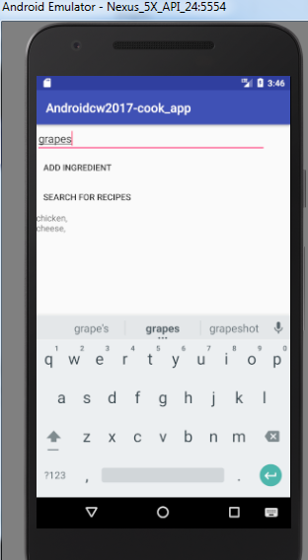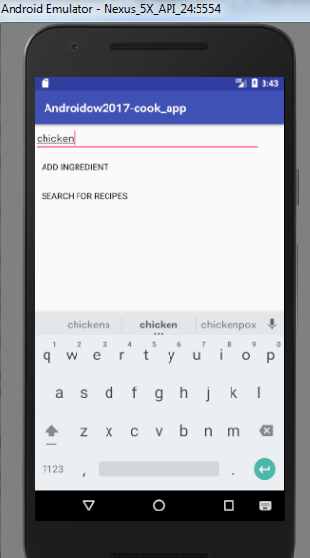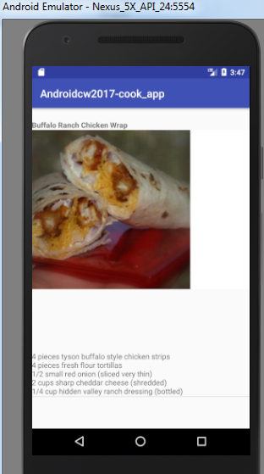fig.1: Search Ingredient fig.2: adding other ingredients in fig.2: result in activity2

4. As it turned out, upon a quick check, later on, in the implementation process, the design of the app was similar to another app. The other app used the same API and had a similar setup including the implementation of the EditText and search recipes button. This proved that though there were few apps this app wouldn’t shine so bright as it was similar to an app already out there. Therefore improvements were made. An improvement the app had, in comparison to the other app out there: "Foodies" was the use of a Textview to make the app give a more visual representation of the ingredients added to the recipe search filter. Another improvement was the search filter itself. In the "Foodies" app, the search could provide support to up to four ingredients, which meant that you couldn’t put the "whole fridge" of ingredients into the search to find a range of different recipes. This is what this app's idea was based on. Therefore, the search was improved to allow any number of ingredients to be entered. This was done by calling the API, every time an "add ingredient Button" was pressed and stored the results in an Arraylist. This meant there was more calls to the API, which if the call was a more "expensive" processing task could render this approach inefficient. Though this had an effect on the processing speed of the app, the app speed of this app is still deemed fast and therefore it is an advantage rather than a disadvantage. However, the app was not tested in a place with low internet speeds. Which, with further testing, could find this search feature to be redundant.

Improvements could be implemented to the app. An improvement that could be made could be the fact that there is not filter for people who may be on a vegetarian diet or the likes. This could be a simple CheckBox That changes a string variable which filters the call to the API. This is a feature that the API call supports and therefore would be a simple implementation. Another improvement could be a "Share Button" that shares a recipe with the user's contacts. This would allow for more user interaction. Another way of improving the app could be the implementation of a rating system. This could allow, again, for more user interaction. Which could be implemented through the use of several clickable images of stars, each one storing a rating for each of the recipes that could update an online database synced with the app.

5. In summary, the app is an app with the scope to improve in the future, given time, could lead to a market leader given the right support and the current hole in the market. This is due to its unique search which allows users to find many more recipes than other, similar, apps out there.

The app's advanced technique in finding recipes meant that an understanding of how to make calls to APIs' using java. This was done using this site:" http://www.androidauthority.com/use-remote-web-api-within-android-app-617869/". Another technique used was parsing the calls so that the data was extracted from the API. This was done using this tutorial: "http://www.androidhive.info/2012/01/android-json-parsing-tutorial/". Another helpful tutorial was a tutorial on Array Adapters found here:" https://www.sitepoint.com/custom-data-layouts-with-your-own-android-arrayadapter/".