ADAP-KDB

Matching to a custom library

# Upload library to ADAP-KDB

## Step 1.1. From the GOLM website (<http://gmd.mpimp-golm.mpg.de/download/>), download a library file and change the file extension from .txt to .msp

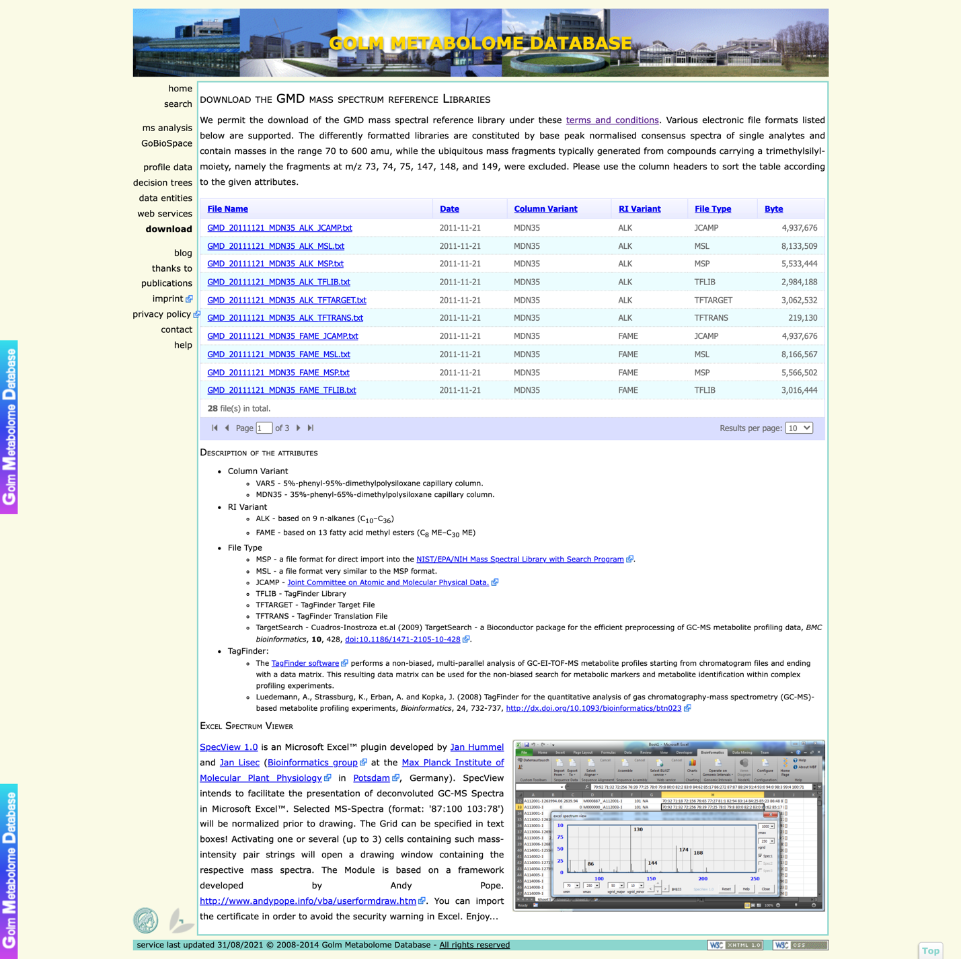

## Step 1.2. At <https://adap.cloud>, first login to your ADAP-KDB account. Click on the Log-in / Sign-up in the left menu and input your username and password. If you don’t have an ADAP-KDB account, first click on Register and follow the instructions.

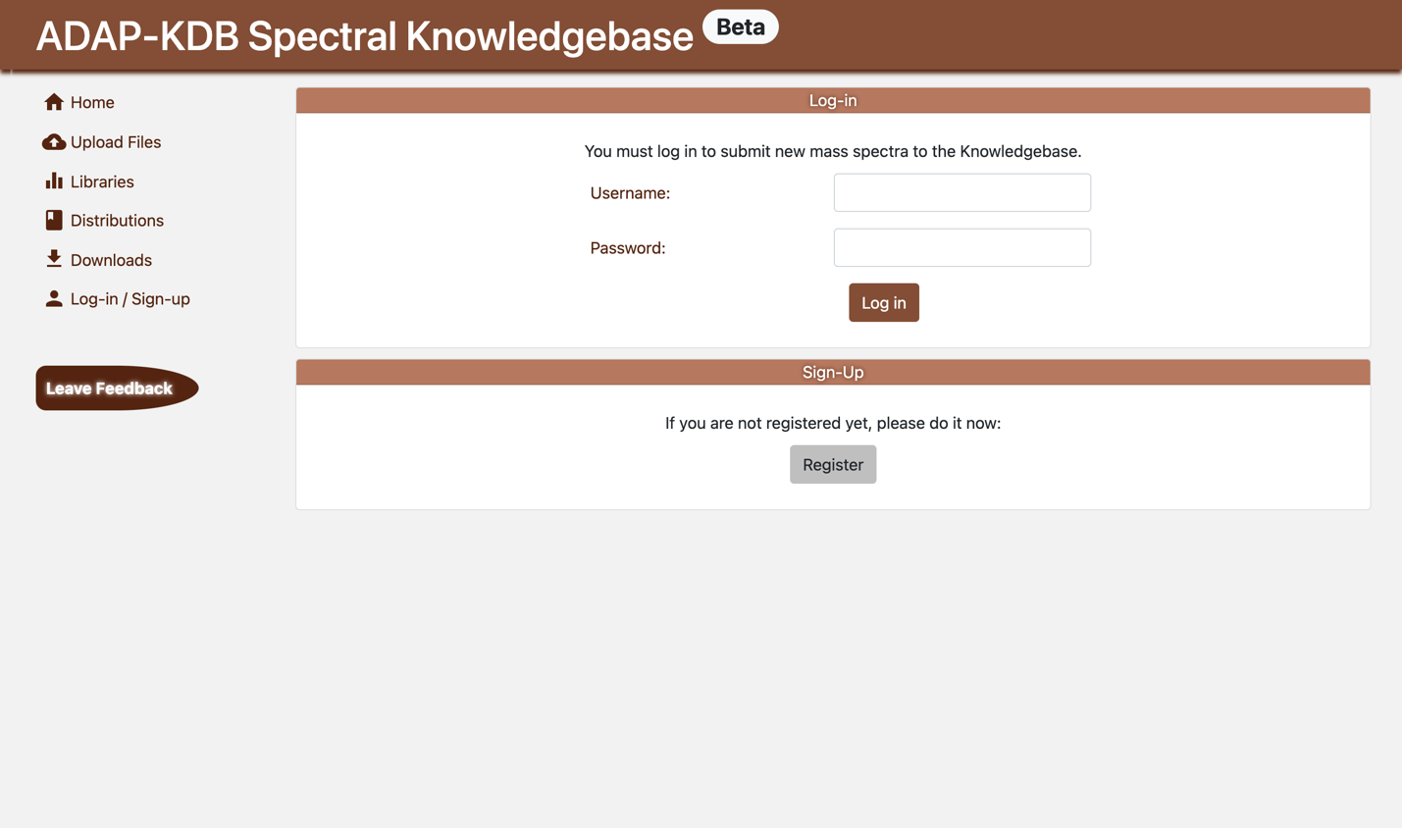

## Step 1.3. Upload a GOLM library file by clicking Upload Files in the left menu. Select GC as the Chromatography Type, click Choose Files, and select the GOLM file in the opened window. In order to read formula, retention index, InChI, and other fields from the GOLM file, you need to click the button Edit Metadata Fields and input the field names in the MSP column. The entered metadata fields should match exactly the ones used in the .msp file. (See the screenshot and the GOLM .msp file side-by-side). Click the “Upload” button at the top right corner.

|  |  |
| --- | --- |
|  |  |

## Step 1.4. Save the library to your account. When you save the library, you can specify its name, ID, description, and URL link. IMPORTANT: to be able to search against this GOLM library, you need to change the switch “Public” to “Private” (makes the file spectra available only to the current user) by clicking the “Public” button, and change “Study” to “Library” by clicking the “Study” button. This change will makes the GOLM spectra available for searching against. Finally, click the Submit button.

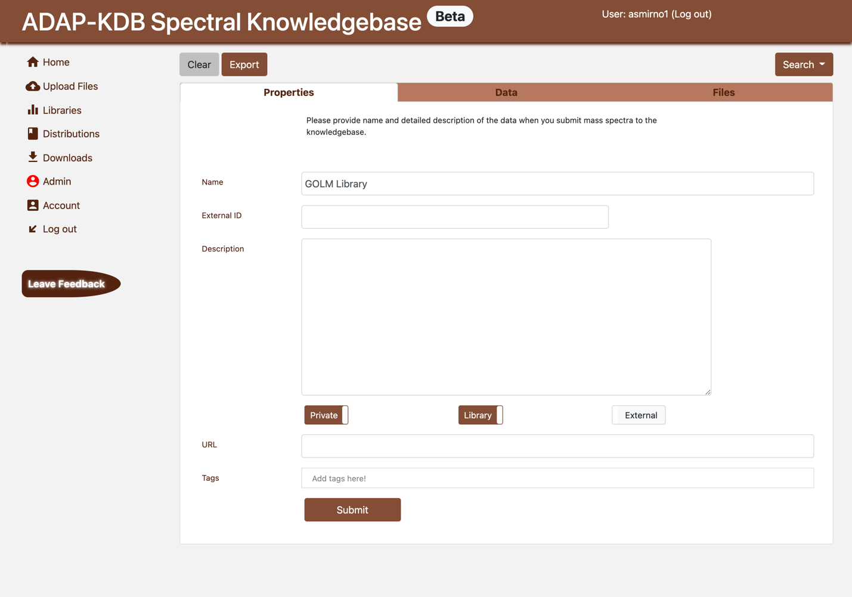

## Step 1.5. You can check that the file is saved into your account by clicking Account in the left menu and selecting the tab Libraries. The uploaded library should be displayed there.

## 

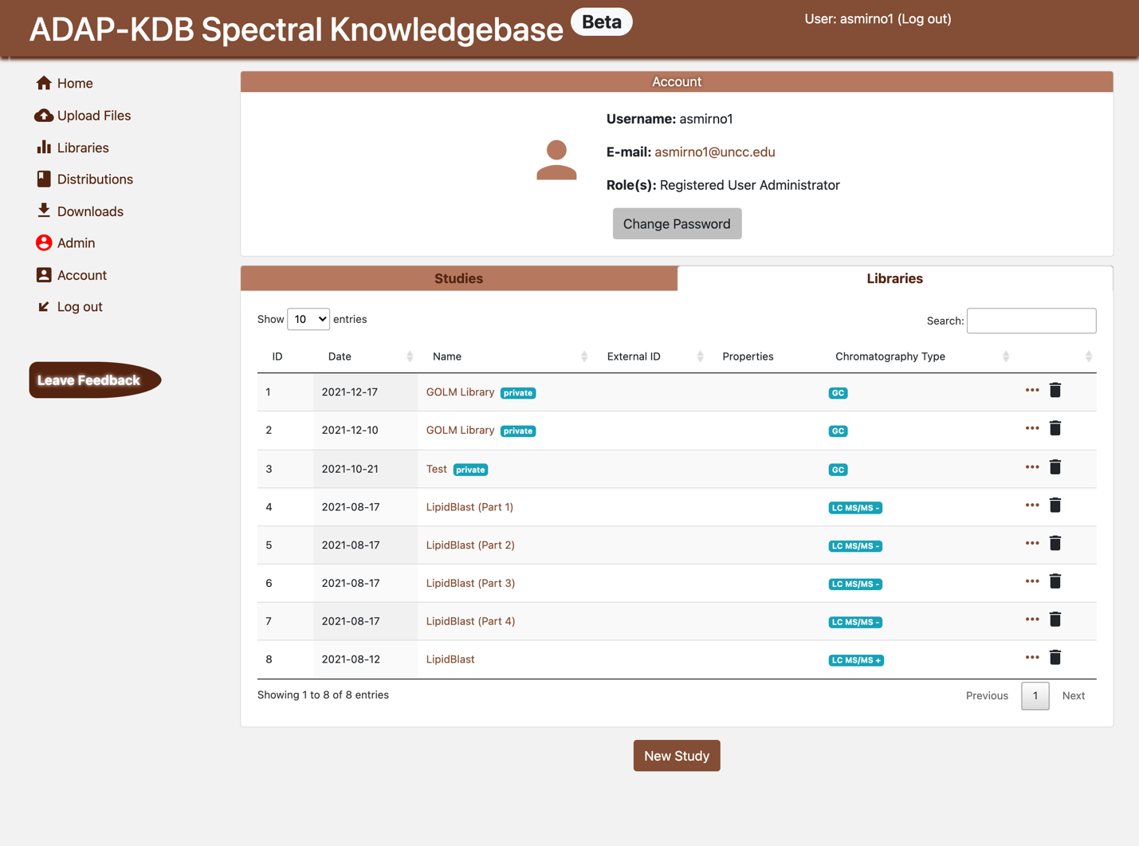

# Search against the GOLM library.

## Step 2.1. Upload another .msp file with mass spectra. See Step 1.3 for details on uploading files to ADAP-KDB.

## Step 2.2. After the file is uploaded, click the button Search / Search for Similar Spectra in the top-right of the current page. You’ll see the Search Parameters page. On the first tab (Libraries), select the libraries that you want to search against, e.g. the GOLM library. On the third page (Parameters), select search parameters. Leave parameters blank to use the default values.

* Score threshold – only matches with the score above the threshold will be included into the search results. The default value is 500.
* Retention Index Tolerance – The difference between Retention Index values should not exceed this tolerance. The default value is 40.
* Retention Index Match:
  + Ignore Retention Index – Retention Index isn’t used when matching spectra;
  + Penalize matches without Retention Index (Strong, Average, Weak) – The similarity scores for the spectra without Retention Index match will be multiplied by 0.5, 0.7, and 0.9 respectively.
  + Always match Retention index – Only matches with the retention index within the tolerance will be included into the search results.
* m/z tolerance – The tolerance used when matching m/z values in the query and library spectra. For the unit-mass-resolution spectra, this tolerance can be anything between 0 and 0.5. The default value is 0.01.
* Matches per Spectrum – maximum number of matches returned for each query spectrum.

## 

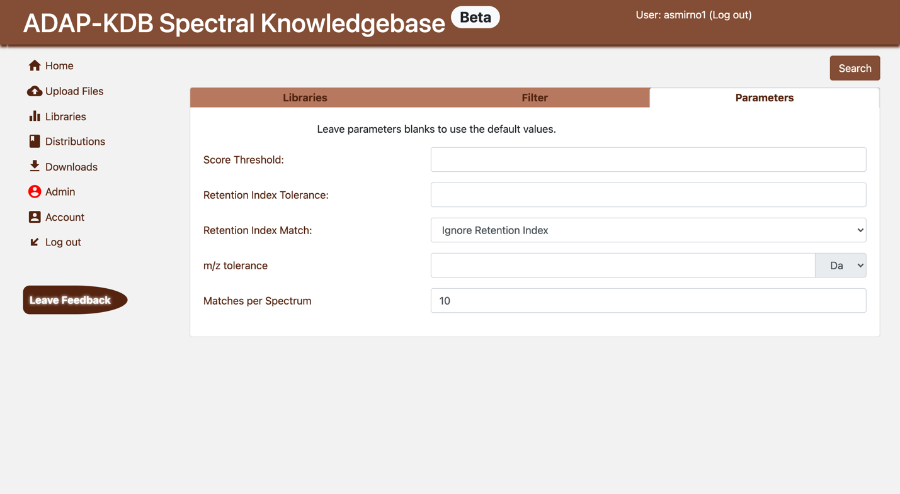

## Step 2.3. Finally, click the Search button. The search will start and its results will show up on the next page. After all spectra are matched (i.e. the progress bar reaches 100%), you can export the search results by click the Export button. You can also visualize the matching results by clicking on a particular “Id”. Each query or library spectrum can also be visualized by clicking on the spectrum name in the “Query” or “Match” column.

