OPR 922 – Operations Research I

Keith Zuckerman

Eben Idiculla

Optimal and Sub-optimal Electric Vehicle Charge Scheduling to Reduce Peak Load

**Problem:**

In order for power grid operators to meet high demand, there is often a need to utilize peaking power plants. While baseload power plants offer a relatively constant supply of power, peaking power plants only run when the demand necessitates it. This means that peaking power plants must be able to ramp up production very quickly, but often just sit idle. Therefore, the cost per kilowatt of a peaking power plant is extremely high compared to that of a baseload power plant.

Due to the high cost associated with peaking power plants, grid operators place a large value on finding ways to avoid using them. One way to limit the use of peaking power plants is through a method known as peak load leveling, which involves both “peak shaving” and “valley filling”. By shaving the peaks and filling the valleys of the total load on the grid, grid operators can purchase energy at a low cost from baseload power plants instead of incurring the higher costs associated with peaking power plants.

In this project, a peak load leveling scheme is simulated which uses the charging and discharging of electric vehicles to impact the peak load on the grid over a 6-hour time window. By effectively scheduling the charging and discharging of each vehicle, the grid operator has the potential to save millions of dollars.

For the purposes of this paper, two different scheduling approaches will be compared. The first approach implements a MILP problem in an attempt to find a solution which minimizes the peak load on the grid. However, as the total number of vehicles in the system grows, this problem becomes computationally burdensome. Therefore, a second approach is utilized which, instead of attempting to find the optimal schedule, simply attempts to find a schedule which is “good enough”. For this approach, the desired peak load is fixed, and there is no objective function for our optimization problem. Instead, we are simply trying to find a feasible solution for the given desired peak load.

The first approach will be known as the “Optimal Scheduling” method, while the second approach will be known as the “Constant Peak” method.

**Model:**

The models for the two different approaches are very similar. We will first attempt to describe the parts of the models that are the same. Then we will describe the differences between each model.

Consider a fleet of N electric vehicles whose charge schedule will be determined by a centralized controller, in this case the grid operator. Each individual schedule will be created based on the goals of the grid operator (i.e. lowering peak load) as well as constraints imposed by each vehicle. The constraints for each vehicle can be broken down into four basic statements:

* The State-of-Charge (SOC) of each vehicle must remain within a certain range for all time steps
  + E.g. Vehicle 1’s battery must always be at least 10% charged, and can never be charged past 100%
* A vehicle has a specific charge rate and a specific discharge rate, which are set
  + i.e. The decision variables are discrete, not continuous
* A vehicle cannot both charge and discharge over the same time step
  + i.e. The decision variables for each vehicle at each time step consist of two binary variables (one for charging, one for discharging) and the sum of these variables must be less than or equal to 1
* The SOC of each vehicle must be greater than the requested SOC at the vehicles time of departure

From the perspective of the grid operator, the goal is to reduce the peak load on the grid. This is done by optimally scheduling the charging and discharging of each vehicle, and then aggregating the contributions from all of the vehicles at each time step.

The power transfer individual vehicle *i* can be written as

$q_{i}\left[k\right]=g_{i}x_{i}\left[k\right]-h_{i}y_{i}[k]$

where $g_{i}$ and $h_{i}$ are the charge and discharge rates and $x\left[k\right]$ and $y[k]$ are binary decision variables for charging and discharging. These decision variables are constrained by

$$x_{i}\left[k\right]+y_{i}[k]≤1$$

$$x_{i}\left[k\right],y_{i}[k] binary$$

which limit each vehicle to either charging, discharging, or doing nothing, but never charging and discharging at the same time. For each time-step, one of these three statuses will be assigned.

The sum of the contributions from the fleet of N vehicles can then be written as

$$E\left[k\right]= \sum_{i=1}^{N}{q_{i}[k]}$$

where a positive value means that the aggregate contribution from the vehicles increases the load on the grid, while a negative value decreases the total load on the grid.

Approach 1: Optimal Scheduling Method

For the Optimal Scheduling method, the model can be written as

$$\operatorname{minimize}{z}$$

$$subject to$$

$$D\left[k\right]+E\left[k\right]≤z for all k$$

$${SOC}_{min,i}≤{SOC}_{i}\left[k\right]≤{SOC}_{max,i} for all k$$

$$x_{i}\left[k\right]+y_{i}[k]≤1 for all k$$

$$x_{i}\left[k\right],y_{i}[k] binary for all k$$

$${SOC}_{i}\left[k\right]≥{SOC}_{req,i} for all k>K_departure$$

where $D\left[k\right]$ is the forecasted demand, and $z$ is a continuous dummy variable that must be greater than or equal to the sum of the forecasted demand and the contribution from the aggregated vehicles. By minimizing z, we are minimizing the peak demand for all time steps.

Approach 2: Constant Peak Method

For the Constant Peak method the model is exactly the same except that $z$ is set to be a constant, and therefore there is no objective function to minimize. Instead of finding an optimal solution, we instead try to determine if we can find a feasible solution for a given peak load. This reduces the size of our constraint matrix because there is one fewer decision variable. In the MATLAB implementation, the objective function was set to all zeros. This results in a problem formulation:

$$\operatorname{minimize}{0}$$

$$subject to$$

$$D\left[k\right]+E\left[k\right]≤z for all k$$

$${SOC}_{min,i}≤{SOC}_{i}\left[k\right]≤{SOC}_{max,i} for all k$$

$$x_{i}\left[k\right]+y_{i}[k]≤1 for all k$$

$$x_{i}\left[k\right],y_{i}[k] binary for all k$$

$${SOC}_{i}\left[k\right]≥{SOC}_{req,i} for all k>K_departure$$

**Constraint Matrix:**

In this section, we will discuss a bit more about the formulation of the constraint matrix for these problems. For each constraint, we will include a visualization of the submatrix to illustrate sparsity.

Departure Time

As mentioned above, one constraint is that each vehicle must reach their desired SOC by the time they depart. This constraint is facilitated by two separate submatrices. The first, which is called the Departure Time submatrix, allows $x_{i}\left[k\right]+y_{i}[k]≤1$ for all time periods before departure. However, after the departure time for a vehicle is reached, the equation becomes $x_{i}\left[k\right]+y_{i}[k]≤0$, which means that no charging or discharging can occur (presumably because the vehicle is no longer plugged in to the system). A visual depiction of the sparsity of this submatrix is shown below. Note, the scale of the y axis has been modified to aid in the visualization. In this case, there are only 2 non-zero entries per row, $x_{i}\left[k\right]$ and $y_{i}\left[k\right]$. This results in a submatrix that is only 0.01% dense.

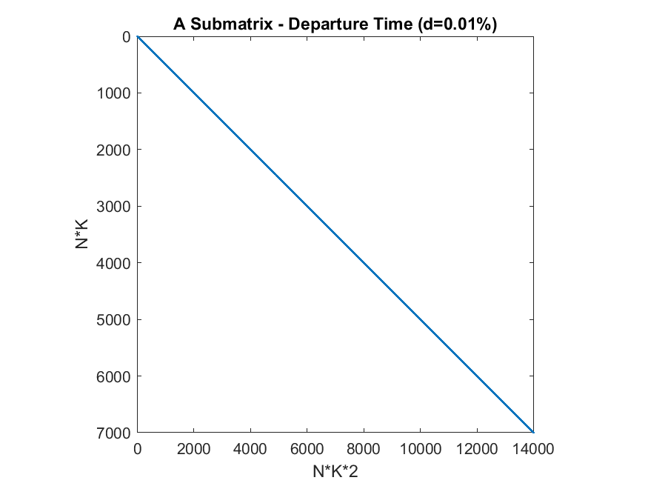

Requested Charge

The second submatrix needed is known as the Requested Charge submatrix. Here, we see that each row has far more non-zero entries. However, because the constraint is based only on an individual vehicle and has nothing to do with all the other vehicles, the matrix is still extremely sparse. With the combination of these two submatrices, the constraint of

$${SOC}_{i}\left[k\right]≥{SOC}_{req,i} for all k>K_departure$$

will ensure that each vehicle is appropriately charged by the desired time.

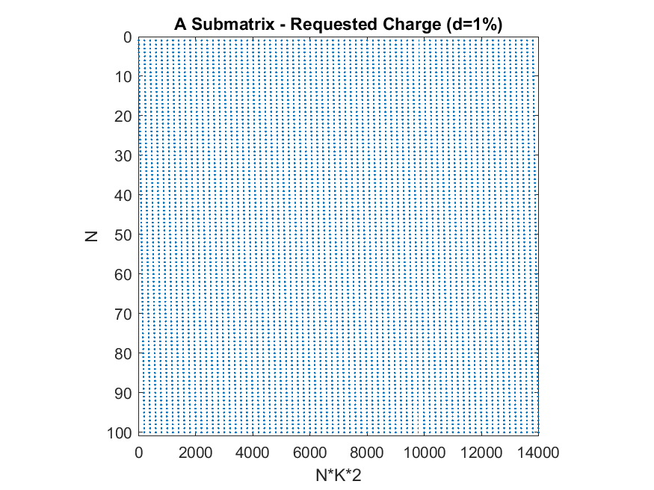

**Results:**

The Optimal scheduling model and constant peak models were evaluated, and their corresponding run times were noted. It can be inferred from figure 1 that with the same peak load both centralized and decentralized model gave similar run times but as the peak load value decreased the runtime also decreased for example, for 1500 vehicles as the load value reduced by 0.02% the runtime was decreased by 100 seconds. This claim is substantiated by figures 2 and 3 where runtimes for 2000 and 2500 vehicles were calculated and plotted. Therefore, using the constant peak models with load value deceased by 0.02% would help in procuring results more swiftly without much change in the total load.

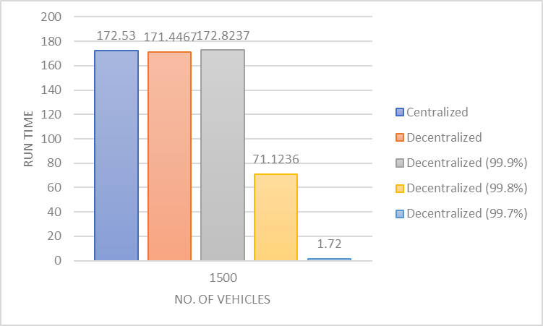

Fig 1 : Plot showing the various run times for 1500 vehicles

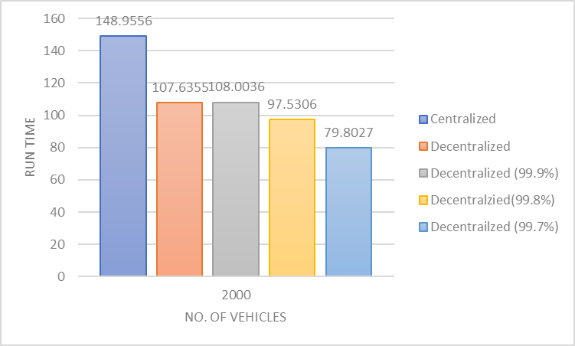

Fig 2 : Plot showing the various run times for 2000 vehicles

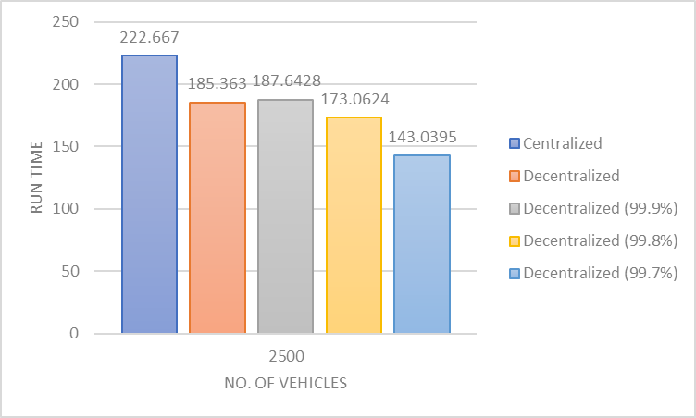

Fig 3 : Plot showing the various run times for 2500 vehicles

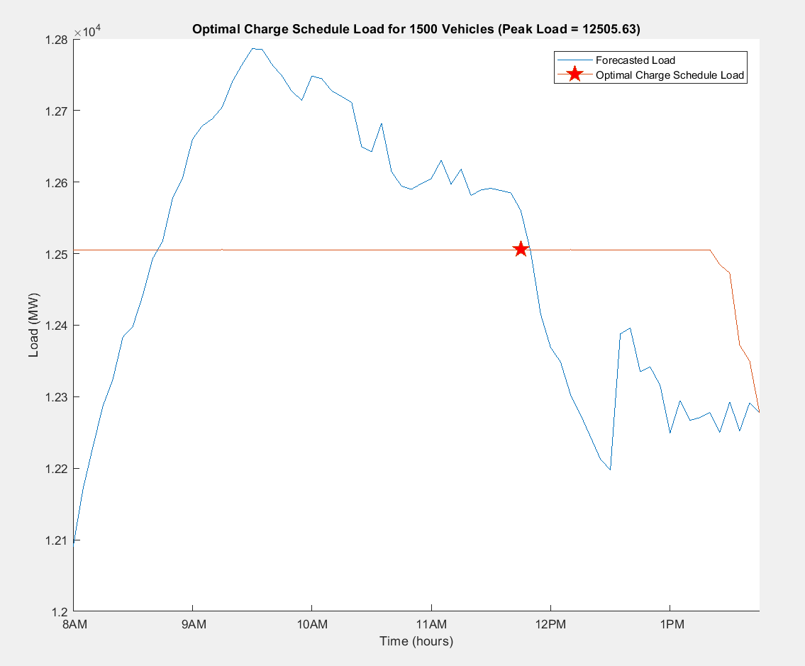

Fig 4: Plot showing the optimal charge schedule for 1500 vehicles.

**Additional Topics to Explore:**

We will be trying to incorporate the power losses associated with charging and discharging and also take into consideration the depreciation factor associated with the charging and discharging of batteries and how it effects the life of a battery and a suitable way to minimize that factor. One thing we noticed while running the models was the discrepancies with the iteration count, we will be looking into it and find a way to explain it in our next report.