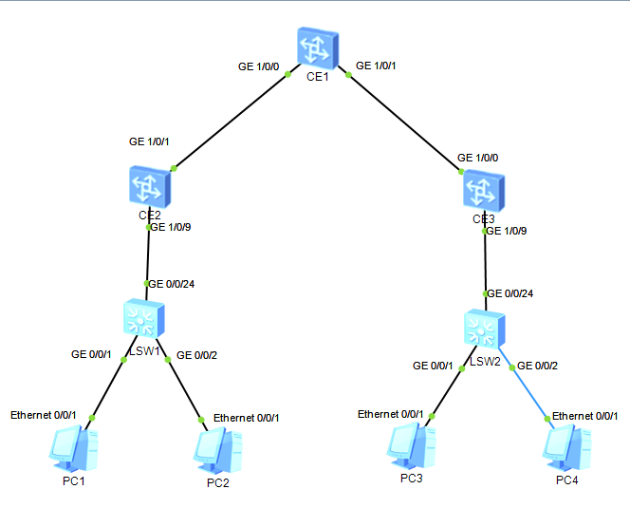
首先配置二层中继
LSW1：
system-view
sysname SW1
vlan batch 10 20
interface GigabitEthernet0/0/1
port link-type access
port default vlan 10
stp edged-port enable
interface GigabitEthernet0/0/2
port link-type access
port default vlan 20
stp edged-port enable
interface GigabitEthernet0/0/24
port link-type trunk
port trunk allow-pass vlan all

LSW2：
system-view
sysname SW2
vlan batch 10 20
interface GigabitEthernet0/0/1
port link-type access
port default vlan 10
stp edged-port enable
interface GigabitEthernet0/0/2
port link-type access
port default vlan 20
stp edged-port enable
interface GigabitEthernet0/0/24
port link-type trunk
port trunk allow-pass vlan all

然后在核心交换机上配置ospfv2
CE1：
system-view
sysname CE1
interface GE1/0/0
undo portswitch
undo shutdown //vrp8中接口默认关闭，需要手动打开
ip address 12.1.1.1 24
interface GE1/0/1
undo portswitch
undo shutdown
ip address 13.1.1.1 24
interface LoopBack0
ip address 1.1.1.1 32
ospf 10 router-id 1.1.1.1
area 0.0.0.0
network 1.1.1.1 0.0.0.0
network 12.1.1.1 0.0.0.0
network 13.1.1.1 0.0.0.0
commit //vrp8中必须执行commit命令方可执行配置的命令。

CE2：
system-view
sysname CE2
interface GE1/0/1
undo portswitch
undo shutdown
ip address 12.1.1.2 24
interface LoopBack0
ip address 2.2.2.2 32
ospf 10 router-id 2.2.2.2
area 0.0.0.0
network 2.2.2.2 0.0.0.0
network 12.1.1.2 0.0.0.0
commit

CE3：
system-view
sysname CE3
interface GE1/0/0
undo portswitch
undo shutdown
ip address 13.1.1.3 24
interface LoopBack0
ip address 3.3.3.3 32
ospf 10 router-id 3.3.3.3
area 0.0.0.0
network 3.3.3.3 0.0.0.0
network 13.1.1.3 0.0.0.0
commit

可利用环回口测试连通性：
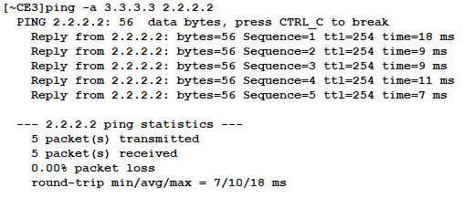

接着我们开始配置VxLAN:
CE2：
evpn-overlay enable
bridge-domain 10
vxlan vni 10
evpn
route-distinguisher 102:102
vpn-target 10:10 both
bridge-domain 20
vxlan vni 20
evpn
route-distinguisher 202:202
vpn-target 20:20 both
interface GE1/0/9
undo shutdown
portswitch
port link-type trunk
interface GE1/0/9.10 mode l2
encapsulation dot1q vid 10
bridge-domain 10
interface GE1/0/9.20 mode l2
encapsulation dot1q vid 20
bridge-domain 20
bgp 100
router-id 2.2.2.2
peer 3.3.3.3 as-number 100
peer 3.3.3.3 connect-interface LoopBack0
l2vpn-family evpn
peer 3.3.3.3 enable
y
peer 3.3.3.3 advertise irb
peer 3.3.3.3 advertise-community
interface Nve1
source 2.2.2.2
vni 10 head-end peer-list protocol bgp
vni 20 head-end peer-list protocol bgp
commit

CE3:
evpn-overlay enable
bridge-domain 10
vxlan vni 10
evpn
route-distinguisher 103:103
vpn-target 10:10 both
bridge-domain 20
vxlan vni 20
evpn
route-distinguisher 203:203
vpn-target 20:20 both
interface GE1/0/9
undo shutdown
portswitch
port link-type trunk
interface GE1/0/9.10 mode l2
encapsulation dot1q vid 10
bridge-domain 10
interface GE1/0/9.20 mode l2
encapsulation dot1q vid 20
bridge-domain 20
bgp 100
router-id 3.3.3.3
peer 2.2.2.2 as-number 100
peer 2.2.2.2 connect-interface LoopBack0
l2vpn-family evpn
peer 2.2.2.2 enable
y
peer 2.2.2.2 advertise irb
peer 2.2.2.2 advertise-community
interface Nve1
source 3.3.3.3
vni 10 head-end peer-list protocol bgp
vni 20 head-end peer-list protocol bgp
commit

验证一下bgp evpn的建立情况：
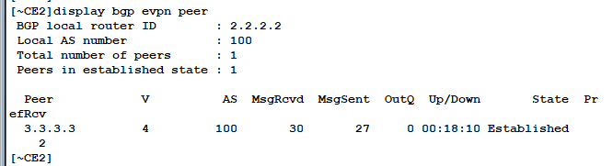
查看一下VxLAN 隧道建立情况：
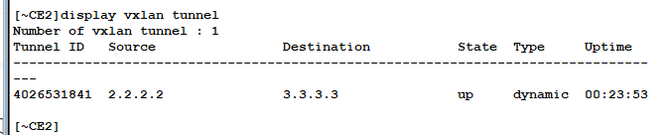
PC1与PC3测试连通性：
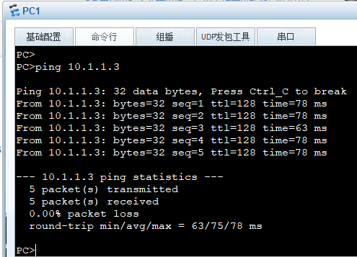
注：
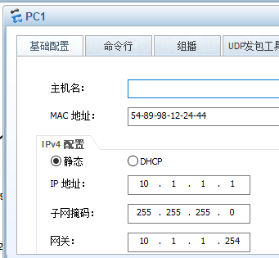
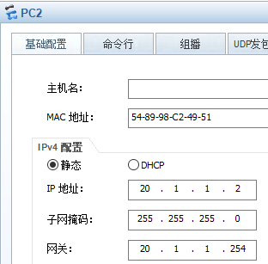

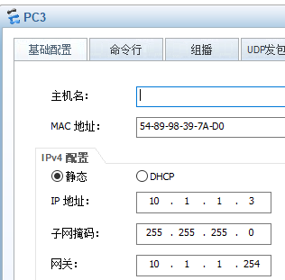
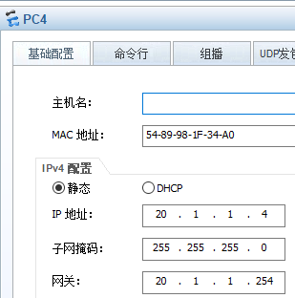

最后我们配置VxLAN的网关：
CE1：
evpn-overlay enable
bridge-domain 10
vxlan vni 10
evpn
route-distinguisher 101:101
vpn-target 10:10 both
bridge-domain 20
vxlan vni 20
evpn
route-distinguisher 102:102
vpn-target 20:20 both
interface Vbdif10
ip address 10.1.1.254 255.255.255.0
vxlan anycast-gateway enable
arp collect host enable
interface Vbdif20
ip address 20.1.1.254 255.255.255.0
vxlan anycast-gateway enable
arp collect host enable
interface Nve1
source 1.1.1.1
vni 10 head-end peer-list protocol bgp
vni 20 head-end peer-list protocol bgp
bgp 100
router-id 1.1.1.1
peer 2.2.2.2 as-number 100
peer 2.2.2.2 connect-interface LoopBack0
peer 3.3.3.3 as-number 100
peer 3.3.3.3 connect-interface LoopBack0
l2vpn-family evpn
peer 2.2.2.2 enable
y
peer 2.2.2.2 advertise irb
peer 2.2.2.2 advertise-community
peer 3.3.3.3 enable
y
peer 3.3.3.3 advertise irb
peer 3.3.3.3 advertise-community

CE2:
bgp 100
peer 1.1.1.1 as-number 100
peer 1.1.1.1 connect-interface LoopBack0
l2vpn-family evpn
peer 1.1.1.1 enable
y
peer 1.1.1.1 advertise irb
peer 1.1.1.1 advertise-community
commit

CE2:
bgp 100
peer 1.1.1.1 as-number 100
peer 1.1.1.1 connect-interface LoopBack0
l2vpn-family evpn
peer 1.1.1.1 enable
y
peer 1.1.1.1 advertise irb
peer 1.1.1.1 advertise-community
commit

由于模拟器bug此时大概率会出现PC间不能通信，正常现象应该是都可以通信。

