## FW1：

Username:admin

Password:

The password needs to be changed. Change now? [Y/N]: y

Please enter old password:

Please enter new password:

Please confirm new password:

Info: Your password has been changed. Save the change to survive a reboot.

*************************************************************************

* Copyright (C) 2014-2018 Huawei Technologies Co., Ltd. *

* All rights reserved. *

* Without the owner's prior written consent, *

* no decompiling or reverse-engineering shall be allowed. *

*************************************************************************

<USG6000V1>sys

Enter system view, return user view with Ctrl+Z.

[USG6000V1]sys FW1

[FW1]fire

[FW1]firewall

Nov 13 2022 06:27:05 FW1 DS/4/DATASYNC_CFGCHANGE:OID 1.3.6.1.4.1.2011.5.25.191.3

.1 configurations have been changed. The current change number is 1, the change

loop count is 0, and the maximum number of records is 4095.

[FW1]firewall

Nov 13 2022 06:27:11 FW1 %%01UPDATE/3/LOAD_FAIL(l)[0]:Failed to load the signatu

re database. (SyslogId=0, Module=AV-SDB, Slot=11, CPU=0, LoadVersion=, Duration(

s)=0, Reason="No SDB version is available for loading")

[FW1]firewall un in en

^

Error: Unrecognized command found at '^' position.

[FW1]un in en

Info: Saving log files...

Info: Information center is disabled.

[FW1]fire

[FW1]firewall zone t

[FW1]firewall zone trust

[FW1-zone-trust]int g1/0/1

[FW1-GigabitEthernet1/0/1]q

[FW1]fire

[FW1]firewall zone t

[FW1]firewall zone trust

[FW1-zone-trust]add int g1/0/1

[FW1-zone-trust]fire

[FW1-zone-trust]q

[FW1]fire

[FW1]firewall zone dmz

[FW1-zone-dmz]add int g1/0/0

[FW1-zone-dmz]dis this

2022-11-13 06:28:55.550

#

firewall zone dmz

set priority 50

add interface GigabitEthernet1/0/0

#

return

[FW1-zone-dmz]q

[FW1]fire

[FW1]firewall zone un

[FW1]firewall zone untrust

[FW1-zone-untrust]add int g1/0/2

[FW1-zone-untrust]dis this

2022-11-13 06:29:49.120

#

firewall zone untrust

set priority 5

add interface GigabitEthernet1/0/2

#

return

[FW1-zone-untrust]q

[FW1]dis ip int bri

2022-11-13 06:30:06.320

*down: administratively down

^down: standby

(l): loopback

(s): spoofing

(d): Dampening Suppressed

(E): E-Trunk down

The number of interface that is UP in Physical is 6

The number of interface that is DOWN in Physical is 4

The number of interface that is UP in Protocol is 2

The number of interface that is DOWN in Protocol is 8

Interface IP Address/Mask Physical Protocol

GigabitEthernet0/0/0 192.168.0.1/24 down down

GigabitEthernet1/0/0 unassigned up down

GigabitEthernet1/0/1 unassigned up down

GigabitEthernet1/0/2 unassigned up down

GigabitEthernet1/0/3 unassigned up down

GigabitEthernet1/0/4 unassigned down down

GigabitEthernet1/0/5 unassigned down down

GigabitEthernet1/0/6 unassigned down down

NULL0 unassigned up up(s)

Virtual-if0 unassigned up up(s)

[FW1]dis zone

2022-11-13 06:30:17.220

local

priority is 100

interface of the zone is (0):

#

trust

priority is 85

interface of the zone is (2):

GigabitEthernet0/0/0

GigabitEthernet1/0/1

#

untrust

priority is 5

interface of the zone is (1):

GigabitEthernet1/0/2

#

dmz

priority is 50

interface of the zone is (1):

GigabitEthernet1/0/0

#

[FW1]fir

[FW1]firewall zone name huawei

[FW1-zone-huawei]add int g1/0/3

[FW1-zone-huawei]q

[FW1]

[FW1]

[FW1]int g1/0/3

[FW1-GigabitEthernet1/0/3]ip add 10.1.10.1 24

[FW1-GigabitEthernet1/0/3]service-m

[FW1-GigabitEthernet1/0/3]service-manage

^

Error:Incomplete command found at '^' position.

[FW1-GigabitEthernet1/0/3]ser

[FW1-GigabitEthernet1/0/3]service-huawei

^

Error: Unrecognized command found at '^' position.

[FW1-GigabitEthernet1/0/3]service-manage all permit

[FW1-GigabitEthernet1/0/3]

登录10.1.10.1Web界面

[FW1]dis ip int bri

2022-11-13 10:59:19.140

*down: administratively down

^down: standby

(l): loopback

(s): spoofing

(d): Dampening Suppressed

(E): E-Trunk down

The number of interface that is UP in Physical is 6

The number of interface that is DOWN in Physical is 4

The number of interface that is UP in Protocol is 3

The number of interface that is DOWN in Protocol is 7

Interface IP Address/Mask Physical Protocol

GigabitEthernet0/0/0 192.168.0.1/24 down down

GigabitEthernet1/0/0 unassigned up down

GigabitEthernet1/0/1 unassigned up down

GigabitEthernet1/0/2 unassigned up down

GigabitEthernet1/0/3 10.1.10.1/24 up up

GigabitEthernet1/0/4 unassigned down down

GigabitEthernet1/0/5 unassigned down down

GigabitEthernet1/0/6 unassigned down down

NULL0 unassigned up up(s)

Virtual-if0 unassigned up up(s)

[FW1]

[FW1]int g1/0/1

[FW1-GigabitEthernet1/0/1]ip add 192.168.10.1 24

[FW1-GigabitEthernet1/0/1]int g1/0/0

[FW1-GigabitEthernet1/0/0]ip add 192.168.20.1 24

[FW1-GigabitEthernet1/0/0]int g1/0/2

[FW1-GigabitEthernet1/0/2]ip add 11.1.1.1 24

[FW1-GigabitEthernet1/0/2]q

[FW1]dis ip int bri

2022-11-13 11:02:40.810

*down: administratively down

^down: standby

(l): loopback

(s): spoofing

(d): Dampening Suppressed

(E): E-Trunk down

The number of interface that is UP in Physical is 6

The number of interface that is DOWN in Physical is 4

The number of interface that is UP in Protocol is 6

The number of interface that is DOWN in Protocol is 4

Interface IP Address/Mask Physical Protocol

GigabitEthernet0/0/0 192.168.0.1/24 down down

GigabitEthernet1/0/0 192.168.20.1/24 up up

GigabitEthernet1/0/1 192.168.10.1/24 up up

GigabitEthernet1/0/2 11.1.1.1/24 up up

GigabitEthernet1/0/3 10.1.10.1/24 up up

GigabitEthernet1/0/4 unassigned down down

GigabitEthernet1/0/5 unassigned down down

GigabitEthernet1/0/6 unassigned down down

NULL0 unassigned up up(s)

Virtual-if0 unassigned up up(s)

[FW1]dis ip routing

2022-11-13 11:17:36.640

Route Flags: R - relay, D - download to fib

------------------------------------------------------------------------------

Routing Tables: Public

Destinations : 10 Routes : 10

Destination/Mask Proto Pre Cost Flags NextHop Interface

10.1.10.0/24 Direct 0 0 D 10.1.10.1 GigabitEthernet

1/0/3

10.1.10.1/32 Direct 0 0 D 127.0.0.1 GigabitEthernet

1/0/3

11.1.1.0/24 Direct 0 0 D 11.1.1.1 GigabitEthernet

1/0/2

11.1.1.1/32 Direct 0 0 D 127.0.0.1 GigabitEthernet

1/0/2

127.0.0.0/8 Direct 0 0 D 127.0.0.1 InLoopBack0

127.0.0.1/32 Direct 0 0 D 127.0.0.1 InLoopBack0

192.168.10.0/24 Direct 0 0 D 192.168.10.1 GigabitEthernet

1/0/1

192.168.10.1/32 Direct 0 0 D 127.0.0.1 GigabitEthernet

1/0/1

192.168.20.0/24 Direct 0 0 D 192.168.20.1 GigabitEthernet

1/0/0

192.168.20.1/32 Direct 0 0 D 127.0.0.1 GigabitEthernet

1/0/0

[FW1]ip route-static 0.0.0.0 0 11.1.1.254

[FW1]nat address-group isp

[FW1-address-group-isp]mode no

[FW1-address-group-isp]mode no-pat g

[FW1-address-group-isp]mode no-pat global

[FW1-address-group-isp]dis this

2022-11-13 11:23:03.870

#

nat address-group isp 0

mode no-pat global

#

return

[FW1-address-group-isp]se

[FW1-address-group-isp]section 0 11.1.1.100 11.1.1.110

[FW1-address-group-isp]dis this

2022-11-13 11:23:40.650

#

nat address-group isp 0

mode no-pat global

section 0 11.1.1.100 11.1.1.110

#

return

[FW1-address-group-isp]q

[FW1]nat-p

[FW1]nat-policy

[FW1-policy-nat]rule name to-isp

[FW1-policy-nat-rule-to-isp]spi

[FW1-policy-nat-rule-to-isp]sou

[FW1-policy-nat-rule-to-isp]source-zone tr

[FW1-policy-nat-rule-to-isp]source-zone trust

[FW1-policy-nat-rule-to-isp]des

[FW1-policy-nat-rule-to-isp]destination-zone

[FW1-policy-nat-rule-to-isp]destination-zone un

[FW1-policy-nat-rule-to-isp]destination-zone untrust

[FW1-policy-nat-rule-to-isp]sou

[FW1-policy-nat-rule-to-isp]source-add

[FW1-policy-nat-rule-to-isp]source-address 192.168.10.0 mask 24

^

Error: Wrong parameter found at '^' position.

[FW1-policy-nat-rule-to-isp]source-address 192.168.10.0 mask 255.255.255.0

[FW1-policy-nat-rule-to-isp]ac

[FW1-policy-nat-rule-to-isp]action source-n

[FW1-policy-nat-rule-to-isp]action source-nat add

[FW1-policy-nat-rule-to-isp]action source-nat address-group isp

Info: The current source conversion address pool type is no-pat, and if some bu

sinesses of the same user do not need to do NAT, please create a new rule with N

AT type No-nat, otherwise the user's business will be NAT.

[FW1-policy-nat-rule-to-isp]dis this

2022-11-13 11:29:04.880

#

rule name to-isp

source-zone trust

destination-zone untrust

source-address 192.168.10.0 mask 255.255.255.0

action source-nat address-group isp

#

return

[FW1-policy-nat-rule-to-isp]

[FW1-policy-nat-rule-to-isp]q

[FW1-policy-nat]

[FW1-policy-nat]

[FW1-policy-nat]dis this

2022-11-13 11:29:21.740

#

nat-policy

rule name to-isp

source-zone trust

destination-zone untrust

source-address 192.168.10.0 mask 255.255.255.0

action source-nat address-group isp

#

return

[FW1-policy-nat]

[FW1-policy-nat]q

[FW1]

[FW1]

[FW1]q

^

Error:Ambiguous command found at '^' position.

[FW1]q

^

Error:Ambiguous command found at '^' position.

[FW1]quit

<FW1>dis fir

<FW1>dis firewall s

<FW1>dis firewall statistics s

<FW1>dis firewall statistics system i

<FW1>dis firewall statistics system di

<FW1>dis firewall statistics system discard

2022-11-13 11:33:13.790

Discard statistic information:

Fib miss packets discarded: 3

TCP session miss packets discarded: 1

Recieve interface error packets discarded: 17

L3 other eth type packets discarded: 1872

Dispatch drop packets discarded: 143

FW1>dis se

<FW1>dis sec

<FW1>dis secur

<FW1>dis security-policy

<FW1>dis security-policy rule all

2022-11-13 11:35:57.870

Total:1

RULE ID RULE NAME STATE ACTION HITS

-------------------------------------------------------------------------------

0 default enable deny 0

-------------------------------------------------------------------------------

策略改成允许，此时PC1可以PING通122.1.1.10

<FW1>sys

Enter system view, return user view with Ctrl+Z.

[FW1]sec

[FW1]security-policy rule name tru

[FW1]security-policy rule name trustto-untrust

^

Error:Too many parameters found at '^' position.

[FW1]security-policy

[FW1-policy-security]security-policy rule name trustto-untrust

^

Error: Unrecognized command found at '^' position.

[FW1-policy-security]rule name trust-to-untrust

[FW1-policy-security-rule-trust-to-untrust]des

[FW1-policy-security-rule-trust-to-untrust]destination-zone un

[FW1-policy-security-rule-trust-to-untrust]destination-zone untrust

[FW1-policy-security-rule-trust-to-untrust]sou

[FW1-policy-security-rule-trust-to-untrust]source-add

[FW1-policy-security-rule-trust-to-untrust]source-address 192.168.10.0 24

[FW1-policy-security-rule-trust-to-untrust]acc

[FW1-policy-security-rule-trust-to-untrust]access

[FW1-policy-security-rule-trust-to-untrust]access-authentication

^

Error:Incomplete command found at '^' position.

[FW1-policy-security-rule-trust-to-untrust]action permit

[FW1-policy-security-rule-trust-to-untrust]dis this

2022-11-13 11:43:32.110

#

rule name trust-to-untrust

destination-zone untrust

source-address 192.168.10.0 mask 255.255.255.0

action permit

#

return

[FW1-policy-security-rule-trust-to-untrust]



Default规则只能放在下面

自定义规则可以调位置

## R1

<Huawei>

<Huawei>sys

Enter system view, return user view with Ctrl+Z.

[Huawei]sys R1

[R1]int g0/0/2

[R1-GigabitEthernet0/0/2]ip add 11.1.1.254 24

Nov 13 2022 19:05:07-08:00 R1 %%01IFNET/4/LINK_STATE(l)[0]:The line protocol IP

on the interface GigabitEthernet0/0/2 has entered the UP state.

[R1-GigabitEthernet0/0/2]q

[R1]

[R1]un in en

Info: Information center is disabled.

[R1]int g0/0/0

[R1-GigabitEthernet0/0/0]ip add 122.1.1.254 24

[R1-GigabitEthernet0/0/0]dis ip int bri

*down: administratively down

^down: standby

(l): loopback

(s): spoofing

The number of interface that is UP in Physical is 3

The number of interface that is DOWN in Physical is 1

The number of interface that is UP in Protocol is 3

The number of interface that is DOWN in Protocol is 1

Interface IP Address/Mask Physical Protocol

GigabitEthernet0/0/0 122.1.1.254/24 up up

GigabitEthernet0/0/1 unassigned down down

GigabitEthernet0/0/2 11.1.1.254/24 up up

NULL0 unassigned up up(s)

[R1-GigabitEthernet0/0/0]

## Client 2：

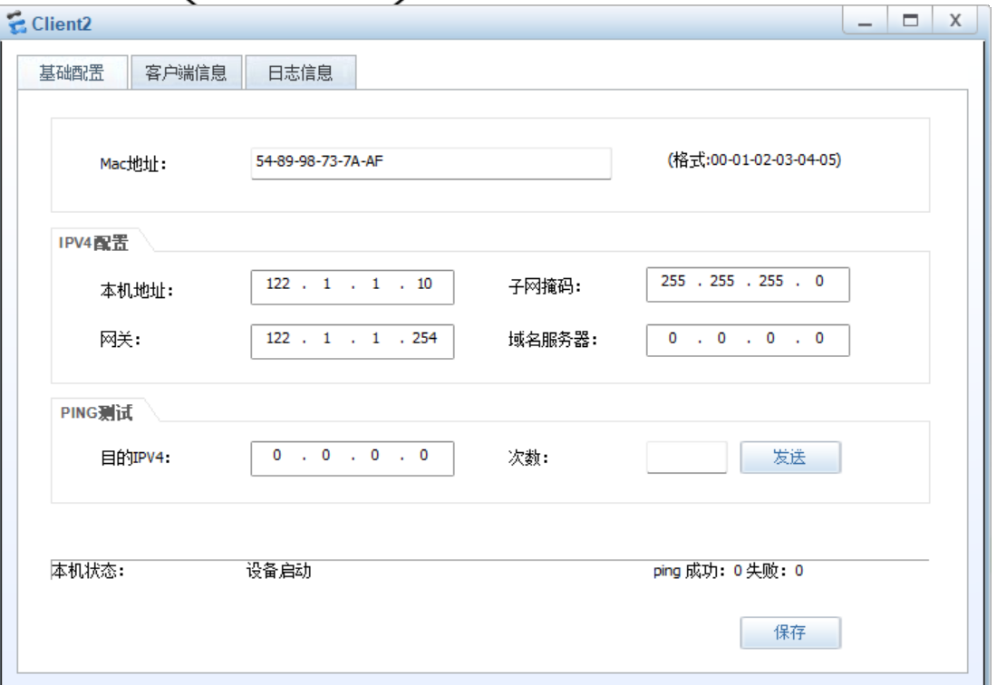

## PC2：

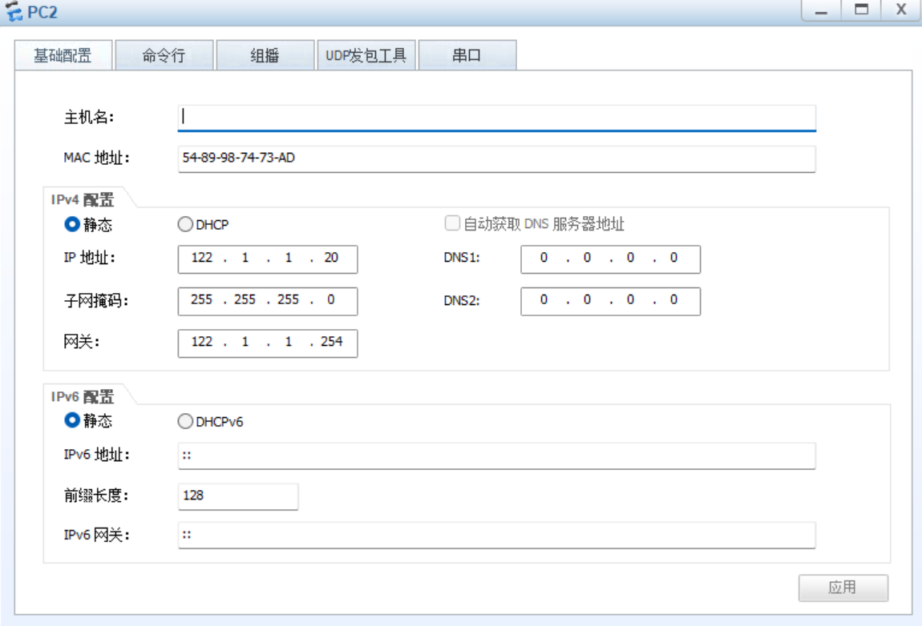

Client 1：

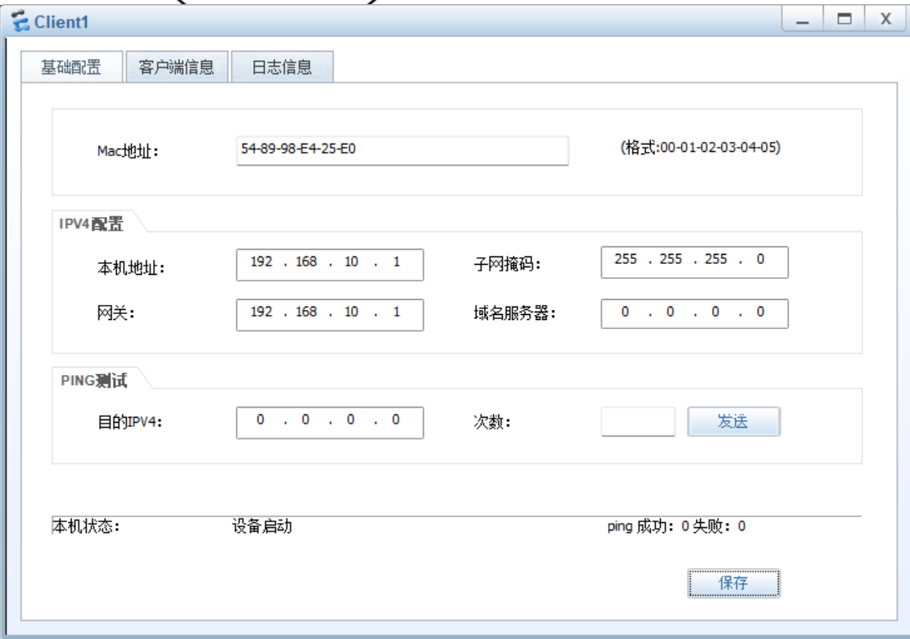

PC1：

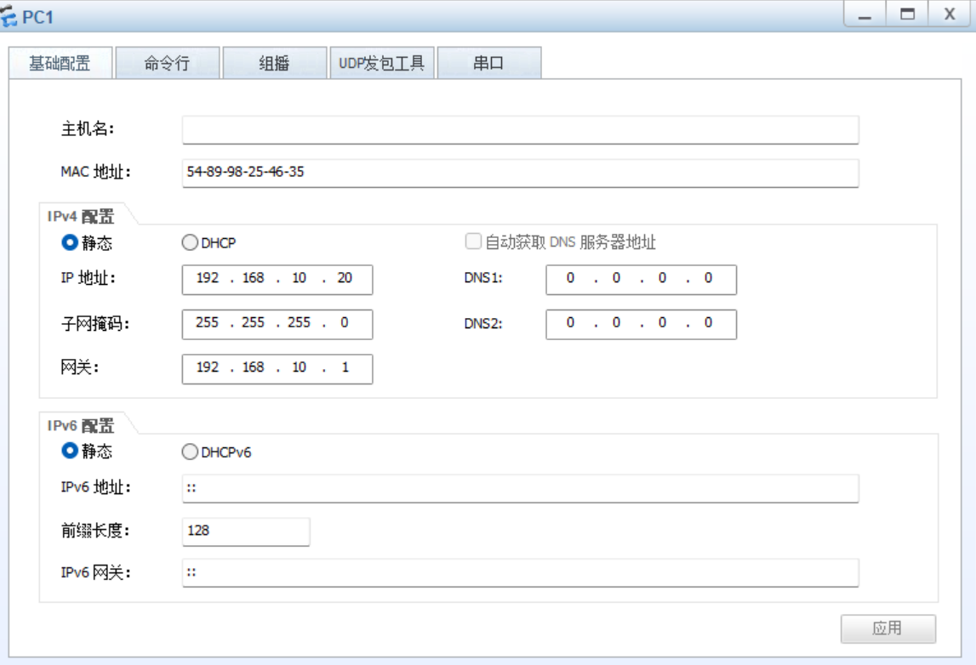

Server 1：

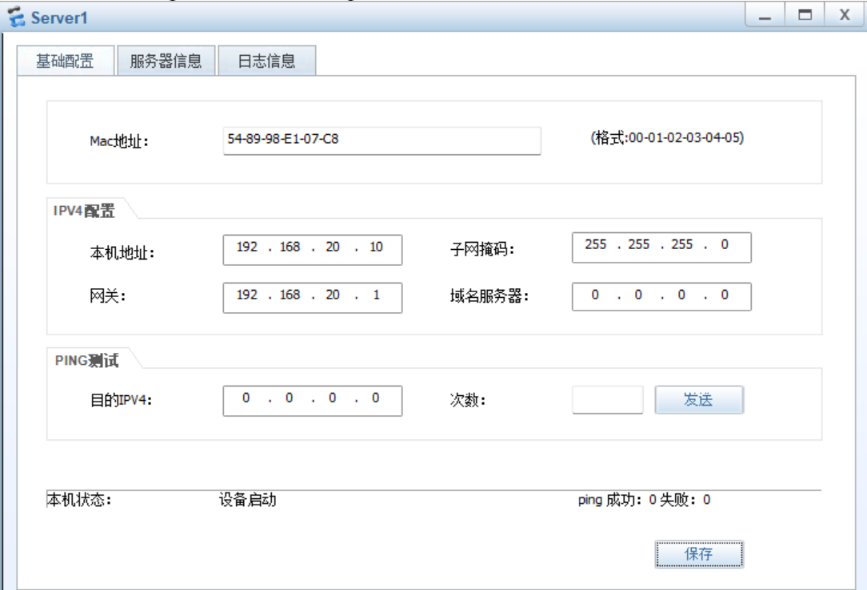

FTP 1：

