## FW1：

Login authentication

Username:admin

Password:

The password needs to be changed. Change now? [Y/N]: y

Please enter old password:

Please enter new password:

Please confirm new password:

Info: Your password has been changed. Save the change to survive a reboot.

*************************************************************************

* Copyright (C) 2014-2018 Huawei Technologies Co., Ltd. *

* All rights reserved. *

* Without the owner's prior written consent, *

* no decompiling or reverse-engineering shall be allowed. *

*************************************************************************

<USG6000V1>sys

Enter system view, return user view with Ctrl+Z.

[USG6000V1]sys FW1

[FW1]fir

Nov 14 2022 10:28:05 FW1 DS/4/DATASYNC_CFGCHANGE:OID 1.3.6.1.4.1.2011.5.25.191.3

.1 configurations have been changed. The current change number is 1, the change

loop count is 0, and the maximum number of records is 4095.

[FW1]firewall zone trust

[FW1-zone-trust]add int g1/0/1

[FW1-zone-trust]q

[FW1]fire

[FW1]firewall z

[FW1]firewall zone u

Nov 14 2022 10:28:35 FW1 DS/4/DATASYNC_CFGCHANGE:OID 1.3.6.1.4.1.2011.5.25.191.3

.1 configurations have been changed. The current change number is 2, the change

loop count is 0, and the maximum number of records is 4095.

[FW1]firewall zone un trust

^

Error: Wrong parameter found at '^' position.

[FW1]un in en

Info: Saving log files...

Info: Information center is disabled.

[FW1]firewall zone untrust

[FW1-zone-untrust]int g1/0/0

[FW1-GigabitEthernet1/0/0]q

[FW1]fire

[FW1]firewall zon

[FW1]firewall zone un

[FW1]firewall zone untrust

[FW1-zone-untrust]add int g1/0/0

[FW1-zone-untrust]q

[FW1]zone name mgmt

^

Error: Unrecognized command found at '^' position.

[FW1]fire

[FW1]firewall zon

[FW1]firewall zone name

[FW1]firewall zone name mgmt

[FW1-zone-mgmt]add int g1/0/6

[FW1-zone-mgmt]q

[FW1]

[FW1]int g1/0/1

[FW1-GigabitEthernet1/0/1]ip add 10.1.1.1 24

[FW1-GigabitEthernet1/0/1]q

[FW1]int g1/0/0

[FW1-GigabitEthernet1/0/0]ip add 11.1.1.1 24

[FW1-GigabitEthernet1/0/0]int g10/0/6

^

Error: Unrecognized command found at '^' position.

[FW1-GigabitEthernet1/0/0]q

[FW1]

[FW1]

[FW1]int g1/0/6

[FW1-GigabitEthernet1/0/6]ip add 10.1.10.1 24

[FW1-GigabitEthernet1/0/6]service-m

[FW1-GigabitEthernet1/0/6]service-manage all permit

[FW1-GigabitEthernet1/0/6]q

[FW1]

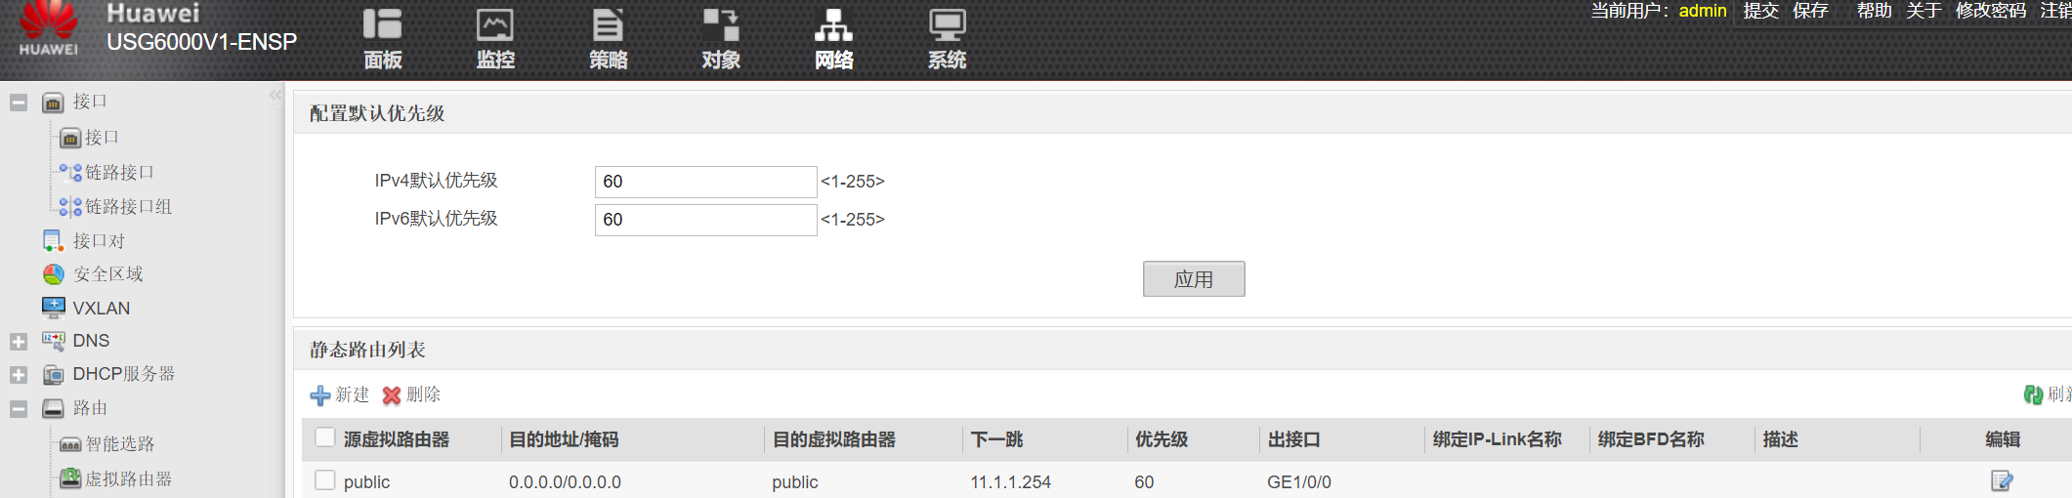

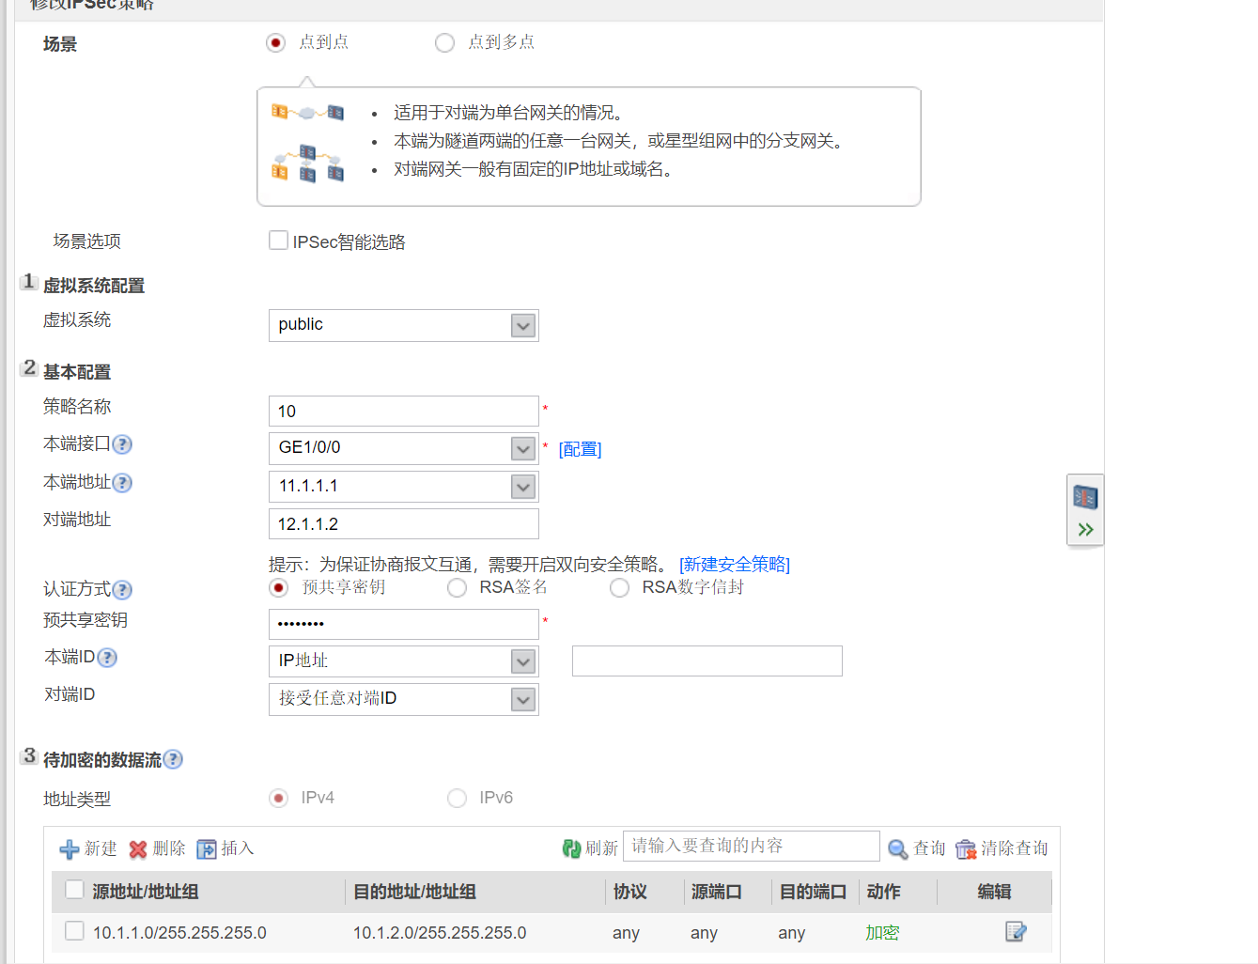

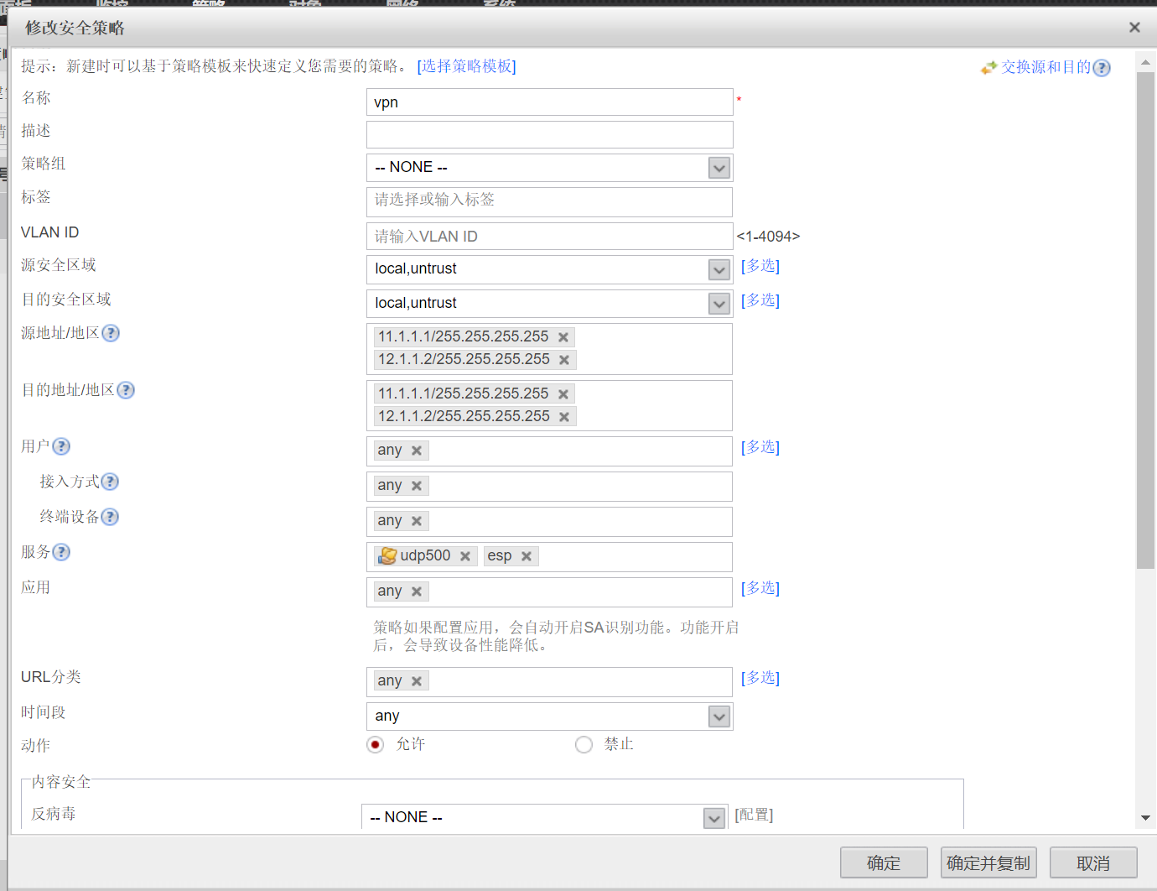

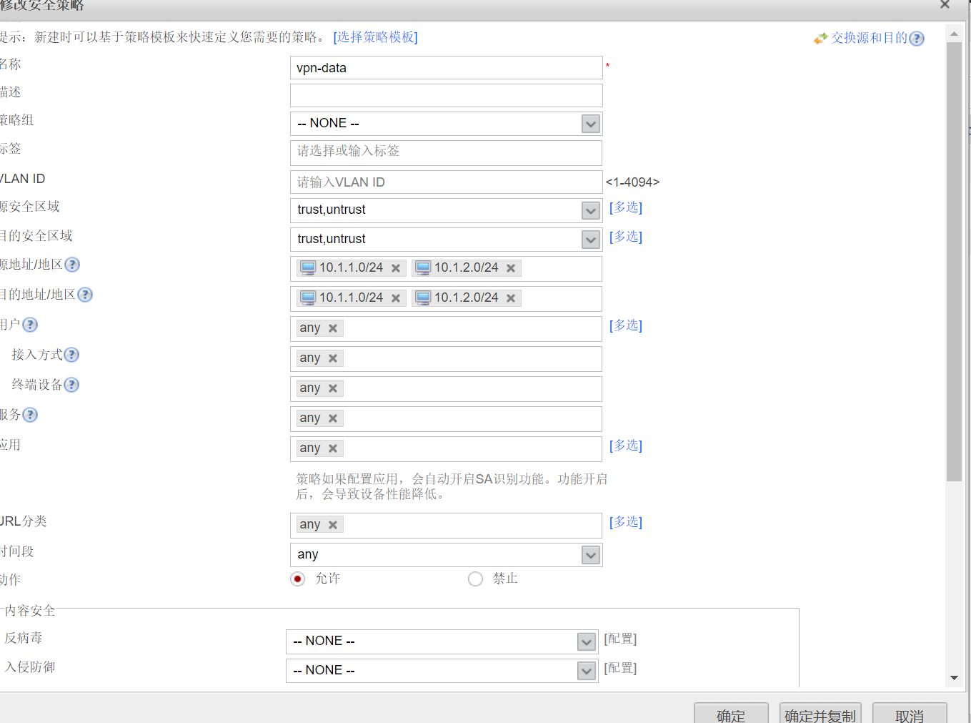

## FW2：

Login authentication

Username:admin

Password:

The password needs to be changed. Change now? [Y/N]: y

Please enter old password:

Please enter new password:

Please confirm new password:

Info: Your password has been changed. Save the change to survive a reboot.

*************************************************************************

* Copyright (C) 2014-2018 Huawei Technologies Co., Ltd. *

* All rights reserved. *

* Without the owner's prior written consent, *

* no decompiling or reverse-engineering shall be allowed. *

*************************************************************************

<USG6000V1>sys

Enter system view, return user view with Ctrl+Z.

[USG6000V1]sys FW2

[FW2]fire

Nov 14 2022 10:33:17 FW2 DS/4/DATASYNC_CFGCHANGE:OID 1.3.6.1.4.1.2011.5.25.191.3

.1 configurations have been changed. The current change number is 1, the change

loop count is 0, and the maximum number of records is 4095.

[FW2]un in en

Info: Saving log files...

Info: Information center is disabled.

[FW2]fir

[FW2]firewall zone trust

[FW2-zone-trust]add int g1/0/1

[FW2-zone-trust]q

[FW2]fire

[FW2]firewall zone untrust

[FW2-zone-untrust]add int g1/0/0

[FW2-zone-untrust]q

[FW2]

[FW2]

[FW2]f

[FW2]firewall zone name mgmt

[FW2-zone-mgmt]add int g1/0/6

[FW2-zone-mgmt]q

[FW2]int g1/0/1

[FW2-GigabitEthernet1/0/1]ip add 10.1.2.1 24

[FW2-GigabitEthernet1/0/1]q

[FW2]int g1/0/0

[FW2-GigabitEthernet1/0/0]ip add 12.1.1.2 24

[FW2-GigabitEthernet1/0/0]q

[FW2]

[FW2]

[FW2]int g1/0/6

[FW2-GigabitEthernet1/0/6]ip add 10.1.10.2 24

[FW2-GigabitEthernet1/0/6]ser

[FW2-GigabitEthernet1/0/6]service-ma

[FW2-GigabitEthernet1/0/6]service-manage all pe

[FW2-GigabitEthernet1/0/6]service-manage all permit

[FW2-GigabitEthernet1/0/6]q

[FW2]

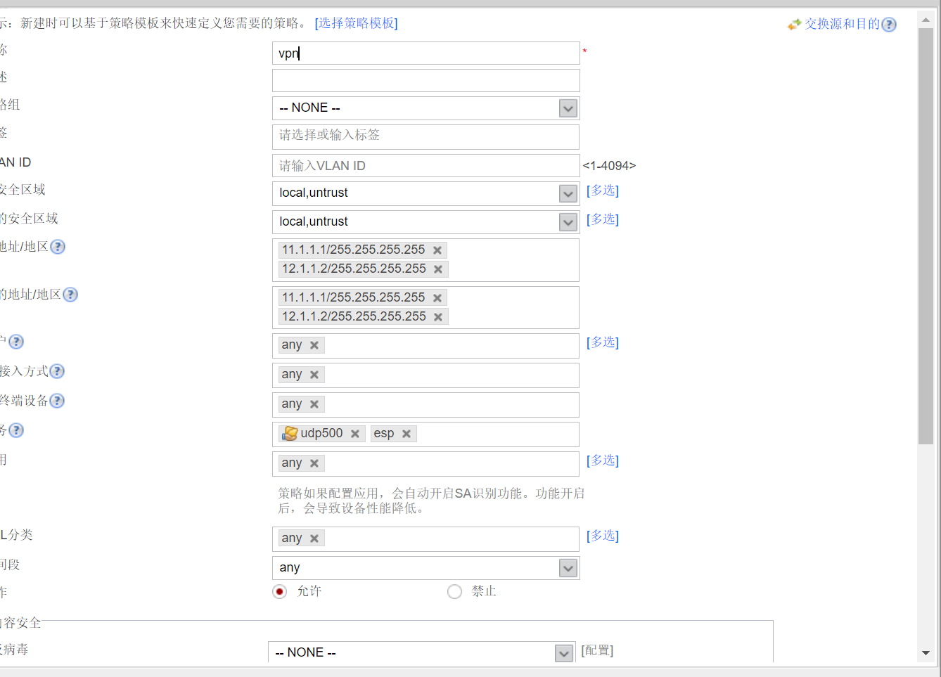

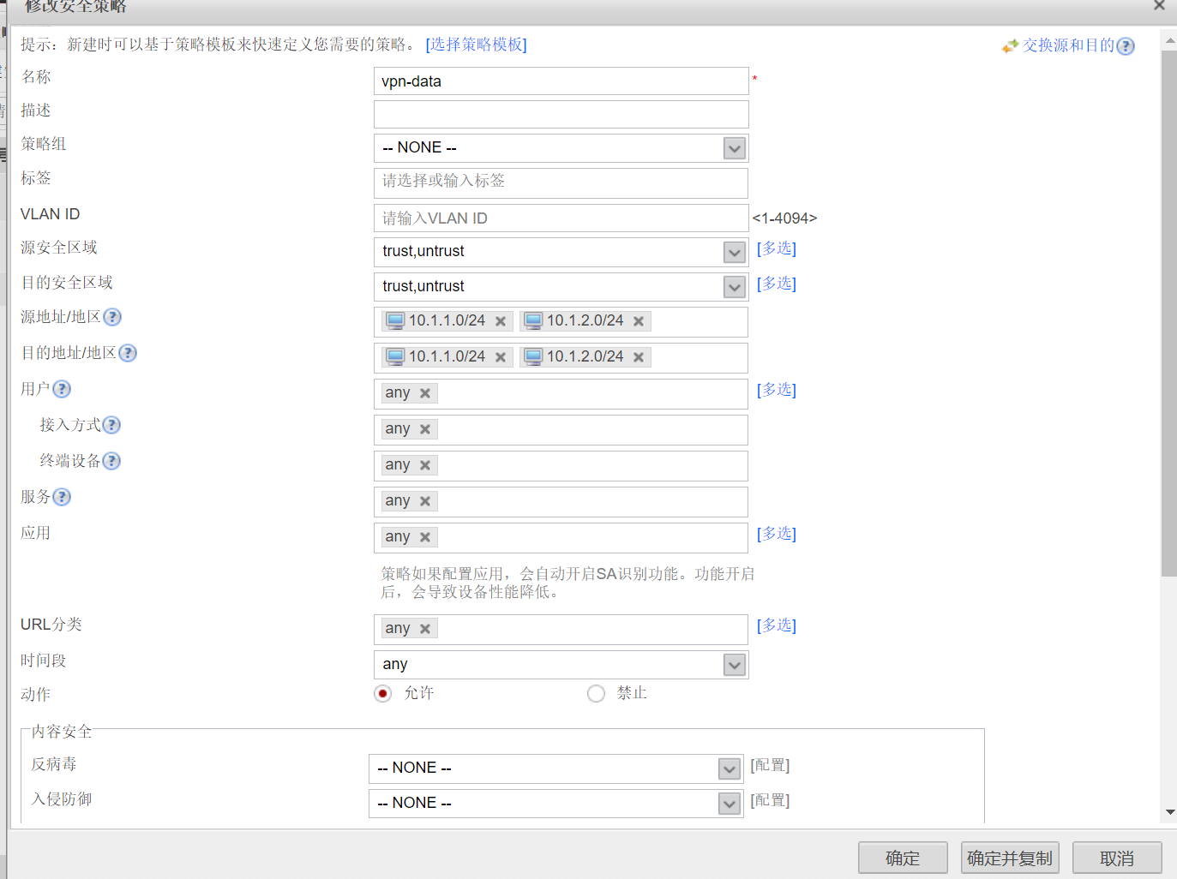

1. 区域、接口、IP配置完成

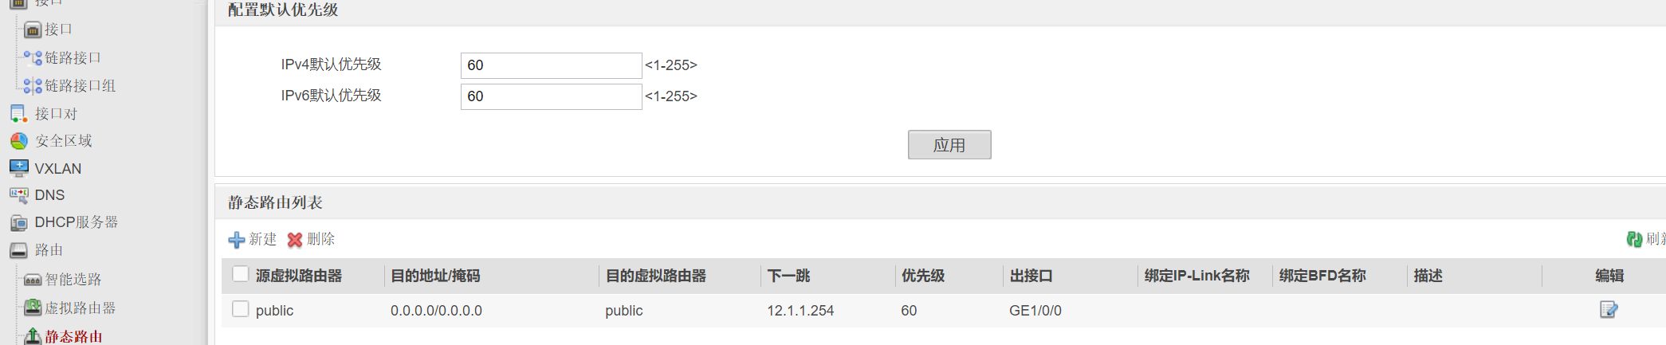

1. 公网路由配置完成

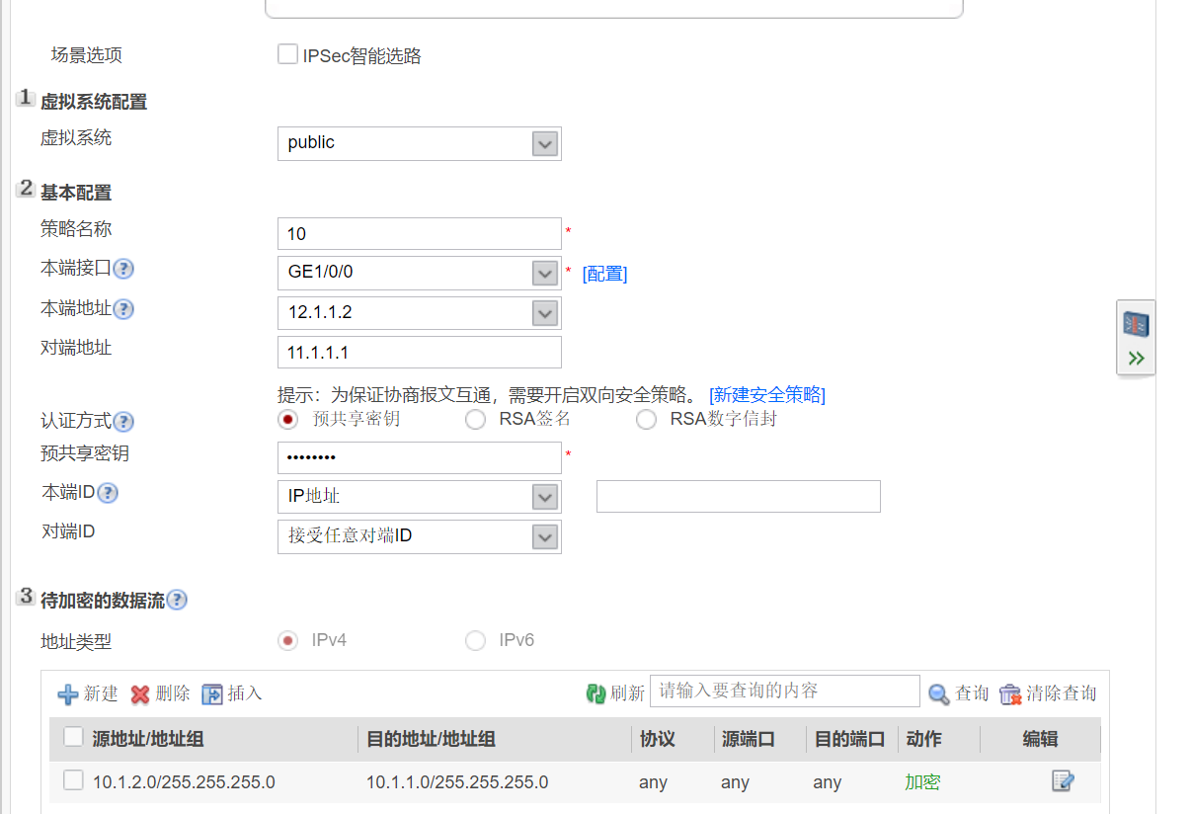

1. IPSec VPN配置完成

## ISP

<Huawei>sys

Enter system view, return user view with Ctrl+Z.

[Huawei]sys ISP

[ISP]int g0/0/0

[ISP-GigabitEthernet0/0/0]ip add 11.1.1.254 24

Nov 14 2022 18:36:41-08:00 ISP %%01IFNET/4/LINK_STATE(l)[0]:The line protocol IP

on the interface GigabitEthernet0/0/0 has entered the UP state.

[ISP-GigabitEthernet0/0/0]un in en

^

Error: Unrecognized command found at '^' position.

[ISP-GigabitEthernet0/0/0]q

[ISP]

[ISP]

[ISP]un in en

Info: Information center is disabled.

[ISP]int g0/0/1

[ISP-GigabitEthernet0/0/1]ip add 12.1.1.254 24

[ISP-GigabitEthernet0/0/1]q

[ISP]