1/ HOME PAGE

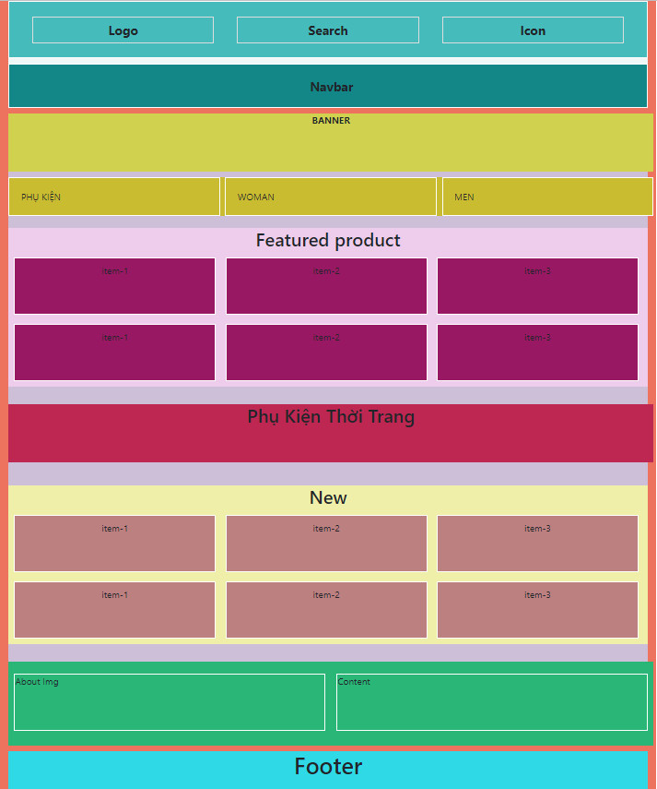

*MÀU SẮC CHỈ MANG TÍNH CHẤT MINH HỌA



<body>

*//parent node*

.container-I{  
 display: grid

}

<footer>

*// child node*

<main>

*//child node*

<header> *//child node*

<header>

.logo

<header>

.nav

.block-6 about

.block-5 new

.block-4

.block-2 .intro=product #intro

.block-3

.block-1

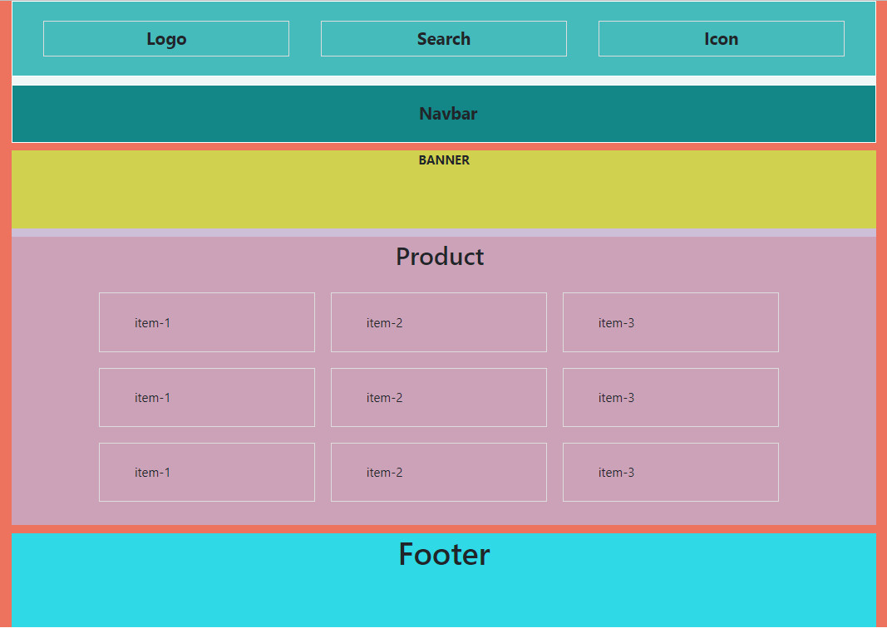

<body> .contaier-I

//pearent node

**PRODUCT**

<footer>

*//child node*

.block-2

.block-1

<main>

*//child node*

<header> .logo

<header> .nav

<header>

*//child node*

**ABOUT US**

<body> .container-I

*//parent node*

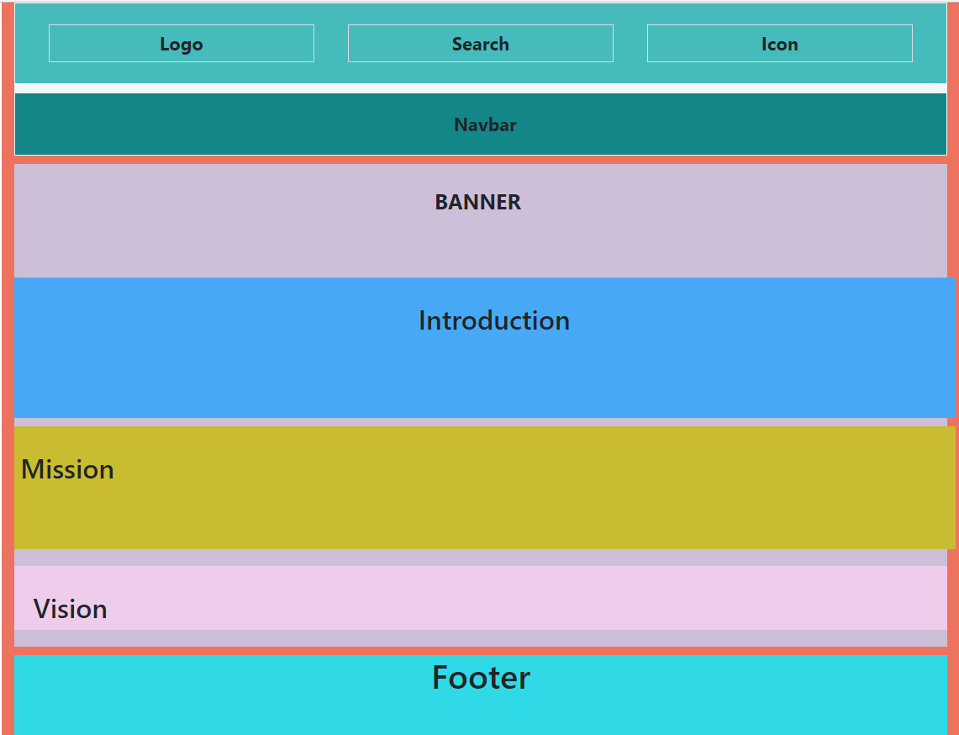

<footer>

*// child node*

.container-fluid .block-4

#background-img

.container block-2

#sec_1

.container block-3

.block-1

<main>

*//child node*

<header> *//child node*

<header>

.logo

<header>

.nav