2.2 Methods

2.2.1 Reconstruction of spatial paleoprecipitation
Table S1 Raw data of paleoprecipitation reconstruction
Fid | Site ID | Longitude | Latitude | P_{observed} (mm) | P_{Chelsa} (mm) | Deviation | ΔP（mm） | Sub-zone
1 | Gahai[] | 97.55 | 37.1333 | 240.68 | 146.00 | 94.68 | 57.24 | Ⅰ
2 | Hurleg Lake[] | 96.9007 | 37.2745 | 132.58 | 112.79 | 19.80
3 | Luanhaizi[] | 101.35 | 37.59 | 274.67 | 368.86 | -94.19 | -16.22 | Ⅱ
4 | Donggi Conag[] | 98.44 | 35.35 | 330.85 | 270.43 | 60.42
5 | Kuhai^{[4]} | 99.31 | 35.52 | 351.90 | 366.79 | -14.89
6 | Caodalian Lake[] | 100.46 | 37.07 | 389.04 | 309.86 | 79.18 | 72.23 | Ⅲ
7 | Qinghai Lake^{[5]} | 100.52 | 36.67 | 389.78 | 322.57 | 67.21
8 | Dalian Sea[] | 100.41 | 36.25 | 390.15 | 289.86 | 100.29
9 | Xiadawu^{[4]} | 99.2606 | 35.0019 | 368.09 | 350.21 | 17.87
10 | Nankanyan[] | 100.2444 | 35.6781 | 474.11 | 275.50 | 198.61
11 | Gengga Sea^{[6]} | 100.1 | 36.11 | 246.61 | 276.43 | -29.82
12 | Zhongda^{[4]} | 97.0226 | 33.2375 | 388.96 | 367.86 | 21.10 | -47.21 | Ⅳ
13 | Maqin^{[4]} | 100.15 | 34.4667 | 350.55 | 466.07 | -115.53
（1）Partition criterion
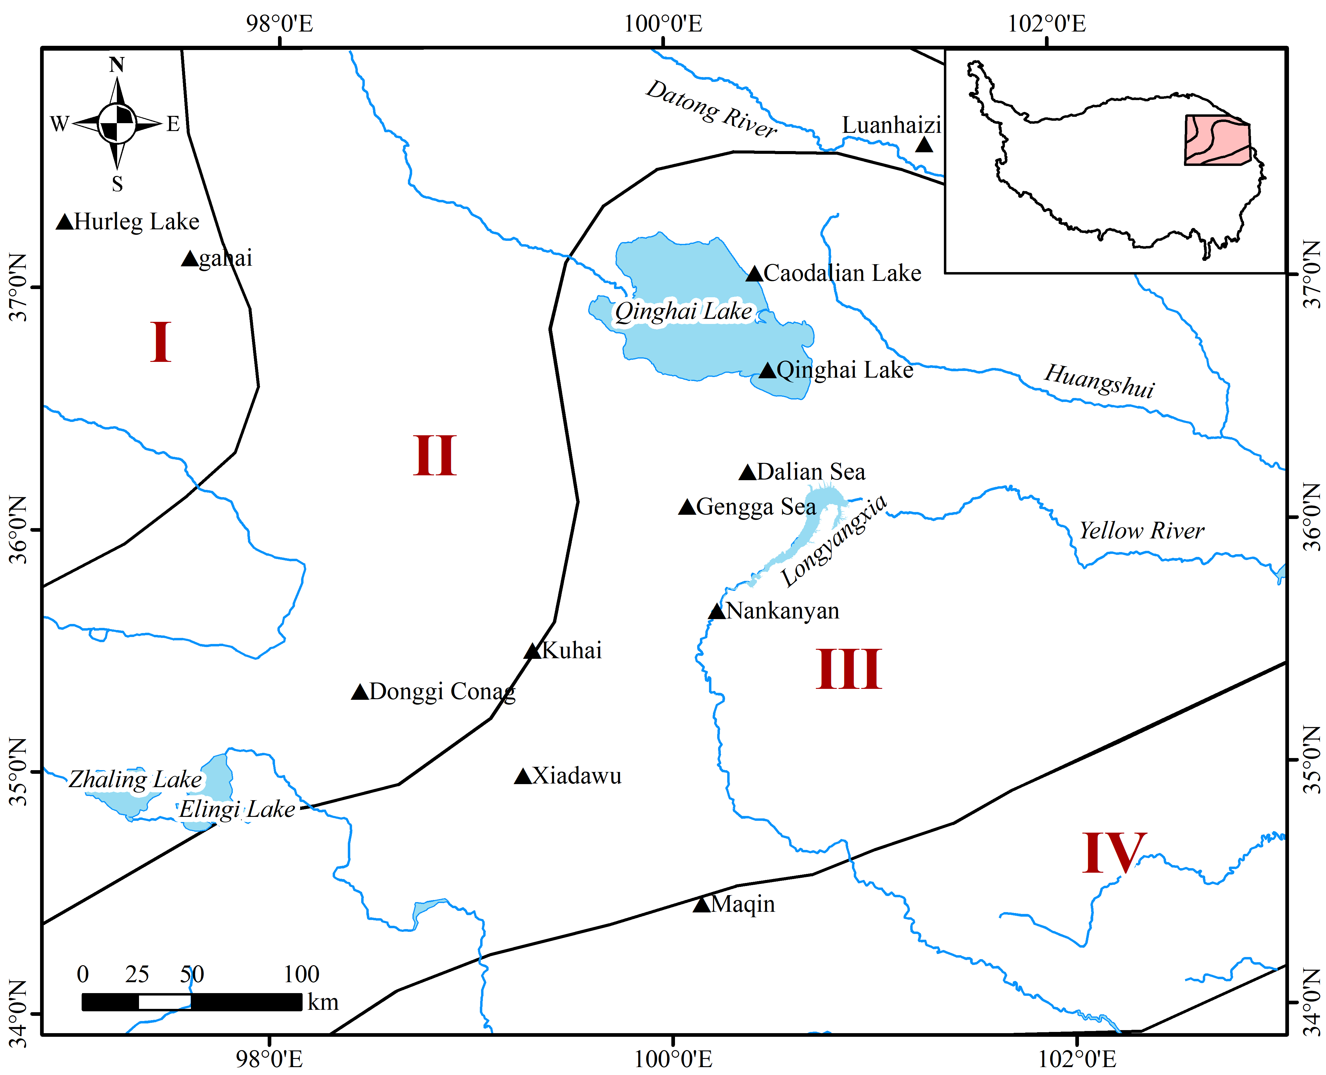
The study area was delineated into four distinct precipitation sub-zones based on the “Holocene Megathermal Precipitation Isopleth Partition Scheme” []. This spatial stratification allows for the accommodation of regional climate heterogeneity across the Northeastern Tibetan Plateau (Figure S1).

Figure S1 Sub-zone partitioning for paleoprecipitation reconstruction in the NETP
（2）Linear correction formula
To generate the spatial paleoprecipitation surface, we applied a linear adjustment to the original Chelsa raster using the following equation:
P_{rec} = P_{Chelsa}+ ΔP_{i} （1）
Where P_{rec} is the reconstructed annual precipitation, P_{Chelsa} is the baseline Chelsa bio12 data, and ΔP_{i} is the mean deviation calculated for sub-zone i. This process was executed using the Raster Calculator tool in ArcGIS 10.8.
2.2.2 Subsistence suitability modeling
(1) Agricultural Suitability Simulation
Table S2 Environment variable data source table
Data name | Data source
Soil | ISRIC — World Soil Information（https://isric.org）
Paleoprecipitation | Section 2.2.1 integrated reconstruction results
Paleotemperature | The average temperature from 2020 to 2023 increased by 1°C^{[8]}
DEM / Hydrological | Resource and Environmental Science and Data Center of the Chinese Academy of Sciences (http://www.resdc.cn)
Slope gradients | Derived based on DEM
Distance to water | Euclidean distance generated based on hydrological vector data
Note: The above data has a uniform resolution of 1 km
Table S3 Soil suitability class ^{[-]}
Suitability class | Value range | Soil type code (DOMSOIL) | Soil type description
Highly suitable | 0.8-1.0 | PHg, CHg, PHh, CHh, CMg, CMd | Heilu Soil, Chestnut Soil, Chernozem
Moderately suitable | 0.5-0.7 | LVh, LVj, LVa, LVg, LVk, LVx | Luvisols, Weakly Developed Soils (Light)
Marginally suitable | 0.2-0.4 | GLm, GLe, GLk, GLi, GLt, GRh | Sierozem, Gray-Cinnamon Soil, Gravelly Soil
Unsuitable | 0.0-0.1 | RGe, RGc, RGd, RGi, RK, VRk, VRe, VRd | Skeletal Soil, Lithosol, Gravel Soil
Unsuitable | 0.0-0.1 | SCg, SCn, SCm, SCy, SCk, SCh, SC | Aeolian Sandy Soil, Sandy Soil
Unsuitable | 0.0-0.1 | CLp, CLl, CLh, ALp, ALh, ALf | Heavy Clay Soil, Aluvial Soil
Unsuitable | 0.0 | UR, ST, DS, NI, NTu | Urban Soil, Disturbed Soil, Arid Soil
Other unspecified types | 0.3 | All codes not listed above (e.g., ANh, ANu, FP, etc.) | Transitional Soil
① Python script for environment variable normalization and weight calculation
This part of the Python script is in the supplementary material “Agriculture_Suitability.docx”
② Agricultural suitability area model
$$\text{Y}\text{=0.375}\text{P}\text{+0.173}\text{T}\text{+0.023}\text{O}\text{+0.204}\text{D}\text{+0.013}\text{S}\text{+0.212}\text{W} \text{（}\text{2}\text{）}$$
Where $\text{Y}$ represents the evaluation result of agricultural suitability; $\text{P}$ is paleoprecipitation; $\text{T}$ is paleotemperature; $\text{O}$ is soil type; $\text{D}$ is DEM; $\text{S}$ is slope; and $\text{W}$ is the distance to water sources.
③ Cost surface
The final agricultural suitability surface (cost surface) was generated using the raster calculator tool in ArcGIS.
- Hunter-Gatherer suitability simulation
① MaxEnt input samples: microlithic sites are listed in the supplementary material “MaxEnt_Input_Samples_Table S4.csv”
② Environmental variables: input the 9 raster layers of MaxEnt 3.4.4（bio2、bio3、bio12、bio14、bio15、bio19、Distance to water sources、Slop、DEM）。
③ MaxEnt model configuration
Output file type: asc
Output Format: Logistic
Create response curves: √
Do jackknife to measure variable importance: √
Random test percentage: 25%
Replicates: 10
Replicated run type: Bootstrap
Maximum iterations: 5000
④ Validation Results
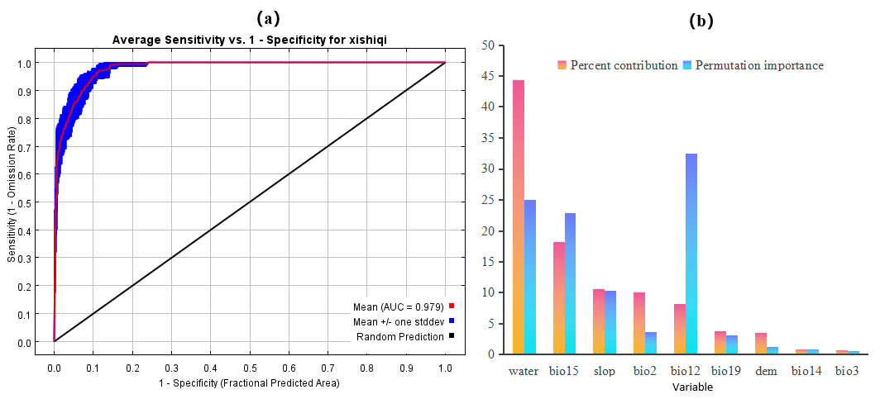

Figure S2 AUC curve
Table S5 Jackknife Test
Variable | Percent contribution | Permutation importance
Water | 44.4 | 25
bio15 | 18.2 | 22.9
Slop | 10.6 | 10.3
bio2 | 10 | 3.6
bio12 | 8.2 | 32.4
bio19 | 3.7 | 3.1
DEM | 3.5 | 1.3
bio14 | 0.9 | 0.9
bio3 | 0.7 | 0.6

2.2.3 FM-CDP cultural diffusion model
(1) Identification of cultural hearth and cultural regions
① The Majiayao culture site is in the supplementary material “Majiayao_Samples_Table S6.csv”（Our dataset integrates the Cultural Relics Atlas (Gansu and Qinghai Volumes) and the Third National Cultural Relics Census. Among them, 65 sites have names, while the rest are just coordinates obtained from the survey.）
② The Zongri site is in supplementary material “Zongri_Samples_Table S7.csv”
③ DCR (Detection of Cultural Region) sub-model
First, site points are converted into a density raster surface. The density value for any given location (x,y） is calculated using the Kernel Density Estimation (KDE) method:
$$\begin{aligned} f\left(x\right)=\frac{1}{nh}\sum_{i=1}^{n}{k}\left(\frac{x−x_{i}}{h}\right) （3）\end{aligned}$$
Where n is the number of resources (sites); h is the bandwidth; k is the kernel function (a quadratic kernel function is employed in this study), representing the distance from the estimation point $x$ to the resource point $x_{i}$.
Second, a 3×3 square moving window is constructed over the original density surface(${\text{W}}_{\text{_ori (3×3)}}$) to extract the local maximum value(${\text{W}}_{\text{_max (3×3)}}$) within each window. This maximum value is assigned to all pixels within the window. The difference between the new window and the original density surface constitutes a derived window(${\text{W}}_{\text{_diff (3×3)}}$), calculated as follows:
$${{\text{W}}_{\text{_diff (3×3)}}\text{=W}}_{\text{_max (3×3)}}\text{−}{\text{W}}_{\text{_ori (3×3)}} \text{（2）}$$
This part of the Python script is in the supplementary material “Cultural_Hearth_Detection”
Finally, in the difference window(${\text{W}}_{\text{_diff (3×3)}}$), pixels with a value of 0 possess the local maximum density and represent potential centers of cultural regions. These pixels are extracted via binarization and vectorization. Final cultural hearths are determined by validating these extracted centers against archaeological literature and the spatial clustering of sites. The conceptual framework is illustrated in Figure S3.
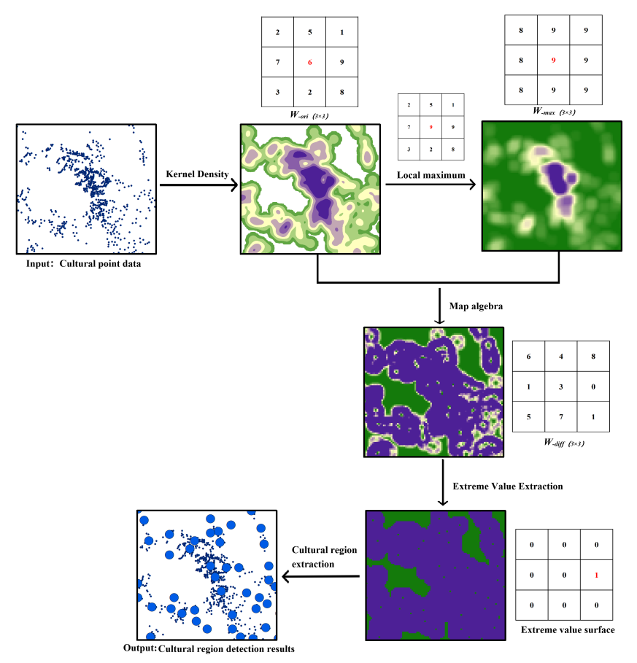

Figure S3 Schematic Diagram of Cultural Region Detection

(2) Recognition of cultural diffusion types
Figure S4 presents a schematic diagram of the contour tree structure within the RDT（Recognition for Diffusion Types） sub-model. In this structure, leaf nodes represent Level-1 cultural regions (highest density), while the root node represents the entire study area. The merging level of each leaf node determines its diffusion type. For instance, consider a specific leaf node (e.g., node ⑫). If its ancestral node is only merged at the root node (e.g., node ㉞), resulting in a merging level of 7, the diffusion pattern of the cultural sub-region represented by that leaf node is classified as “Leapfrog diffusion.” Otherwise, it is classified as “Radial diffusion” in a global context. Similarly, for levels other than the root node, a consistent discriminant method is applied to determine the diffusion types for all cultural regions.
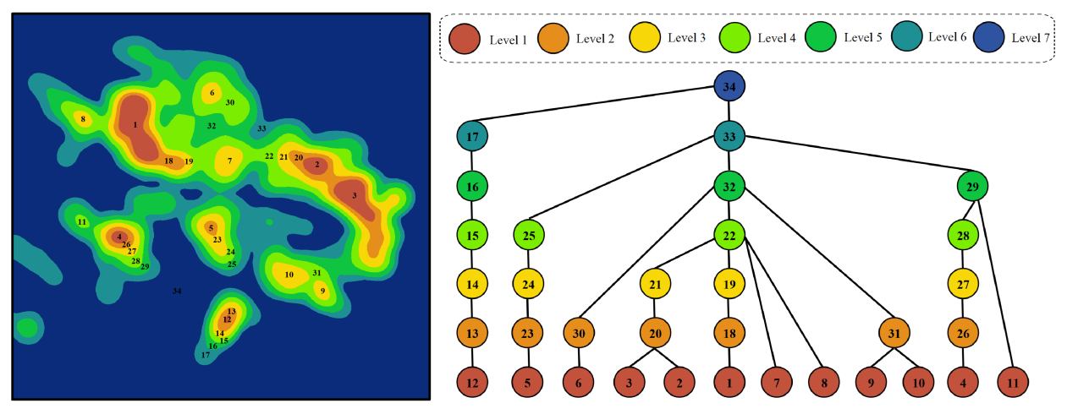

Figure S4 Cultural diffusion type recognition gradient tree

2.2.4 Cultural diffusion pathways (CDP)
The methods for calculating weight and cost surfaces refer to the script and operation process in Section 2.2.2(1)above.
The specific Python script for the cultural diffusion path is in the supplementary material “Cultural_Diffusion_Path”.

2.2.5 Strontium isotope analysis
Specifically in the supplementary material “Isotope_Raw Data_Table S8”.

References:

[] S. Zhou. Climatic and environmental changes in NE Tibetan Plateau during the Holocene, recorded by lake sediments from Lake Gahai [D]. Lanzhou: Lanzhou University, (2024).
[] Y. Yu, Y. Jin, D. Xu, et al. Vegetational and climatic changes in the Hurleg Lake, Qinghai, during the last 14,000 years [J]. Quaternary Sciences, 41 (5) (2021), 1229-1243.
[] T. Wang. Studies on vegetation cover, pastoralism and paleo-fire activities in the eastern Qinghai-Tibet Plateau since the last deglaciation [D]. Lanzhou: Lanzhou University, (2024).
[] Y. Wang. Study on Holocene Climate and Environmental Change and Human Activities in the Source of Three Rivers [D]. Xining: Qinghai Normal University, (2023).
[] Y. Lv. A novel procedure for quantitative paleoclimate reconstructions based on pollen assemblages and its application in China and adjacent area [D]. Lanzhou: Lanzhou University, (2021).
[] M. Ao. Human activities and environmental contexts in the Republican Basin during the Neolithic—the case of the ZBK site [D]. Xining: Qinghai Normal University, (2025).
[] B. Qi. Environmental Evolution and Human Activities in the Gonghe Basin during the Mid Late Holocene—A Case Study of Nankanyan Site [D]. Xining: Qinghai Normal University, (2022).
[] X. Fang, G. Hou. Synthetically Reconstructed Holocene Temperature Change in China [J]. Geographical Science, 31 (4) (2011), 385-393.
[] K. Wu, L. Kang, X. Li, et al. Explanation of the Methods and Standards for Evaluating Soil Suitability for Agricultural Use[J]. Chinese Journal of Soil Science, 55(05) (2024), 1201-1204.
[] Z. Gong. Soil geography of China [M]. Beijing: Science Press, (2014).

