Leighanne Hsu

Angus Ding

COMS W4111

Project 1 Part 1

Proposal

Our goal is to build a database of competitive Team Fortress 2 players.  Some of the entities involved that we would use are League, Division, Format, Team, Player, and Class.  Some of the relationships between these entities are PlaysOn(Player, Team), ClassPlayed(Player, Class), TeamDivision(Team,Division), PlaysFormat(Player, Format, Class), LeagueFormat(League, Format), LeagueDivision(League, Division).  The ClassPlayed relation will include player statistic attributes.  Since players may play multiple classes in different formats, the PlaysFormat relation is also needed.  Right now, this data is stored across different league websites, each with different setups.  We would like to build a website (option 3a) which would allow users to easily and conveniently search for information they want.  This includes simply viewing information about players and teams as well as comparing different players across teams, divisions, and even leagues using their statistics.  The latter has never been done before and would potentially require some creativity with the query creation to accomplish.

ER Diagram

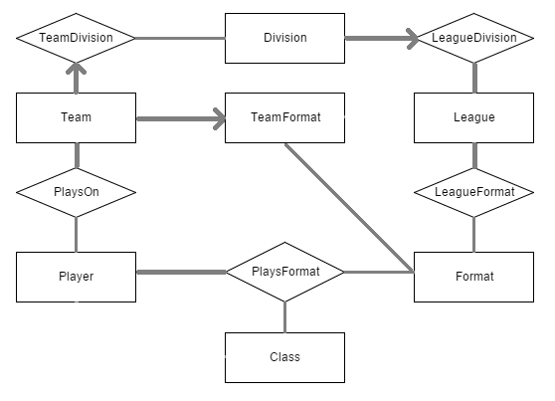

Relational Schema

CREATE TABLE Player(

   name text NOT NULL,

   id int NOT NULL,

   UNIQUE(id)

);

CREATE TABLE League(

   name text NOT NULL,

   UNIQUE(name)

);

CREATE TABLE Format(

   name text NOT NULL,

   UNIQUE(name)

);

CREATE TABLE Division(

   name text NOT NULL,

   UNIQUE(name)

   -- divisions in different leagues can have the same names

   -- still need a unique key

);

CREATE TABLE Team(

   name text NOT NULL,

   id int NOT NULL,

   UNIQUE(id)

   -- teams in different leagues can have the same names

   -- still need a unique key

);

CREATE TABLE Class(

   name text NOT NULL,

   UNIQUE(name)

);

CREATE TABLE PlaysOn(

   player int NOT NULL,

   team int NOT NULL,

   FOREIGN KEY(player) REFERENCES Player(id),

   FOREIGN KEY(team) REFERENCES Team(id),

   UNIQUE(player, team)

);

CREATE TABLE TeamFormat(

   team int NOT NULL,

   format text NOT NULL,

   FOREIGN KEY(team) REFERENCES team(id),

   FOREIGN KEY(format) REFERENCES format(name),

   UNIQUE(team, format)

);

CREATE TABLE LeagueDivision(

   league text NOT NULL,

   division text NOT NULL,

   FOREIGN KEY(league) REFERENCES League(name),

   FOREIGN KEY(division) REFERENCES Division(name),

   UNIQUE(league,division)

);

CREATE TABLE LeagueFormat(

   league text NOT NULL,

   format text NOT NULL,

   FOREIGN KEY(league) REFERENCES League(name),

   FOREIGN KEY(format) REFERENCES Format(name),

   UNIQUE(league, format)

);

CREATE TABLE PlaysFormat(

   playerID int NOT NULL,

   class name NOT NULL,

   format name NOT NULL,

kills int NOT NULL,

assists int NOT NULL,

deaths int NOT NULL,

kad float NOT NULL,

healsPerMin float,

damagePerMin float,

ubers int,

drops int,

   FOREIGN KEY(playerID) REFERENCES Player(id),

   FOREIGN KEY(class) REFERENCES Class(name),

   FOREIGN KEY(format) REFERENCES Format(name),

   UNIQUE(playerID, class, format)

);