CS457_hw6

Dua Batool

[db07098@st.habib.edu.pk](mailto:db07098@st.habib.edu.pk)

*showing the data:*

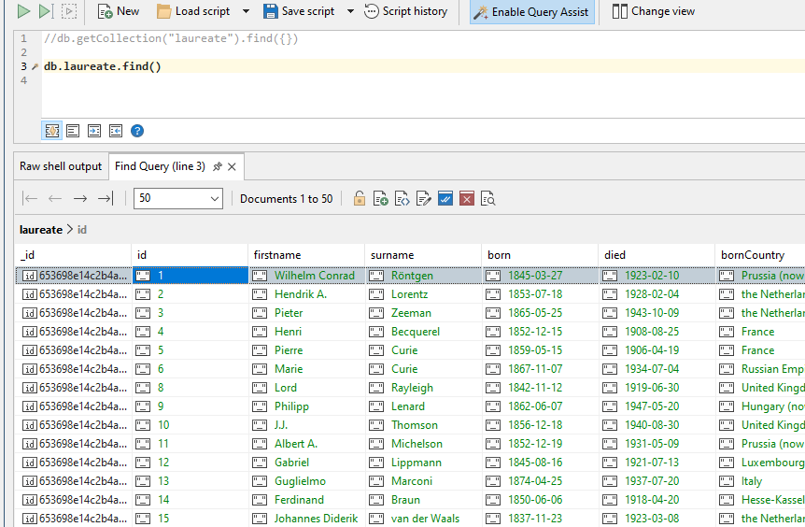

*the count of total number of records in the collection:*

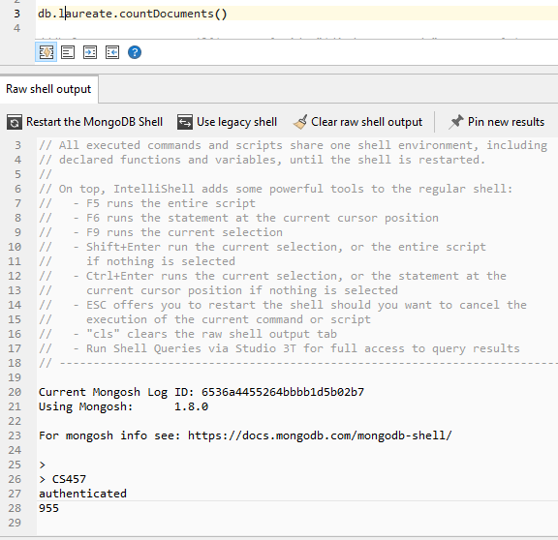

The total number of records in the collection is 955.

*the count of records for each diedCountryCode in descending order of count:*

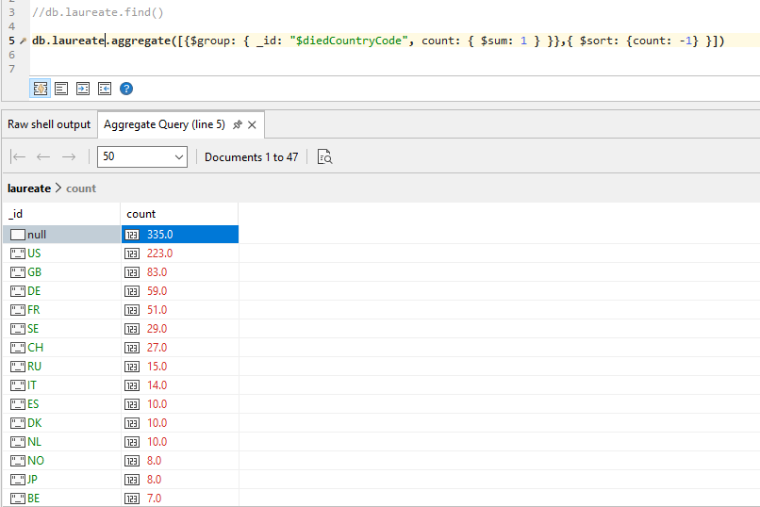

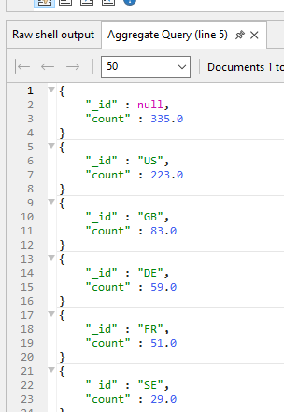

the record of death of Nobel prize winners is mostly missing.

*the count of records for each prizes.category in descending order of count:*

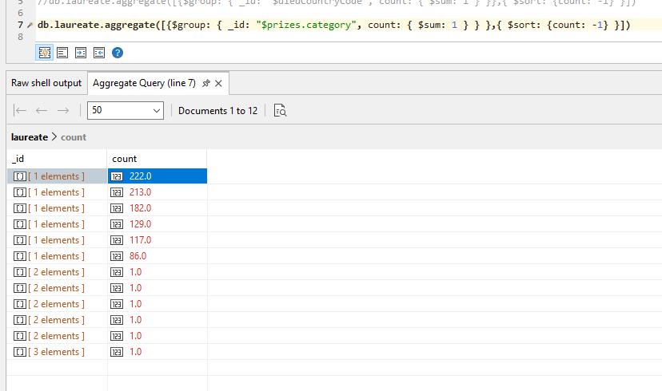

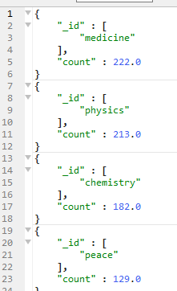

The category in which there are the most number of nobel prizes is medicine.

*the count of records for each gender, diedCountryCode, prize.category when prize.category is “physics”. Order the output by diedCountryCode:*

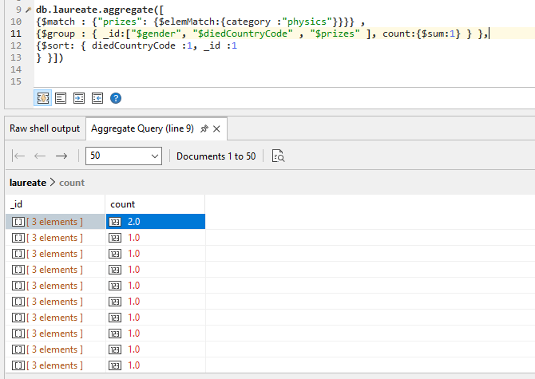

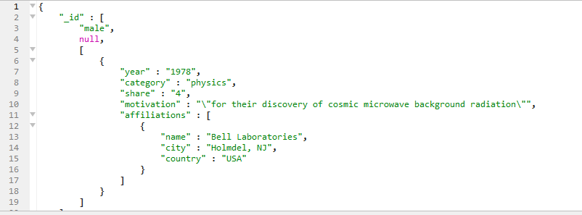

There are only 2 females who won the prize in physics.

*Come up with your own query to show any interesting insight. Use atleast two fields for match and two fields for group:*

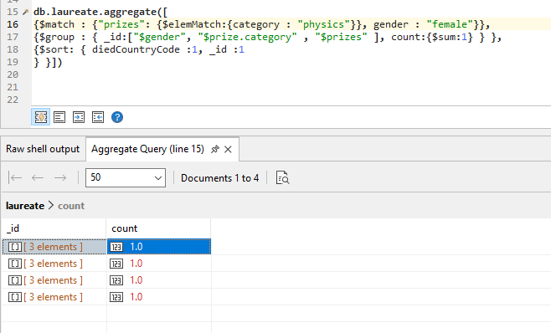



There above query tells the female prize winners in the field of physics. With count related to their country. We can see that the female nobel prize winners are less than the male prize winners.