
《JAVA程序设计》 Servlet作业报告

学 院 经济与金融学院
专 业 23“金融学+计算机科学与技术”双学位试点项目
学生姓名 全宣羽 202330334771
任课教师 李粤
提交日期 2025年12月29日

- 目的任务
1.目的
1.1掌握servlet和jsp的使用
1.2掌握jdbc，即java与数据库的连接
2.任务
实现
设计工作要求
1、总体要求
1.1代码正确性
要求：所谓“程序正确”，指的是在各层次上正确，经得起检测，对合法的所有数据，要能够输入，且程序要都能正确执行，并获得正确的结果。
1.2设计合理性
要求：指类框架、程序结构等设计的合理性。
1.3文档规范性
要求：文档撰写规范，能正确阐述设计方案及设计过程，分析结果，总结其中存在的问题及收获。
2、详细要求
1.基本要求
1.1要求用到servlet来完成项目
1.2要求在设计的过程中，建立清晰的层次；
1.3要求系统完成后能够正常运行；
1.4各部分的功能安排合理，层次分明

- 设计背景
1. 项目目的
本项目旨在开发一个功能完整、用户友好的在线购物网站，用于模拟电子商务平台的基本业务流程，包括用户注册登录、商品浏览、购物车管理、订单生成和管理等核心功能。

2. 技术选型
- 后端技术 ：Java + Servlet + JSP，采用MVC设计模式，实现业务逻辑与视图分离
- 数据库 ：MySQL，用于存储用户信息、商品数据、购物车数据和订单数据
- 前端技术 ：HTML + CSS + JavaScript，结合JSTL标签库实现动态页面渲染
- Web服务器 ：Apache Tomcat，用于部署和运行Java Web应用
3. 项目意义
- 提供一个完整的电子商务平台实践案例，帮助理解在线购物系统的设计和实现
- 掌握Java Web开发的核心技术和最佳实践
- 理解MVC设计模式在Web开发中的应用
- 学习数据库设计和优化的基本方法
- 熟悉Web应用的部署和维护流程
4. 主要功能
- 用户管理 ：注册、登录、注销
- 商品管理 ：浏览商品、搜索商品、查看商品详情
- 购物车管理 ：添加商品、更新数量、删除商品
- 订单管理 ：生成订单、查看订单列表、查看订单详情
- 管理员功能 ：商品管理、订单管理、销售报表

三、运行环境
1. 操作系统
- 开发环境 ：Windows 10/11（64位）
- 部署环境 ：可支持Windows、Linux等多种操作系统
2. 编译环境
- JDK版本 ：JDK 8或以上（推荐JDK 11）
- 编译工具 ：使用JDK自带的javac编译器
- 项目结构 ：采用标准的Java Web项目结构，包含src、WebContent等目录
3. Web服务器
- Apache Tomcat ：9.0版本或以上
- 配置要求 ：默认端口8080，可根据需要修改
- 部署方式 ：将WAR文件直接放置在Tomcat的webapps目录下

四、执行代码
1.前端代码（jsp）：
//index.jsp
<%@ page language="java" contentType="text/html; charset=UTF-8"
pageEncoding="UTF-8"%>
<!DOCTYPE html>
<html>
<head>
<meta charset="UTF-8">
<title>在线购物网站</title>
<link rel="stylesheet" type="text/css" href="css/style.css">
</head>
<body>
<header>
<div class="container">
<h1>在线购物网站</h1>
<nav>
<ul>
<li><a href="${pageContext.request.contextPath}/productList">首页</a></li>
<% if (session.getAttribute("user") == null) { %>
<li><a href="${pageContext.request.contextPath}/login">登录</a></li>
<li><a href="${pageContext.request.contextPath}/register">注册</a></li>
<% } else { %>
<li><a href="${pageContext.request.contextPath}/cartList">购物车</a></li>
<li><a href="${pageContext.request.contextPath}/orderList">我的订单</a></li>
<% if ("admin".equals(((com.shopping.model.User) session.getAttribute("user")).getRole())) { %>
<li><a href="${pageContext.request.contextPath}/admin/productList">管理后台</a></li>
<% } %>
<li><a href="${pageContext.request.contextPath}/logout">注销</a></li>
<% } %>
</ul>
</nav>
</div>
</header>

<div class="container">
<main>
<h2>欢迎来到在线购物网站</h2>
<p>这里有各种各样的商品供您选择，快来选购吧！</p>
<a href="${pageContext.request.contextPath}/productList" class="btn btn-primary">开始购物</a>
</main>
</div>

<footer>
<div class="container">
<p>&copy; 2025 在线购物网站 版权所有</p>
</div>
</footer>
</body>
</html>
//login.jsp
<%@ page language="java" contentType="text/html; charset=UTF-8"
pageEncoding="UTF-8"%>
<!DOCTYPE html>
<html>
<head>
<meta charset="UTF-8">
<title>用户登录</title>
<link rel="stylesheet" type="text/css" href="../css/style.css">
</head>
<body>
<header>
<div class="container">
<h1>在线购物网站</h1>
<nav>
<ul>
<li><a href="${pageContext.request.contextPath}/productList">首页</a></li>
<li><a href="${pageContext.request.contextPath}/login">登录</a></li>
<li><a href="${pageContext.request.contextPath}/register">注册</a></li>
</ul>
</nav>
</div>
</header>

<div class="container">
<main>
<h2>用户登录</h2>

<% if (request.getAttribute("error") != null) { %>
<div class="message message-error">
<%= request.getAttribute("error") %>
</div>
<% } %>

<form action="${pageContext.request.contextPath}/login" method="post">
<div class="form-group">
<label for="username">用户名</label>
<input type="text" id="username" name="username" required>
</div>
<div class="form-group">
<label for="password">密码</label>
<input type="password" id="password" name="password" required>
</div>
<div class="form-group">
<input type="submit" value="登录" class="btn btn-primary">
</div>
</form>

<p>还没有账号？<a href="${pageContext.request.contextPath}/register">立即注册</a></p>
</main>
</div>

<footer>
<div class="container">
<p>&copy; 2024 在线购物网站 版权所有</p>
</div>
</footer>
</body>
</html>
//orderList.jsp
<%@ page language="java" contentType="text/html; charset=UTF-8"
pageEncoding="UTF-8"%>
<%@ page import="java.util.List" %>
<%@ page import="com.shopping.model.Order" %>
<%@ page import="com.shopping.model.OrderItem" %>
<!DOCTYPE html>
<html>
<head>
<meta charset="UTF-8">
<title>我的订单</title>
<link rel="stylesheet" type="text/css" href="../css/style.css">
</head>
<body>
<header>
<div class="container">
<h1>在线购物网站</h1>
<nav>
<ul>
<li><a href="${pageContext.request.contextPath}/productList">首页</a></li>
<% if (session.getAttribute("user") == null) { %>
<li><a href="${pageContext.request.contextPath}/login">登录</a></li>
<li><a href="${pageContext.request.contextPath}/register">注册</a></li>
<% } else { %>
<li><a href="${pageContext.request.contextPath}/cartList">购物车</a></li>
<li><a href="${pageContext.request.contextPath}/orderList">我的订单</a></li>
<% if ("admin".equals(((com.shopping.model.User) session.getAttribute("user")).getRole())) { %>
<li><a href="${pageContext.request.contextPath}/admin/productList">管理后台</a></li>
<% } %>
<li><a href="${pageContext.request.contextPath}/logout">注销</a></li>
<% } %>
</ul>
</nav>
</div>
</header>

<div class="container">
<main>
<h2>我的订单</h2>

<% List<Order> orders = (List<Order>) request.getAttribute("orders");
if (orders == null || orders.isEmpty()) { %>
<p>还没有订单，快去购物吧！</p>
<a href="${pageContext.request.contextPath}/productList" class="btn btn-primary">去购物</a>
<% } else { %>
<div class="order-list">
<% for (Order order : orders) { %>
<div class="order-item">
<div class="order-header">
<h3>订单号: <%= order.getId() %></h3>
<p>状态: <%= order.getStatus() %></p>
</div>
<p>下单时间: <%= order.getOrderDate() %></p>
<p>支付方式: <%= order.getPaymentMethod() %></p>
<p>收货地址: <%= order.getShippingAddress() %></p>

<div class="order-items">
<h4>订单项:</h4>
<% for (OrderItem item : order.getOrderItems()) { %>
<div class="order-item-details">
<span><%= item.getProductName() %> x <%= item.getQuantity() %></span>
<span>¥<%= item.getUnitPrice() %> × <%= item.getQuantity() %> = ¥<%= item.getSubtotal() %></span>
</div>
<% } %>
</div>

<div class="order-summary">
<p>总价: ¥<%= order.getTotalAmount() %></p>
</div>

<a href="${pageContext.request.contextPath}/orderDetail?orderId=<%= order.getId() %>" class="btn">查看详情</a>
</div>
<% } %>
</div>
<% } %>
</main>
</div>

<footer>
<div class="container">
<p>&copy; 2024 在线购物网站 版权所有</p>
</div>
</footer>
</body>
</html>
//productList.jsp
<%@ page language="java" contentType="text/html; charset=UTF-8"
pageEncoding="UTF-8"%>
<%@ page import="java.util.List" %>
<%@ page import="com.shopping.model.Product" %>
<!DOCTYPE html>
<html>
<head>
<meta charset="UTF-8">
<title>产品列表</title>
<link rel="stylesheet" type="text/css" href="../css/style.css">
</head>
<body>
<header>
<div class="container">
<h1>在线购物网站</h1>
<nav>
<ul>
<li><a href="${pageContext.request.contextPath}/productList">首页</a></li>
<% if (session.getAttribute("user") == null) { %>
<li><a href="${pageContext.request.contextPath}/login">登录</a></li>
<li><a href="${pageContext.request.contextPath}/register">注册</a></li>
<% } else { %>
<li><a href="${pageContext.request.contextPath}/cartList">购物车</a></li>
<li><a href="${pageContext.request.contextPath}/orderList">我的订单</a></li>
<% if ("admin".equals(((com.shopping.model.User) session.getAttribute("user")).getRole())) { %>
<li><a href="${pageContext.request.contextPath}/admin/productList">管理后台</a></li>
<% } %>
<li><a href="${pageContext.request.contextPath}/logout">注销</a></li>
<% } %>
</ul>
</nav>
</div>
</header>

<div class="container">
<main>
<h2>产品列表</h2>

<!-- 搜索和分类筛选 -->
<div style="margin-bottom: 20px;">
<form action="${pageContext.request.contextPath}/productList" method="get" style="display: inline;">
<input type="text" name="keyword" placeholder="搜索商品" value="<%= request.getAttribute("keyword") != null ? request.getAttribute("keyword") : "" %>">
<input type="submit" value="搜索" class="btn">
</form>

<form action="${pageContext.request.contextPath}/productList" method="get" style="display: inline; margin-left: 20px;">
<select name="category">
<option value="">全部分类</option>
<option value="手机" <%= "手机".equals(request.getAttribute("category")) ? "selected" : "" %>>手机</option>
<option value="电脑" <%= "电脑".equals(request.getAttribute("category")) ? "selected" : "" %>>电脑</option>
<option value="耳机" <%= "耳机".equals(request.getAttribute("category")) ? "selected" : "" %>>耳机</option>
</select>
<input type="submit" value="筛选" class="btn">
</form>
</div>

<!-- 产品列表 -->
<div class="product-grid">
<% List<Product> products = (List<Product>) request.getAttribute("products");
if (products != null && !products.isEmpty()) {
for (Product product : products) { %>
<div class="product-card">
<img src="../images/<%= product.getImage() %>" alt="<%= product.getName() %>" onerror="this.src='../images/default.jpg'">
<h3><%= product.getName() %></h3>
<p><%= product.getDescription() %></p>
<p class="price">¥<%= product.getPrice() %></p>
<p>库存: <%= product.getStock() %></p>
<a href="${pageContext.request.contextPath}/productDetail?id=<%= product.getId() %>" class="btn">查看详情</a>
<form action="${pageContext.request.contextPath}/addToCart" method="post" style="display: inline; margin-left: 10px;">
<input type="hidden" name="productId" value="<%= product.getId() %>">
<input type="hidden" name="quantity" value="1">
<input type="submit" value="加入购物车" class="btn btn-success">
</form>
</div>
<% }
} %>
</div>

<!-- 如果没有产品 -->
<% List<Product> productsEmptyCheck = (List<Product>) request.getAttribute("products");
if (productsEmptyCheck == null || productsEmptyCheck.isEmpty()) { %>
<p>没有找到相关产品</p>
<% } %>
</main>
</div>

<footer>
<div class="container">
<p>&copy; 2024 在线购物网站 版权所有</p>
</div>
</footer>
</body>
</html>

- 业务逻辑层代码（servlet）
//AddProductServlet.java
package com.shopping.controller;

import com.shopping.model.User;
import com.shopping.model.Product;
import com.shopping.service.ProductService;
import com.shopping.service.impl.ProductServiceImpl;

import jakarta.servlet.ServletException;
import jakarta.servlet.http.HttpServlet;
import jakarta.servlet.http.HttpServletRequest;
import jakarta.servlet.http.HttpServletResponse;
import jakarta.servlet.http.HttpSession;
import java.io.IOException;

public class AddProductServlet extends HttpServlet {

private ProductService productService = new ProductServiceImpl();

@Override
protected void doGet(HttpServletRequest req, HttpServletResponse resp) throws ServletException, IOException {
// 获取session中的用户信息
HttpSession session = req.getSession();
User user = (User) session.getAttribute("user");

if (user == null || !"admin".equals(user.getRole())) {
// 如果用户未登录或不是管理员，重定向到登录页面
resp.sendRedirect(req.getContextPath() + "/login");
return;
}

// 转发到添加商品页面
req.getRequestDispatcher("/jsp/admin/addProduct.jsp").forward(req, resp);
}

@Override
protected void doPost(HttpServletRequest req, HttpServletResponse resp) throws ServletException, IOException {
// 获取session中的用户信息
HttpSession session = req.getSession();
User user = (User) session.getAttribute("user");

if (user == null || !"admin".equals(user.getRole())) {
// 如果用户未登录或不是管理员，重定向到登录页面
resp.sendRedirect(req.getContextPath() + "/login");
return;
}

// 获取请求参数
String name = req.getParameter("name");
String description = req.getParameter("description");
String priceStr = req.getParameter("price");
String stockStr = req.getParameter("stock");
String category = req.getParameter("category");
String image = req.getParameter("image");

if (name == null || name.isEmpty() || description == null || description.isEmpty() ||
priceStr == null || priceStr.isEmpty() || stockStr == null || stockStr.isEmpty() ||
category == null || category.isEmpty()) {
// 如果参数不完整，返回添加商品页面并显示错误信息
req.setAttribute("error", "请填写完整的商品信息");
req.getRequestDispatcher("/jsp/admin/addProduct.jsp").forward(req, resp);
return;
}

try {
double price = Double.parseDouble(priceStr);
int stock = Integer.parseInt(stockStr);

// 创建商品对象
Product product = new Product();
product.setName(name);
product.setDescription(description);
product.setPrice(price);
product.setStock(stock);
product.setCategory(category);
product.setImage(image);

// 添加商品
boolean success = productService.addProduct(product);

if (success) {
// 添加成功，重定向到管理员商品列表页面
resp.sendRedirect(req.getContextPath() + "/admin/productList");
} else {
// 添加失败，返回添加商品页面并显示错误信息
req.setAttribute("error", "添加商品失败");
req.getRequestDispatcher("/jsp/admin/addProduct.jsp").forward(req, resp);
}
} catch (NumberFormatException e) {
// 价格或库存格式错误，返回添加商品页面并显示错误信息
req.setAttribute("error", "价格或库存格式错误");
req.getRequestDispatcher("/jsp/admin/addProduct.jsp").forward(req, resp);
}
}
}
//CartListServlet.java
package com.shopping.controller;

import com.shopping.model.User;
import com.shopping.model.ShoppingCart;
import com.shopping.service.ShoppingCartService;
import com.shopping.service.impl.ShoppingCartServiceImpl;

import jakarta.servlet.ServletException;
import jakarta.servlet.http.HttpServlet;
import jakarta.servlet.http.HttpServletRequest;
import jakarta.servlet.http.HttpServletResponse;
import jakarta.servlet.http.HttpSession;
import java.io.IOException;
import java.util.List;

public class CartListServlet extends HttpServlet {

private ShoppingCartService shoppingCartService = new ShoppingCartServiceImpl();

@Override
protected void doGet(HttpServletRequest req, HttpServletResponse resp) throws ServletException, IOException {
// 获取session中的用户信息
HttpSession session = req.getSession();
User user = (User) session.getAttribute("user");

if (user == null) {
// 如果用户未登录，重定向到登录页面
resp.sendRedirect(req.getContextPath() + "/login");
return;
}

// 获取用户的购物车项
List<ShoppingCart> cartItems = shoppingCartService.getCartByUserId(user.getId());

// 计算购物车总价格
double totalPrice = 0;
for (ShoppingCart cartItem : cartItems) {
totalPrice += cartItem.getSubtotal();
}

// 将购物车项和总价格设置到request中
req.setAttribute("cartItems", cartItems);
req.setAttribute("totalPrice", totalPrice);

// 转发到购物车列表页面
req.getRequestDispatcher("/jsp/cartList.jsp").forward(req, resp);
}
}
//LoginServlet.java
package com.shopping.controller;

import com.shopping.model.User;
import com.shopping.service.UserService;
import com.shopping.service.impl.UserServiceImpl;

import jakarta.servlet.ServletException;
import jakarta.servlet.http.HttpServlet;
import jakarta.servlet.http.HttpServletRequest;
import jakarta.servlet.http.HttpServletResponse;
import jakarta.servlet.http.HttpSession;
import java.io.IOException;

public class LoginServlet extends HttpServlet {

private UserService userService = new UserServiceImpl();

@Override
protected void doGet(HttpServletRequest req, HttpServletResponse resp) throws ServletException, IOException {
// 转发到登录页面
req.getRequestDispatcher("/jsp/login.jsp").forward(req, resp);
}

@Override
protected void doPost(HttpServletRequest req, HttpServletResponse resp) throws ServletException, IOException {
// 获取登录信息
String username = req.getParameter("username");
String password = req.getParameter("password");

// 调用service层进行登录验证
User user = userService.login(username, password);

if (user != null) {
// 登录成功，将用户信息存储到session中
HttpSession session = req.getSession();
session.setAttribute("user", user);

// 根据用户角色重定向到不同页面
if ("admin".equals(user.getRole())) {
// 管理员重定向到后台管理页面
resp.sendRedirect(req.getContextPath() + "/admin/productList");
} else {
// 普通用户重定向到首页
resp.sendRedirect(req.getContextPath() + "/productList");
}
} else {
// 登录失败，返回登录页面并显示错误信息
req.setAttribute("error", "用户名或密码错误");
req.getRequestDispatcher("/jsp/login.jsp").forward(req, resp);
}
}
}

- Model类
//User.java
package com.shopping.model;

import java.util.Date;

public class User {
private int id;
private String username;
private String password;
private String email;
private String phone;
private String address;
private String role;
private Date createdAt;

// 无参构造方法
public User() {
}

// 构造方法
public User(String username, String password, String email) {
this.username = username;
this.password = password;
this.email = email;
}

public int getId() {
return id;
}

public void setId(int id) {
this.id = id;
}

public String getUsername() {
return username;
}

public void setUsername(String username) {
this.username = username;
}

public String getPassword() {
return password;
}

public void setPassword(String password) {
this.password = password;
}

public String getEmail() {
return email;
}

public void setEmail(String email) {
this.email = email;
}

public String getPhone() {
return phone;
}

public void setPhone(String phone) {
this.phone = phone;
}

public String getAddress() {
return address;
}

public void setAddress(String address) {
this.address = address;
}

public String getRole() {
return role;
}

public void setRole(String role) {
this.role = role;
}

public Date getCreatedAt() {
return createdAt;
}

public void setCreatedAt(Date createdAt) {
this.createdAt = createdAt;
}
}
//Product.java
package com.shopping.model;

import java.util.Date;

public class Product {
private int id;
private String name;
private String description;
private double price;
private int stock;
private String category;
private String image;
private Date createdAt;

// 无参构造方法
public Product() {
}

// 构造方法
public Product(String name, String description, double price, int stock) {
this.name = name;
this.description = description;
this.price = price;
this.stock = stock;
}

public int getId() {
return id;
}

public void setId(int id) {
this.id = id;
}

public String getName() {
return name;
}

public void setName(String name) {
this.name = name;
}

public String getDescription() {
return description;
}

public void setDescription(String description) {
this.description = description;
}

public double getPrice() {
return price;
}

public void setPrice(double price) {
this.price = price;
}

public int getStock() {
return stock;
}

public void setStock(int stock) {
this.stock = stock;
}

public String getCategory() {
return category;
}

public void setCategory(String category) {
this.category = category;
}

public String getImage() {
return image;
}

public void setImage(String image) {
this.image = image;
}

public Date getCreatedAt() {
return createdAt;
}

public void setCreatedAt(Date createdAt) {
this.createdAt = createdAt;
}
}

- DAO类
//UserDAOImpl.java
package com.shopping.dao.impl;

import com.shopping.dao.UserDAO;
import com.shopping.model.User;
import com.shopping.util.DBUtil;

import java.sql.Connection;
import java.sql.PreparedStatement;
import java.sql.ResultSet;
import java.sql.SQLException;

public class UserDAOImpl implements UserDAO {

@Override
public boolean addUser(User user) {
Connection conn = null;
PreparedStatement pstmt = null;
String sql = "INSERT INTO users (username, password, email, phone, address, role) VALUES (?, ?, ?, ?, ?, ?)";

try {
conn = DBUtil.getConnection();
pstmt = conn.prepareStatement(sql);
pstmt.setString(1, user.getUsername());
pstmt.setString(2, user.getPassword());
pstmt.setString(3, user.getEmail());
pstmt.setString(4, user.getPhone());
pstmt.setString(5, user.getAddress());
pstmt.setString(6, user.getRole());

int rows = pstmt.executeUpdate();
return rows > 0;
} catch (SQLException e) {
e.printStackTrace();
return false;
} finally {
DBUtil.close(conn, pstmt);
}
}

@Override
public User getUserByUsernameAndPassword(String username, String password) {
Connection conn = null;
PreparedStatement pstmt = null;
ResultSet rs = null;
String sql = "SELECT * FROM users WHERE username = ? AND password = ?";

try {
conn = DBUtil.getConnection();
pstmt = conn.prepareStatement(sql);
pstmt.setString(1, username);
pstmt.setString(2, password);
rs = pstmt.executeQuery();

if (rs.next()) {
User user = new User();
user.setId(rs.getInt("id"));
user.setUsername(rs.getString("username"));
user.setPassword(rs.getString("password"));
user.setEmail(rs.getString("email"));
user.setPhone(rs.getString("phone"));
user.setAddress(rs.getString("address"));
user.setRole(rs.getString("role"));
user.setCreatedAt(rs.getTimestamp("created_at"));
return user;
}
} catch (SQLException e) {
e.printStackTrace();
} finally {
DBUtil.close(conn, pstmt, rs);
}
return null;
}

@Override
public User getUserByUsername(String username) {
Connection conn = null;
PreparedStatement pstmt = null;
ResultSet rs = null;
String sql = "SELECT * FROM users WHERE username = ?";

try {
conn = DBUtil.getConnection();
pstmt = conn.prepareStatement(sql);
pstmt.setString(1, username);
rs = pstmt.executeQuery();

if (rs.next()) {
User user = new User();
user.setId(rs.getInt("id"));
user.setUsername(rs.getString("username"));
user.setPassword(rs.getString("password"));
user.setEmail(rs.getString("email"));
user.setPhone(rs.getString("phone"));
user.setAddress(rs.getString("address"));
user.setRole(rs.getString("role"));
user.setCreatedAt(rs.getTimestamp("created_at"));
return user;
}
} catch (SQLException e) {
e.printStackTrace();
} finally {
DBUtil.close(conn, pstmt, rs);
}
return null;
}

@Override
public User getUserByEmail(String email) {
Connection conn = null;
PreparedStatement pstmt = null;
ResultSet rs = null;
String sql = "SELECT * FROM users WHERE email = ?";

try {
conn = DBUtil.getConnection();
pstmt = conn.prepareStatement(sql);
pstmt.setString(1, email);
rs = pstmt.executeQuery();

if (rs.next()) {
User user = new User();
user.setId(rs.getInt("id"));
user.setUsername(rs.getString("username"));
user.setPassword(rs.getString("password"));
user.setEmail(rs.getString("email"));
user.setPhone(rs.getString("phone"));
user.setAddress(rs.getString("address"));
user.setRole(rs.getString("role"));
user.setCreatedAt(rs.getTimestamp("created_at"));
return user;
}
} catch (SQLException e) {
e.printStackTrace();
} finally {
DBUtil.close(conn, pstmt, rs);
}
return null;
}

@Override
public User getUserById(int id) {
Connection conn = null;
PreparedStatement pstmt = null;
ResultSet rs = null;
String sql = "SELECT * FROM users WHERE id = ?";

try {
conn = DBUtil.getConnection();
pstmt = conn.prepareStatement(sql);
pstmt.setInt(1, id);
rs = pstmt.executeQuery();

if (rs.next()) {
User user = new User();
user.setId(rs.getInt("id"));
user.setUsername(rs.getString("username"));
user.setPassword(rs.getString("password"));
user.setEmail(rs.getString("email"));
user.setPhone(rs.getString("phone"));
user.setAddress(rs.getString("address"));
user.setRole(rs.getString("role"));
user.setCreatedAt(rs.getTimestamp("created_at"));
return user;
}
} catch (SQLException e) {
e.printStackTrace();
} finally {
DBUtil.close(conn, pstmt, rs);
}
return null;
}
}
//OrderDAOImpl.java
package com.shopping.dao.impl;

import com.shopping.dao.OrderDAO;
import com.shopping.model.Order;
import com.shopping.model.OrderItem;
import com.shopping.util.DBUtil;

import java.sql.Connection;
import java.sql.PreparedStatement;
import java.sql.ResultSet;
import java.sql.SQLException;
import java.util.ArrayList;
import java.util.List;

public class OrderDAOImpl implements OrderDAO {

@Override
public boolean createOrder(Order order) {
Connection conn = null;
PreparedStatement pstmt = null;
String sql = "INSERT INTO orders (user_id, order_date, total_amount, status, shipping_address, payment_method) VALUES (?, ?, ?, ?, ?, ?)";

try {
conn = DBUtil.getConnection();
pstmt = conn.prepareStatement(sql, PreparedStatement.RETURN_GENERATED_KEYS);
pstmt.setInt(1, order.getUserId());
pstmt.setTimestamp(2, new java.sql.Timestamp(order.getOrderDate().getTime()));
pstmt.setDouble(3, order.getTotalAmount());
pstmt.setString(4, order.getStatus());
pstmt.setString(5, order.getShippingAddress());
pstmt.setString(6, order.getPaymentMethod());

int rows = pstmt.executeUpdate();

// 获取生成的订单ID
ResultSet rs = pstmt.getGeneratedKeys();
if (rs.next()) {
order.setId(rs.getInt(1));
}

return rows > 0;
} catch (SQLException e) {
e.printStackTrace();
return false;
} finally {
DBUtil.close(conn, pstmt);
}
}

@Override
public boolean addOrderItem(OrderItem orderItem) {
Connection conn = null;
PreparedStatement pstmt = null;
String sql = "INSERT INTO order_items (order_id, product_id, quantity, unit_price) VALUES (?, ?, ?, ?)";

try {
conn = DBUtil.getConnection();
pstmt = conn.prepareStatement(sql);
pstmt.setInt(1, orderItem.getOrderId());
pstmt.setInt(2, orderItem.getProductId());
pstmt.setInt(3, orderItem.getQuantity());
pstmt.setDouble(4, orderItem.getUnitPrice());

int rows = pstmt.executeUpdate();
return rows > 0;
} catch (SQLException e) {
e.printStackTrace();
return false;
} finally {
DBUtil.close(conn, pstmt);
}
}

@Override
public Order getOrderById(int id) {
Connection conn = null;
PreparedStatement pstmt = null;
ResultSet rs = null;
String sql = "SELECT * FROM orders WHERE id = ?";

try {
conn = DBUtil.getConnection();
pstmt = conn.prepareStatement(sql);
pstmt.setInt(1, id);
rs = pstmt.executeQuery();

if (rs.next()) {
Order order = new Order();
order.setId(rs.getInt("id"));
order.setUserId(rs.getInt("user_id"));
order.setOrderDate(rs.getTimestamp("order_date"));
order.setTotalAmount(rs.getDouble("total_amount"));
order.setStatus(rs.getString("status"));
order.setShippingAddress(rs.getString("shipping_address"));
order.setPaymentMethod(rs.getString("payment_method"));

// 获取订单项
List<OrderItem> orderItems = getOrderItemsByOrderId(id);
order.setOrderItems(orderItems);

return order;
}
} catch (SQLException e) {
e.printStackTrace();
} finally {
DBUtil.close(conn, pstmt, rs);
}
return null;
}

@Override
public List<Order> getOrdersByUserId(int userId) {
Connection conn = null;
PreparedStatement pstmt = null;
ResultSet rs = null;
String sql = "SELECT * FROM orders WHERE user_id = ? ORDER BY order_date DESC";
List<Order> orders = new ArrayList<>();

try {
conn = DBUtil.getConnection();
pstmt = conn.prepareStatement(sql);
pstmt.setInt(1, userId);
rs = pstmt.executeQuery();

while (rs.next()) {
Order order = new Order();
order.setId(rs.getInt("id"));
order.setUserId(rs.getInt("user_id"));
order.setOrderDate(rs.getTimestamp("order_date"));
order.setTotalAmount(rs.getDouble("total_amount"));
order.setStatus(rs.getString("status"));
order.setShippingAddress(rs.getString("shipping_address"));
order.setPaymentMethod(rs.getString("payment_method"));

// 获取订单项
List<OrderItem> orderItems = getOrderItemsByOrderId(order.getId());
order.setOrderItems(orderItems);

orders.add(order);
}
} catch (SQLException e) {
e.printStackTrace();
} finally {
DBUtil.close(conn, pstmt, rs);
}
return orders;
}

@Override
public List<Order> getAllOrders() {
Connection conn = null;
PreparedStatement pstmt = null;
ResultSet rs = null;
String sql = "SELECT * FROM orders ORDER BY order_date DESC";
List<Order> orders = new ArrayList<>();

try {
conn = DBUtil.getConnection();
pstmt = conn.prepareStatement(sql);
rs = pstmt.executeQuery();

while (rs.next()) {
Order order = new Order();
order.setId(rs.getInt("id"));
order.setUserId(rs.getInt("user_id"));
order.setOrderDate(rs.getTimestamp("order_date"));
order.setTotalAmount(rs.getDouble("total_amount"));
order.setStatus(rs.getString("status"));
order.setShippingAddress(rs.getString("shipping_address"));
order.setPaymentMethod(rs.getString("payment_method"));

// 获取订单项
List<OrderItem> orderItems = getOrderItemsByOrderId(order.getId());
order.setOrderItems(orderItems);

orders.add(order);
}
} catch (SQLException e) {
e.printStackTrace();
} finally {
DBUtil.close(conn, pstmt, rs);
}
return orders;
}

@Override
public boolean updateOrderStatus(int orderId, String status) {
Connection conn = null;
PreparedStatement pstmt = null;
String sql = "UPDATE orders SET status = ? WHERE id = ?";

try {
conn = DBUtil.getConnection();
pstmt = conn.prepareStatement(sql);
pstmt.setString(1, status);
pstmt.setInt(2, orderId);

int rows = pstmt.executeUpdate();
return rows > 0;
} catch (SQLException e) {
e.printStackTrace();
return false;
} finally {
DBUtil.close(conn, pstmt);
}
}

@Override
public List<OrderItem> getOrderItemsByOrderId(int orderId) {
Connection conn = null;
PreparedStatement pstmt = null;
ResultSet rs = null;
String sql = "SELECT oi.*, p.name FROM order_items oi JOIN products p ON oi.product_id = p.id WHERE oi.order_id = ?";
List<OrderItem> orderItems = new ArrayList<>();

try {
conn = DBUtil.getConnection();
pstmt = conn.prepareStatement(sql);
pstmt.setInt(1, orderId);
rs = pstmt.executeQuery();

while (rs.next()) {
OrderItem orderItem = new OrderItem();
orderItem.setId(rs.getInt("id"));
orderItem.setOrderId(rs.getInt("order_id"));
orderItem.setProductId(rs.getInt("product_id"));
orderItem.setProductName(rs.getString("name"));
orderItem.setQuantity(rs.getInt("quantity"));
orderItem.setUnitPrice(rs.getDouble("unit_price"));

orderItems.add(orderItem);
}
} catch (SQLException e) {
e.printStackTrace();
} finally {
DBUtil.close(conn, pstmt, rs);
}
return orderItems;
}
}

- 底层数据库操作实现
//DBUtil.java
package com.shopping.util;

import java.io.InputStream;
import java.sql.Connection;
import java.sql.DriverManager;
import java.sql.PreparedStatement;
import java.sql.ResultSet;
import java.sql.SQLException;
import java.util.Properties;

public class DBUtil {
private static String url;
private static String username;
private static String password;
private static String driver;

// 静态代码块，加载配置文件和驱动
static {
try {
// 加载配置文件
InputStream is = DBUtil.class.getClassLoader().getResourceAsStream("db.properties");
Properties props = new Properties();
props.load(is);

// 获取配置信息
url = props.getProperty("db.url");
username = props.getProperty("db.username");
password = props.getProperty("db.password");
driver = props.getProperty("db.driver");

// 加载驱动
Class.forName(driver);
} catch (Exception e) {
e.printStackTrace();
}
}

// 获取数据库连接
public static Connection getConnection() throws SQLException {
return DriverManager.getConnection(url, username, password);
}

// 关闭资源
public static void close(Connection conn, PreparedStatement pstmt, ResultSet rs) {
try {
if (rs != null) {
rs.close();
}
if (pstmt != null) {
pstmt.close();
}
if (conn != null) {
conn.close();
}
} catch (SQLException e) {
e.printStackTrace();
}
}

// 关闭资源（重载方法，用于没有ResultSet的情况）
public static void close(Connection conn, PreparedStatement pstmt) {
close(conn, pstmt, null);
}
}
//EmailUtil.java
package com.shopping.util;

import java.io.IOException;
import java.io.InputStream;
import java.util.Properties;
import javax.mail.*;
import javax.mail.internet.*;

public class EmailUtil {

private static Properties getMailProperties() {
Properties properties = new Properties();
try (InputStream input = EmailUtil.class.getClassLoader().getResourceAsStream("com/shopping/util/mail.properties")) {
if (input == null) {
System.out.println("Sorry, unable to find mail.properties");
return null;
}
properties.load(input);
} catch (IOException ex) {
ex.printStackTrace();
return null;
}
return properties;
}

public static boolean sendEmail(String to, String subject, String body) {
Properties properties = getMailProperties();
if (properties == null) {
return false;
}

String username = properties.getProperty("mail.smtp.username");
String password = properties.getProperty("mail.smtp.password");
String from = properties.getProperty("mail.from");

Session session = Session.getInstance(properties, new Authenticator() {
@Override
protected PasswordAuthentication getPasswordAuthentication() {
return new PasswordAuthentication(username, password);
}
});

try {
Message message = new MimeMessage(session);
message.setFrom(new InternetAddress(from));
message.setRecipients(Message.RecipientType.TO, InternetAddress.parse(to));
message.setSubject(subject);
message.setText(body);
Transport.send(message);
System.out.println("Email sent successfully to: " + to);
return true;
} catch (MessagingException e) {
e.printStackTrace();
System.out.println("Failed to send email to: " + to);
return false;
}
}
}
//EncodingFilter.java
package com.shopping.util;

import java.io.IOException;
import jakarta.servlet.Filter;
import jakarta.servlet.FilterChain;
import jakarta.servlet.FilterConfig;
import jakarta.servlet.ServletException;
import jakarta.servlet.ServletRequest;
import jakarta.servlet.ServletResponse;
import jakarta.servlet.http.HttpServletRequest;
import jakarta.servlet.http.HttpServletResponse;

public class EncodingFilter implements Filter {

private String encoding = "UTF-8";

@Override
public void init(FilterConfig filterConfig) throws ServletException {
// 从web.xml中获取编码配置，如果没有则使用默认UTF-8
String configEncoding = filterConfig.getInitParameter("encoding");
if (configEncoding != null && !configEncoding.isEmpty()) {
encoding = configEncoding;
}
}

@Override
public void doFilter(ServletRequest request, ServletResponse response, FilterChain chain)
throws IOException, ServletException {
HttpServletRequest httpRequest = (HttpServletRequest) request;
HttpServletResponse httpResponse = (HttpServletResponse) response;

// 设置请求和响应的编码
httpRequest.setCharacterEncoding(encoding);
httpResponse.setCharacterEncoding(encoding);
httpResponse.setContentType("text/html; charset=" + encoding);

// 继续执行过滤器链
chain.doFilter(httpRequest, httpResponse);
}

@Override
public void destroy() {
// 过滤器销毁时的操作
}
}

执行结果：
用户管理 ：注册、登录、注销
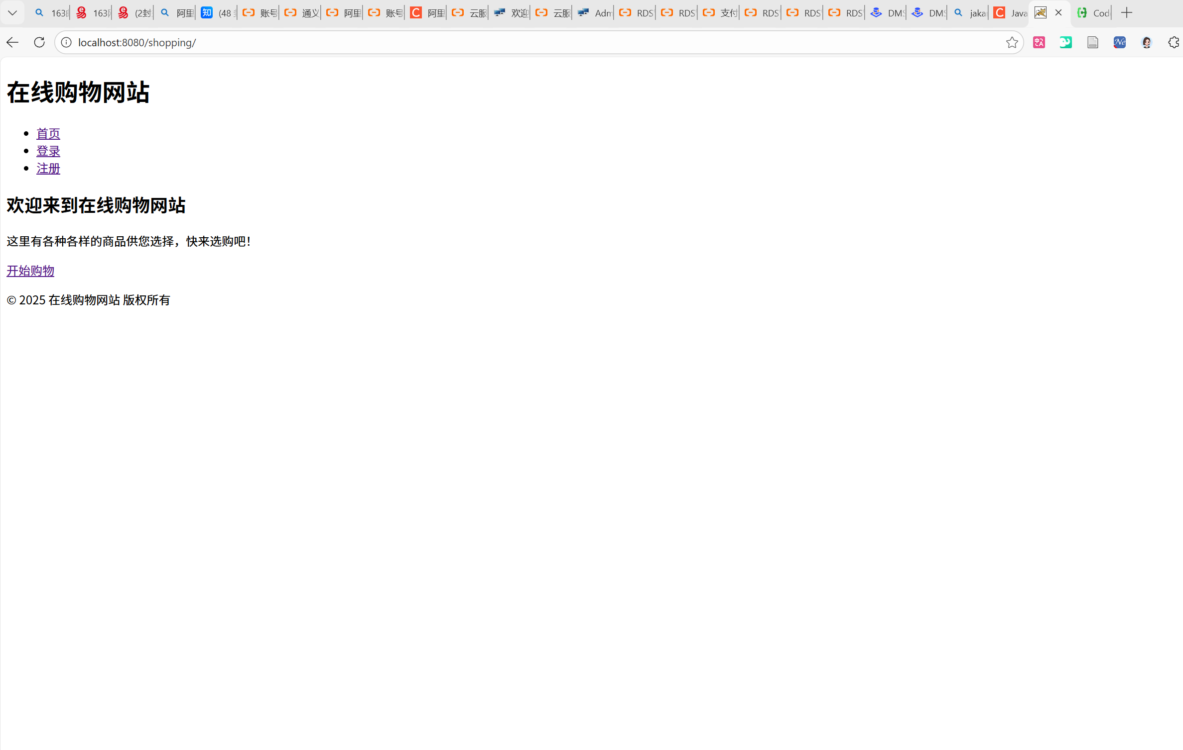
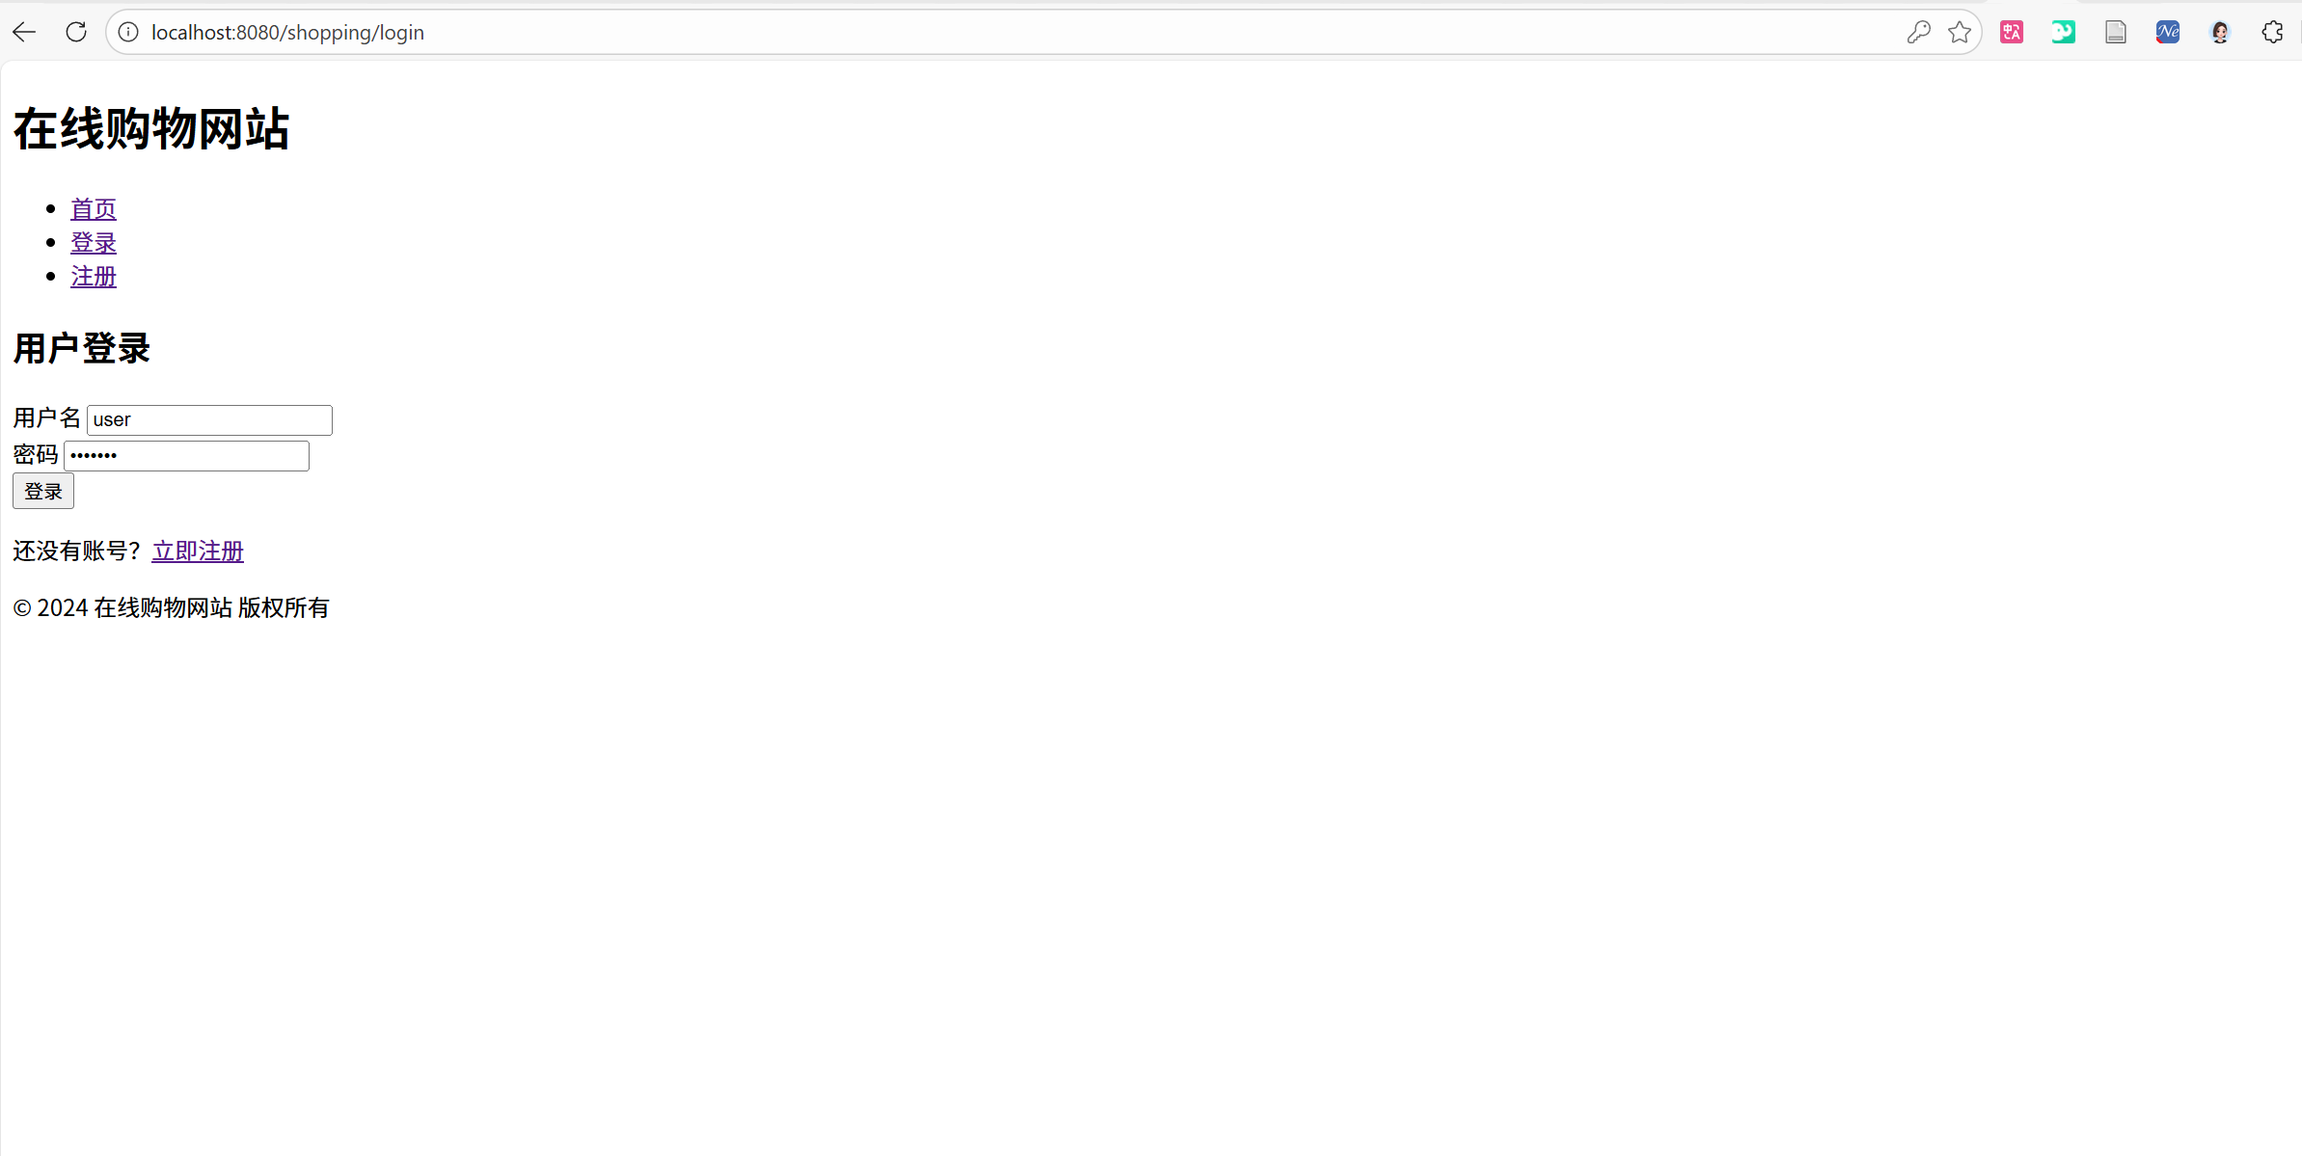
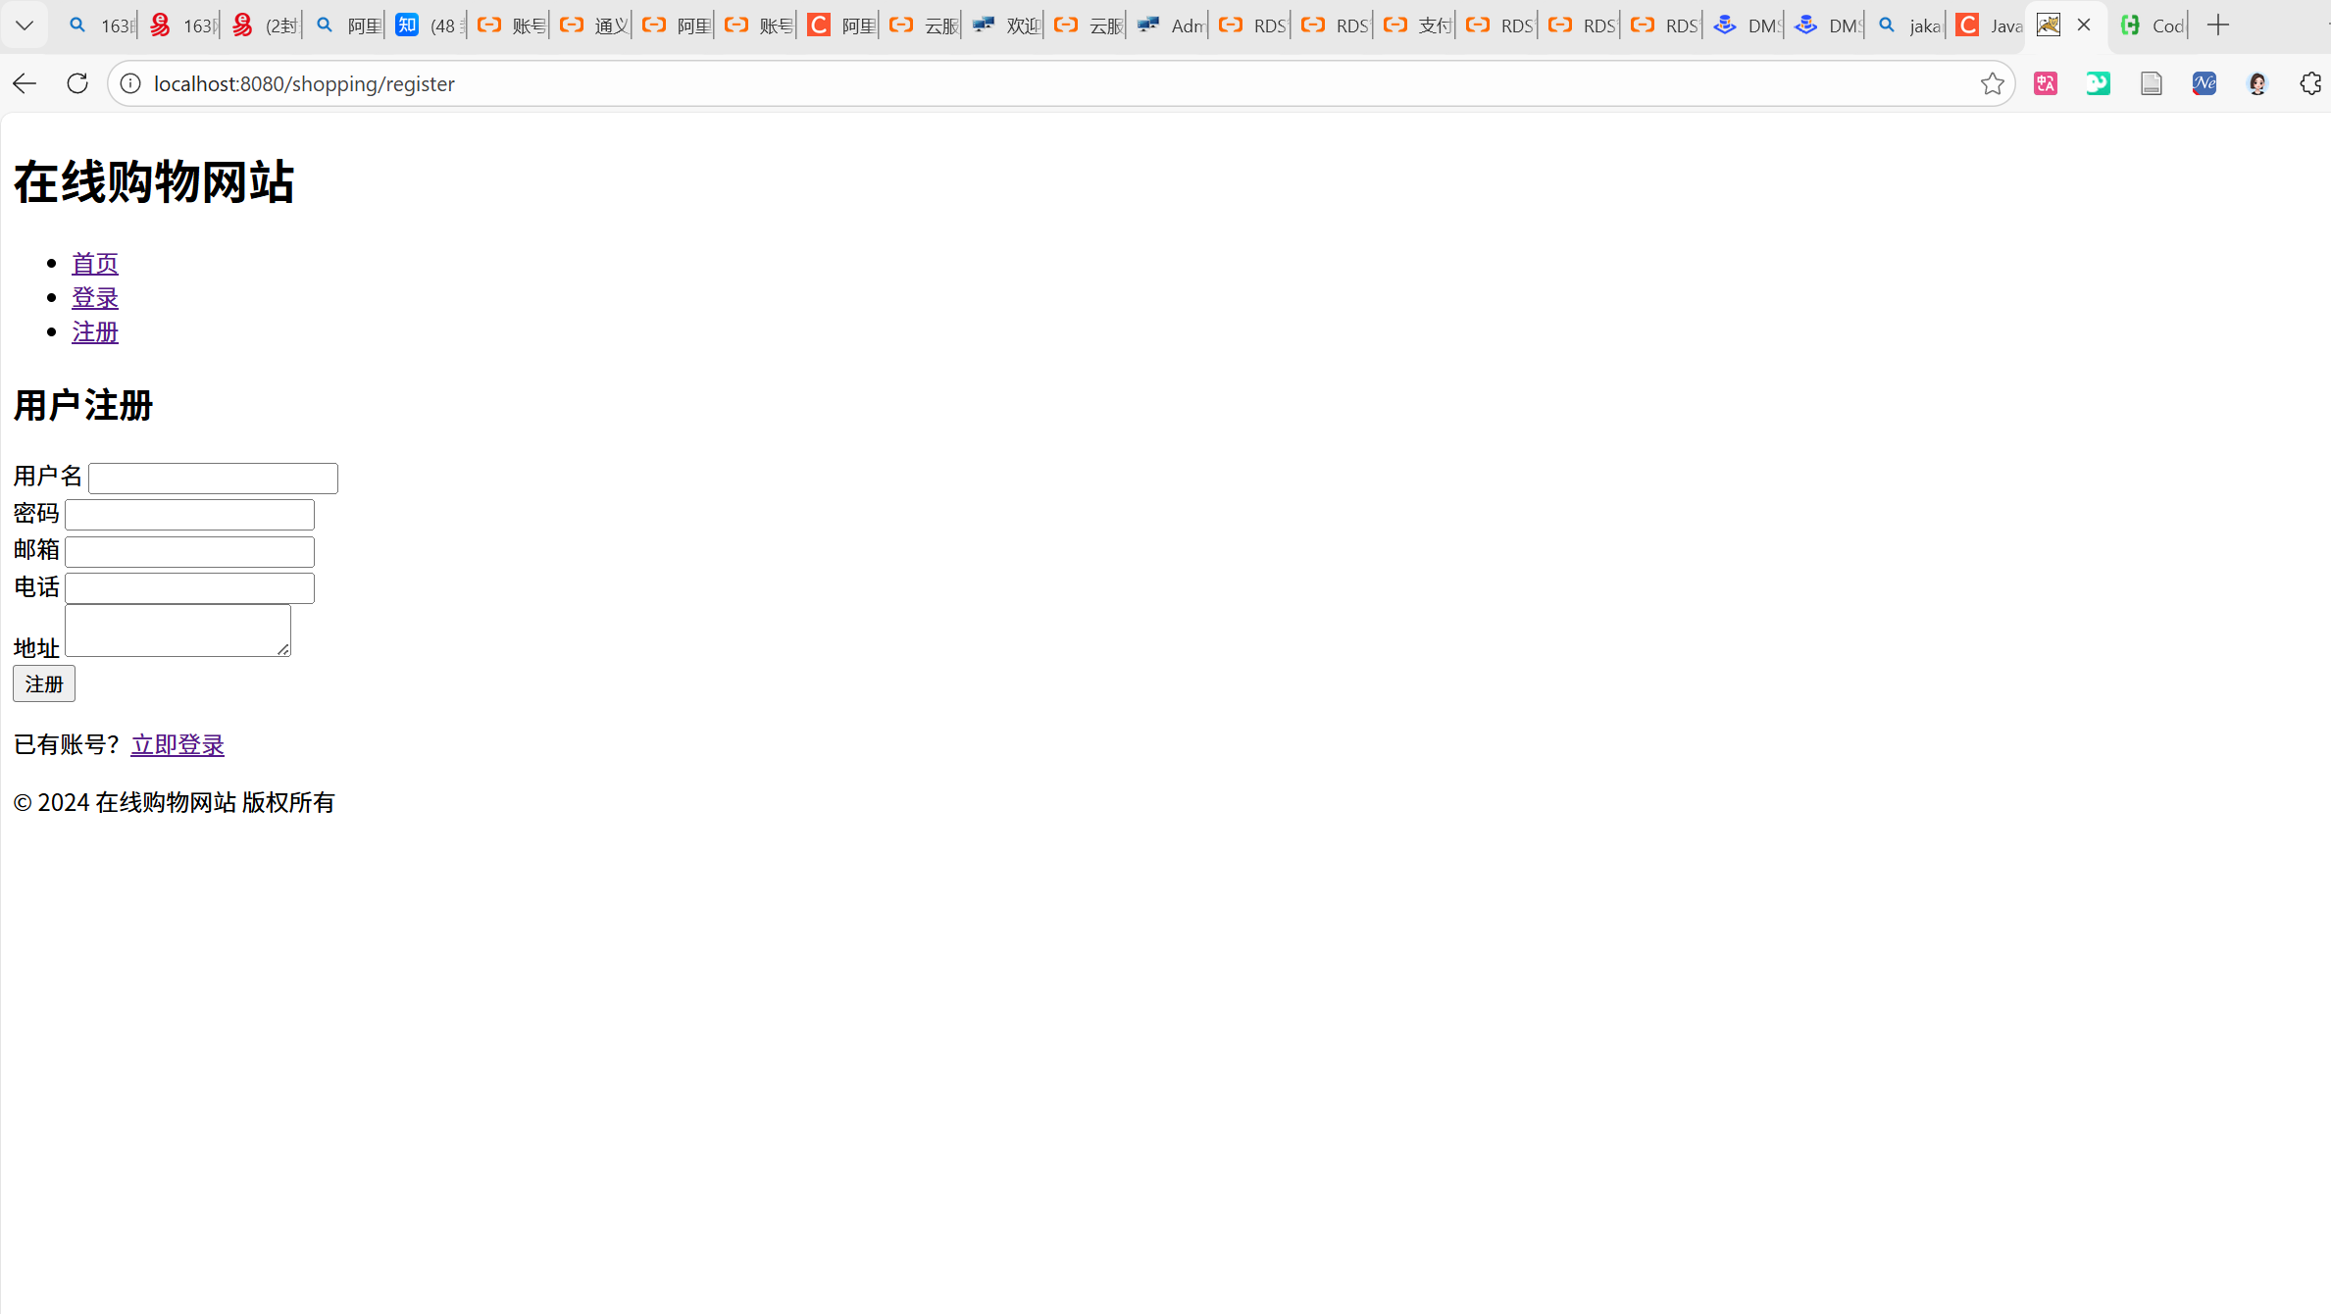

商品管理 ：浏览商品、搜索商品、查看商品详情
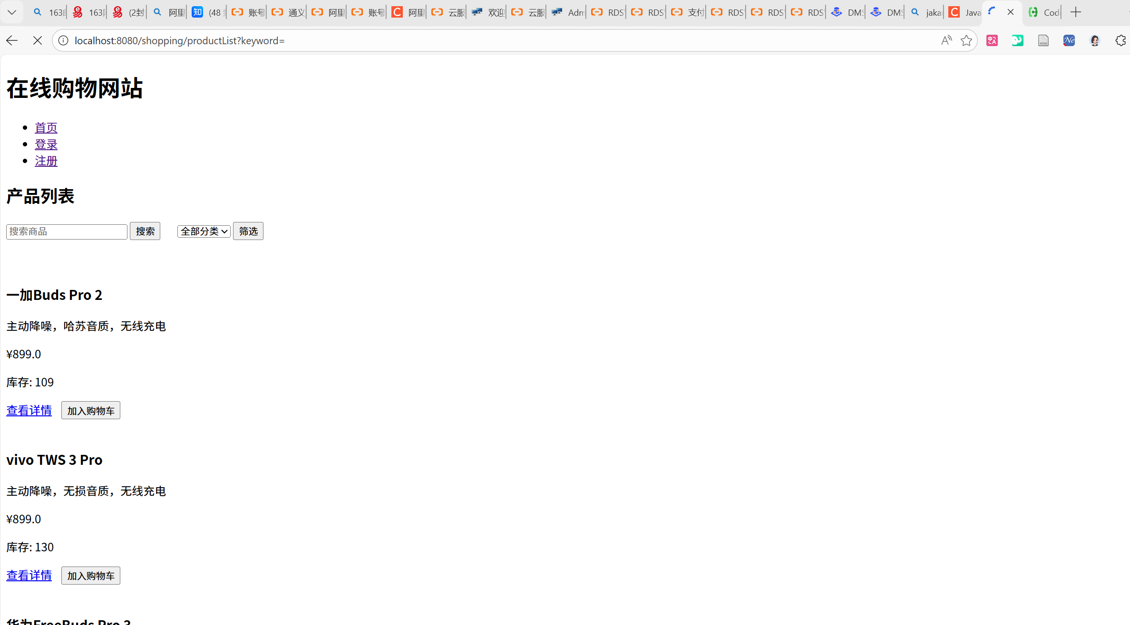
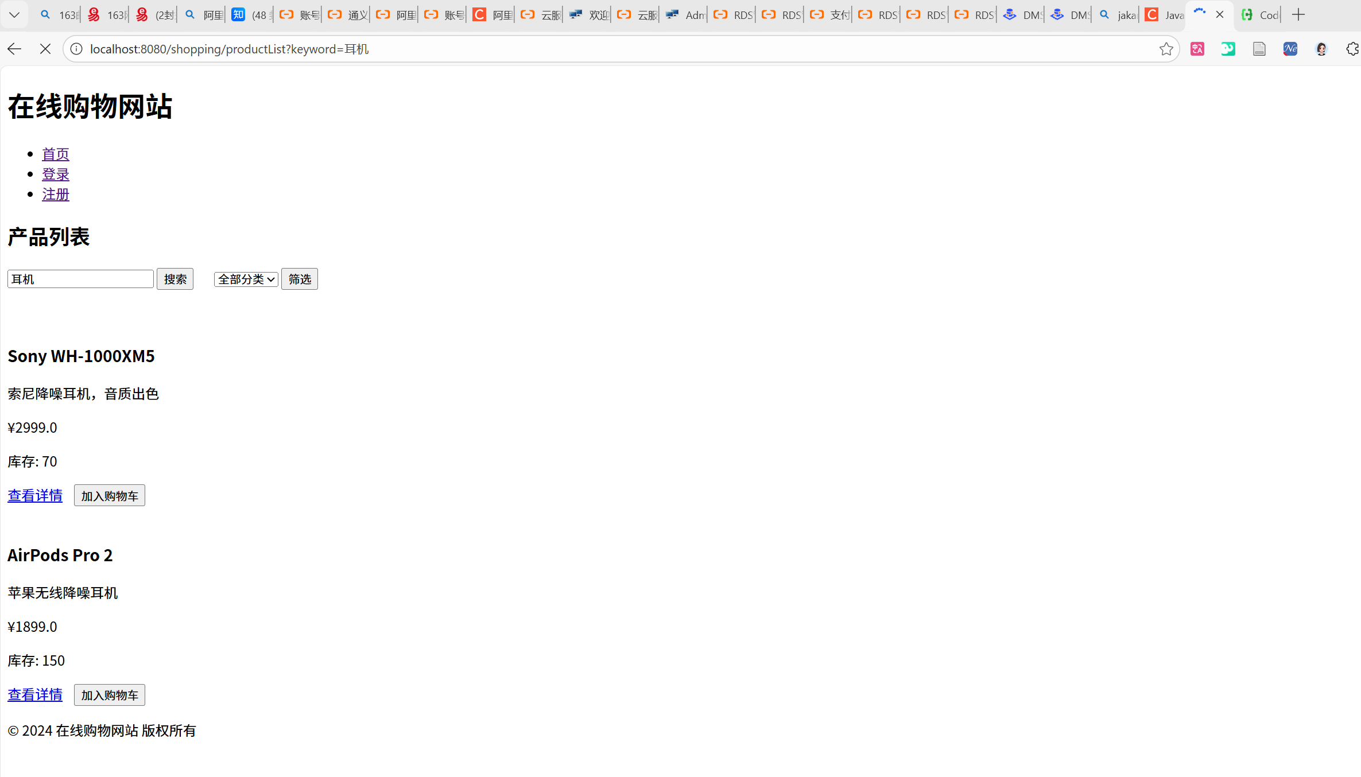
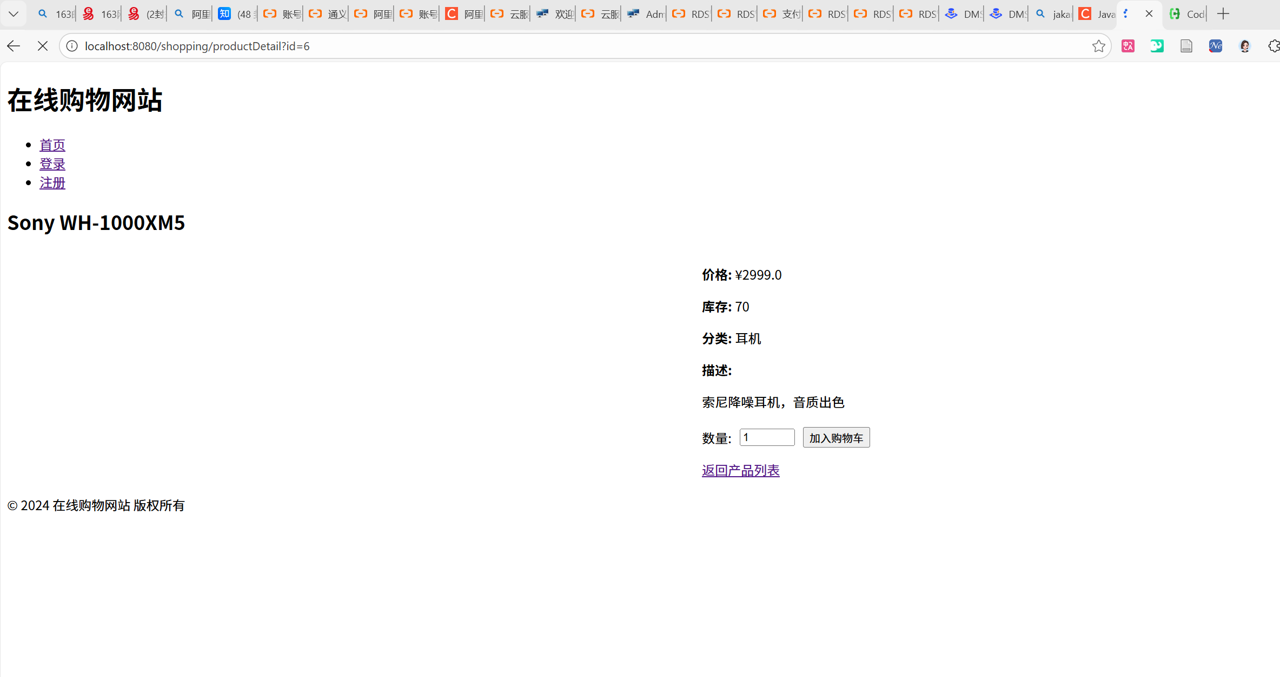

购物车管理 ：添加商品、更新数量、删除商品
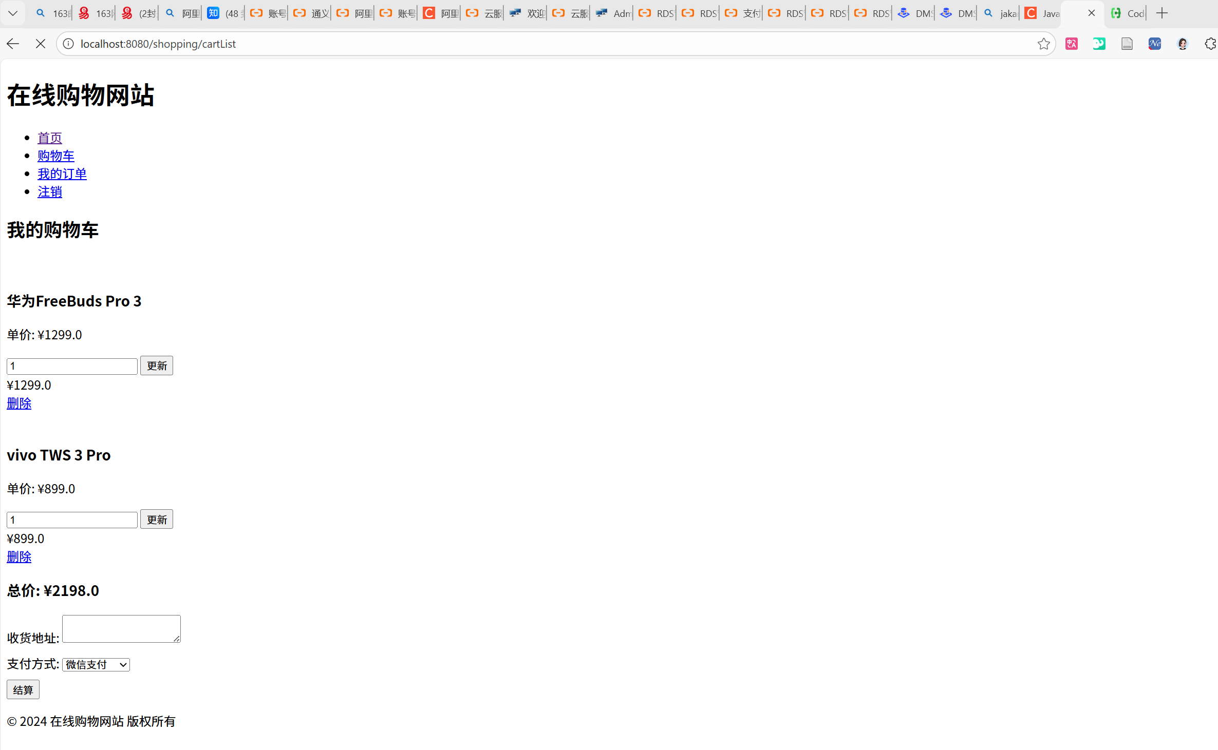

订单管理 ：生成订单、查看订单列表、查看订单详情
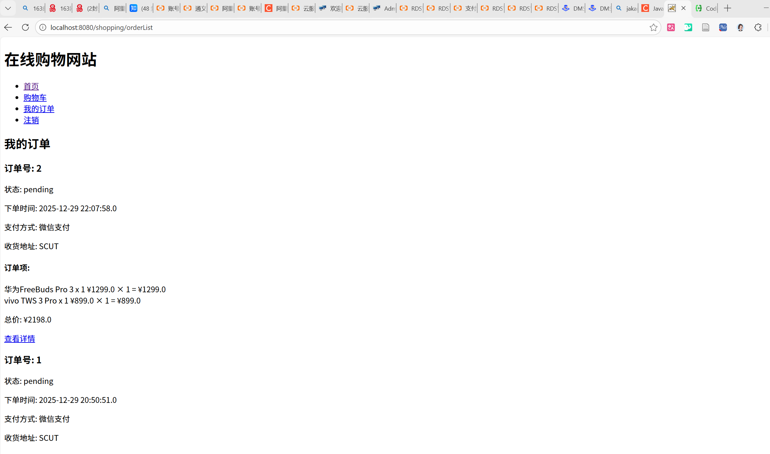

管理员功能 ：商品管理、订单管理、销售报表
