DUA AFTAB

ASSIGNEMENT # 3
Scenario: You are a Data Analyst for a retail company who has completed the data cleaning process. Now, your task is to enhance the dataset by creating meaningful categories and key sales metrics to analyze business performance and ensure the accuracy of results through proper validation from a reporting view.
Tasks:
- To classify records based on discount, labeling entries with zero discount as “No Discount” and others as “Discount Applied”. Name the new column as Discount Category.

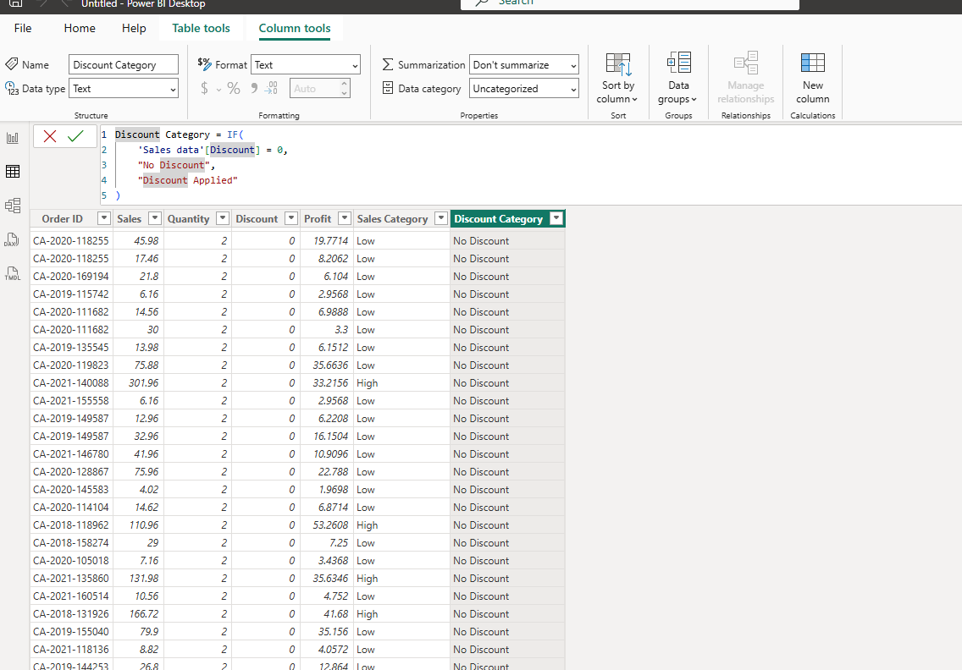

- To categorize sales into High and Low based on the Sales value, where values greater than 100 are labeled as High and others as Low. Name the new column as Sales Category

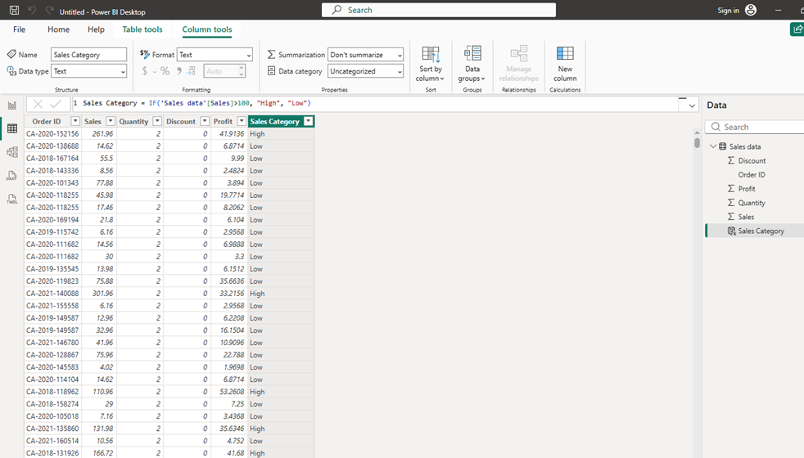
Create calculated measures: (Marks – 5)
- Total Sales (Sum of Sales)
- Qty Sold (Sum of Quantity)
- Total Orders (Count of Order ID)
- Total Profit (Calculate by multiplying quantity by profit) using iterator function.
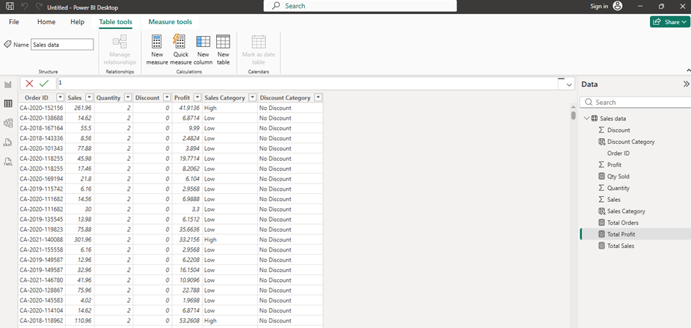
3. Validate all the results of calculated measures by using the Matrix visual. (Marks – 2)
