Temporal Trends in Acute Myocardial Infarction Outcomes Among Patients With Opioid Use Disorder: An Analysis of Sex and Racial Disparities Using the Nationwide Inpatient Sample (2017–2022)
  - Analysis for RCOP NIS Cardio-3
Dua Ali

Preamble
- Reference Studies:
  - Ranka et al., 2021
  - Thuemmler et al., 2023
- Study Objective:
- To characterise national trends in acute myocardial infarction (AMI) hospitalisations among patients with opioid use disorder (OUD) from 2017 to 2022 using ICD-10 data, spanning the transition through the opioid epidemic’s third and fourth waves. Specifically, this study (1) determines temporal trends in in-hospital outcomes (mortality, cardiogenic shock, cardiac arrest, acute kidney injury, mechanical ventilation, and PCI utilisation) among OUD-AMI hospitalisations; (2) characterises trends in length of stay and inflation-adjusted hospitalisation costs; (3) examines sex-based disparities in outcomes and hospitalisation patterns; and (4) identifies racial/ethnic disparities in outcomes among OUD-AMI patients.
- Data Source:
- Retrospective cross-sectional analysis of the Nationwide Inpatient Sample (NIS), 2017–2022, developed by AHRQ through HCUP. The NIS is the largest all-payer inpatient database in the United States, comprising a 20% stratified sample of discharges from approximately 4,000 non-federal community hospitals. All analyses incorporate the complex survey design (stratified cluster sampling with discharge weights) to produce nationally representative estimates.
- Cohort Definition:
- Study cohort:Adult discharges (age ≥18) with AMI as the principal diagnosis and a concomitant diagnosis of opioid use disorder (OUD) in any listed position. Excluded: age <18; missing discharge weight (DISCWT).
  - AMI inclusion codes (ICD-10-CM): I21.01, I21.02, I21.09, I21.11, I21.19, I21.21, I21.29, I21.3, I21.4, I21.9, I21.A1, I21.A9, I21.B, I22.0, I22.1, I22.2, I22.8, I22.9.
  - AMI subtype classification: STEMI was defined by codes I21.01, I21.02, I21.09, I21.11, I21.19, I21.21, I21.29, and I21.3, corresponding to ST-elevation infarctions of the anterior, inferior, and other specified walls. NSTEMI was defined exclusively by I21.4 (non-ST-elevation myocardial infarction).
- Exposure Variables:
  - Primary exposure; Opioid Use Disorder: Identified using ICD-10-CM codes within the F11.1x (opioid abuse) and F11.2x (opioid dependence) subcategories, encompassing the spectrum from uncomplicated abuse to dependence with withdrawal or psychotic features. F11.9x (unspecified opioid use) was excluded to maintain diagnostic specificity. Full code list provided in the supplementary material.
  - Temporal trend: Year of hospitalisation (2017–2022), modelled as a continuous linear predictor. The resulting coefficient represents the average annual change in each outcome across the study period.
  - Sex disparities: Sex (Male [reference] vs. Female), derived from NIS variable FEMALE.
  - Racial/ethnic disparities: Race/ethnicity — White (reference), Black, Hispanic, Asian or Pacific Islander, and Other.
- Outcomes:
  - Primary: In-hospital all-cause mortality.
  - Secondary:
    - Cardiogenic shock
    - Cardiac arrest
    - Acute kidney injury
    - Mechanical ventilation or Respiratory failure
    - PCI utilisation
    - Non-routine discharge disposition (transfer to SNF/intermediate care/another facility, left against medical advice, or in-hospital death)
    - Length of stay (days)
    - Inflation-adjusted total hospitalisation costs (2022 USD, CPI-U adjusted using All-Urban CPI-U base year 2022).
- Covariates:
  - Demographic/Socioeconomic: Age, sex, race/ethnicity, primary expected payer (Medicare [reference], Medicaid, Private, Self-pay/Uninsured, Other), ZIP-based median household income quartile (Q1 [reference]–Q4).
  - Clinical: AMI type (NSTEMI [reference] vs. STEMI).
  - Comorbidities: Congestive heart failure, hypertension, diabetes mellitus (Type 1 or 2), chronic kidney disease, liver disease, chronic lung disease, psychiatric disorder, alcohol use disorder, tobacco use disorder, cocaine use disorder.
  - Hospital: Census region (Northeast [reference], Midwest, South, West), bed size (Large [reference], Medium, Small), location/teaching status (Urban teaching [reference], Urban non-teaching, Rural).
- Statistical Methods:
  - Descriptive statistics: Survey-weighted proportions and means (±SD), restricted to OUD-AMI patients. Weighted estimates are stratified by sex and by race/ethnicity separately. Rao–Scott chi-square for categorical variables; design-based t-test or Kruskal–Wallis for continuous variables. Tables produced with tbl_svysummary() (gtsummary) with overall column, stratified columns, and p-values.
  - Temporal trends: Weighted OUD-AMI discharge volume by year (absolute counts) and OUD prevalence as a proportion of all weighted AMI admissions per year, stratified by sex and race/ethnicity.Survey-weighted Wald F-test for continuous linear trend was utilized.
  - Multivariable regression — binary outcomes (mortality, cardiogenic shock, cardiac arrest, AKI, mechanical ventilation, PCI utilisation, non-routine discharge): Survey-weighted logistic regression (svyglm, quasibinomial family); results reported as adjusted odds ratios (aORs) with 95% CIs.
  - Multivariable regression — continuous outcomes (LOS, costs): Survey-weighted linear regression (svyglm, Gaussian family, identity link); results reported as adjusted mean differences (β coefficients) with 95% CIs.
  - Survey design: All models incorporate the NIS complex survey design (id = ~HOSP_NIS, strata = ~NIS_STRATUM, weights = ~DISCWT, nest = TRUE); lonely PSU handled with the “adjust” method (survey.lonely.psu = "adjust").
  - Software: R version 4.5.1 (R Foundation for Statistical Computing); key packages: arrow, duckdb, survey, gtsummary, tidyverse.

Table 1A: Baseline Characteristics Table, stratified by Sex
Characteristic | Overall N = 103,355¹ | Male N = 59,675¹ | Female N = 43,680¹ | p-value²
Age, years (continuous) | 58 (14) | 56 (14) | 60 (14) | <0.001
Race/Ethnicity |  |  |  | <0.001
White | 70,805 (70%) | 38,810 (67%) | 31,995 (75%)
Black | 17,325 (17%) | 11,140 (19%) | 6,185 (15%)
Hispanic | 8,455 (8.4%) | 5,595 (9.6%) | 2,860 (6.7%)
Asian or Pacific Islander | 695 (0.7%) | 410 (0.7%) | 285 (0.7%)
Other | 3,510 (3.5%) | 2,195 (3.8%) | 1,315 (3.1%)
Year (continuous) |  |  |  | 0.4
2017 | 12,705 (12%) | 7,130 (12%) | 5,575 (13%)
2018 | 14,940 (14%) | 8,520 (14%) | 6,420 (15%)
2019 | 16,440 (16%) | 9,575 (16%) | 6,865 (16%)
2020 | 18,350 (18%) | 10,770 (18%) | 7,580 (17%)
2021 | 19,915 (19%) | 11,635 (19%) | 8,280 (19%)
2022 | 21,005 (20%) | 12,045 (20%) | 8,960 (21%)
Median Household Income Quartile (by ZIP) |  |  |  | <0.001
Q1 | 39,100 (39%) | 22,600 (39%) | 16,500 (39%)
Q2 | 25,865 (26%) | 14,235 (25%) | 11,630 (27%)
Q3 | 21,815 (22%) | 12,590 (22%) | 9,225 (22%)
Q4 | 13,525 (13%) | 8,140 (14%) | 5,385 (13%)
Primary Expected Payer |  |  |  | <0.001
Medicare | 48,090 (47%) | 24,635 (41%) | 23,455 (54%)
Medicaid | 32,910 (32%) | 20,115 (34%) | 12,795 (29%)
Private | 13,645 (13%) | 8,665 (15%) | 4,980 (11%)
Self-pay/Uninsured | 5,655 (5.5%) | 3,990 (6.7%) | 1,665 (3.8%)
Other | 3,055 (3.0%) | 2,270 (3.8%) | 785 (1.8%)
AMI Type |  |  |  | <0.001
NSTEMI | 47,340 (83%) | 27,280 (80%) | 20,060 (86%)
STEMI | 9,995 (17%) | 6,635 (20%) | 3,360 (14%)
Hospital Region |  |  |  | <0.001
Northeast | 21,185 (20%) | 13,960 (23%) | 7,225 (17%)
Midwest | 18,785 (18%) | 10,975 (18%) | 7,810 (18%)
South | 38,230 (37%) | 21,285 (36%) | 16,945 (39%)
West | 25,155 (24%) | 13,455 (23%) | 11,700 (27%)
Hospital Bed Size |  |  |  | 0.2
Large | 53,065 (51%) | 30,965 (52%) | 22,100 (51%)
Medium | 30,395 (29%) | 17,425 (29%) | 12,970 (30%)
Small | 19,895 (19%) | 11,285 (19%) | 8,610 (20%)
Hospital Location & Teaching Status |  |  |  | <0.001
Urban, teaching | 78,335 (76%) | 46,615 (78%) | 31,720 (73%)
Rural | 7,015 (6.8%) | 3,510 (5.9%) | 3,505 (8.0%)
Urban, non-teaching | 18,005 (17%) | 9,550 (16%) | 8,455 (19%)
Elixhauser Comorbidity Index (score) | 5.94 (2.24) | 5.76 (2.25) | 6.19 (2.20) | <0.001
Congestive Heart Failure | 50,980 (49%) | 29,495 (49%) | 21,485 (49%) | 0.7
Hypertension | 71,920 (70%) | 41,280 (69%) | 30,640 (70%) | 0.14
Diabetes Mellitus (Type 1 or 2) | 31,840 (31%) | 18,000 (30%) | 13,840 (32%) | 0.020
Chronic Kidney Disease | 24,610 (24%) | 14,370 (24%) | 10,240 (23%) | 0.3
Chronic Lung Disease | 39,850 (39%) | 19,850 (33%) | 20,000 (46%) | <0.001
Obesity | 18,155 (18%) | 9,330 (16%) | 8,825 (20%) | <0.001
Peripheral Vascular Disease | 10,315 (10.0%) | 6,050 (10%) | 4,265 (9.8%) | 0.4
Liver Disease | 17,525 (17%) | 11,065 (19%) | 6,460 (15%) | <0.001
Dyslipidemia / Hyperlipidemia | 38,840 (38%) | 22,445 (38%) | 16,395 (38%) | >0.9
Smoking | 60,270 (58%) | 36,810 (62%) | 23,460 (54%) | <0.001
Atrial Fibrillation | 16,980 (16%) | 10,090 (17%) | 6,890 (16%) | 0.028
Prior Myocardial Infarction | 11,455 (11%) | 7,100 (12%) | 4,355 (10.0%) | <0.001
Prior Revascularization (PCI or CABG) | 12,595 (12%) | 8,445 (14%) | 4,150 (9.5%) | <0.001
Alcohol Use Disorder | 13,600 (13%) | 10,175 (17%) | 3,425 (7.8%) | <0.001
Tobacco Use Disorder | 60,230 (58%) | 36,795 (62%) | 23,435 (54%) | <0.001
Cocaine Use Disorder | 13,180 (13%) | 9,500 (16%) | 3,680 (8.4%) | <0.001
Psychiatric Disorder | 24,695 (24%) | 12,240 (21%) | 12,455 (29%) | <0.001
Other Non-Opioid Substance Use Disorder | 14,110 (14%) | 8,840 (15%) | 5,270 (12%) | <0.001
¹– denotes suppressed cells (n < 11) per HCUP guidelines
²Design-based KruskalWallis test; Pearson's X^2: Rao & Scott adjustment

Table 1B: Baseline Characteristics Table, stratified by Race
Characteristic | Overall N = 100,795¹ | White N = 70,810¹ | Black N = 17,325¹ | Hispanic N = 8,455¹ | Asian or Pacific Islander N = 695¹ | Other N = 3,510¹ | p-value²
Age, years (continuous) | 58 (14) | 58 (15) | 57 (12) | 54 (14) | 59 (17) | 55 (15) | <0.001
Sex |  |  |  |  |  |  | <0.001
Male | 58,150 (58%) | 38,810 (55%) | 11,140 (64%) | 5,595 (66%) | 410 (59%) | 2,195 (63%)
Female | 42,640 (42%) | 31,995 (45%) | 6,185 (36%) | 2,860 (34%) | 285 (41%) | 1,315 (37%)
Year (continuous) |  |  |  |  |  |  | 0.5
2017 | 12,280 (12%) | 8,985 (13%) | 1,990 (11%) | 830 (9.8%) | 85 (12%) | 390 (11%)
2018 | 14,665 (15%) | 10,530 (15%) | 2,440 (14%) | 1,070 (13%) | 140 (20%) | 485 (14%)
2019 | 16,135 (16%) | 11,275 (16%) | 2,890 (17%) | 1,335 (16%) | 100 (14%) | 535 (15%)
2020 | 17,790 (18%) | 12,460 (18%) | 2,955 (17%) | 1,635 (19%) | 120 (17%) | 620 (18%)
2021 | 19,375 (19%) | 13,400 (19%) | 3,500 (20%) | 1,665 (20%) | 110 (16%) | 700 (20%)
2022 | 20,550 (20%) | 14,160 (20%) | 3,550 (20%) | 1,920 (23%) | 140 (20%) | 780 (22%)
Median Household Income Quartile (by ZIP) |  |  |  |  |  |  | <0.001
Q1 | 38,100 (39%) | 22,975 (33%) | 9,860 (59%) | 3,800 (48%) | 140 (21%) | 1,325 (40%)
Q2 | 25,240 (26%) | 19,490 (28%) | 3,115 (19%) | 1,720 (22%) | 165 (24%) | 750 (23%)
Q3 | 21,315 (22%) | 16,615 (24%) | 2,310 (14%) | 1,555 (20%) | 185 (27%) | 650 (20%)
Q4 | 13,175 (13%) | 9,975 (14%) | 1,535 (9.1%) | 890 (11%) | 190 (28%) | 585 (18%)
Primary Expected Payer |  |  |  |  |  |  | <0.001
Medicare | 46,950 (47%) | 35,675 (50%) | 6,725 (39%) | 2,910 (34%) | 300 (43%) | 1,340 (38%)
Medicaid | 32,145 (32%) | 18,965 (27%) | 7,455 (43%) | 3,940 (47%) | 270 (39%) | 1,515 (43%)
Private | 13,230 (13%) | 10,190 (14%) | 1,725 (10.0%) | 860 (10%) | 90 (13%) | 365 (10%)
Self-pay/Uninsured | 5,485 (5.4%) | 3,710 (5.2%) | 985 (5.7%) | 560 (6.6%) | - | 215 (6.1%)
Other | 2,985 (3.0%) | 2,270 (3.2%) | 435 (2.5%) | 185 (2.2%) | - | 75 (2.1%)
AMI Type |  |  |  |  |  |  | 0.7
NSTEMI | 46,125 (83%) | 33,480 (82%) | 7,120 (83%) | 3,725 (83%) | 370 (88%) | 1,430 (82%)
STEMI | 9,725 (17%) | 7,110 (18%) | 1,510 (17%) | 740 (17%) | - | 315 (18%)
Hospital Region |  |  |  |  |  |  | <0.001
Northeast | 20,905 (21%) | 12,705 (18%) | 4,130 (24%) | 2,875 (34%) | 60 (8.6%) | 1,135 (32%)
Midwest | 17,860 (18%) | 12,340 (17%) | 4,520 (26%) | 475 (5.6%) | 65 (9.4%) | 460 (13%)
South | 37,655 (37%) | 28,565 (40%) | 6,540 (38%) | 1,665 (20%) | 70 (10%) | 815 (23%)
West | 24,375 (24%) | 17,200 (24%) | 2,135 (12%) | 3,440 (41%) | 500 (72%) | 1,100 (31%)
Hospital Bed Size |  |  |  |  |  |  | 0.2
Large | 51,675 (51%) | 36,295 (51%) | 8,790 (51%) | 4,280 (51%) | 385 (55%) | 1,925 (55%)
Medium | 29,820 (30%) | 21,040 (30%) | 4,890 (28%) | 2,695 (32%) | 175 (25%) | 1,020 (29%)
Small | 19,300 (19%) | 13,475 (19%) | 3,645 (21%) | 1,480 (18%) | 135 (19%) | 565 (16%)
Hospital Location & Teaching Status |  |  |  |  |  |  | <0.001
Urban, teaching | 76,465 (76%) | 50,425 (71%) | 15,545 (90%) | 7,140 (84%) | 555 (80%) | 2,800 (80%)
Rural | 6,785 (6.7%) | 6,155 (8.7%) | 240 (1.4%) | 115 (1.4%) | - | 265 (7.5%)
Urban, non-teaching | 17,545 (17%) | 14,230 (20%) | 1,540 (8.9%) | 1,200 (14%) | 130 (19%) | 445 (13%)
Elixhauser Comorbidity Index (score) | 5.95 (2.24) | 5.95 (2.24) | 6.08 (2.24) | 5.68 (2.17) | 6.13 (2.23) | 5.82 (2.33) | <0.001
Congestive Heart Failure | 49,840 (49%) | 34,780 (49%) | 9,215 (53%) | 3,750 (44%) | 420 (60%) | 1,675 (48%) | <0.001
Hypertension | 70,235 (70%) | 47,935 (68%) | 13,940 (80%) | 5,575 (66%) | 515 (74%) | 2,270 (65%) | <0.001
Diabetes Mellitus (Type 1 or 2) | 31,080 (31%) | 20,625 (29%) | 5,805 (34%) | 3,235 (38%) | 280 (40%) | 1,135 (32%) | <0.001
Chronic Kidney Disease | 24,020 (24%) | 14,980 (21%) | 5,990 (35%) | 2,000 (24%) | 275 (40%) | 775 (22%) | <0.001
Chronic Lung Disease | 38,900 (39%) | 28,355 (40%) | 6,695 (39%) | 2,540 (30%) | 190 (27%) | 1,120 (32%) | <0.001
Obesity | 17,685 (18%) | 13,055 (18%) | 2,580 (15%) | 1,415 (17%) | 85 (12%) | 550 (16%) | <0.001
Peripheral Vascular Disease | 10,085 (10%) | 7,350 (10%) | 1,760 (10%) | 610 (7.2%) | 80 (12%) | 285 (8.1%) | <0.001
Liver Disease | 17,025 (17%) | 11,585 (16%) | 2,740 (16%) | 1,785 (21%) | 145 (21%) | 770 (22%) | <0.001
Dyslipidemia / Hyperlipidemia | 37,975 (38%) | 27,900 (39%) | 5,890 (34%) | 2,860 (34%) | 295 (42%) | 1,030 (29%) | <0.001
Smoking | 58,900 (58%) | 40,545 (57%) | 11,380 (66%) | 4,695 (56%) | 350 (50%) | 1,930 (55%) | <0.001
Atrial Fibrillation | 16,630 (16%) | 13,085 (18%) | 2,105 (12%) | 830 (9.8%) | 100 (14%) | 510 (15%) | <0.001
Prior Myocardial Infarction | 11,295 (11%) | 8,120 (11%) | 1,980 (11%) | 750 (8.9%) | 95 (14%) | 350 (10.0%) | 0.015
Prior Revascularization (PCI or CABG) | 12,320 (12%) | 9,125 (13%) | 1,925 (11%) | 870 (10%) | 85 (12%) | 315 (9.0%) | <0.001
Alcohol Use Disorder | 13,285 (13%) | 8,675 (12%) | 2,720 (16%) | 1,240 (15%) | 60 (8.6%) | 590 (17%) | <0.001
Tobacco Use Disorder | 58,860 (58%) | 40,520 (57%) | 11,375 (66%) | 4,690 (55%) | 350 (50%) | 1,925 (55%) | <0.001
Cocaine Use Disorder | 12,830 (13%) | 5,790 (8.2%) | 5,170 (30%) | 1,245 (15%) | 60 (8.6%) | 565 (16%) | <0.001
Psychiatric Disorder | 24,170 (24%) | 18,020 (25%) | 3,350 (19%) | 1,805 (21%) | 140 (20%) | 855 (24%) | <0.001
Other Non-Opioid Substance Use Disorder | 13,835 (14%) | 9,325 (13%) | 2,685 (15%) | 1,180 (14%) | 65 (9.4%) | 580 (17%) | <0.001
¹– denotes suppressed cells (n < 11) per HCUP guidelines
²Design-based KruskalWallis test; Pearson's X^2: Rao & Scott adjustment

Table 2A: Univariable Analysis, Stratified by Sex
Characteristic | Overall N = 103,355¹ | Male N = 59,675¹ | Female N = 43,680¹ | p-value²
In-hospital All-Cause Mortality | 8,455 (8.2%) | 4,900 (8.2%) | 3,555 (8.1%) | 0.9
Cardiogenic Shock | 5,670 (5.5%) | 3,405 (5.7%) | 2,265 (5.2%) | 0.11
Cardiac Arrest | 6,145 (5.9%) | 3,870 (6.5%) | 2,275 (5.2%) | <0.001
Acute Kidney Injury | 44,005 (43%) | 26,625 (45%) | 17,380 (40%) | <0.001
Mechanical Ventilation / Respiratory Failure | 45,860 (44%) | 25,445 (43%) | 20,415 (47%) | <0.001
PCI Utilization | 14,240 (14%) | 9,255 (16%) | 4,985 (11%) | <0.001
Non-Routine Discharge Disposition | 39,915 (39%) | 22,780 (38%) | 17,135 (39%) | 0.13
Length of Stay (days) | 5 (3, 9) | 5 (2, 9) | 5 (3, 10) | <0.001
Inflation-Adjusted Total Hospital Costs (2022 USD) | 19,961 (11,294, 37,278) | 20,065 (11,162, 38,156) | 19,844 (11,453, 35,963) | 0.5
¹n (%); Median (Q1, Q3)
²Pearson's X^2: Rao & Scott adjustment; Design-based KruskalWallis test

Table 2B: Univariable Analysis, Stratified by Race
Characteristic | Overall N = 100,795¹ | White N = 70,810¹ | Black N = 17,325¹ | Hispanic N = 8,455¹ | Asian or Pacific Islander N = 695¹ | Other N = 3,510¹ | p-value²
In-hospital All-Cause Mortality | 8,195 (8.1%) | 5,885 (8.3%) | 1,205 (7.0%) | 775 (9.2%) | 35 (5.0%) | 295 (8.4%) | 0.024
Cardiogenic Shock | 5,500 (5.5%) | 4,165 (5.9%) | 685 (4.0%) | 450 (5.3%) | 55 (7.9%) | 145 (4.1%) | <0.001
Cardiac Arrest | 5,950 (5.9%) | 4,085 (5.8%) | 1,030 (5.9%) | 570 (6.7%) | 60 (8.6%) | 205 (5.8%) | 0.4
Acute Kidney Injury | 42,845 (43%) | 29,400 (42%) | 7,940 (46%) | 3,565 (42%) | 345 (50%) | 1,595 (45%) | <0.001
Mechanical Ventilation / Respiratory Failure | 44,580 (44%) | 32,675 (46%) | 6,460 (37%) | 3,560 (42%) | 295 (42%) | 1,590 (45%) | <0.001
PCI Utilization | 13,855 (14%) | 10,460 (15%) | 1,865 (11%) | 995 (12%) | 75 (11%) | 460 (13%) | <0.001
Non-Routine Discharge Disposition | 38,860 (39%) | 27,870 (39%) | 6,230 (36%) | 3,205 (38%) | 220 (32%) | 1,335 (38%) | 0.003
Length of Stay (days) | 5 (3, 9) | 5 (3, 10) | 5 (3, 9) | 5 (2, 10) | 5 (3, 10) | 5 (3, 10) | <0.001
Inflation-Adjusted Total Hospital Costs (2022 USD) | 19,934 (11,282, 37,198) | 20,288 (11,562, 37,577) | 17,981 (10,297, 33,183) | 20,040 (11,387, 40,225) | 23,829 (14,090, 42,839) | 23,143 (11,215, 41,550) | <0.001
¹n (%); Median (Q1, Q3)
²Pearson's X^2: Rao & Scott adjustment; Design-based KruskalWallis test

Primary Outcome: Temporal Trend in In-Hospital Mortality
Characteristic | OR | 95% CI | p-value
Sex
Male | — | —
Female | 1.00 | 0.86, 1.17 | >0.9
Race/Ethnicity
White | — | —
Black | 1.13 | 0.91, 1.40 | 0.3
Hispanic | 0.91 | 0.69, 1.20 | 0.5
Asian or Pacific Islander | 0.51 | 0.21, 1.26 | 0.14
Other | 0.83 | 0.55, 1.26 | 0.4
Year (continuous) | 1.04 | 1.00, 1.08 | 0.083
AGE | 1.00 | 1.00, 1.01 | 0.4
AMI Type
NSTEMI | — | —
STEMI | 1.52 | 1.28, 1.82 | <0.001
Median Household Income Quartile (by ZIP)
Q1 | — | —
Q2 | 1.09 | 0.90, 1.31 | 0.4
Q3 | 1.08 | 0.88, 1.32 | 0.5
Q4 | 1.11 | 0.87, 1.40 | 0.4
Primary Expected Payer
Medicare | — | —
Medicaid | 1.20 | 0.99, 1.46 | 0.067
Private | 0.97 | 0.76, 1.23 | 0.8
Self-pay/Uninsured | 1.25 | 0.90, 1.74 | 0.2
Other | 1.73 | 1.19, 2.52 | 0.004
Hospital Census Region
Northeast | — | —
Midwest | 1.00 | 0.79, 1.27 | >0.9
South | 0.93 | 0.75, 1.15 | 0.5
West | 1.23 | 0.99, 1.54 | 0.063
Hospital Bed Size
Large | — | —
Medium | 0.95 | 0.80, 1.13 | 0.6
Small | 0.90 | 0.74, 1.09 | 0.3
Hospital Location & Teaching Status
Urban, teaching | — | —
Rural | 0.63 | 0.43, 0.92 | 0.016
Urban, non-teaching | 0.83 | 0.68, 1.01 | 0.058
Congestive Heart Failure
No | — | —
Yes | 0.92 | 0.80, 1.06 | 0.3
Hypertension
No | — | —
Yes | 0.50 | 0.43, 0.59 | <0.001
Diabetes Mellitus
No | — | —
Yes | 0.74 | 0.62, 0.87 | <0.001
Chronic Kidney Disease
No | — | —
Yes | 1.29 | 1.08, 1.55 | 0.006
Liver Disease
No | — | —
Yes | 3.28 | 2.79, 3.86 | <0.001
Chronic Lung Disease
No | — | —
Yes | 0.98 | 0.83, 1.15 | 0.8
Psychiatric Disorder
No | — | —
Yes | 0.64 | 0.53, 0.78 | <0.001
Alcohol Use Disorder
No | — | —
Yes | 0.97 | 0.78, 1.21 | 0.8
Tobacco Use Disorder
No | — | —
Yes | 0.40 | 0.34, 0.47 | <0.001
Cocaine Use Disorder
No | — | —
Yes | 1.0 | 0.79, 1.25 | >0.9
Abbreviations: CI = Confidence Interval, OR = Odds Ratio

Secondary Outcomes - Multivariable Logistic Regression

Cardiogenic Shock:
Characteristic | OR | 95% CI | p-value
Sex
Male | — | —
Female | 1.05 | 0.89, 1.24 | 0.6
Race/Ethnicity
White | — | —
Black | 0.80 | 0.61, 1.04 | 0.091
Hispanic | 1.03 | 0.77, 1.38 | 0.9
Asian or Pacific Islander | 0.92 | 0.41, 2.05 | 0.8
Other | 0.82 | 0.50, 1.33 | 0.4
Year (continuous) | 1.04 | 1.00, 1.09 | 0.058
AGE | 1.00 | 0.99, 1.00 | 0.3
AMI Type
NSTEMI | — | —
STEMI | 3.97 | 3.36, 4.69 | <0.001
Median Household Income Quartile (by ZIP)
Q1 | — | —
Q2 | 1.22 | 1.00, 1.49 | 0.055
Q3 | 1.16 | 0.93, 1.45 | 0.2
Q4 | 1.04 | 0.80, 1.36 | 0.8
Primary Expected Payer
Medicare | — | —
Medicaid | 1.11 | 0.89, 1.37 | 0.4
Private | 0.99 | 0.77, 1.28 | >0.9
Self-pay/Uninsured | 0.89 | 0.60, 1.31 | 0.5
Other | 0.75 | 0.45, 1.24 | 0.3
Hospital Census Region
Northeast | — | —
Midwest | 1.13 | 0.87, 1.48 | 0.4
South | 1.11 | 0.88, 1.41 | 0.4
West | 1.29 | 1.01, 1.65 | 0.039
Hospital Bed Size
Large | — | —
Medium | 0.86 | 0.72, 1.03 | 0.095
Small | 0.69 | 0.55, 0.87 | 0.001
Hospital Location & Teaching Status
Urban, teaching | — | —
Rural | 0.55 | 0.36, 0.82 | 0.004
Urban, non-teaching | 0.77 | 0.62, 0.95 | 0.017
Congestive Heart Failure
No | — | —
Yes | 3.82 | 3.18, 4.59 | <0.001
Hypertension
No | — | —
Yes | 0.73 | 0.61, 0.87 | <0.001
Diabetes Mellitus
No | — | —
Yes | 0.77 | 0.65, 0.93 | 0.005
Chronic Kidney Disease
No | — | —
Yes | 1.03 | 0.84, 1.27 | 0.8
Liver Disease
No | — | —
Yes | 2.62 | 2.19, 3.15 | <0.001
Chronic Lung Disease
No | — | —
Yes | 0.91 | 0.76, 1.08 | 0.3
Psychiatric Disorder
No | — | —
Yes | 0.87 | 0.72, 1.05 | 0.2
Alcohol Use Disorder
No | — | —
Yes | 1.00 | 0.78, 1.27 | >0.9
Tobacco Use Disorder
No | — | —
Yes | 0.65 | 0.55, 0.77 | <0.001
Cocaine Use Disorder
No | — | —
Yes | 0.90 | 0.70, 1.18 | 0.5
Abbreviations: CI = Confidence Interval, OR = Odds Ratio

Cardiac Arrest:
Characteristic | OR | 95% CI | p-value
Sex
Male | — | —
Female | 0.93 | 0.78, 1.10 | 0.4
Race/Ethnicity
White | — | —
Black | 1.14 | 0.90, 1.44 | 0.3
Hispanic | 0.99 | 0.74, 1.33 | >0.9
Asian or Pacific Islander | 1.46 | 0.68, 3.12 | 0.3
Other | 0.89 | 0.57, 1.39 | 0.6
Year (continuous) | 1.08 | 1.03, 1.13 | <0.001
AGE | 0.99 | 0.98, 0.99 | <0.001
AMI Type
NSTEMI | — | —
STEMI | 2.22 | 1.87, 2.64 | <0.001
Median Household Income Quartile (by ZIP)
Q1 | — | —
Q2 | 1.15 | 0.94, 1.42 | 0.2
Q3 | 1.08 | 0.87, 1.35 | 0.5
Q4 | 1.13 | 0.88, 1.46 | 0.3
Primary Expected Payer
Medicare | — | —
Medicaid | 1.26 | 1.01, 1.57 | 0.040
Private | 1.18 | 0.91, 1.53 | 0.2
Self-pay/Uninsured | 1.18 | 0.81, 1.71 | 0.4
Other | 1.81 | 1.20, 2.73 | 0.005
Hospital Census Region
Northeast | — | —
Midwest | 0.90 | 0.70, 1.15 | 0.4
South | 0.80 | 0.64, 1.00 | 0.053
West | 0.88 | 0.69, 1.13 | 0.3
Hospital Bed Size
Large | — | —
Medium | 1.21 | 1.01, 1.45 | 0.034
Small | 0.92 | 0.74, 1.15 | 0.5
Hospital Location & Teaching Status
Urban, teaching | — | —
Rural | 0.83 | 0.56, 1.21 | 0.3
Urban, non-teaching | 0.85 | 0.68, 1.05 | 0.14
Congestive Heart Failure
No | — | —
Yes | 1.05 | 0.89, 1.24 | 0.6
Hypertension
No | — | —
Yes | 0.77 | 0.64, 0.92 | 0.004
Diabetes Mellitus
No | — | —
Yes | 0.74 | 0.61, 0.90 | 0.002
Chronic Kidney Disease
No | — | —
Yes | 0.87 | 0.69, 1.08 | 0.2
Liver Disease
No | — | —
Yes | 2.49 | 2.08, 2.98 | <0.001
Chronic Lung Disease
No | — | —
Yes | 0.94 | 0.79, 1.13 | 0.5
Psychiatric Disorder
No | — | —
Yes | 0.73 | 0.59, 0.90 | 0.004
Alcohol Use Disorder
No | — | —
Yes | 0.90 | 0.71, 1.13 | 0.4
Tobacco Use Disorder
No | — | —
Yes | 0.57 | 0.48, 0.67 | <0.001
Cocaine Use Disorder
No | — | —
Yes | 1.25 | 1.00, 1.57 | 0.053
Abbreviations: CI = Confidence Interval, OR = Odds Ratio

Acute Kidney Injury:
Characteristic | OR | 95% CI | p-value
Sex
Male | — | —
Female | 0.90 | 0.82, 0.98 | 0.016
Race/Ethnicity
White | — | —
Black | 0.98 | 0.87, 1.12 | 0.8
Hispanic | 0.83 | 0.70, 0.98 | 0.030
Asian or Pacific Islander | 1.02 | 0.65, 1.60 | >0.9
Other | 1.13 | 0.88, 1.45 | 0.3
Year (continuous) | 1.00 | 0.97, 1.02 | 0.8
AGE | 1.00 | 0.99, 1.00 | 0.2
AMI Type
NSTEMI | — | —
STEMI | 0.82 | 0.73, 0.92 | <0.001
Median Household Income Quartile (by ZIP)
Q1 | — | —
Q2 | 1.01 | 0.91, 1.13 | 0.8
Q3 | 0.98 | 0.87, 1.10 | 0.7
Q4 | 1.03 | 0.90, 1.19 | 0.6
Primary Expected Payer
Medicare | — | —
Medicaid | 1.11 | 0.98, 1.25 | 0.089
Private | 1.05 | 0.92, 1.21 | 0.4
Self-pay/Uninsured | 1.04 | 0.85, 1.27 | 0.7
Other | 1.09 | 0.86, 1.38 | 0.5
Hospital Census Region
Northeast | — | —
Midwest | 1.09 | 0.95, 1.25 | 0.2
South | 1.07 | 0.95, 1.22 | 0.3
West | 1.14 | 1.0, 1.31 | 0.059
Hospital Bed Size
Large | — | —
Medium | 1.06 | 0.96, 1.17 | 0.3
Small | 1.06 | 0.94, 1.19 | 0.3
Hospital Location & Teaching Status
Urban, teaching | — | —
Rural | 0.79 | 0.65, 0.96 | 0.019
Urban, non-teaching | 0.92 | 0.82, 1.03 | 0.13
Congestive Heart Failure
No | — | —
Yes | 1.20 | 1.10, 1.31 | <0.001
Hypertension
No | — | —
Yes | 0.68 | 0.62, 0.75 | <0.001
Diabetes Mellitus
No | — | —
Yes | 1.00 | 0.91, 1.10 | >0.9
Chronic Kidney Disease
No | — | —
Yes | 3.19 | 2.87, 3.55 | <0.001
Liver Disease
No | — | —
Yes | 2.54 | 2.26, 2.86 | <0.001
Chronic Lung Disease
No | — | —
Yes | 1.03 | 0.94, 1.13 | 0.5
Psychiatric Disorder
No | — | —
Yes | 0.84 | 0.76, 0.93 | <0.001
Alcohol Use Disorder
No | — | —
Yes | 0.99 | 0.86, 1.13 | 0.8
Tobacco Use Disorder
No | — | —
Yes | 0.54 | 0.49, 0.59 | <0.001
Cocaine Use Disorder
No | — | —
Yes | 1.38 | 1.21, 1.57 | <0.001
Abbreviations: CI = Confidence Interval, OR = Odds Ratio

Mechanical Ventilation / Respiratory Failure:
Characteristic | OR | 95% CI | p-value
Sex
Male | — | —
Female | 1.12 | 1.02, 1.21 | 0.013
Race/Ethnicity
White | — | —
Black | 0.82 | 0.72, 0.93 | 0.002
Hispanic | 0.95 | 0.80, 1.13 | 0.6
Asian or Pacific Islander | 0.89 | 0.56, 1.42 | 0.6
Other | 0.98 | 0.77, 1.25 | 0.9
Year (continuous) | 1.01 | 0.99, 1.03 | 0.4
AGE | 0.99 | 0.99, 1.0 | <0.001
AMI Type
NSTEMI | — | —
STEMI | 0.94 | 0.84, 1.05 | 0.3
Median Household Income Quartile (by ZIP)
Q1 | — | —
Q2 | 1.02 | 0.91, 1.14 | 0.7
Q3 | 1.05 | 0.94, 1.18 | 0.4
Q4 | 1.02 | 0.88, 1.17 | 0.8
Primary Expected Payer
Medicare | — | —
Medicaid | 0.97 | 0.86, 1.10 | 0.7
Private | 0.95 | 0.83, 1.08 | 0.4
Self-pay/Uninsured | 0.87 | 0.71, 1.06 | 0.2
Other | 1.13 | 0.88, 1.44 | 0.3
Hospital Census Region
Northeast | — | —
Midwest | 1.12 | 0.98, 1.29 | 0.10
South | 1.08 | 0.95, 1.22 | 0.2
West | 1.15 | 1.01, 1.31 | 0.039
Hospital Bed Size
Large | — | —
Medium | 1.11 | 1.01, 1.23 | 0.032
Small | 1.13 | 1.00, 1.26 | 0.042
Hospital Location & Teaching Status
Urban, teaching | — | —
Rural | 0.82 | 0.68, 0.99 | 0.036
Urban, non-teaching | 1.00 | 0.90, 1.12 | >0.9
Congestive Heart Failure
No | — | —
Yes | 2.13 | 1.95, 2.32 | <0.001
Hypertension
No | — | —
Yes | 0.57 | 0.51, 0.63 | <0.001
Diabetes Mellitus
No | — | —
Yes | 0.83 | 0.76, 0.91 | <0.001
Chronic Kidney Disease
No | — | —
Yes | 1.10 | 0.99, 1.22 | 0.080
Liver Disease
No | — | —
Yes | 2.49 | 2.22, 2.79 | <0.001
Chronic Lung Disease
No | — | —
Yes | 1.93 | 1.77, 2.11 | <0.001
Psychiatric Disorder
No | — | —
Yes | 0.82 | 0.74, 0.91 | <0.001
Alcohol Use Disorder
No | — | —
Yes | 1.10 | 0.96, 1.25 | 0.2
Tobacco Use Disorder
No | — | —
Yes | 0.47 | 0.43, 0.51 | <0.001
Cocaine Use Disorder
No | — | —
Yes | 1.07 | 0.93, 1.23 | 0.4
Abbreviations: CI = Confidence Interval, OR = Odds Ratio

PCI Utilization:
Characteristic | OR | 95% CI | p-value
Sex
Male | — | —
Female | 0.75 | 0.68, 0.84 | <0.001
Race/Ethnicity
White | — | —
Black | 0.69 | 0.59, 0.81 | <0.001
Hispanic | 0.83 | 0.68, 1.00 | 0.050
Asian or Pacific Islander | 0.71 | 0.38, 1.31 | 0.3
Other | 1.06 | 0.80, 1.41 | 0.7
Year (continuous) | 1.04 | 1.01, 1.07 | 0.003
AGE | 1.01 | 1.00, 1.01 | 0.002
AMI Type
NSTEMI | — | —
STEMI | 6.62 | 5.90, 7.43 | <0.001
Median Household Income Quartile (by ZIP)
Q1 | — | —
Q2 | 1.01 | 0.89, 1.15 | 0.9
Q3 | 1.01 | 0.88, 1.15 | >0.9
Q4 | 1.00 | 0.85, 1.19 | >0.9
Primary Expected Payer
Medicare | — | —
Medicaid | 1.08 | 0.94, 1.23 | 0.3
Private | 1.37 | 1.18, 1.60 | <0.001
Self-pay/Uninsured | 1.20 | 0.95, 1.52 | 0.13
Other | 1.00 | 0.75, 1.32 | >0.9
Hospital Census Region
Northeast | — | —
Midwest | 1.26 | 1.07, 1.49 | 0.005
South | 1.16 | 1.00, 1.35 | 0.043
West | 0.98 | 0.84, 1.15 | 0.8
Hospital Bed Size
Large | — | —
Medium | 0.87 | 0.77, 0.98 | 0.020
Small | 0.64 | 0.55, 0.73 | <0.001
Hospital Location & Teaching Status
Urban, teaching | — | —
Rural | 0.56 | 0.45, 0.71 | <0.001
Urban, non-teaching | 0.79 | 0.70, 0.90 | <0.001
Congestive Heart Failure
No | — | —
Yes | 0.81 | 0.74, 0.90 | <0.001
Hypertension
No | — | —
Yes | 1.91 | 1.68, 2.18 | <0.001
Diabetes Mellitus
No | — | —
Yes | 1.44 | 1.29, 1.60 | <0.001
Chronic Kidney Disease
No | — | —
Yes | 0.77 | 0.67, 0.88 | <0.001
Liver Disease
No | — | —
Yes | 0.58 | 0.50, 0.68 | <0.001
Chronic Lung Disease
No | — | —
Yes | 0.80 | 0.72, 0.89 | <0.001
Psychiatric Disorder
No | — | —
Yes | 1.02 | 0.91, 1.14 | 0.8
Alcohol Use Disorder
No | — | —
Yes | 0.60 | 0.51, 0.71 | <0.001
Tobacco Use Disorder
No | — | —
Yes | 1.59 | 1.43, 1.78 | <0.001
Cocaine Use Disorder
No | — | —
Yes | 0.80 | 0.68, 0.95 | 0.008
Abbreviations: CI = Confidence Interval, OR = Odds Ratio

Non-Home Discharge:
Characteristic | OR | 95% CI | p-value
Sex
Male | — | —
Female | 1.03 | 0.94, 1.12 | 0.5
Race/Ethnicity
White | — | —
Black | 1.02 | 0.90, 1.16 | 0.7
Hispanic | 0.89 | 0.76, 1.05 | 0.2
Asian or Pacific Islander | 0.68 | 0.42, 1.11 | 0.12
Other | 0.81 | 0.63, 1.04 | 0.091
Year (continuous) | 1.01 | 0.98, 1.03 | 0.7
AGE | 1.01 | 1.00, 1.01 | <0.001
AMI Type
NSTEMI | — | —
STEMI | 0.92 | 0.82, 1.02 | 0.12
Median Household Income Quartile (by ZIP)
Q1 | — | —
Q2 | 1.07 | 0.96, 1.19 | 0.2
Q3 | 1.05 | 0.94, 1.18 | 0.4
Q4 | 1.07 | 0.93, 1.22 | 0.4
Primary Expected Payer
Medicare | — | —
Medicaid | 0.91 | 0.81, 1.02 | 0.10
Private | 0.67 | 0.59, 0.77 | <0.001
Self-pay/Uninsured | 0.82 | 0.67, 1.01 | 0.059
Other | 0.96 | 0.76, 1.20 | 0.7
Hospital Census Region
Northeast | — | —
Midwest | 0.88 | 0.77, 1.01 | 0.069
South | 0.78 | 0.69, 0.89 | <0.001
West | 0.85 | 0.75, 0.97 | 0.017
Hospital Bed Size
Large | — | —
Medium | 1.09 | 0.98, 1.20 | 0.10
Small | 1.48 | 1.32, 1.66 | <0.001
Hospital Location & Teaching Status
Urban, teaching | — | —
Rural | 1.78 | 1.48, 2.13 | <0.001
Urban, non-teaching | 1.28 | 1.15, 1.43 | <0.001
Congestive Heart Failure
No | — | —
Yes | 1.18 | 1.09, 1.29 | <0.001
Hypertension
No | — | —
Yes | 0.66 | 0.60, 0.72 | <0.001
Diabetes Mellitus
No | — | —
Yes | 0.94 | 0.85, 1.02 | 0.2
Chronic Kidney Disease
No | — | —
Yes | 1.11 | 1.00, 1.24 | 0.050
Liver Disease
No | — | —
Yes | 1.83 | 1.64, 2.06 | <0.001
Chronic Lung Disease
No | — | —
Yes | 0.96 | 0.88, 1.05 | 0.4
Psychiatric Disorder
No | — | —
Yes | 0.87 | 0.79, 0.96 | 0.007
Alcohol Use Disorder
No | — | —
Yes | 1.10 | 0.96, 1.25 | 0.2
Tobacco Use Disorder
No | — | —
Yes | 0.61 | 0.56, 0.67 | <0.001
Cocaine Use Disorder
No | — | —
Yes | 1.19 | 1.04, 1.36 | 0.010
Abbreviations: CI = Confidence Interval, OR = Odds Ratio

Multivariable Linear Regression

Length of Stay (days):
Characteristic | Beta | 95% CI | p-value
Sex
Male | — | —
Female | 0.09 | -0.29, 0.46 | 0.6
Race/Ethnicity
White | — | —
Black | -0.34 | -0.97, 0.29 | 0.3
Hispanic | -0.08 | -0.91, 0.76 | 0.9
Asian or Pacific Islander | 1.6 | -0.98, 4.2 | 0.2
Other | 0.56 | -0.73, 1.8 | 0.4
Year (continuous) | 0.03 | -0.09, 0.15 | 0.6
AGE | -0.01 | -0.03, 0.00 | 0.11
AMI Type
NSTEMI | — | —
STEMI | -0.25 | -0.71, 0.22 | 0.3
Median Household Income Quartile (by ZIP)
Q1 | — | —
Q2 | 0.48 | 0.04, 0.92 | 0.033
Q3 | 0.18 | -0.30, 0.65 | 0.5
Q4 | 0.42 | -0.22, 1.1 | 0.2
Primary Expected Payer
Medicare | — | —
Medicaid | 0.33 | -0.21, 0.88 | 0.2
Private | -0.14 | -0.67, 0.40 | 0.6
Self-pay/Uninsured | -0.77 | -1.7, 0.13 | 0.092
Other | 0.08 | -0.98, 1.1 | 0.9
Hospital Census Region
Northeast | — | —
Midwest | -0.49 | -1.1, 0.10 | 0.10
South | 0.04 | -0.56, 0.64 | 0.9
West | -0.75 | -1.4, -0.14 | 0.016
Hospital Bed Size
Large | — | —
Medium | -1.1 | -1.6, -0.71 | <0.001
Small | -2.0 | -2.5, -1.6 | <0.001
Hospital Location & Teaching Status
Urban, teaching | — | —
Rural | -2.9 | -3.4, -2.3 | <0.001
Urban, non-teaching | -1.5 | -1.9, -1.0 | <0.001
Congestive Heart Failure
No | — | —
Yes | 2.1 | 1.7, 2.4 | <0.001
Hypertension
No | — | —
Yes | -1.3 | -1.8, -0.85 | <0.001
Diabetes Mellitus
No | — | —
Yes | -0.09 | -0.47, 0.29 | 0.6
Chronic Kidney Disease
No | — | —
Yes | 0.89 | 0.43, 1.4 | <0.001
Liver Disease
No | — | —
Yes | 2.9 | 2.2, 3.6 | <0.001
Chronic Lung Disease
No | — | —
Yes | 0.10 | -0.25, 0.46 | 0.6
Psychiatric Disorder
No | — | —
Yes | 0.39 | -0.04, 0.83 | 0.075
Alcohol Use Disorder
No | — | —
Yes | 0.31 | -0.22, 0.83 | 0.3
Tobacco Use Disorder
No | — | —
Yes | -3.1 | -3.6, -2.7 | <0.001
Cocaine Use Disorder
No | — | —
Yes | -0.44 | -1.1, 0.19 | 0.2
Abbreviation: CI = Confidence Interval

Inflation-Adjusted Hospital Costs:
Characteristic | Beta | 95% CI | p-value
Sex
Male | — | —
Female | -1,742 | -3,341, -144 | 0.033
Race/Ethnicity
White | — | —
Black | -1,392 | -4,072, 1,288 | 0.3
Hispanic | -463 | -3,741, 2,816 | 0.8
Asian or Pacific Islander | 9,647 | -12,394, 31,687 | 0.4
Other | 2,106 | -3,611, 7,823 | 0.5
Year (continuous) | 796 | 340, 1,251 | <0.001
AGE | -117 | -194, -40 | 0.003
AMI Type
NSTEMI | — | —
STEMI | 9,465 | 7,099, 11,832 | <0.001
Median Household Income Quartile (by ZIP)
Q1 | — | —
Q2 | 3,213 | 1,378, 5,048 | <0.001
Q3 | 3,270 | 1,191, 5,349 | 0.002
Q4 | 5,443 | 2,489, 8,397 | <0.001
Primary Expected Payer
Medicare | — | —
Medicaid | 988 | -1,375, 3,351 | 0.4
Private | 1,958 | -373, 4,290 | 0.10
Self-pay/Uninsured | -3,696 | -6,806, -587 | 0.020
Other | 1,819 | -2,106, 5,744 | 0.4
Hospital Census Region
Northeast | — | —
Midwest | 237 | -2,262, 2,736 | 0.9
South | -2,604 | -4,900, -309 | 0.026
West | 4,105 | 1,296, 6,914 | 0.004
Hospital Bed Size
Large | — | —
Medium | -4,291 | -6,181, -2,400 | <0.001
Small | -9,588 | -11,577, -7,598 | <0.001
Hospital Location & Teaching Status
Urban, teaching | — | —
Rural | -9,635 | -11,933, -7,337 | <0.001
Urban, non-teaching | -7,086 | -8,865, -5,306 | <0.001
Congestive Heart Failure
No | — | —
Yes | 7,332 | 5,794, 8,871 | <0.001
Hypertension
No | — | —
Yes | -4,450 | -6,579, -2,322 | <0.001
Diabetes Mellitus
No | — | —
Yes | 861 | -752, 2,474 | 0.3
Chronic Kidney Disease
No | — | —
Yes | 1,140 | -856, 3,135 | 0.3
Liver Disease
No | — | —
Yes | 10,839 | 8,146, 13,532 | <0.001
Chronic Lung Disease
No | — | —
Yes | 655 | -1,030, 2,340 | 0.4
Psychiatric Disorder
No | — | —
Yes | -1,372 | -3,090, 347 | 0.12
Alcohol Use Disorder
No | — | —
Yes | 829 | -1,435, 3,094 | 0.5
Tobacco Use Disorder
No | — | —
Yes | -12,455 | -14,377, -10,533 | <0.001
Cocaine Use Disorder
No | — | —
Yes | -2,901 | -5,244, -557 | 0.015
Abbreviation: CI = Confidence Interval

Figure 1A — Stacked bar: weighted OUD-AMI volume by year and sex
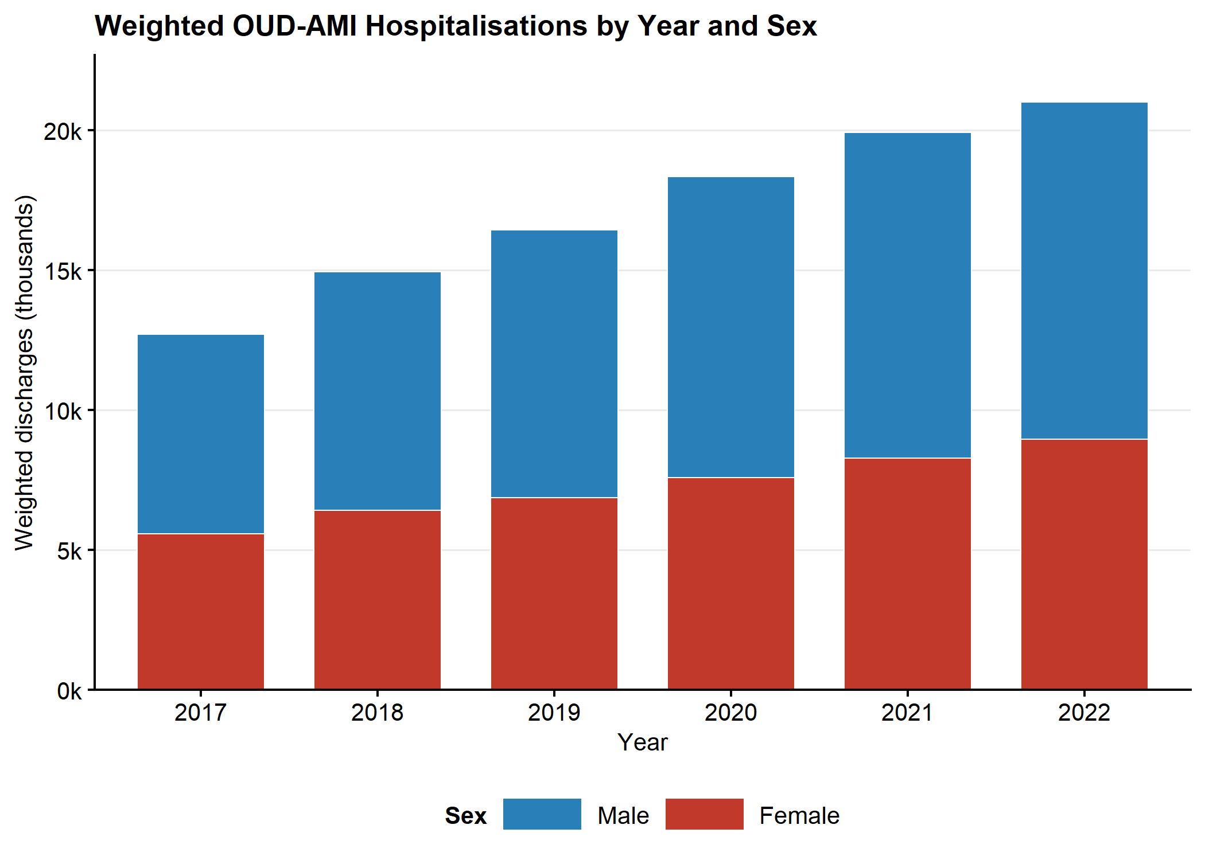

Figure 1B — Line plot: OUD prevalence among AMI by year and sex
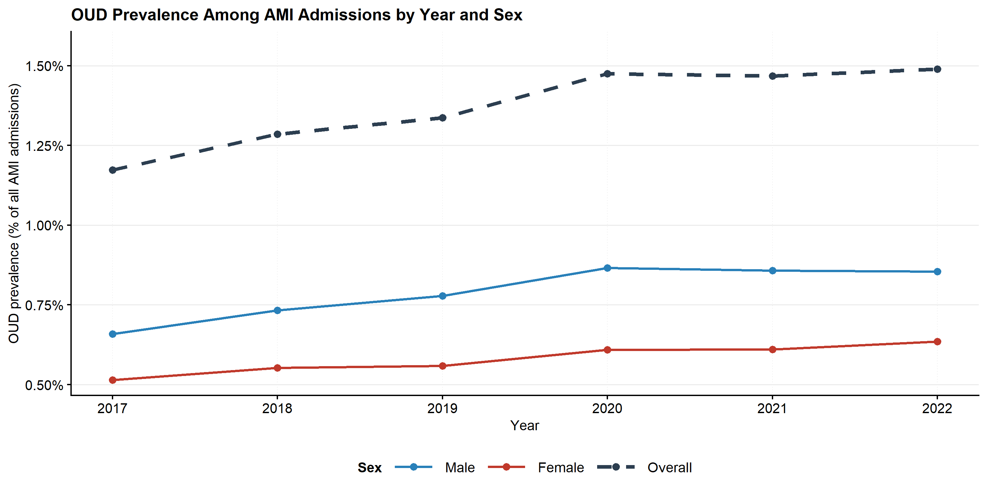

Figure 2A — Stacked bar: weighted OUD-AMI volume by year and race
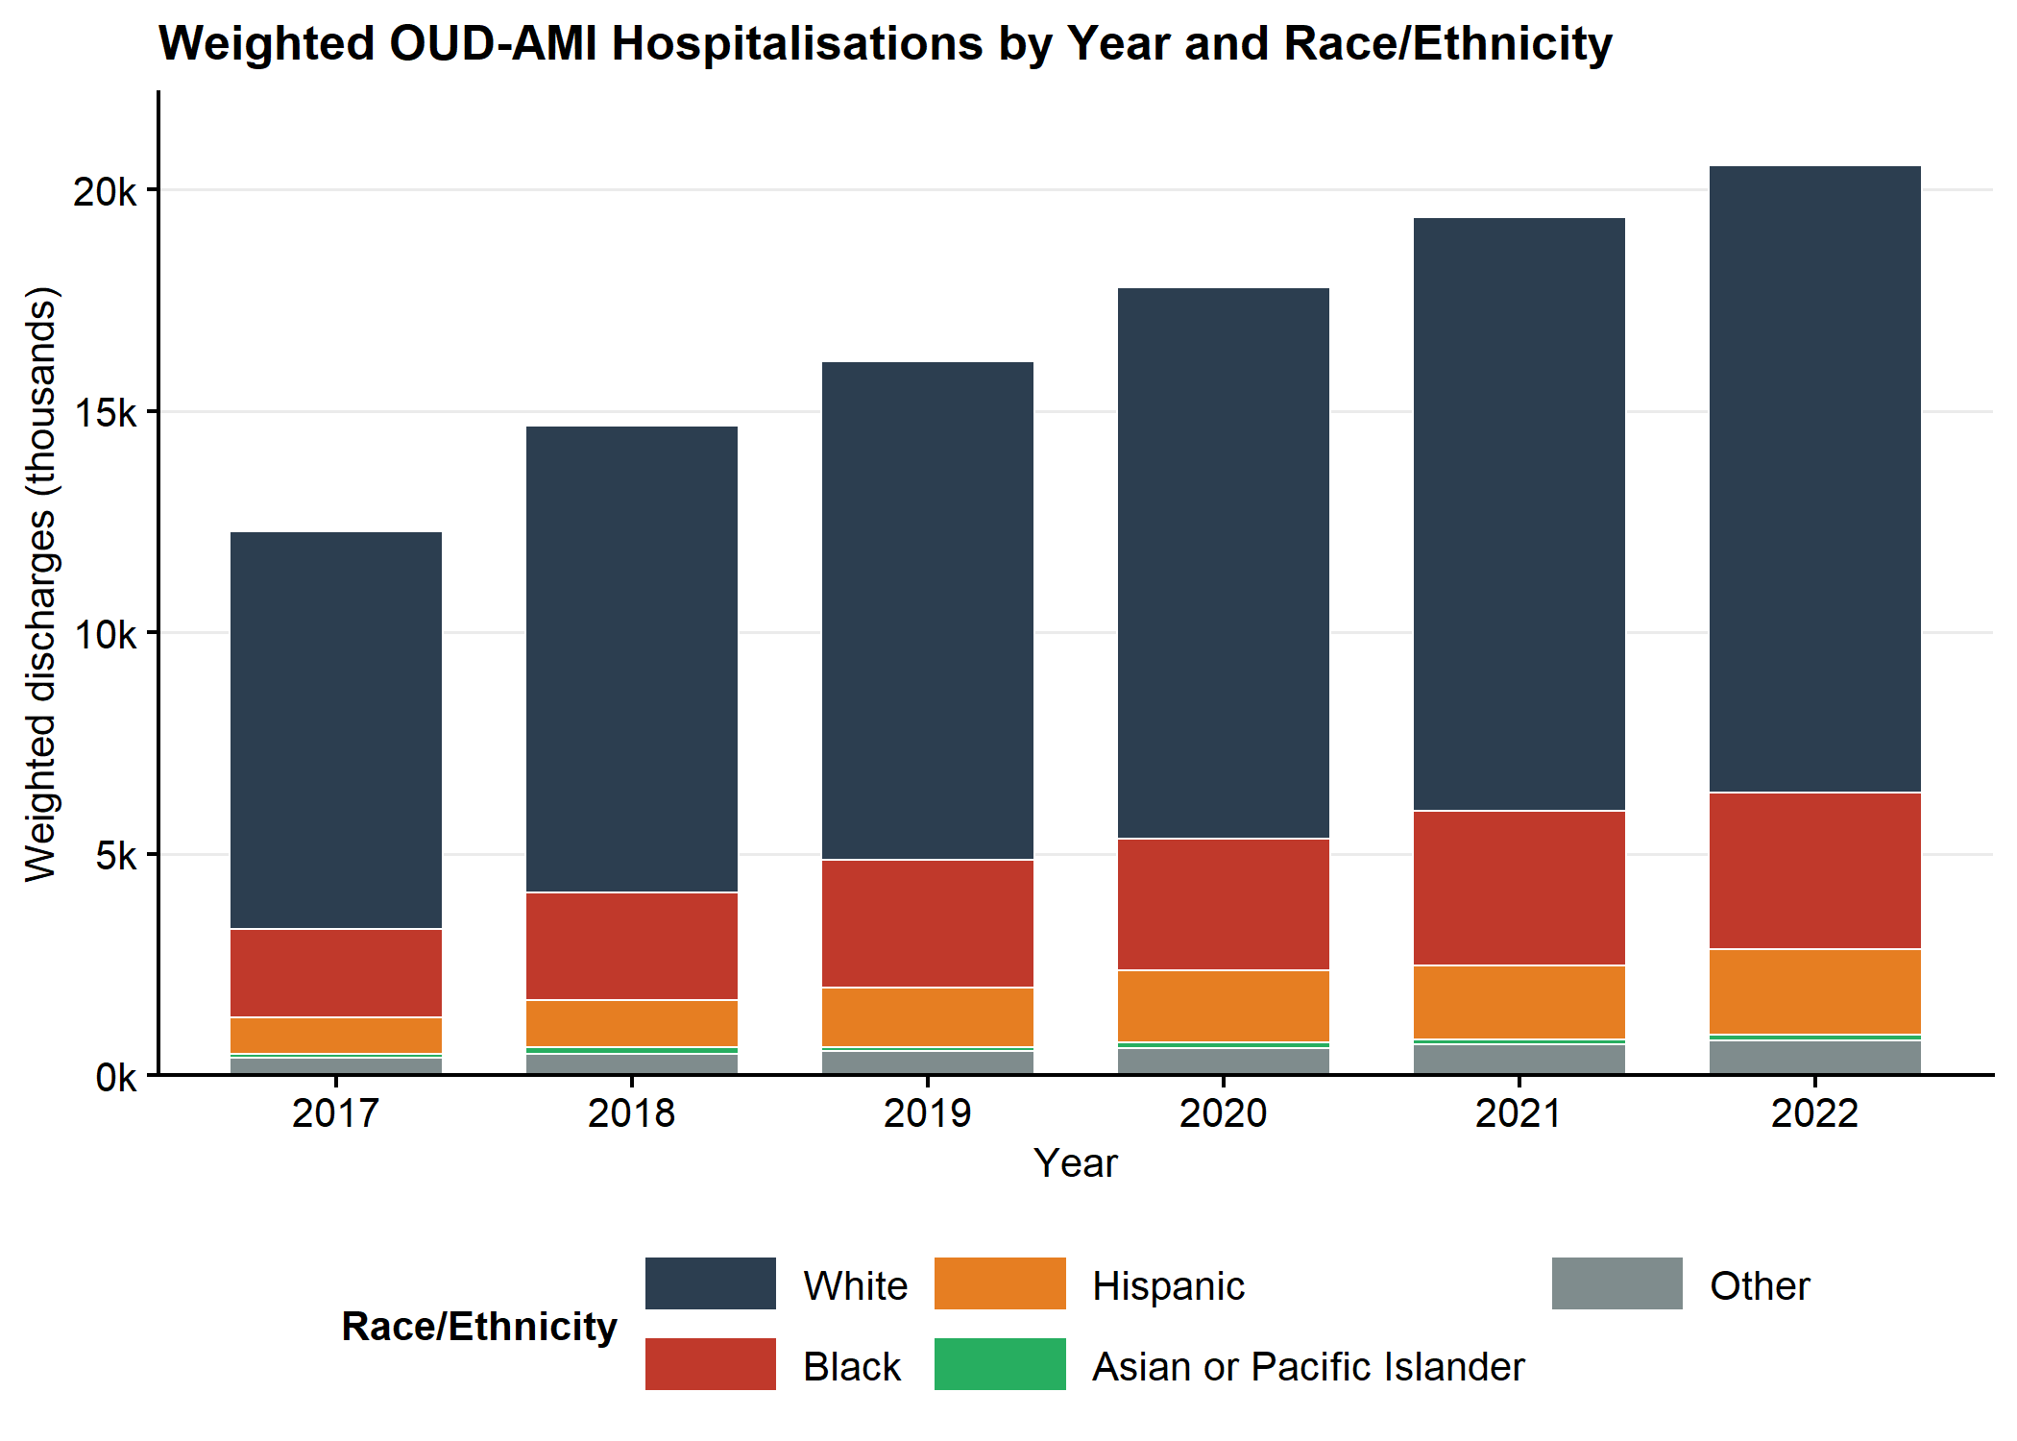

Figure 2B — Line plot: OUD prevalence among AMI by year and race
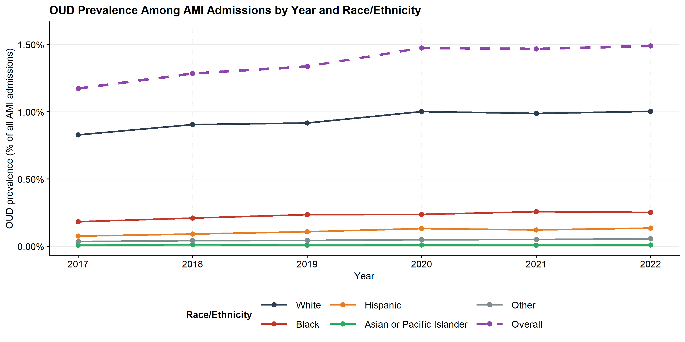

Figure 3 - Outcome trends stratified by sex (OUD patients)
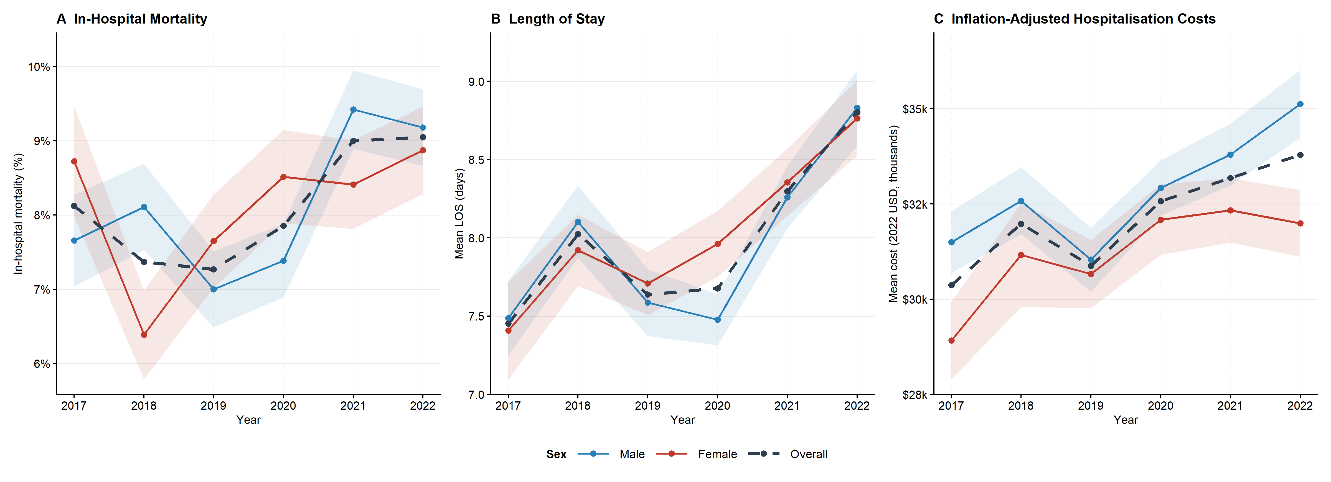

Figure 4 - Outcome trends stratified by race (OUD patients)
