**Low-Cost Microclimate Monitoring System in New York**

*IECE442: Systems Analysis and Design*

*Ryma Chowdhury, Nick Iverson, Dua Kaurejo, Shereena Thames*

**Abstract**

Weather monitoring systems have been implemented by many engineers and companies all around the world. These systems are efficient as they allow customers to receive weather information. However, a significant problem exists in the lack of a low-cost system that receives and extracts data on climate change specifically targeting microclimates. Most weather monitoring systems come with a high cost, as they perform different user-based functionality. Additionally, the existing systems have been found to output temperature and weather quality for locations within one proximity. Our weather system would bring affordability for the New York department and homeowners and will include field units located in various locations within New York to receive data. Our system will receive weather data from built-in sensors in the field unit that will keep track of air quality, perception, humidity, etc. This would prevent uncertainty due to lack of actionable data for the NY Department of Environmental Conservation as it senses specific climate behavior. Moreover, the weather data will be received and transmitted to a home unit and subsequently sent to a server that networks with the NY Department of Environmental Conservation. Overall, the low-cost monitoring system creates a more resourceful way to observe climate change without an expensive cost.

**The Problem**

1. **Problem Statement**

The New York Department of Environmental Conservation seeks to develop a cost-effective weather monitoring system to analyze the effects of climate change on microclimates in New York State.

1. **Problem Introduction**:

Climate change is causing significant issues such as increasing temperatures, unpredictable weather, and poor air quality. The UN has officially stated that the Earth is past warming, and it is now in an “era of global boiling” [1]. This is impacting our health and safety in New York. In recent months, there has been a rise in air pollution brought on by wildfires, thus monitoring microclimates within one’s proximity is crucial. This project aims to develop an affordable and accurate weather monitoring system to track these environmental effects more efficiently. By allowing the collection and analysis of weather data in real time and over more precise areas, this system will help improve our better understanding of localized climate change that can be provided to the New York Department of Environmental Conversation and home users.

**2. Inspiration**

Our design has been inspired by many existing home-weather monitoring systems currently on the market largely categorized in either traditional or more simplified systems. Traditional systems, such as Kennedy Space Center’s WX Subsystem Weather Station, feature data acquisition for weather parameters (i.e., temperature, wind speed, etc.) and are robust, with built-in power supply units, and weatherproof enclosures designed to withstand harsh environmental conditions [2]. However, these systems are costly and the expense of deploying them throughout New York State would be excessive. Furthermore, common drawbacks include occasional inaccuracies or inconsistencies in the readings, lack of internet connectivity, and complexities in setup and usage.

Simplified systems commonly available on the market provide affordability and ease of use at the expense of advanced features that traditional systems tend to have, for example, high-resolution sensors, data logging/long-term storage, advanced software interface, and durability in harsh environments. They also frequently encounter limitations including slower response times, sensor inaccuracies, and insufficient weather data coverage [3].

Our design (data acquisition subsystem) aims to bridge these gaps by developing an affordable, accurate, user-friendly, and customizable home weather monitoring data acquisition subsystem that is suitable for deployment across homes and businesses throughout New York State.

**3. System Requirements**

1. **Use Case Diagram**

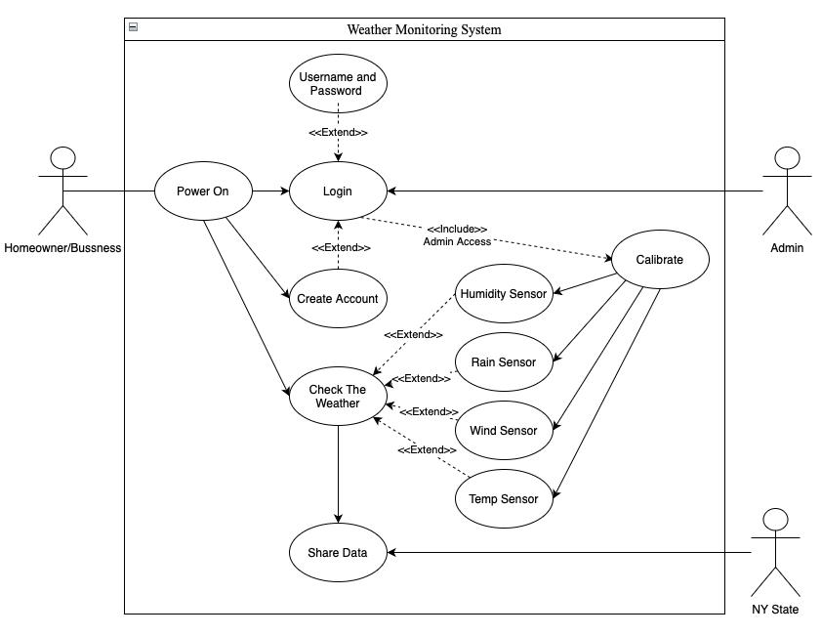

Figure 1 Use case diagram demonstrating how different users interact with the weather monitoring station.

1. **Functional Requirements**

* Accuracy: Sensors must provide accurate readings of temperature by +/- 5°C and +/- 5% RH for humidity. This requirement ensures the data collected is accurate and reliable.
* Power Efficiency: The system should minimize power use by collecting data at intervals of 15 minutes or longer. This allows the system to operate efficiently without unnecessarily draining power sources.
* Scalability: The design should allow for easy integration of additional sensors or functionality without extensive modifications, allowing the system to adapt to changing needs in the future with minimal reconfiguration/development.
* Precision: The measurements of an individual sensor across one interval should be within a minimal difference of each other. The exact values are customizable based on sensor accuracy/precision, but the software should allow for outlier measurements to be filtered. For example, in 100 samples for 1 interval (taken within a few seconds of each other), the difference should not be more than 5°C and 5%RH.

1. **Non-Functional Requirements**

* Durability: Designed to withstand weather conditions, ensuring long term operation without intervention. For initial testing, the system should be able to run for at least 5 hours (outside or near a window) without external intervention after startup.
* Portability: System should be simple to move or transport without breaking or damaging the system.
* Repeatability: The system should produce consistent and reproduceable results (accurate and reliable measurements) across multiple measurement iterations under similar environmental conditions.

1. **Design Constraints**

* Budget: The system design must have a maximum cost of 200 USD.
* Time: The project must be completed within less than one semester.
* Resources: The design will rely on components' availability, limiting choices to items in stock to avoid delays.

**4**. **System Design**

1. **Design Overview & Justification:**

Our design involves separating the home weather monitoring station into field, home, and cloud backend units which allow the system to be organized. It is simpler to understand how each part interconnects with the others and how to effectively manage the design of the system.

We briefly considered design alternatives for the overall design of the weather station. One alternative was using built-in sensors on phones (iPhone/android) to capture weather data. However, people’s phones are not consistently outside, so this would make achieving accurate and reliable data particularly challenging. Another option was to have technicians install weather stations across New York State, and while this would provide extensive coverage and ensure the stations are properly setup/calibrated, it poses many logistical challenges such as cost, resource allocation, and maintenance/support.

In the end, we settled on breaking the design into three separate units that an ordinary civilian can easily set up in their area of residence. The field unit would be installed in the civilian’s area of residence, covering some microclimate area(s). The field unit consists of sensors to collect the data, a data processing unit, a transmitter that sends data to the home unit, and a power system. The home unit would be installed in user’s place of choice and consists of a receiver to collect data from the field unit, a processer, a user interface, and Wi-Fi capabilities for communication to a cloud backend. Lastly, the cloud backend is connected to the home unit (via Wi-Fi hub) and consists of a server-database connection which researchers within NYS Department of Environmental Conservation can access.

Our design focuses on the data acquisition subsystem within the field unit (sensing circuits and data processing) and the biggest decisions we made were the data we would be collecting, the sensor(s) in use, and the microcontroller we would be using for the subsystem prototype. We chose to focus on one sensor since the I2C communication protocol makes our design scalable so users (or future iterations of this design) can incorporate in additional sensors with minimal adjustments.

We chose to measure temperature and humidity for several reasons. They are both critical indicators of climate change and can provide key insights into how climate change affects microclimates. Also, temperature and humidity sensors were widely available at low costs compared to sensors like wind speed which could be added to future designs since I2C communication is used. Additionally, for testing purposes, we needed sensors that are relatively larger in size, allowing for soldering with minimal equipment, and we found that temperature and humidity sensors met these criteria.

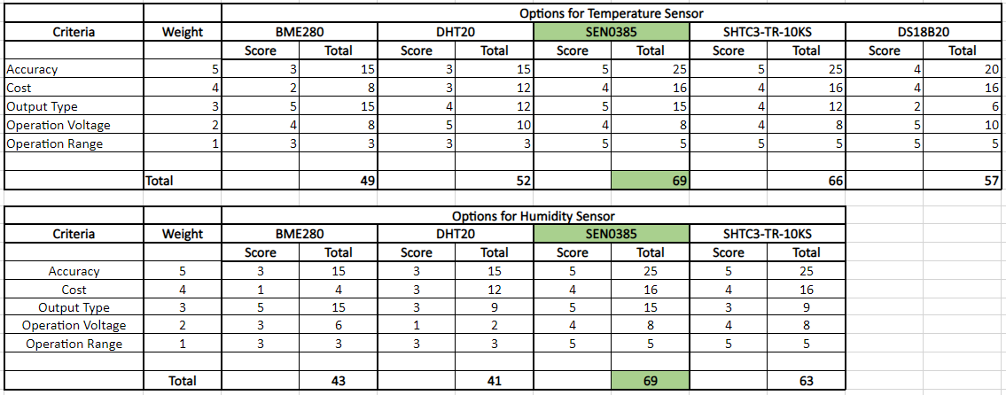

Figure 2 Decision Matrix for Sensor Selection

We conducted a detailed comparison and analysis of 5 different sensors for temperature and humidity to determine the optimal sensor for our project. Based on a decision matrix and other specifications, we selected the SEN0385 sensor. The primary reason for this choice includes its high accuracy, with a tolerance of +/- 0.2°C and +/- 2% RH. This sensor is specifically designed for outdoor environmental monitoring and is both weather and water-resistant. Additionally, the sensor communicates via I2C and is supported by the Arduino library, which gives ease of integration and use. Given these key factors, the SEN0385 sensor is the best choice for our project.

1. **Black Box Diagram**

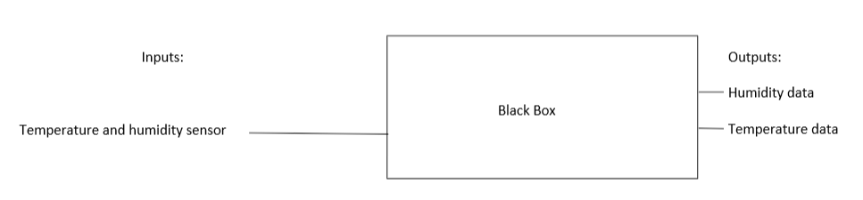

Figure 3 Black Box Diagram for Data Acquisition Subsystem

Figure 3 shows a simplified diagram of the data acquisition subsystem where weather sensors for temperature and humidity are connected to a “black box” which readily outputs to transmit data (to the home unit). The black box serves as a central processing unit where raw data is received, processed, and converted into data values that can be used by the home unit. It can involve details such as data filtering and signal processing algorithms to ensure that the data output is accurate and reliable.

1. **Logical Design**

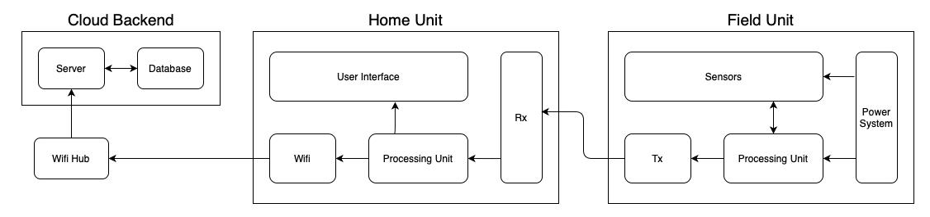

Figure 4 Logical Design diagram depicting how the complete Home Weather Monitoring System functions, with each subsystem interconnected with other subsystems to receive, process, and transmit the weather data.

The system has three parts which consist of a home unit, field unit, and cloud backend. The field unit and home unit location are chosen by the user, as the field unit has sensors to collect and transmit data. Figure 4 shows that the home unit has a receiver to collect data and other components that allow communication to the cloud backend. The cloud backend has a server-database connection that allows the NY Department of Environmental Conservation to access data.

1. **Wireframe Model**

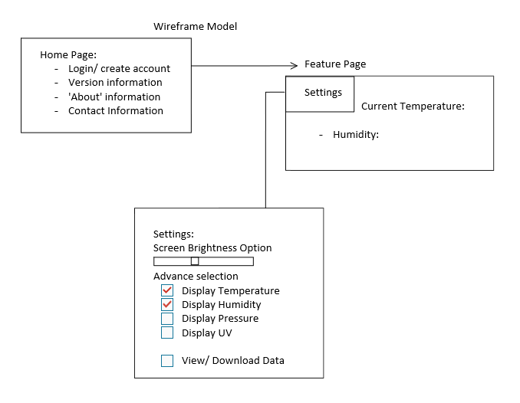

Figure 5 Wireframe Model for the user interface

The wireframe model depicts the user interface for the weather monitoring system. Users will be able to create an account and see information about the system. There are settings to let individuals decide what data they want to view displayed on the Feature Page, as seen in Figure 5.

1. **Physical Diagram**

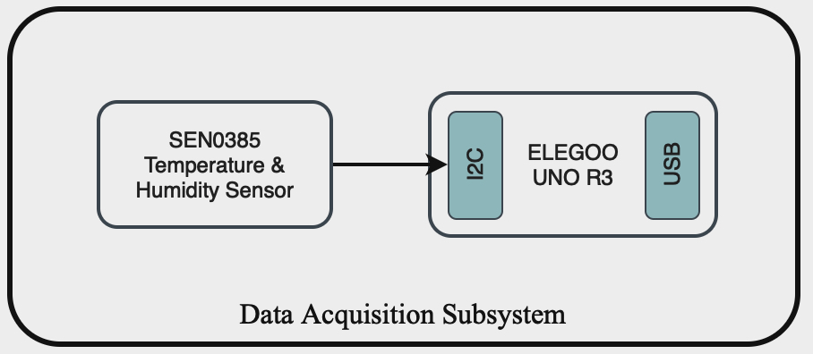

Figure 6 Physical Design Diagram

The Data Acquisition Subsystem will retrieve and process temperature and humidity data, as well as output them as digital signals. The sensors were selected using a design matrix considering sensor accuracy, cost, output type, operation voltage, and operation range. The results are shown in the physical diagram above. The SEN0385 sensor was used to measure both humidity and temperature. It is contained in a weather-proof enclosure so it can safely be used outside. The ELEGOO UNO R3 will take in the I2C signals produced by the sensor, process them, and output processed digital signals.

Our design prioritizes energy efficiency in data collection and processing by acquiring data at intervals of 15 minutes or longer with a minimum of 100 samples. It takes the average of these samples (after filtering outliers), stores it, then sleeps until the next cycle. However, it is also important to note that using different sensors may require adjustments to these constraints depending on sensor response rates. Further iterations of the design process can also consider microcontrollers that consume less power compared to ELEGOO UNO R3.

Additionally, we currently use the Arduino millis () function for timestamping data, referencing elapsed time since system startup. However, an RTC unit can be easily incorporated into the design to provide real life timestamps.

The sensor was mounted on a Printed Circuit Board (PCB) that’s connected to the microcontroller. The field unit would be outside, so an enclosure is needed to protect the microcontroller from harsh weather conditions. We added an enclosure in the implementation of our design and recommend that weatherproof material such as ABS plastic or polycarbonate, known for their durability and resistance to impact or weathering, is used to make the enclosure. These considerations will ensure that the system is durable.

Our overall design is a modular system that uses I2C communication, allowing the system to be easily configured with a large variety of sensors. For testing, the system will store the output from the microcontroller onto an SD card and data will be compared to locally available data for accuracy.

1. **Bill of Materials**

Figure 7 Bill of Materials

**5. Semester Planning**

1. **Gantt Chart**

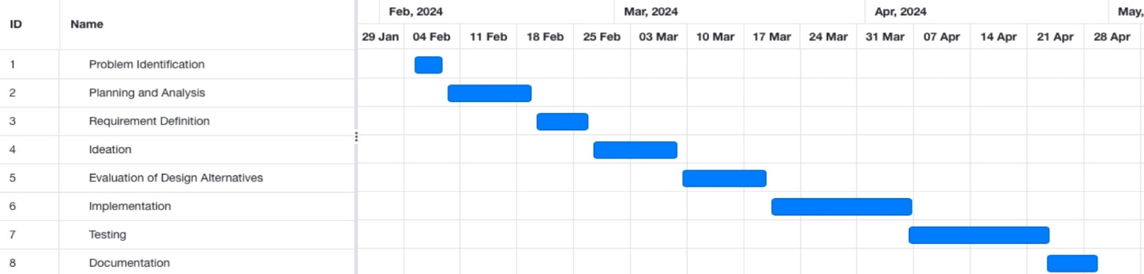

**References**

[1] “UN chief says Earth in ‘era of global boiling’, calls for radical action,” Al Jazeera, http://www.aljazeera.com/news/2023/7/27/un-chief-says-earth-in-era-of-global-boiling-calls-for-radical-action#:~:text=United%20Nations%20Secretary%2DGeneral%20Antonio (accessed Feb. 25, 2024).

[2] “WX Subsystem Weather Station,” Tech Briefs | Green Design & Manufacturing, http://www.techbriefs.com/component/content/article/26876-ksc-13291 (accessed Feb. 25, 2024).

[3] S. John, “Best home weather stations of 2024 | U.S. news,” U.S. News, https://www.usnews.com/360-reviews/technology/best-home-weather-stations (accessed Feb. 25, 2024).