CYBER GUARD
RANSOMWARE AWARENESS LAB
Final Project Report

Submitted By: ______________________________
Pin Number: ______________________________
Department: ______________________________
College Name: ______________________________
Project Guide: ______________________________
Academic Year: ______________________________

CYBER GUARD: RANSOMWARE AWARENESS LAB

Formal Project Report

Submitted As A Detailed Academic Project Report

________________________________________________________________________________

Title Page

**Project Title:** Cyber Guard: Ransomware Awareness Lab
**Project Type:** Cybersecurity Awareness and Training Web Application
**Prepared For:** Academic Project Submission / Technical Documentation
**Prepared By:** V.SANTHOSH
**Department:** Computer Science Engineering
**College Name:** SVS POLYTECHNIC
**Academic Year:** 2023-2026

________________________________________________________________________________

Certificate

This is to certify that the project entitled **Cyber Guard: Ransomware Awareness Lab** is a bonafide work carried out as part of the academic requirement for the award of the relevant degree/diploma in the field of Computer Science / Information Technology / Cybersecurity.

**Project Guide Signature:** ____________________
**Head of Department:** ____________________
**Date:** ____________________

.

________________________________________________________________________________

Acknowledgement

I express my sincere gratitude to my project guide for providing continuous guidance, valuable suggestions, and technical support throughout the development of the project Cyber Guard: Ransomware Awareness Lab. Their direction helped in shaping the structure, improving the quality, and ensuring the successful completion of this work.
I extend my heartfelt thanks to the Principal, Mr.A.Ranjith Kumar, for his encouragement and for providing a supportive academic environment to carry out this project. I also express my deep gratitude to the Head of the Department, Mrs. K. Mamatha, Department of Computer Science and Engineering, for her constant support, valuable guidance, and motivation during the course of this work.
I sincerely thank SVS Polytechnic, Hanamkonda, for providing the necessary infrastructure, resources, and academic environment that enabled the successful completion of this project.
I also thank the faculty members of the Computer Science and Engineering department for their support, suggestions, and encouragement throughout the project development.
I acknowledge the developers and communities behind modern technologies that played a crucial role in building this system, including React, TypeScript, Node.js, Express.js, Socket.IO, Firebase, and Tailwind CSS, which enabled efficient development and implementation of this application.
I would like to thank Google for providing tools and services such as Firebase and AI-based technologies that enhanced the functionality of the application.
Finally, I express my appreciation to my peers, friends, and family members for their encouragement and support, which helped in overcoming challenges and successfully completing this project.

By

V. SANTHOSH 23544-cs-004

Declaration

I hereby declare that the project report entitled “Cyber Guard: Ransomware Awareness Lab” is a genuine and original work carried out by me as part of the academic requirements for the completion of my course in Computer Science and Engineering.
This project has been developed under the guidance and supervision of the project guide, and has not been submitted previously, either in full or in part, to any other institution or university for the award of any degree or diploma.
I further declare that all the information, data, and materials presented in this report are true to the best of my knowledge. Wherever external sources, tools, or technologies have been used, proper acknowledgment and references have been provided.
I take full responsibility for the authenticity and originality of the work presented in this project report.

By

V. SANTHOSH 23544-cs-004

Abstract

Cyber Guard: Ransomware Awareness Lab is an interactive, web-based cybersecurity training platform designed to address the growing threat of ransomware attacks by transforming traditional awareness methods into practical, hands-on learning. Ransomware continues to impact organizations across sectors by encrypting critical data, disrupting operations, and demanding financial payment, often combined with data exfiltration and extortion. Existing awareness approaches are typically passive, relying on static content that fails to convey the dynamic nature of real-world cyber incidents. This project overcomes that limitation by providing a structured, simulation-driven learning environment.
The system integrates multiple functional modules, including ransomware lifecycle education, encryption concept visualization, threat simulation, malware and indicator analysis, and real-time incident response drills. Users can explore how ransomware attacks originate through phishing or malicious entry points, escalate through privilege abuse and lateral movement, and ultimately result in data encryption and operational disruption. The platform emphasizes both attacker behavior and defender response, enabling users to understand detection signals, response priorities, and mitigation strategies.
Developed using modern web technologies such as React, TypeScript, Node.js, Express.js, Socket.IO, and Firebase, the application ensures scalability, responsiveness, and real-time interaction. The inclusion of a malware analyzer supports inspection of URLs, domains, IP addresses, and file hashes using pattern recognition and external threat intelligence sources such as Abuse.ch MalwareBazaar. Additionally, the system incorporates AI-assisted analysis using Google GenAI to enhance threat interpretation.
A key feature of the platform is its safe-simulation architecture. All ransomware behaviors, including file encryption, ransom note generation, and attack progression, are purely visual and non-destructive. This ensures that users gain realistic exposure to cyber threats without any risk to actual systems or data. The live lab module further enhances engagement by simulating real-time attack scenarios where users can act as defenders, observe system telemetry, and practice containment strategies under time-based conditions.
The platform supports both authenticated access through Google sign-in and a demo mode for offline or academic demonstrations, improving accessibility and usability. Its modular design, intuitive interface, and cybersecurity-focused visual elements make it suitable for classroom learning, project demonstrations, and awareness training sessions.
In conclusion, Cyber Guard: Ransomware Awareness Lab bridges the gap between theoretical cybersecurity education and practical understanding by providing a comprehensive, interactive, and safe learning environment. It equips users with the knowledge and skills required to recognize, analyze, and respond effectively to ransomware threats in real-world scenarios.

________________________________________________________________________________

Table Of Contents

Acknowledgemnt
Abstract
- Introduction
- Problem Statement
- Objectives
- Scope Of The Project
- Literature And Conceptual Background
- Existing System And Proposed System
- System Architecture
- Technology Stack
- Module Description
- User Workflow
- Authentication And Access Design
- Interface And Visual Design
- Safety And Ethical Considerations
- Testing And Verification
- Challenges Faced
- Results And Outcomes
- Limitations
- Future Enhancements
- Visual Evidence Appendix
- Code Appendix
- This project uses these main tools and technologies
- References
- Conclusion

________________________________________________________________________________

1. Introduction

Ransomware is one of the most serious cyber threats in the modern digital environment. It affects educational institutions, hospitals, businesses, government offices, and individuals by encrypting or blocking access to important data and systems. In many modern incidents, attackers also steal sensitive files, disable backups, and create financial and reputational pressure to force payment.

The aim of this project is to create an educational and interactive web platform where users can learn ransomware concepts, analyze suspicious indicators, observe safe simulations, and practice defender response in a controlled environment. Cyber Guard: Ransomware Awareness Lab is built as a practical learning system rather than a static content website.

________________________________________________________________________________

2. Problem Statement

Most ransomware awareness resources are either:
- too theoretical and passive
- too limited to basic awareness posters and presentations
- too dangerous if they simulate offensive behavior carelessly

Because of this, learners often fail to connect definitions with real-world warning signs and response priorities. There is a need for a web platform that can teach ransomware concepts in a realistic but safe way.

This project addresses that need by building a secure, interactive, and educational ransomware learning environment.

________________________________________________________________________________

3. Objectives

The objectives of the project are:
- To design and develop a ransomware awareness web application.
- To provide detailed educational content explaining ransomware attacks and business impact.
- To implement safe ransomware simulation without any destructive capability.
- To provide an analyzer for suspicious URLs, domains, IPs, hashes, and files.
- To implement a live training lab for simulated incident response.
- To support both demo-mode access and authenticated access.
- To make the system suitable for academic presentation and practical awareness sessions.

________________________________________________________________________________

4. Scope Of The Project

Included Scope

- awareness website
- ransomware lifecycle explanation
- malware analyzer
- threat simulator
- live incident drill
- defense guidance
- theme customization
- local and tunnel-based demo support

Excluded Scope

- real malware execution
- real peer attacking
- destructive local file changes
- offensive exploitation tools
- real unauthorized access workflows
________________________________________________________________________________

5. Literature And Conceptual Background

Ransomware awareness requires understanding several linked concepts:

- phishing as an initial access vector
- privilege escalation and lateral movement
- data exfiltration before encryption
- cryptographic locking of files
- extortion pressure through ransom notes and downtime
- business continuity and backup recovery

This project integrates those concepts into separate but connected modules so users can learn both the theory and the practical meaning of a ransomware incident.

________________________________________________________________________________

6. Existing System And Proposed System

Existing System

Traditional awareness systems usually provide:

- static text explanation
- slideshow or PDF-based learning
- limited engagement
- no practical analysis tools
- no interactive incident workflow

Proposed System

The proposed Cyber Guard platform offers:

- modular ransomware education
- safe simulation and visual training
- malware and indicator analysis
- real-time live drill environment
- login or demo usage
- theme customization and better presentation readiness

________________________________________________________________________________

7. System Architecture

7.1 High-Level Architecture

[mermaid]
flowchart LR
U["User"] --> FE["React Frontend"]
FE --> AU["Firebase Authentication"]
FE --> BE["Node + Express Server"]
FE --> TI["Indicator Analysis Logic"]
AU --> FS["Firestore"]
BE --> RT["Socket.IO Realtime Layer"]
BE --> MB["MalwareBazaar Lookup"]

7.2 Module Architecture

[mermaid]
flowchart TD
APP["Cyber Guard"] --> DASH["Dashboard"]
APP --> ABOUT["About Ransomware"]
APP --> LAB["Encryption Lab"]
APP --> SIM["Threat Simulator"]
APP --> LIVE["Live Lab"]
APP --> ANALYZER["Malware Analyzer"]
APP --> DEF["Defense Center"]

7.3 Runtime Flow

[mermaid]
sequenceDiagram
participant User
participant Frontend
participant Auth
participant Server
participant External
User->>Frontend: Open application
Frontend->>Auth: Check login or demo session
Auth-->>Frontend: User or demo operator
User->>Frontend: Select module
alt Analyzer
Frontend->>External: Lookup / inspect indicator
External-->>Frontend: Risk or intelligence result
else Live Lab
Frontend->>Server: Join room
Server-->>Frontend: Realtime drill events
else Simulator
Frontend-->>User: Visual ransomware simulation
end

________________________________________________________________________________

8. Technology Stack

| Category | Tools / Technologies |
|---|---|
| Frontend | React 19, TypeScript, Vite |
| Styling | Tailwind CSS v4, custom CSS variables |
| Backend | Node.js, Express |
| Realtime | Socket.IO |
| Authentication | Firebase Authentication |
| Database | Firestore |
| Analysis Support | Google GenAI integration, Safe Browsing logic, MalwareBazaar |
| Deployment | Localhost, ngrok, Cloud Run ready setup |
________________________________________________________________________________

9. Module Description

9.1 Dashboard

The dashboard provides the main navigation surface and introduces the platform as a ransomware defense and awareness tool.

9.2 About Ransomware

This module explains ransomware, attack stages, operational impact, and includes a visual walkthrough of a ransomware incident.

9.3 Encryption Lab

This module explains how ransomware uses encryption to make data inaccessible and why recovery becomes difficult without clean backups or decryption keys.

9.4 Threat Simulator

This module visually simulates file encryption behavior, ransomware logging, ransom note generation, and the impact of different attacker profiles in a safe environment.

9.5 Live Lab

This module simulates a real-time ransomware drill using controller and defender roles, scenario progression, compromise visuals, alerts, telemetry, and containment scoring.

9.6 Malware Analyzer

This module inspects suspicious indicators such as URLs, domains, IP addresses, file hashes, and uploaded files. It highlights suspicious patterns and performs malware-oriented checks.

9.7 Defense Center

This module presents defense strategy, incident response guidance, and best practices for prevention, detection, and recovery.

________________________________________________________________________________

10. User Workflow

The expected user interaction sequence is:

- User opens the application.
- User signs in with Google or uses demo mode.
- User accesses the dashboard.
- User selects a learning or training module.
- User studies concepts or performs analysis.
- User explores simulations or live drills.
- User observes results and response outcomes.

________________________________________________________________________________

11. Authentication And Access Design

The system supports:

11.1 Google Sign-In

Used for authenticated access through Firebase Authentication.

11.2 Demo Mode

Used for local demonstration and preview when Firebase login is not required.

This dual-mode access improves presentation flexibility and development convenience.

________________________________________________________________________________

12. Interface And Visual Design

The interface is designed around clarity, modularity, and cybersecurity-themed emphasis. The project uses:

- strong section headers
- dashboard cards
- training overlays
- warning colors for incident pressure
- a theme toggle for white/light and black/dark customization

This allows the application to function both as a learning tool and as a polished presentation system.

________________________________________________________________________________

13. Safety And Ethical Considerations

The project follows a strict safe-simulation model. It avoids:

- real attack functionality
- destructive host actions
- real system compromise
- peer targeting

All compromise effects are visual, educational, and controlled. This makes the system appropriate for academic and awareness use.

________________________________________________________________________________

14. Testing And Verification

The project has been tested through:

- build verification using `npm.cmd run build`
- type checking using `npm.cmd run lint`
- localhost execution
- browser rendering checks
- process cleanup and restart validation
- sign-in flow handling
- UI module checks

________________________________________________________________________________

15. Challenges Faced

Major challenges included:

- Firebase localhost sign-in restrictions
- stale old page assets and wrong app shell restoration
- CSS mismatch causing white-screen render issues
- balancing realism and safety in the live lab
- browser cache and stale localhost process conflicts

________________________________________________________________________________

16. Results And Outcomes

The final application successfully delivers:

- a detailed ransomware awareness website
- interactive learning modules
- indicator inspection functionality
- safe ransomware simulation
- real-time training drills
- theme customization
- a project-ready presentation structure

________________________________________________________________________________

17. Limitations

Current limitations include:

- Google sign-in requires Firebase console domain setup
- some intelligence checks depend on external APIs
- the platform is educational, not a forensic or enterprise response product
- live lab realism is visual and training-based rather than operational

________________________________________________________________________________

18. Future Enhancements

Potential improvements include:

- PDF export of reports
- automated screenshot capture
- instructor dashboards
- richer drill branching
- performance optimization through code splitting
- formal printable report generation from the app itself

_______________________________________________________________________________

19. Visual Evidence Appendix

19.1 Architecture Visual

Use the Mermaid diagrams in this report as architecture visuals for the final document.

19.2 Screenshot Slots

The workspace currently does not contain screenshot image files to embed directly. Add screenshots in the following places for final submission:
- Login page with theme toggle
- Dashboard overview
- About Ransomware page
- Malware Analyzer results page
- Threat Simulator ransom note
- Live Lab compromise drill
- Defense Center page

19.3 Suggested Markdown Image Format

When screenshot files are available, add them like this:

[md]
![Dashboard Screenshot](./report-assets/dashboard.png)
![Malware Analyzer Screenshot](./report-assets/malware-analyzer.png)
![Live Lab Screenshot](./report-assets/live-lab.png)

________________________________________________________________________________

Final Project Identity

- **Project Name:** Cyber Guard: Ransomware Awareness Lab
- **Project Category:** Cybersecurity Awareness and Training
- **Project Nature:** Safe educational web application
- **Primary Focus:** Ransomware awareness, analysis, simulation, and defender training

________________________________________________________________________________

Visual Evidence
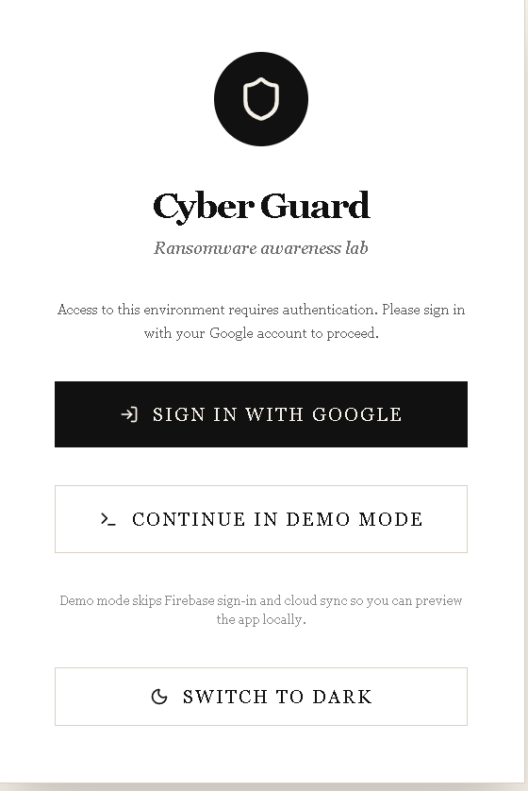
Figure 1. Login page with Google sign-in, demo mode, and theme toggle.

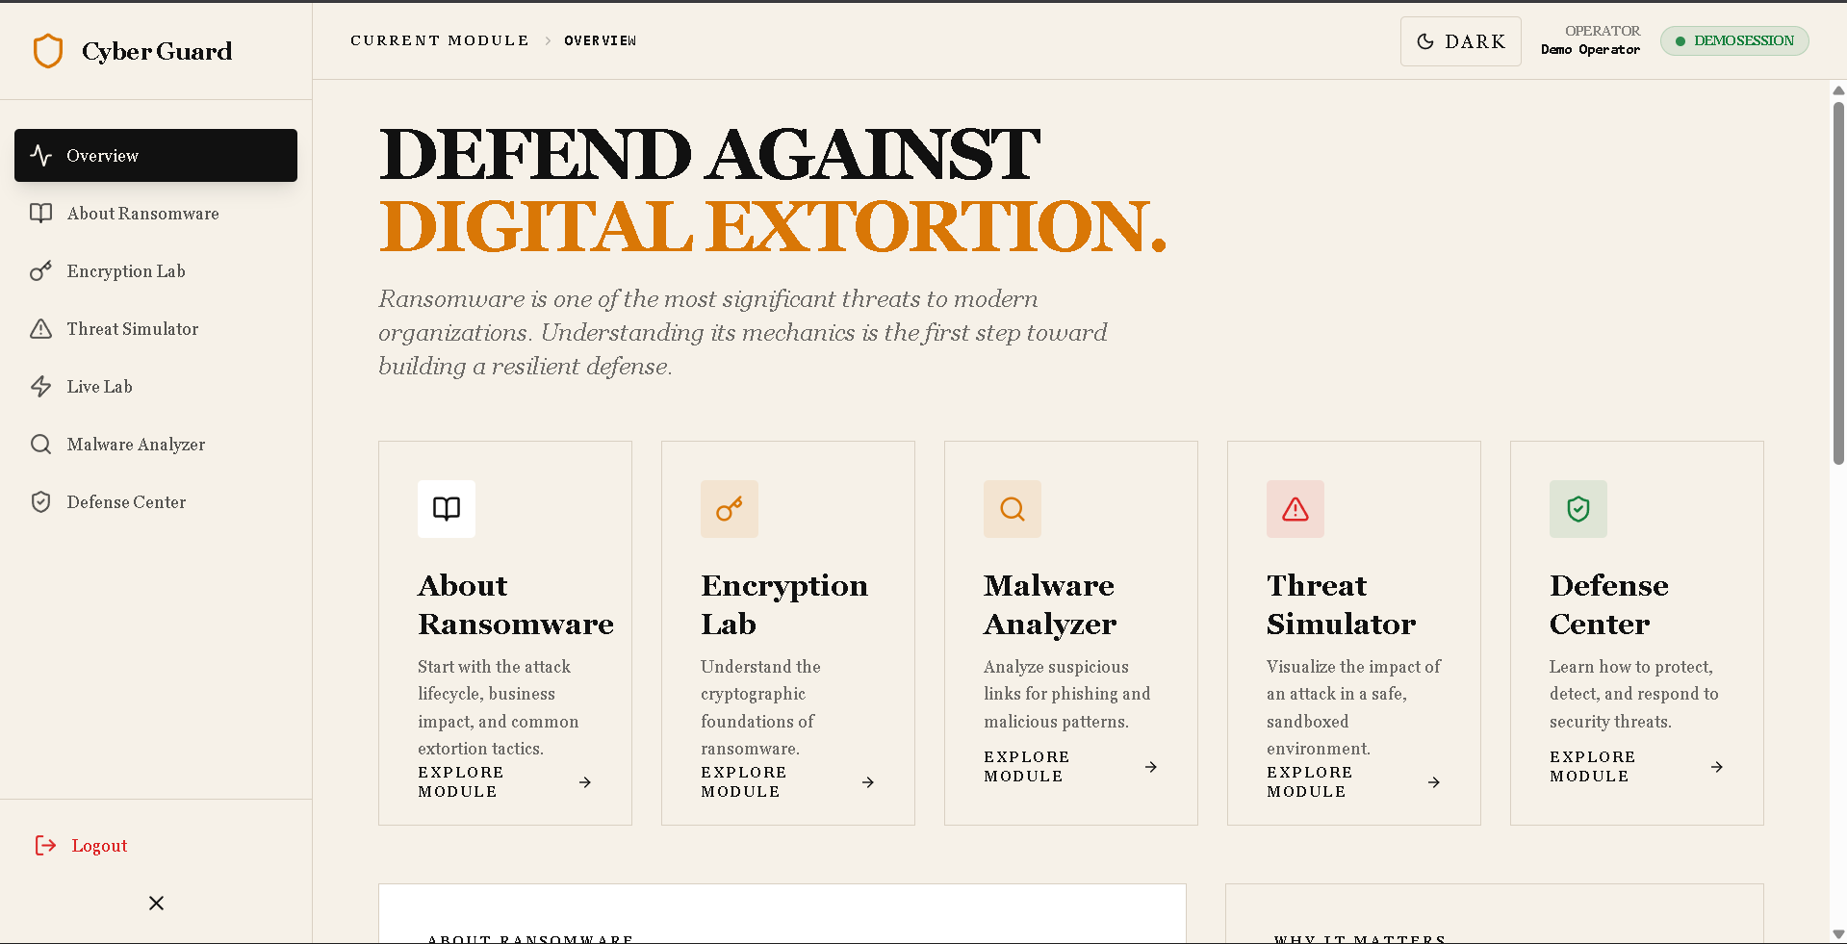
Figure 2. Dashboard overview showing the main modules of Cyber Guard.

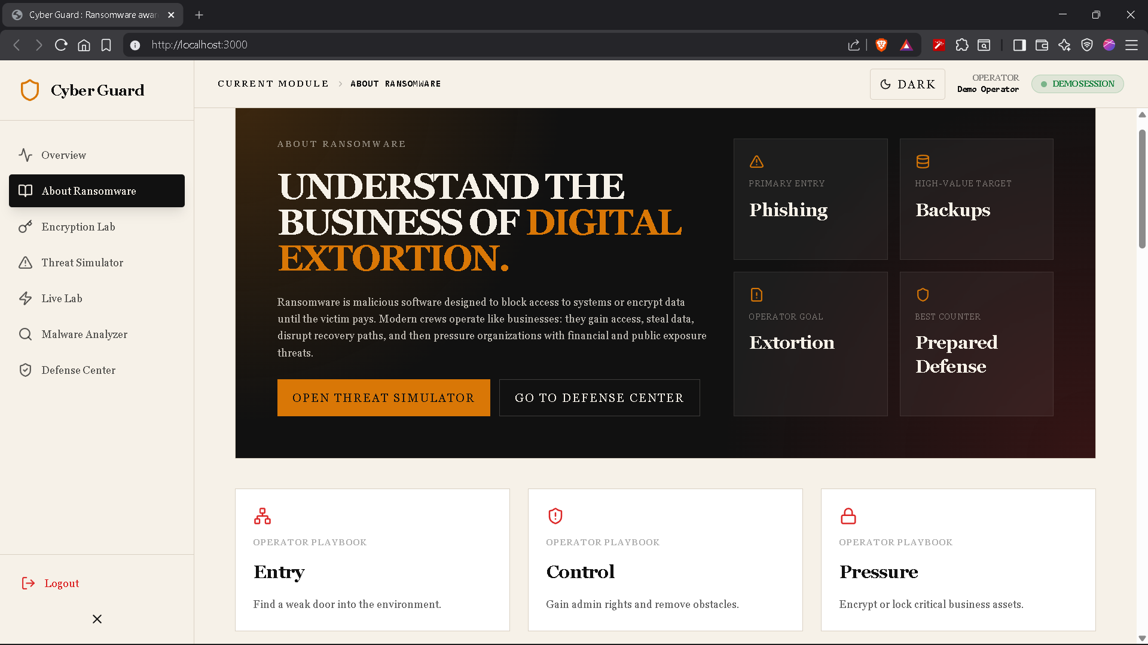
Figure 3. About Ransomware module with business-of-extortion overview.

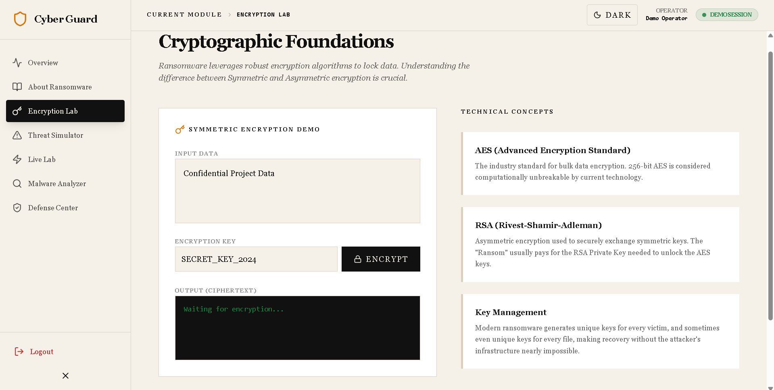
Figure 4. Encryption Lab showing the cryptographic learning interface.

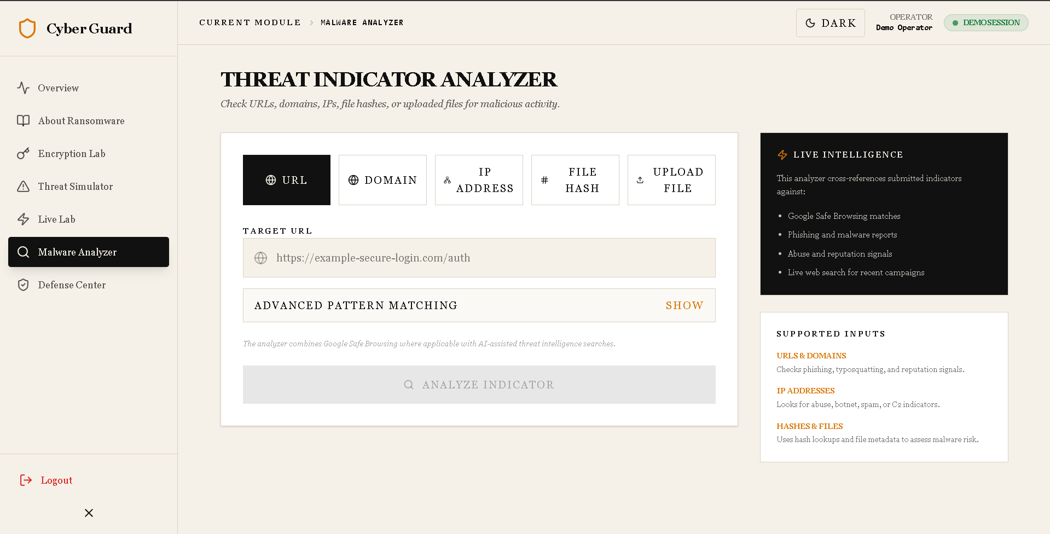
Figure 5. Malware Analyzer interface for suspicious indicator analysis.

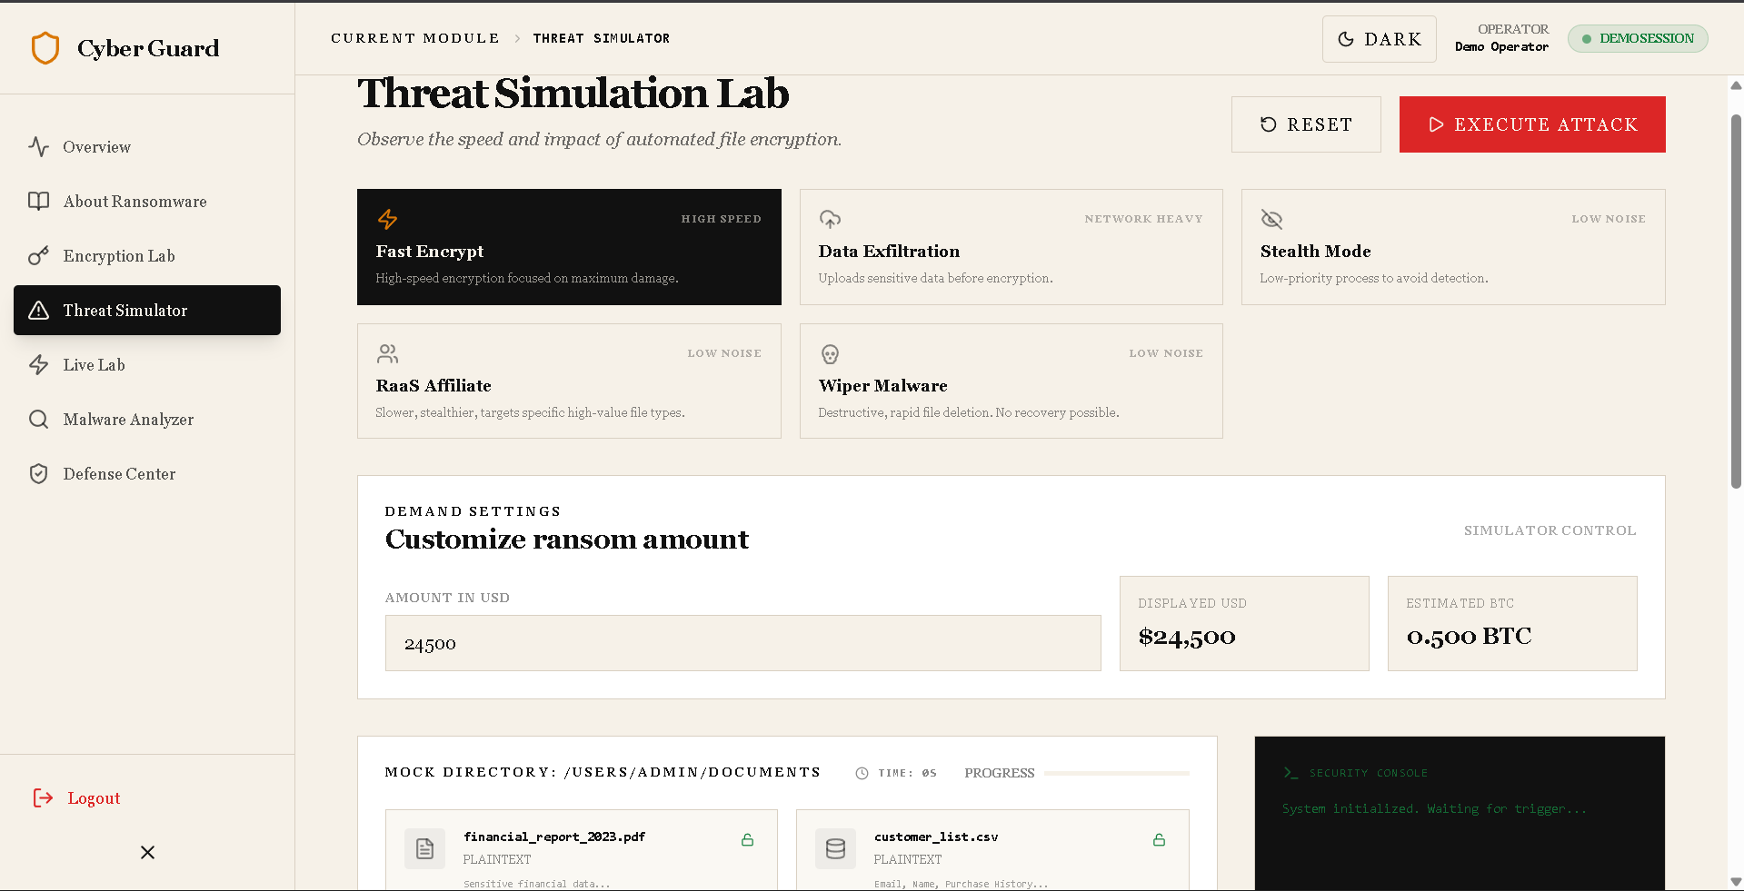
Figure 6. Threat Simulator with attack profiles and ransom amount customization.

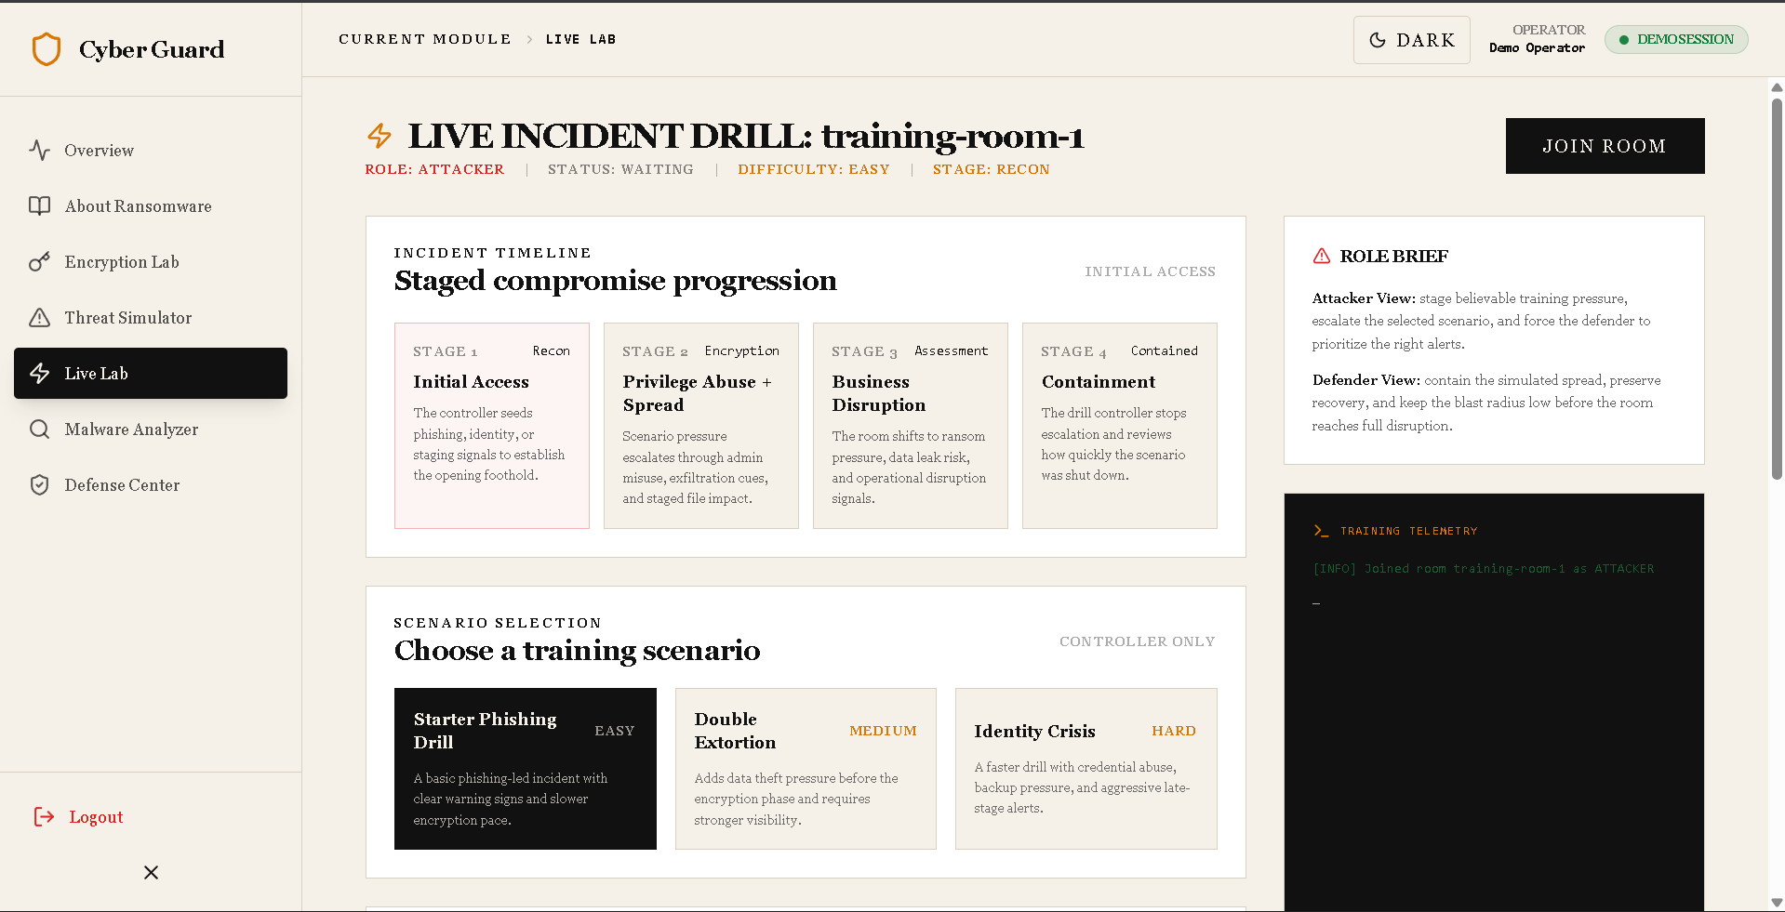
Figure 7. Live Lab showing staged compromise progression and training telemetry.

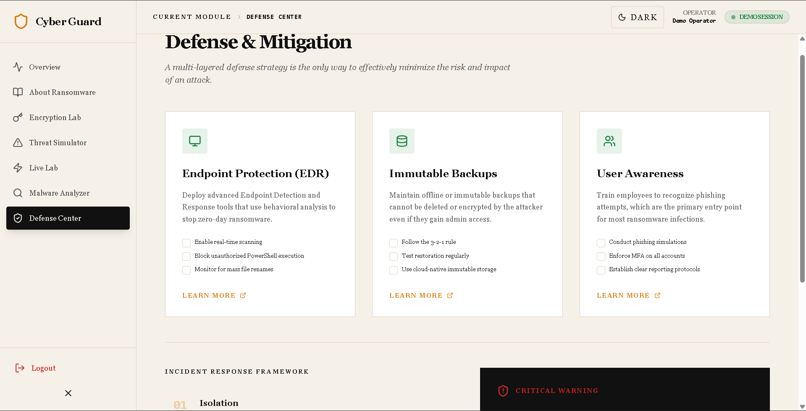
Figure 8. Defense Center presenting mitigation and response guidance.

________________________________________________________________________________

20.Code Appendix

20.1 Appendix A. Main Application Shell

File: C:\CyberGuard\ransomware-awareness-lab\src\App.tsx
This code shows the overall application shell, navigation, authentication-aware entry flow, and theme toggle.
import React, { useEffect, useState } from 'react';
import {
Shield,
Terminal,
Activity,
AlertTriangle,
BookOpen,
ShieldCheck,
Menu,
X,
ChevronRight,
Key,
LogOut,
LogIn,
Zap,
Search,
Sun,
Moon,
} from 'lucide-react';
import { motion, AnimatePresence } from 'motion/react';
import { View } from './types';
import { FirebaseProvider, useFirebase } from './components/FirebaseProvider';
import { signInWithGoogle, logout, startDemoSession, isGuestUser } from './firebase';
import Dashboard from './components/Dashboard';
import AboutRansomware from './components/AboutRansomware';
import EncryptionLab from './components/EncryptionLab';
import DefenseCenter from './components/DefenseCenter';
import Simulator from './components/Simulator';
import LiveLab from './components/LiveLab';
import PhishingAnalyzer from './components/PhishingAnalyzer';
function AppContent() {
const { user, loading } = useFirebase();
const [currentView, setCurrentView] = useState<View>('dashboard');
const [isSidebarOpen, setIsSidebarOpen] = useState(true);
const [authError, setAuthError] = useState<string | null>(null);
const [theme, setTheme] = useState<'light' | 'dark'>(() => {
if (typeof window === 'undefined') {
return 'light';
}
const storedTheme = window.localStorage.getItem('cyberguard-theme');
return storedTheme === 'dark' ? 'dark' : 'light';
});
useEffect(() => {
document.documentElement.dataset.theme = theme;
window.localStorage.setItem('cyberguard-theme', theme);
}, [theme]);
const navItems = [
{ id: 'dashboard', label: 'Overview', icon: Activity },
{ id: 'about', label: 'About Ransomware', icon: BookOpen },
{ id: 'lab', label: 'Encryption Lab', icon: Key },
{ id: 'simulator', label: 'Threat Simulator', icon: AlertTriangle },
{ id: 'livelab', label: 'Live Lab', icon: Zap },
{ id: 'phishing', label: 'Malware Analyzer', icon: Search },
{ id: 'defense', label: 'Defense Center', icon: ShieldCheck },
];
if (loading) {
return (
<div className="h-screen w-screen flex items-center justify-center bg-bg">
<div className="flex flex-col items-center gap-4">
<Shield className="w-12 h-12 text-accent animate-pulse" />
<span className="col-header">Initializing Secure Environment...</span>
</div>
</div>
);
}
if (!user) {
return (
<div className="h-screen w-screen flex items-center justify-center bg-bg p-6">
<motion.div
initial={{ opacity: 0, scale: 0.95 }}
animate={{ opacity: 1, scale: 1 }}
className="max-w-md w-full p-12 border border-line bg-white space-y-8 text-center shadow-2xl"
>
<div className="flex justify-center">
<div className="w-20 h-20 bg-ink text-bg flex items-center justify-center rounded-full">
<Shield className="w-10 h-10" />
</div>
</div>
<div className="space-y-2">
<h1 className="text-3xl font-bold tracking-tighter">Cyber Guard</h1>
<p className="text-sm text-ink/60 font-serif italic">Ransomware awareness lab</p>
</div>
<p className="text-xs leading-relaxed opacity-70">
Access to this environment requires authentication. Please sign in with your Google account to proceed.
</p>
{authError && (
<div className="border border-danger/20 bg-danger/5 p-3 text-left text-xs text-danger">
{authError}
</div>
)}
<button
onClick={async () => {
setAuthError(null);
try {
await signInWithGoogle();
} catch (error) {
const message = error instanceof Error ? error.message : 'Google sign-in failed.';
setAuthError(`Google sign-in failed. ${message}`);
}
}}
className="w-full py-4 bg-ink text-bg font-bold text-xs uppercase tracking-widest flex items-center justify-center gap-3 hover:opacity-90 transition-all"
>
<LogIn className="w-4 h-4" /> Sign In with Google
</button>
<button
onClick={() => {
setAuthError(null);
startDemoSession();
window.location.reload();
}}
className="w-full py-4 border border-line font-bold text-xs uppercase tracking-widest flex items-center justify-center gap-3 hover:bg-ink hover:text-bg transition-all"
>
<Terminal className="w-4 h-4" /> Continue in Demo Mode

20.2 Appendix B. Backend Server And Hash Lookup API
File: C:\CyberGuard\ransomware-awareness-lab\server.ts
This code shows the Express server, MalwareBazaar hash lookup endpoint, and Socket.IO drill room handling.
import 'dotenv/config';
import express from 'express';
import { createServer } from 'http';
import { Server } from 'socket.io';
import { createServer as createViteServer } from 'vite';
import path from 'path';
async function startServer() {
const app = express();
const httpServer = createServer(app);
const io = new Server(httpServer, {
cors: {
origin: "*",
methods: ["GET", "POST"]
}
});
const PORT = Number(process.env.PORT || 3000);
const MALWAREBAZAAR_API_URL = 'https://mb-api.abuse.ch/api/v1/';
app.use(express.json());
app.post('/api/hash-lookup', async (req, res) => {
const hash = String(req.body?.hash || '').trim().toLowerCase();
const authKey = process.env.MALWAREBAZAAR_AUTH_KEY;
if (!hash) {
res.status(400).json({ error: 'Missing hash.' });
return;
}
if (!/^[a-f0-9]{32}$|^[a-f0-9]{40}$|^[a-f0-9]{64}$/.test(hash)) {
res.status(400).json({ error: 'Invalid hash. Expected MD5, SHA-1, or SHA-256.' });
return;
}
if (!authKey) {
res.status(503).json({
error: 'Malware database lookup is not configured.',
code: 'missing_auth_key',
});
return;
}
try {
const payload = new URLSearchParams({
query: 'get_info',
hash,
});
const response = await fetch(MALWAREBAZAAR_API_URL, {
method: 'POST',
headers: {
'Auth-Key': authKey,
'Content-Type': 'application/x-www-form-urlencoded',
},
body: payload.toString(),
});
if (!response.ok) {
res.status(502).json({ error: 'Malware database lookup failed upstream.' });
return;
}
const data = await response.json() as {
query_status?: string;
data?: Array<{
sha256_hash?: string;
sha3_384_hash?: string;
md5_hash?: string;
sha1_hash?: string;
file_name?: string;
file_type?: string;
file_size?: number;
signature?: string;
first_seen?: string;
last_seen?: string;
tags?: string[];
intelligence?: { uploads?: number; mail?: Record<string, unknown> };
vendor_intel?: Record<string, unknown>;
}>;
};
if (data.query_status === 'ok' && data.data?.[0]) {
const match = data.data[0];
res.json({
found: true,
source: 'MalwareBazaar',
match: {
sha256: match.sha256_hash || null,
sha1: match.sha1_hash || null,
md5: match.md5_hash || null,
fileName: match.file_name || null,
fileType: match.file_type || null,
fileSize: match.file_size || null,
signature: match.signature || null,
firstSeen: match.first_seen || null,
lastSeen: match.last_seen || null,
tags: match.tags || [],
},
});
return;
}
if (data.query_status === 'hash_not_found') {
res.json({
found: false,
source: 'MalwareBazaar',
});
return;
}
res.status(502).json({
error: 'Unexpected malware database response.',
code: data.query_status || 'unknown_response',
});
} catch (error) {
console.error('Hash lookup failed:', error);
res.status(502).json({ error: 'Hash lookup failed.' });
}
});
// Real-time Simulation Rooms
const rooms = new Map<string, {
attackerId: string | null;
defenderId: string | null;
status: 'waiting' | 'ready' | 'attacking' | 'finished';
files: any[];
}>();
io.on('connection', (socket) => {
console.log('User connected:', socket.id);
socket.on('join-room', (roomId: string, role: 'attacker' | 'defender') => {
socket.join(roomId);
if (!rooms.has(roomId)) {
rooms.set(roomId, {
attackerId: null,
defenderId: null,
status: 'waiting',
files: []
});
}
const room = rooms.get(roomId)!;
if (role === 'attacker') room.attackerId = socket.id;
if (role === 'defender') room.defenderId = socket.id;
if (room.attackerId && room.defenderId) {
room.status = 'ready';
}
io.to(roomId).emit('room-update', room);
console.log(`User ${socket.id} joined room ${roomId} as ${role}`);
});
socket.on('start-attack', (roomId: string) => {
const room = rooms.get(roomId);
if (room) {
room.status = 'attacking';
io.to(roomId).emit('attack-started');
io.to(roomId).emit('room-update', room);
}
});
socket.on('file-encrypted', (roomId: string, fileId: string) => {
io.to(roomId).emit('file-status-update', { fileId, status: 'encrypted' });
});
socket.on('broadcast-drill-event', (roomId: string, event: { level: string; message: string }) => {
io.to(roomId).emit('drill-event', {
by: socket.id,
level: event.level,
message: event.message,
});
});
socket.on('contain-attack', (roomId: string) => {
const room = rooms.get(roomId);

20.3 Appendix C. Malware Analyzer Logic

File: C:\CyberGuard\ransomware-awareness-lab\src\components\PhishingAnalyzer.tsx
This code shows indicator types, suspicious component inspection, regex matching, and fallback analysis logic.
import React, { useMemo, useState } from 'react';
import {
Search,
Globe,
ShieldAlert,
ShieldCheck,
AlertCircle,
CheckCircle2,
XCircle,
Loader2,
Zap,
Hash,
Upload,
FileText,
Network,
} from 'lucide-react';
import { motion, AnimatePresence } from 'motion/react';
import { GoogleGenAI } from '@google/genai';
type IndicatorType = 'url' | 'domain' | 'ip' | 'hash' | 'file';
interface AnalysisResult {
isPhishing: boolean;
riskScore: number;
threats: string[];
recommendations: string[];
details: string;
}
interface SuspiciousComponent {
label: string;
value: string;
reason: string;
}
interface VisualInspection {
displayValue: string;
components: SuspiciousComponent[];
}
interface MalwareDbMatch {
sha256: string | null;
sha1: string | null;
md5: string | null;
fileName: string | null;
fileType: string | null;
fileSize: number | null;
signature: string | null;
firstSeen: string | null;
lastSeen: string | null;
tags: string[];
}
interface MalwareDbLookup {
found: boolean;
source: string;
match?: MalwareDbMatch;
unavailableReason?: string;
}
interface UploadedFileInfo {
name: string;
size: number;
type: string;
sha256: string;
}
const INDICATOR_TYPES: { id: IndicatorType; label: string; icon: React.ElementType }[] = [
{ id: 'url', label: 'URL', icon: Globe },
{ id: 'domain', label: 'Domain', icon: Globe },
{ id: 'ip', label: 'IP Address', icon: Network },
{ id: 'hash', label: 'File Hash', icon: Hash },
{ id: 'file', label: 'Upload File', icon: Upload },
];
function isValidIpAddress(value: string) {
const ipv4 =
/^(25[0-5]|2[0-4]\d|1\d\d|[1-9]?\d)(\.(25[0-5]|2[0-4]\d|1\d\d|[1-9]?\d)){3}$/;
const ipv6 = /^([0-9a-fA-F]{1,4}:){1,7}[0-9a-fA-F]{1,4}$/;
return ipv4.test(value) || ipv6.test(value);
}
function isLikelyDomain(value: string) {
return /^(?!-)(?:[a-zA-Z0-9-]{1,63}\.)+[A-Za-z]{2,63}$/.test(value);
}
function isLikelyHash(value: string) {
return /^[A-Fa-f0-9]{32}$|^[A-Fa-f0-9]{40}$|^[A-Fa-f0-9]{64}$/.test(value.trim());
}
function containsNonAscii(value: string) {
return /[^\x00-\x7F]/.test(value);
}
function inspectUrlLikeIndicator(rawValue: string, type: 'url' | 'domain' | 'ip'): VisualInspection | null {
if (type === 'ip') {
return {
displayValue: rawValue,
components: [
{
label: 'Host',
value: rawValue,
reason: 'Direct IP destinations are unusual for legitimate user-facing portals and often bypass recognizable brand domains.',
},
],
};
}
const url = type === 'url' ? new URL(rawValue) : new URL(`https://${rawValue}`);
const host = url.hostname;
const path = url.pathname + url.search;
const components: SuspiciousComponent[] = [];
if (containsNonAscii(host)) {
components.push({
label: 'Hostname',
value: host,
reason: 'Contains non-ASCII characters that can visually imitate trusted brands.',
});
}
const hostLabels = host.split('.');
if (hostLabels.length >= 4) {
components.push({
label: 'Subdomain chain',
value: host,
reason: 'Uses multiple nested subdomains, a common pattern for misleading login pages.',
});
}
const suspiciousKeywords = ['login', 'verify', 'secure', 'account', 'update', 'signin', 'wallet', 'auth', 'reset'];
const matchedLabels = hostLabels.filter((label) =>
suspiciousKeywords.some((keyword) => label.toLowerCase().includes(keyword))
);
if (matchedLabels.length > 0) {
components.push({
label: 'Subdomain keywords',
value: matchedLabels.join('.'),
reason: 'Contains urgency or credential-themed keywords often used in phishing infrastructure.',
});
}
if (/-/.test(hostLabels[0] ?? '')) {
components.push({
label: 'Leading host label',
value: hostLabels[0],
reason: 'Hyphenated leading labels are frequently used to mimic brands or departments.',
});
}
if (path && path !== '/') {
const suspiciousPathSegments = path
.split(/[/?#&=]+/)
.filter(Boolean)
.filter((segment) => suspiciousKeywords.some((keyword) => segment.toLowerCase().includes(keyword)));
if (suspiciousPathSegments.length > 0) {
components.push({
label: 'Path segments',
value: suspiciousPathSegments.join(' / '),
reason: 'The path contains credential or verification language associated with lure pages.',
});
}
}
return {
displayValue: type === 'url' ? rawValue : host,
components,
};
}

20.4 Appendix D. Live Lab Realtime Drill

File: C:\CyberGuard\ransomware-awareness-lab\src\components\LiveLab.tsx
This code shows the incident drill state, scenarios, telemetry behavior, and realtime attacker/defender simulation.
import React, { useState, useEffect } from 'react';
import { io, Socket } from 'socket.io-client';
import { motion, AnimatePresence } from 'motion/react';
import {
Shield,
Terminal,
Users,
Zap,
Lock,
Unlock,
AlertTriangle,
Play,
FileText,
Database,
Image as ImageIcon,
Radio,
Siren,
ShieldCheck,
ScanLine,
ClipboardList,
} from 'lucide-react';
import { useFirebase } from './FirebaseProvider';
interface RoomState {
attackerId: string | null;
defenderId: string | null;
status: 'waiting' | 'ready' | 'attacking' | 'finished';
}
interface DrillEvent {
level: 'info' | 'warning' | 'critical' | 'success';
message: string;
}
interface DrillReport {
performance: 'excellent' | 'pass' | 'needs_improvement';
outcome: 'contained' | 'degraded';
encryptedCount: number;
detectionScore: number;
elapsedSeconds: number;
summary: string;
recommendations: string[];
}
interface DrillScenario {
id: 'starter' | 'double-extortion' | 'identity-crisis';
title: string;
difficulty: 'easy' | 'medium' | 'hard';
description: string;
introEvents: { level: DrillEvent['level']; message: string; delayMs: number }[];
fileDelayMs: number;
finalEvent: { level: DrillEvent['level']; message: string };
excellentThresholdSeconds: number;
passThresholdSeconds: number;
passThresholdScore: number;
excellentThresholdScore: number;
}
interface ScenarioArtifact {
id: string;
label: string;
stage: 'Recon' | 'Encryption' | 'Assessment' | 'Contained';
severity: 'warning' | 'critical' | 'success';
title: string;
detail: string;
}
interface ControllerAction {
id: string;
label: string;
description: string;
level: DrillEvent['level'];
message: string;
scoreBoost: number;
}
interface IncidentStageDetail {
id: 'Recon' | 'Encryption' | 'Assessment' | 'Contained';
title: string;
attackerView: string;
defenderView: string;
}
const MOCK_FILES = [
{ id: '1', name: 'secrets.txt', type: 'doc' },
{ id: '2', name: 'database.db', type: 'data' },
{ id: '3', name: 'backup.zip', type: 'data' },
{ id: '4', name: 'photo.jpg', type: 'img' },
];
const DRILL_SCENARIOS: DrillScenario[] = [
{
id: 'starter',
title: 'Starter Phishing Drill',
difficulty: 'easy',
description: 'A basic phishing-led incident with clear warning signs and slower encryption pace.',
introEvents: [
{ level: 'warning', message: 'Simulated phishing lure delivered to target user mailbox.', delayMs: 0 },
{ level: 'warning', message: 'Suspicious macro execution drill triggered on a user workstation.', delayMs: 1200 },
],
fileDelayMs: 1700,
finalEvent: {
level: 'critical',
message: 'Ransom note simulation dropped after staged workstation encryption.',
},
excellentThresholdSeconds: 14,
passThresholdSeconds: 28,
passThresholdScore: 50,
excellentThresholdScore: 78,
},
{
id: 'double-extortion',
title: 'Double Extortion',
difficulty: 'medium',
description: 'Adds data theft pressure before the encryption phase and requires stronger visibility.',
introEvents: [
{ level: 'warning', message: 'Simulated phishing lure delivered to target user mailbox.', delayMs: 0 },
{ level: 'warning', message: 'Credential abuse drill triggered. Lateral movement path opened in training scenario.', delayMs: 1100 },
{ level: 'critical', message: 'Archive staging detected. Sensitive data exfiltration drill now in progress.', delayMs: 1500 },
],
fileDelayMs: 1450,
finalEvent: {
level: 'critical',
message: 'Leak-site pressure simulated alongside ransomware note and degraded backup access.',
},
excellentThresholdSeconds: 12,
passThresholdSeconds: 24,
passThresholdScore: 55,
excellentThresholdScore: 82,
},
{
id: 'identity-crisis',
title: 'Identity Crisis',
difficulty: 'hard',
description: 'A faster drill with credential abuse, backup pressure, and aggressive late-stage alerts.',
introEvents: [
{ level: 'warning', message: 'Suspicious sign-in drill observed from an unmanaged device.', delayMs: 0 },
{ level: 'critical', message: 'Administrative credential abuse simulated across privileged accounts.', delayMs: 900 },
{ level: 'critical', message: 'Backup deletion warning raised in training telemetry.', delayMs: 1200 },
],
fileDelayMs: 1050,
finalEvent: {
level: 'critical',
message: 'Rapid encryption and extortion pressure simulated across critical business assets.',
},
excellentThresholdSeconds: 10,
passThresholdSeconds: 18,
passThresholdScore: 65,
excellentThresholdScore: 88,
},
];
const SCENARIO_ARTIFACTS: Record<DrillScenario['id'], ScenarioArtifact[]> = {
starter: [
{
id: 'starter-mail',
label: 'Mailbox Alert',
stage: 'Recon',
severity: 'warning',
title: 'Suspicious invoice lure flagged',
detail: 'A mock finance-themed email with a macro attachment appears in the user inbox as the initial access clue.',
},
{
id: 'starter-macro',
label: 'Execution Trace',
stage: 'Encryption',
severity: 'critical',
title: 'Office child-process chain detected',
detail: 'The drill shows a fake macro execution path spawning script activity before the workstation encryption phase.',
},
{
id: 'starter-note',
label: 'User Impact',
stage: 'Assessment',
severity: 'critical',
title: 'Ransom note splash page rendered',
detail: 'A visual-only ransom note and lock-screen prompt are displayed to simulate business disruption after encryption.',
},
],
'double-extortion': [
{
id: 'double-archive',
label: 'Exfil Queue',
stage: 'Recon',
severity: 'warning',
title: 'Archive staging job started',
detail: 'Fake archive bundles and outbound transfer labels appear to simulate data theft before file locking begins.',
},
{
id: 'double-leak',
label: 'Leak Site Monitor',
stage: 'Encryption',
severity: 'critical',
title: 'Leak warning banner escalated',
detail: 'The drill surfaces a mock leak-site pressure card indicating that sensitive files may be exposed if response lags.',
},
{
id: 'double-legal',
label: 'Business Pressure',
stage: 'Assessment',
severity: 'critical',
title: 'Customer notification draft generated',
detail: 'A simulated legal and communications alert appears to reinforce the added pressure of double-extortion incidents.',
},
],
'identity-crisis': [
{
id: 'identity-login',
label: 'Identity Alert',
stage: 'Recon',
severity: 'warning',
title: 'Privileged sign-in from unmanaged host',
detail: 'The scenario highlights a mock administrator login from an unusual device to emphasize identity-centric detection.',
},
{
id: 'identity-admin',
label: 'Privilege Abuse',
stage: 'Encryption',
severity: 'critical',
title: 'Domain admin activity spike detected',

___________________________________________________________________________________________________________

21.This project uses these main tools and technologies

- OpenAI Codex for developing the project
- React v19 for the frontend UI
- TypeScript for typed development
- Vite for frontend build and dev server integration
- Node.js for runtime
- Express for the backend server
- Socket.IO and socket.io-client for realtime live lab communication
- Firebase Authentication for Google sign-in
- Firestore for cloud data storage
- Tailwind CSS v4 for styling
- Lucide React for icons
- Motion for animations
- Google GenAI for AI-assisted analyzer logic
- MalwareBazaar API for malware hash lookups
- ngrok for exposing localhost publicly during testing
- python-docx for generating the Word project report

1.OpenAI Codex

AI model that generates and understands code. Helps automate development tasks.
Example: Generating backend API code from a description.

2. React (v19)

Frontend library for building UI with components. Uses virtual DOM for efficient updates. Supports hooks for state and lifecycle.
Example: A chat UI where messages update instantly without reloading.

3. TypeScript

Adds static typing to JavaScript. Catches errors at compile time and improves code maintainability.
Example: Defining a User interface to ensure correct data structure.

Example:

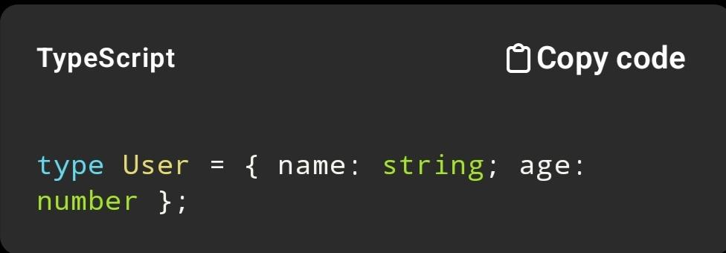

4. Vite

Fast dev server and build tool. Uses native ES modules for instant reload. Much faster than older tools like Webpack.
Example: Instant UI update when editing a React component (hot reload).

5. Node.js

Runs JavaScript on the server using V8 engine. Handles asynchronous operations efficiently.
Example: Processing API requests without blocking other users.

Example:

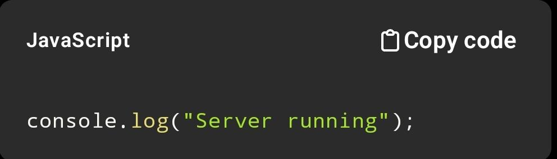

6. Express

Minimal backend framework for building APIs and web servers.
Example: Creating an endpoint /login to handle user authentication.

Example:

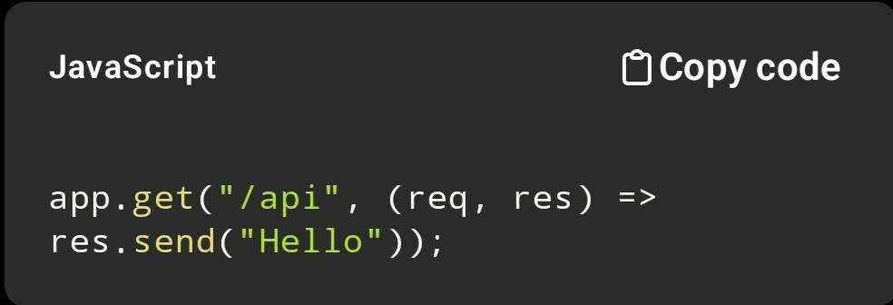

7. Socket.IO + socket.io-client

Enables real-time, bidirectional communication between client and server.
Example: Live chat or collaborative lab updates.
Live chat message appears instantly for all users.

8. Firebase Authentication

Handles user authentication (Google, email, etc.). Secure and easy integration.
Example: Login using Google account without building auth from scratch.

9. Cloud Firestore

Realtime cloud database storing data as documents and collections. Scalable and fast.
Example: Storing user messages or lab results.

10. Tailwind CSS (v4)

Provides utility classes for fast UI styling directly in HTML/JSX.
Example: class="bg-blue-500 text-white p-4" for styling a button.

Example:
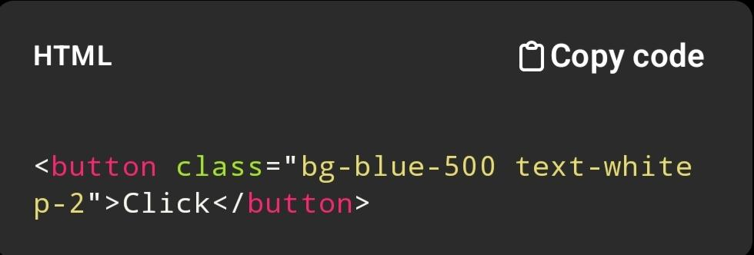

11. Lucide React

Modern icon set for React apps. Lightweight and customizable.
Example: Adding a search icon in input fields.

Example:

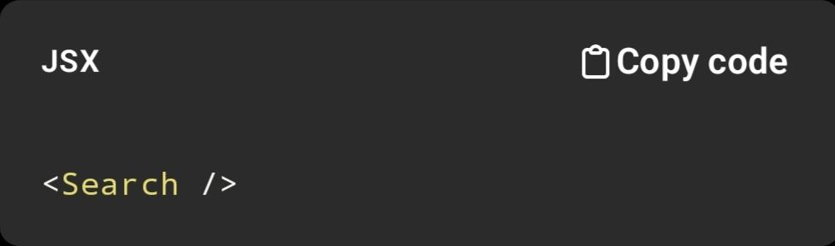

12. Motion

Animation library (like Framer Motion) for smooth UI transitions.
Example: Fade-in effect when components load.

13. Google GenAI

Provides AI models for analysis, generation, and automation.
Example: Analyzing suspicious code or generating insights.

14. MalwareBazaar API

API to query malware samples using hashes. Useful for threat intelligence.
Example: Checking if a file hash is malicious.

15. ngrok

Exposes local server to the internet via a public URL.
Example: Sharing your localhost app for testing and reviewing.
localhost:3000 → public URL like abc.ngrok.io

16. python-docx

Used to create and edit Word (.docx) documents programmatically.
Example: Automatically generating a project report

Example
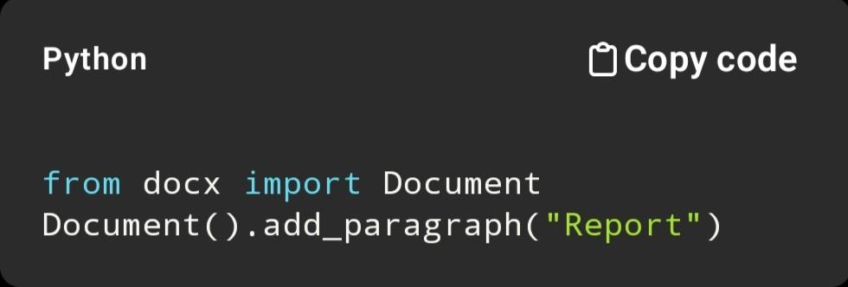

________________________________________________________________________________

22. References

- National Institute of Standards and Technology (NIST)
Guide to Malware Incident Prevention and Handling (SP 800-83)
https://nvlpubs.nist.gov/nistpubs/⁠

- Cybersecurity and Infrastructure Security Agency
Ransomware Guide
https://www.cisa.gov/ransomware

- Kaspersky
What is Ransomware?
https://www.kaspersky.com/resource-center/threats/ransomware⁠

- Microsoft
Ransomware Protection and Trend
https://learn.microsoft.com/security⁠

- OWASP
Web Security Testing Guide.
https://owasp.org⁠

- React Documentation
https://react.dev⁠

- TypeScript Documentation
https://www.typescriptlang.org⁠

- Node.js Documentation
https://nodejs.org⁠

- Express.js Documentation
https://expressjs.com⁠

- Firebase Documentation
https://firebase.google.com/docs⁠

- Socket.IO Documentation
https://socket.io⁠

- Tailwind CSS Documentation
https://tailwindcss.com⁠
- Abuse.ch
MalwareBazaar API
https://bazaar.abuse.ch⁠

- Google
Safe Browsing & AI Security Concepts
https://developers.google.com/safe-browsing⁠

________________________________________________________________________________

23. Conclusion

Cyber Guard: Ransomware Awareness Lab demonstrates how a modern web application can be used to educate users about ransomware in a safe, engaging, and structured manner. The platform integrates theory, analysis, simulation, and response practice in one environment, making it suitable for both learning and project presentation. Its key strength lies in making ransomware education interactive without crossing safety boundaries.

