HIST250 – Introduction to Philippines History and Culture
Offshore Trimester 3 - 2025

Obelisk of Gomburza - UNESCO Heritage Analysis

14.582375792274158, 120.97720809967554
Luneta Park, Ermita, Manila, 1000 Metro Manila, Philippines
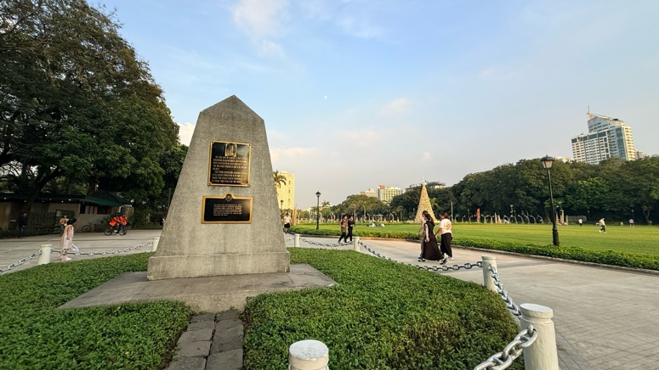

The Obelisk of Gomburza marks the place where three priests – turned martyrs – were executed by Spanish authorities in 1872. The Filipino priests, Mariano Gomez, José Burgos, and Jacinto Zamora were charged with subversion, treason, and sedition on the 15th of February, and executed by garrotte two days later, in the exact spot this obelisk stands.

Luneta Park (or Rizal Park) was known as Bagumbayan during the Spanish rule and was the place of execution for many Filipinos who bravely combatted the Spanish colonial empire. The beauty and tranquillity of the park contrasts against its history as a ‘killing field’, where colonialists could witness of executions – it was at Bagumbayan where enemies of the Spanish rule were shot, garrotted or hanged.

Gomburza is a portmanteau of the three father’s surnames: Gom for Gómes, Bur for Burgos, and Za for Zamora. The three men were priests engaged in the secularization of the Philippines, strongly advocating for the rights of clergymen who were not allowed to govern due to their race, and perceived inferiority to the Europeans. Father José burgos in particular was advocating for Filipino priests’ right to administer parishes and assume leadership within the Catholic Church, challenging the institutional bias that favoured the friars of European descent.

The advocacy of the fathers became entangled in the Cavite Mutiny of 1872, an uprising at Fort San Felipe, where 200 local labourers and soldiers rose against the colonial powers in hopes they would start a national uprising. Spanish officials, who were eager to quell further resistance, used the mutiny as an opportunity to arrest and put the three priests on trial, despite a lack of evidence linking Gomburza to that rebellion movement. Charged and convicted of ‘subversion’, Gomburza were publicly garrotted two days later in Bagumbayan. Their deaths were intended to serve as a warning to those who opposed the Spanish rule.
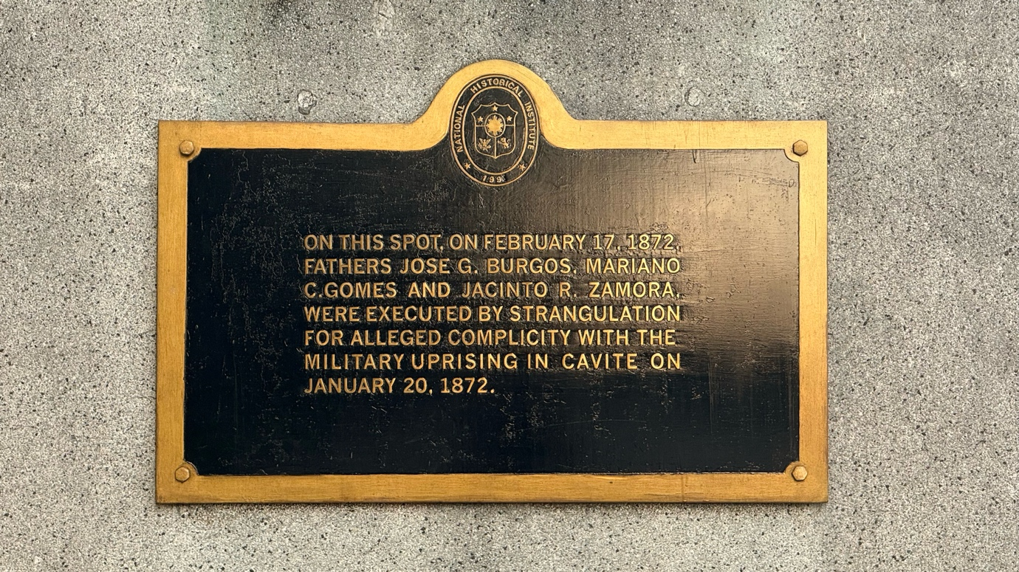

Despite the intentions of the colonialists, the executions of Fathers Gómez, Burgos, and Zamora did not silence the calls for reform. Instead, their deaths ignited the national consciousness, inspiring a new generation of Filipino reformers and revolutionists. The Cavite mutiny, while unsuccessful in that moment, is now considered to be one of the anchors of Filipino nationalism that lead to the eventual Philippine revolution. José Rizal, who would later become the national hero of the Philippines, would dedicate his second novel to Gomburza. The forward in El Filibusterismo immortalizes the fathers not just as victims of fierce and harsh oppression but also as catalysts for enlightenment and progression – as martyrs for a just cause. The motif of martyrdom is one that is very common in the commemoration of those who fought for the Philippine revolution.

The interest of this smaller obelisk, positioned at the location of the executions, lies in its simplicity. The monument is a simple, white-washed stone obelisk, standing 100 metres away from the more famous José Rizal monument. Compared to the towering Rizal monument, the obelisk is minimalist, with clean lines and no adornments other than the plaques in both English and Tagalog that describe the history that led to the monument’s creation. The simplicity of the monument asks the viewer to reflect. The obelisk itself is not as prominent as its ‘brother’ monument, the Gomburza National Monument, a bronze impression of the three fathers that stands in a pool of water in front of the National Museum of Fine Arts. The bronze monument at the National Museum shows two of the fathers fallen, with the last standing, waiting for his execution; that statute is a very emotive piece that portrays anguish and pain yet dignity in the face of adversity. In comparison with the drama of the bronze National Gomburza Monument, the white obelisk has a sense of sobriety. The clean lines and small stature of the obelisk suggest remembrance of the injustice and consequences of death, rather than the spectacle of heroism. There is no sense of triumph in this monument. The descripting textual markers on the statue continue this feeling, with the honesty and brutalness of the men’s deaths displayed with no flowery language.

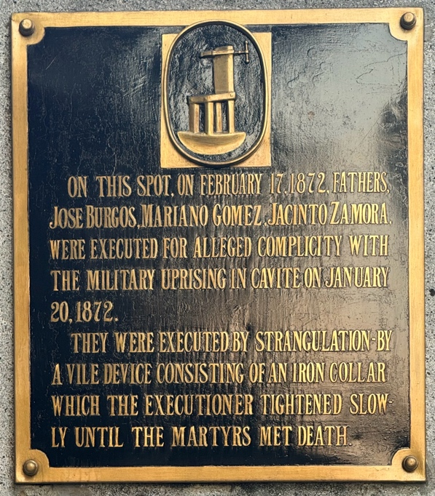
“THEY WERE EXECUTED BY STRANGULATION BY A VILE DEVICE CONSISTING OF AN IRON COLLAR WHICH THE EXECUTIONER TIGHTENED SLOWLY UNTIL THE MARTYRS MET DEATH.”

When looking from the view of a modern audience, the factual tone and lack of euphemism keeps the attention on the pain and suffering of the men. The reference to ‘alleged complicity’ reminds the viewer of the injustice faced by those who dissented against Spanish colonialism. Through its physical simplicity, explicit text, and powerful location, it is difficult to miss the monument’s moral stance, even for visitors with limited historical background. Encouraging reflection, rather than admiration, the obelisk works especially well as a counterpoint to the other monuments in the park.

The proximity of the monument to the Rizal monument and the history of the park itself links the deaths of Gomburza to the broader nationalism and revolutionary movements, reframing the ‘killing field’ to a martyr’s park, where the tranquil urban park is a place of relaxation and recreation, in honour of the sacrifice of those who led to the movement’s success.

Bagumbayan, once feared as an execution ground, is now a place for visitors to enjoy. The obelisk acknowledges the horrors that occurred at its location, while also acts as a statement on how societies remember the traumas of their past.
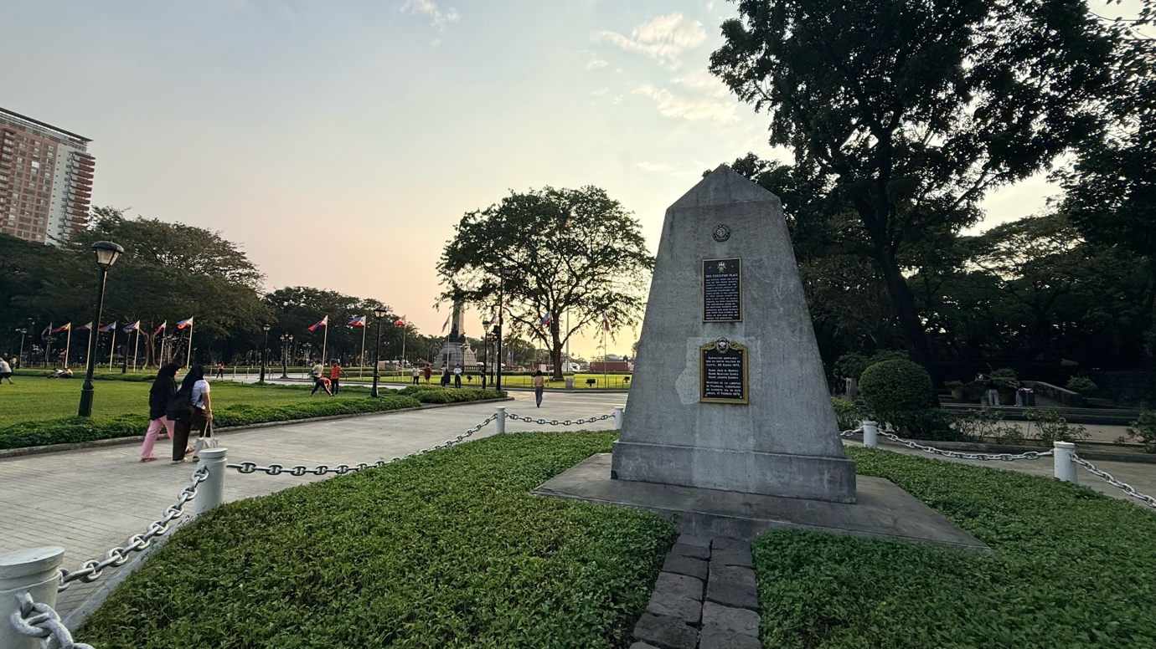
The Rizal Monument can be seen behind the obelisk, to the left.

Abueva, Jose Veloso. 1998. The Making of the Filipino Nation and Republic.
‌
Anon. 2008. “Gomburza – Traveler on Foot.” 2008. Traveler on Foot. 2008. https://traveleronfoot.wordpress.com/tag/gomburza/

Miano, Troy Alexander. 2022. “GOMBURZA @ 150.” Blogspot.com. Blogger. April 5, 2022. https://anghistorya.blogspot.com/2022/04/149-gomburza-150.html

National Museum. 2025. “NMP Commemorates GOMBURZA on 153rd Martyrdom Anniversary – National Museum.” Nationalmuseum.gov.ph. February 17, 2025. https://www.nationalmuseum.gov.ph/2025/02/17/nmp-commemorates-gomburza-on-153rd-martyrdom-anniversary/

National Parks Development Committee. 2021. “GomBurZa Marker at Rizal Park with Prof. Xiao Chua.” YouTube. September 15, 2021. https://www.youtube.com/watch?v=Vac6rLAaJhU

Rizal, José. 1891.“The Project Gutenberg EBook of El Filibusterismo, by José Rizal.” 2025. Gutenberg.org. 2025. https://www.gutenberg.org/files/30903/30903-h/30903-h.htm
‌
Schumacher, John. 1997. The Propaganda Movement, 1880-1895. Ateneo University Press.
‌
Uckung, Peter Jaynul. 2012. “The Secularization Issue Was an International Issue - National Historical Commission of the Philippines.” National Historical Commission of the Philippines. September 5, 2012. https://nhcp.gov.ph/the-secularization-issue-was-an-international-issue/.

Zaide, F. Gregorio. n.d “With Their Death Philippine Nationalism was Born.” 2023. Nhcp.gov.ph. 2023. https://memory.nhcp.gov.ph/collections/?ptermid=3657.
‌
‌

National Parks Development Committee, 2021.
Uckung, 2012.
Schumacher, 1997.
Zaide, n.d.
Abueva, 1998.
Rizal, 1891.

