PCCST503 • MACHINE LEARNING • SEMESTER S5
Module 3
Generalisation, Evaluation, SVM & Neural Networks
Complete study notes with diagrams, worked numerical problems and exam-style questions

Syllabus topic (Module 3) | Section | Reference
Generalisation and overfitting – LASSO & RIDGE, training / testing / validation | 1 | Alpaydin (Ch. on Generalization & Model Selection); Bishop Ch. 9
Evaluation measures – precision, recall, accuracy, F-measure, ROC, AUC; MAE, RMSE, R² | 2 | Alpaydin (Assessing & Comparing Classifiers); Zaki Ch. 22
Support Vector Machines – hyperplane, maximum margin, non-linear SVM, kernels | 3 | Alpaydin (Kernel Machines); Zaki Ch. 21
Neural networks – perceptron, MLP, activation functions, back-propagation | 4 | Alpaydin (Multilayer Perceptrons); Bishop Ch. 3–4
Quick-revision formula sheet | 5 | –
Sample questions (Part A / Part B / internal-test style) and practice problems with answers | 6 | Follows the pattern of the shared sample paper

How to use these notes
This module maps to CO2 (supervised learning concepts), CO3 (multilayer neural networks) and CO5 (performance measures). In the ESE it supplies 2 Part-A questions (3 marks each) and one 9-mark Part-B question (a choice of one out of two).
Numerical problems are most likely from: confusion-matrix metrics, ROC/AUC, MAE/RMSE/R², SVM hyperplane, kernel value, perceptron learning and one back-propagation step. Each is worked out below.

1. Generalisation and Overfitting

1.1 What is generalisation?
A learning algorithm is trained on a finite sample, but it is judged on unseen data. Generalisation is the ability of a trained model to perform well on new examples drawn from the same distribution as the training data. Memorising the training set is easy; capturing the underlying pattern is the real goal.
Generalisation error = expected error on unseen data (we can only estimate it with held-out data)

1.2 Underfitting and overfitting
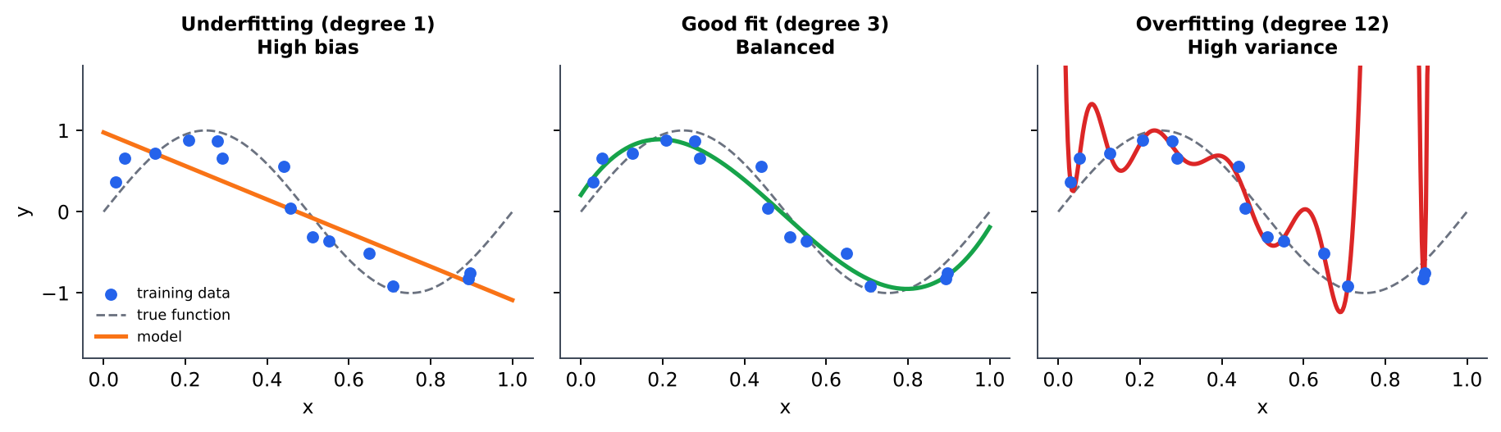
Figure 1: The same data fitted with a too-simple (degree 1), suitable (degree 3) and too-complex (degree 12) polynomial.
 | Underfitting | Overfitting
Meaning | Model too simple to capture the pattern | Model so flexible that it also fits noise
Training error | High | Very low (≈ 0)
Validation / test error | High | High (much larger than training error)
Statistical view | High bias, low variance | Low bias, high variance
Typical causes | Too few features, low-degree model, too much regularisation, too little training | Too many features / parameters, very small dataset, noisy data, training too long
Remedies | Add features, use a more complex model, reduce regularisation, train longer | More data, simpler model, regularisation, feature selection, early stopping, cross-validation, dropout (NN)

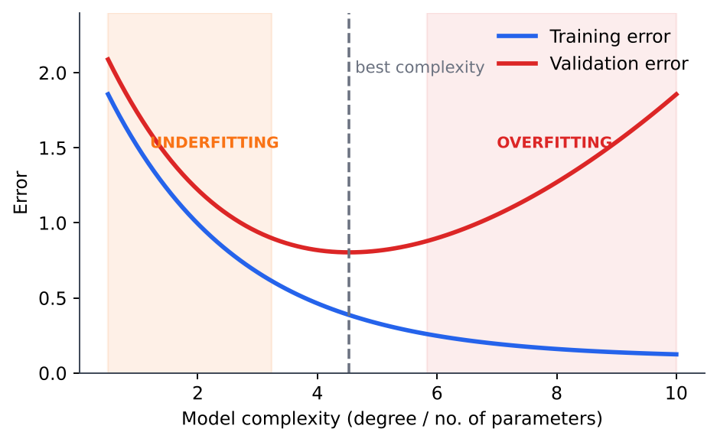
Figure 2: Training error keeps falling with complexity; validation error falls, then rises. The minimum of the validation curve marks the best model.
Exam tip
Always draw Figure 1 or 2 when asked for 'overfitting and underfitting with diagrams' (the sample paper Q4b). Label the three panels and write the training/validation error behaviour under each.

1.3 Training, validation and test sets
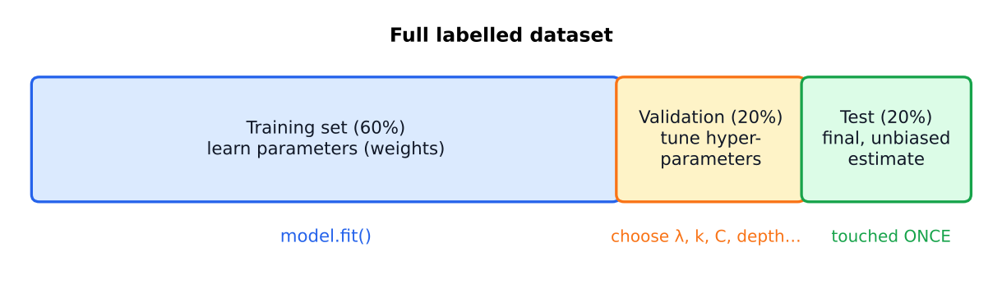
Figure 3: Typical 60 : 20 : 20 split of the labelled data.
Set | Purpose | Used how often?
Training set | Fit the model parameters (e.g. weights w, b) | Many times, during learning
Validation set | Choose hyper-parameters and the model (λ, k in KNN, C and kernel in SVM, tree depth, no. of hidden units, early-stopping epoch) | Many times, during model selection
Test set | Report the final, unbiased estimate of generalisation error | Once, at the very end

Why a separate validation set? If we pick hyper-parameters by looking at test error, the test set has influenced the model, so the reported score becomes optimistically biased (information leakage). The validation set absorbs this tuning, and the untouched test set gives an honest estimate. When data is scarce, k-fold cross-validation replaces the single validation set (Module 4).

1.4 Regularisation: Ridge and LASSO
Overfitted linear models usually have very large weights. Regularisation adds a penalty on the size of the weights to the loss, so the optimiser trades off data fit against model simplicity. λ ≥ 0 is the regularisation strength (a hyper-parameter chosen on the validation set). The intercept w₀ is normally not penalised.
 | Ridge (L2) | LASSO (L1)
Cost function | J(w) = Σᵢ (yᵢ − wᵀxᵢ)² + λ Σⱼ wⱼ² | J(w) = Σᵢ (yᵢ − wᵀxᵢ)² + λ Σⱼ |wⱼ|
Penalty | Squared L2 norm ‖w‖₂² | L1 norm ‖w‖₁
Effect on weights | Shrinks all weights smoothly towards 0, rarely exactly 0 | Shrinks and sets some weights exactly to 0
Feature selection | No | Yes (sparse model)
Closed-form solution | w = (XᵀX + λI)⁻¹ Xᵀy (always invertible for λ>0) | None in general (|w| not differentiable at 0); solved by coordinate descent / sub-gradient
Best when | Many small, correlated useful features | Few features truly matter (sparse truth)
Gradient step | ∂J/∂wⱼ = −2Σ(y−ŷ)xⱼ + 2λwⱼ | ∂J/∂wⱼ = −2Σ(y−ŷ)xⱼ + λ·sign(wⱼ)

Special cases: λ = 0 gives ordinary least squares (may overfit); λ → ∞ forces all weights to 0 (underfit). Elastic Net combines both penalties: λ₁Σ|wⱼ| + λ₂Σwⱼ².
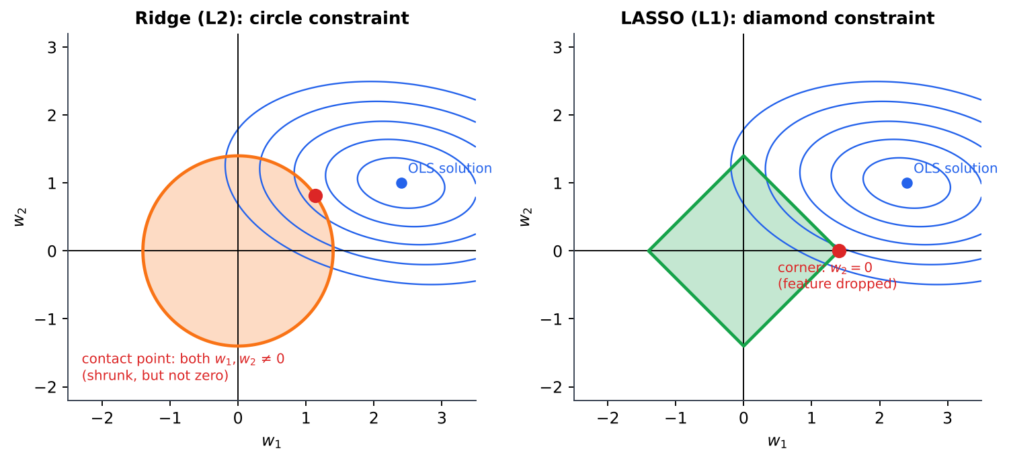
Figure 4: Geometry of regularisation. The solution is where the loss contours first touch the constraint region. The L1 diamond has corners on the axes, so contact often occurs where a weight is exactly zero.
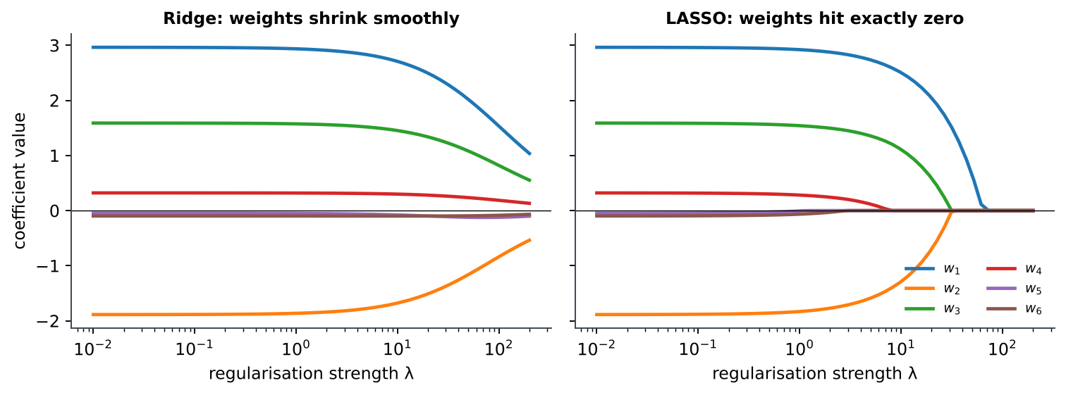
Figure 5: Coefficient paths as λ grows (6 features, 2 of them irrelevant). LASSO drives weights exactly to zero; ridge only shrinks them.
Numerical 1 – Computing the penalised cost
A model has weights w = (3, −2, 0.5) and its sum of squared errors on the training set is 4.0. Find the Ridge and LASSO cost for λ = 0.1.
Ridge penalty = λ Σ w² = 0.1 × (9 + 4 + 0.25) = 0.1 × 13.25 = 1.325 → J = 4.0 + 1.325 = 5.325
LASSO penalty = λ Σ |w| = 0.1 × (3 + 2 + 0.5) = 0.1 × 5.5 = 0.55 → J = 4.0 + 0.55 = 4.55
Observe: the large weight 3 is penalised much more strongly by the squared (L2) term.

Numerical 2 – Ridge vs LASSO on one feature
Data: x = (1, 2, 3), y = (2, 4, 5). Fit y = w·x (no intercept) minimising Σ(y − wx)² + penalty. Find w for several λ.
Compute Σxy = 1·2 + 2·4 + 3·5 = 25 and Σx² = 1 + 4 + 9 = 14.
OLS (λ = 0): w = Σxy / Σx² = 25/14 = 1.786.
Ridge: set dJ/dw = −2(25 − 14w) + 2λw = 0 ⟹ w = 25 / (14 + λ).
LASSO: for w>0, dJ/dw = −2(25 − 14w) + λ = 0 ⟹ w = (25 − λ/2)/14, and w = 0 once λ/2 ≥ 25 (soft-thresholding).
For λ = 2: Ridge w = 25/16 = 1.5625. For λ = 14: Ridge w = 25/28 = 0.893.
For λ = 10: LASSO w = (25 − 5)/14 = 1.429. For λ = 30: w = (25 − 15)/14 = 0.714. For λ = 50: w = (25 − 25)/14 = 0.
Conclusion: ridge shrinks w but never reaches 0, whereas LASSO sets w = 0 for λ ≥ 50.

λ | 0 | 2 | 10 | 14 | 30 | 50
Ridge w | 1.786 | 1.563 | 1.042 | 0.893 | 0.568 | 0.391
LASSO w | 1.786 | 1.714 | 1.429 | 1.286 | 0.714 | 0.000

2. Evaluation Measures

2.1 Classification: the confusion matrix
For a binary problem, every prediction falls in one of four cells. Choose a positive class (the class of interest, e.g. 'spam', 'disease').
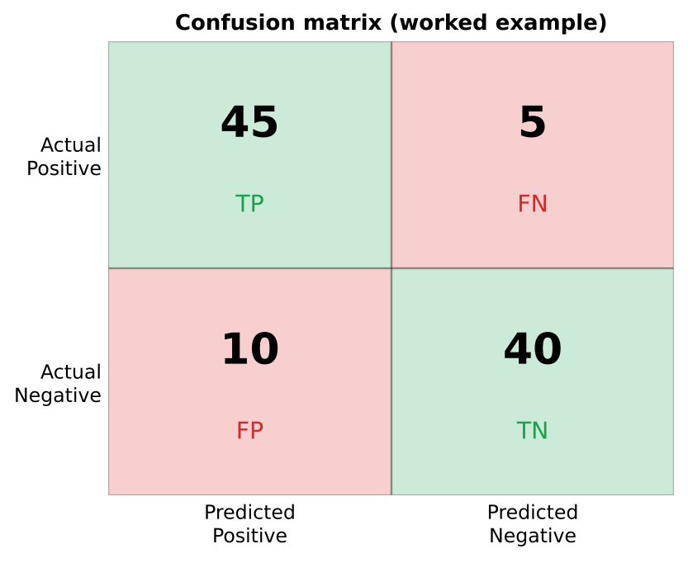
Figure 6: Confusion matrix with the worked-example numbers (TP = 45, FN = 5, FP = 10, TN = 40).
Measure | Formula | Meaning / when it matters
Accuracy | (TP + TN) / (TP + TN + FP + FN) | Fraction of all predictions that are correct. Misleading for imbalanced classes.
Precision | TP / (TP + FP) | Of everything predicted positive, how much is truly positive. Important when false alarms are costly (spam filter deleting real mail, recommending a risky drug).
Recall (Sensitivity, TPR) | TP / (TP + FN) | Of all real positives, how many were found. Important when missing a positive is costly (cancer screening, fraud detection).
Specificity (TNR) | TN / (TN + FP) | Fraction of real negatives correctly rejected.
False Positive Rate | FP / (FP + TN) = 1 − Specificity | x-axis of the ROC curve.
F-measure (F1) | 2·P·R / (P + R) (harmonic mean) | Single score balancing precision and recall; low if either is low. Used for imbalanced data.
Fβ score | (1+β²)·P·R / (β²·P + R) | β>1 stresses recall, β<1 stresses precision.

Numerical 3 – Metrics from a confusion matrix
A classifier is tested on 100 samples: TP = 45, FN = 5, FP = 10, TN = 40. Compute all measures.
Accuracy = (45 + 40)/100 = 0.85
Precision = 45/(45 + 10) = 45/55 = 0.818
Recall = 45/(45 + 5) = 45/50 = 0.90
Specificity = 40/(40 + 10) = 0.80, FPR = 10/50 = 0.20
F1 = 2 × 0.818 × 0.90 / (0.818 + 0.90) = 1.4727/1.718 = 0.857

Why accuracy can mislead (the accuracy paradox)
A dataset has 990 healthy and 10 diseased patients. A 'model' that always predicts 'healthy' gets 99% accuracy but recall = 0 – it never finds a sick patient. Hence precision, recall and F1 are preferred on imbalanced data.

2.2 ROC curve and AUC
Most classifiers output a score (probability); a class is assigned by comparing the score with a threshold. Changing the threshold trades recall against false alarms. The Receiver Operating Characteristic (ROC) curve plots TPR (y-axis) against FPR (x-axis) for every possible threshold. The Area Under the Curve (AUC) summarises it in one number between 0 and 1.
- Perfect classifier: curve through the top-left corner (0,1), AUC = 1.
- Random guessing: the diagonal, AUC = 0.5.
- AUC < 0.5: worse than random (labels are inverted).
- AUC = probability that a randomly chosen positive gets a higher score than a randomly chosen negative.
- ROC is insensitive to class imbalance and to the choice of a single threshold.
Numerical 4 – Drawing a ROC curve and finding AUC
10 test samples (5 positive, 5 negative) with classifier scores, sorted in decreasing order:
Score: 0.95 0.85 0.80 0.70 0.60 0.55 0.45 0.40 0.30 0.10
Actual: P P N P N P N P N N
Lower the threshold step by step, classifying a sample as positive when score ≥ threshold. TPR = TP/5, FPR = FP/5.

Threshold | 0.95 | 0.85 | 0.80 | 0.70 | 0.60 | 0.55 | 0.45 | 0.40 | 0.30 | 0.10
TP | 1 | 2 | 2 | 3 | 3 | 4 | 4 | 5 | 5 | 5
FP | 0 | 0 | 1 | 1 | 2 | 2 | 3 | 3 | 4 | 5
TPR | 0.2 | 0.4 | 0.4 | 0.6 | 0.6 | 0.8 | 0.8 | 1.0 | 1.0 | 1.0
FPR | 0 | 0 | 0.2 | 0.2 | 0.4 | 0.4 | 0.6 | 0.6 | 0.8 | 1.0

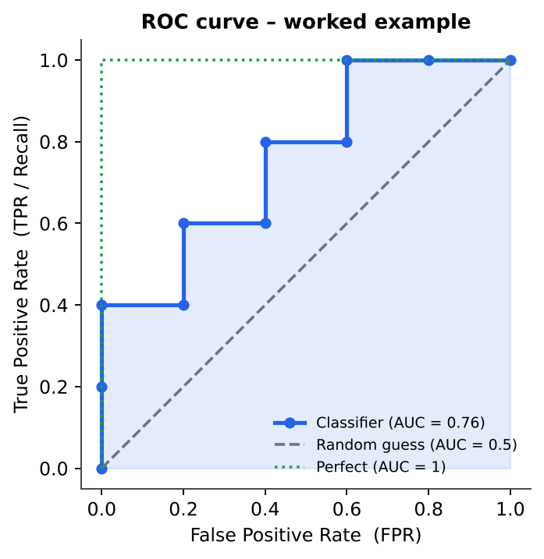
Figure 7: ROC curve obtained from the table; shaded region is the AUC.
AUC = sum of (width of each FPR step × height TPR) = 0.2×0.4 + 0.2×0.6 + 0.2×0.8 + 0.2×1.0 + 0.2×1.0 = 0.08 + 0.12 + 0.16 + 0.20 + 0.20 = 0.76. Check by pairs: 19 of the 5×5 = 25 (positive, negative) pairs have the positive scored higher → 19/25 = 0.76. ✓

2.3 Regression metrics
Measure | Formula | Remarks
MAE – Mean Absolute Error | (1/n) Σ |yᵢ − ŷᵢ| | Same unit as y; robust to outliers; easy to interpret.
MSE – Mean Squared Error | (1/n) Σ (yᵢ − ŷᵢ)² | Penalises big errors heavily; the quantity minimised in linear regression.
RMSE – Root MSE | √MSE | Same unit as y; ≥ MAE always; more sensitive to outliers.
R² – Coefficient of determination | 1 − SSE/SST, SSE = Σ(yᵢ−ŷᵢ)², SST = Σ(yᵢ−ȳ)² | Fraction of variance in y explained by the model. 1 = perfect, 0 = no better than predicting the mean, can be negative for a bad model.

Numerical 5 – MAE, RMSE and R²
Actual y = (3, 5, 2, 7); predicted ŷ = (2.5, 5.5, 2, 8).
Errors (y − ŷ) = (0.5, −0.5, 0, −1).
MAE = (0.5 + 0.5 + 0 + 1)/4 = 2/4 = 0.5
MSE = (0.25 + 0.25 + 0 + 1)/4 = 1.5/4 = 0.375; RMSE = √0.375 = 0.612
ȳ = (3 + 5 + 2 + 7)/4 = 4.25; SST = (−1.25)² + 0.75² + (−2.25)² + 2.75² = 1.5625 + 0.5625 + 5.0625 + 7.5625 = 14.75; SSE = 1.5
R² = 1 − 1.5/14.75 = 1 − 0.1017 = 0.898 → the model explains about 89.8% of the variance.

3. Support Vector Machines (SVM)

3.1 Hyperplane and the maximum-margin idea
In d dimensions, a hyperplane is the set of points satisfying wᵀx + b = 0 (a line in 2-D, a plane in 3-D). It divides space into two half-spaces; a point is classified by ŷ = sign(wᵀx + b). The vector w is normal (perpendicular) to the hyperplane, and the distance of a point x from it is |wᵀx + b| / ‖w‖.
Many hyperplanes can separate two linearly separable classes. The SVM chooses the one with the maximum margin – the largest gap to the nearest training points of either class – because a wider margin generally means better generalisation.
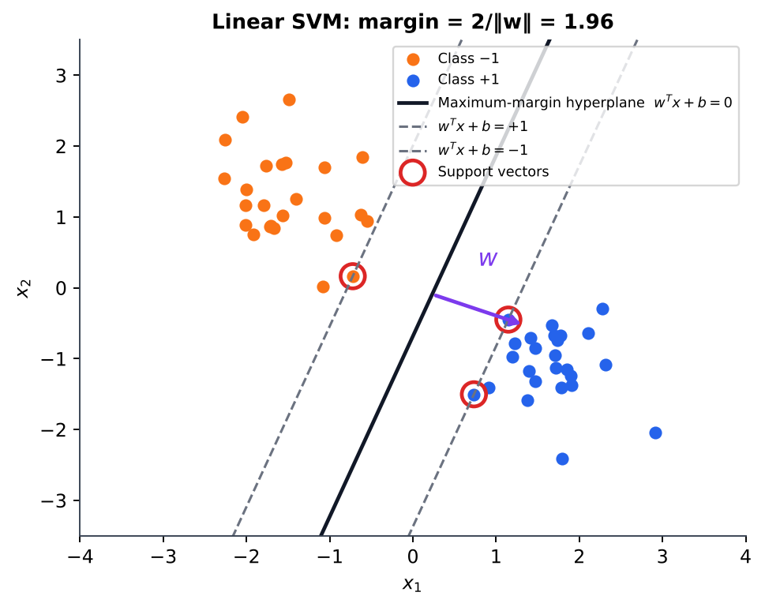
Figure 8: Maximum-margin hyperplane. The dashed lines are the margin boundaries; the circled points lying on them are the support vectors.
Key idea
Scale w and b so that the closest points satisfy y(wᵀx + b) = 1. The two margin boundaries are then wᵀx + b = +1 and wᵀx + b = −1, and
Margin width = 2 / ‖w‖
Maximising the margin ⇔ minimising ‖w‖. Support vectors are the training points exactly on the margin; only they determine the hyperplane – deleting any other point changes nothing.

Primal (hard-margin) optimisation problem
minimise ½‖w‖² subject to yᵢ(wᵀxᵢ + b) ≥ 1, i = 1,…,N

Dual form (Lagrange multipliers αᵢ ≥ 0)
maximise Σᵢ αᵢ − ½ Σᵢ Σⱼ αᵢαⱼ yᵢyⱼ (xᵢ·xⱼ) s.t. αᵢ ≥ 0, Σᵢ αᵢyᵢ = 0
w = Σᵢ αᵢ yᵢ xᵢ , b = yₛ − wᵀxₛ (any support vector s), f(x) = sign( Σᵢ αᵢ yᵢ (xᵢ·x) + b )
Only support vectors have αᵢ > 0. The data enter the dual only through dot products xᵢ·xⱼ, which is what makes the kernel trick possible.

Soft-margin SVM (non-separable data)
Real data overlap, so slack variables ξᵢ ≥ 0 allow some points inside the margin or misclassified:
minimise ½‖w‖² + C Σᵢ ξᵢ s.t. yᵢ(wᵀxᵢ + b) ≥ 1 − ξᵢ, ξᵢ ≥ 0
C large | C small
Penalises violations heavily → narrow margin, fewer training errors, risk of overfitting | Tolerates violations → wide margin, more training errors, risk of underfitting

Numerical 6 – Maximum-margin hyperplane from support vectors
Training points: s₁ = (1, 0) with class −1; s₂ = (3, 1) with class +1; s₃ = (3, −1) with class +1. All three are support vectors. Find w, b, the margin, and classify (4, 0) and (0.5, 2).
Step 1 – Support-vector equations y(wᵀx + b) = 1:
• s₁: −(w₁ + b) = 1 ⟹ w₁ + b = −1
• s₂: 3w₁ + w₂ + b = 1
• s₃: 3w₁ − w₂ + b = 1
Step 2 – Solve. Subtract s₃ from s₂: 2w₂ = 0 ⟹ w₂ = 0. Then 3w₁ + b = 1 and w₁ + b = −1; subtracting gives 2w₁ = 2 ⟹ w₁ = 1, b = −2.
Hyperplane: x₁ − 2 = 0, i.e. the vertical line x₁ = 2.
Step 3 – Margin = 2/‖w‖ = 2/1 = 2 (boundaries x₁ = 1 and x₁ = 3).
Step 4 – Check with the dual. α = (0.5, 0.25, 0.25): Σαy = −0.5 + 0.25 + 0.25 = 0 ✓; w = Σαyx = −0.5(1,0) + 0.25(3,1) + 0.25(3,−1) = (1, 0) ✓.
Step 5 – Classify. (4, 0): 1·4 − 2 = +2 > 0 → class +1. (0.5, 2): 0.5 − 2 = −1.5 < 0 → class −1.

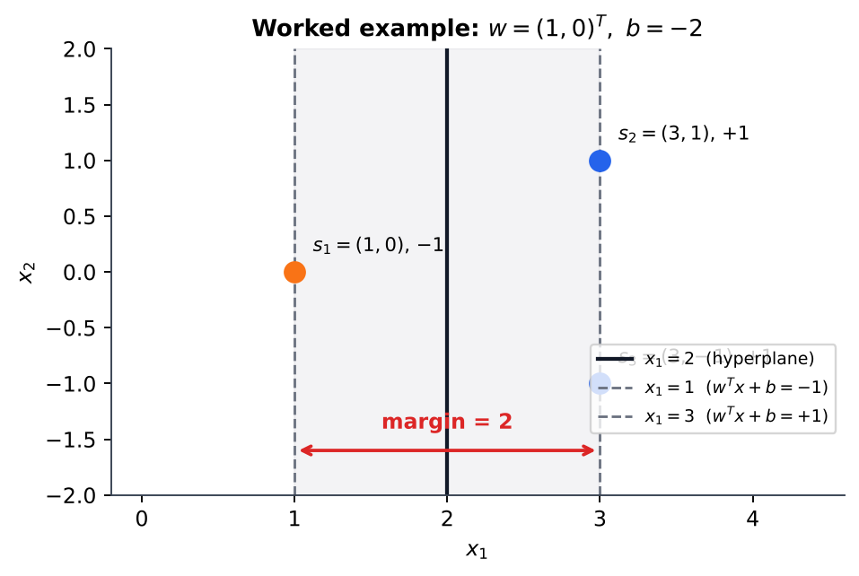
Figure 9: Geometry of Numerical 6: the hyperplane x₁ = 2 and the margin of width 2.

3.2 Non-linear SVM and the kernel trick
If classes cannot be separated by a line, map the inputs to a higher-dimensional feature space with φ(x), where a linear separator may exist. Computing φ explicitly can be very expensive (even infinite-dimensional). Because the SVM uses only dot products, we replace φ(xᵢ)·φ(xⱼ) by a kernel function K(xᵢ, xⱼ) computed directly in the original space – the kernel trick.
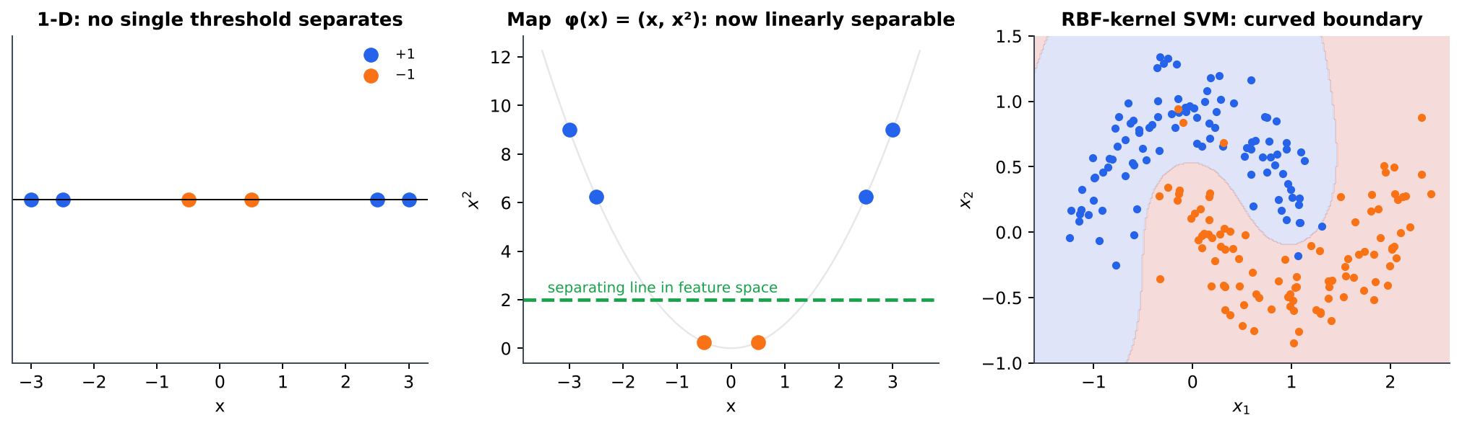
Figure 10: Left/centre: 1-D data that no threshold can separate become separable after mapping x → (x, x²). Right: an RBF-kernel SVM produces a curved decision boundary on the 'two moons' data.
Kernel | K(x, z) | Parameters / remarks
Linear | xᵀz | No mapping; fast; for (nearly) linearly separable or very high-dimensional data
Polynomial | (xᵀz + c)ᵈ | Degree d, constant c; captures feature interactions
RBF / Gaussian | exp( −‖x − z‖² / 2σ² ) = exp(−γ‖x−z‖²) | Width σ (or γ). Infinite-dimensional feature space; the most popular default. Small σ → wavy boundary (overfit); large σ → smooth (underfit)
Sigmoid | tanh(κ xᵀz + θ) | Behaves like a 2-layer neural network

Numerical 7 – Kernel value without computing φ
Let x = (1, 2) and z = (3, 1). Use the polynomial kernel K(x, z) = (xᵀz + 1)² and the RBF kernel with σ = 1.
Polynomial: xᵀz = 1·3 + 2·1 = 5 ⟹ K = (5 + 1)² = 36.
Verification through the explicit map φ(a) = (1, √2·a₁, √2·a₂, a₁², a₂², √2·a₁a₂) (6-D):
φ(x) = (1, 1.414, 2.828, 1, 4, 2.828), φ(z) = (1, 4.243, 1.414, 9, 1, 4.243)
φ(x)·φ(z) = 1 + 6 + 4 + 9 + 4 + 12 = 36 ✓ – the kernel gave the 6-D dot product while working only with 2-D vectors.
RBF: ‖x − z‖² = (1−3)² + (2−1)² = 5 ⟹ K = exp(−5/2) = e^(−2.5) = 0.0821 (similar points → K near 1, distant points → K near 0).

Advantages of SVM | Limitations of SVM
Effective in high dimensions; global optimum (convex problem); good generalisation via margin; flexible through kernels; memory-efficient (only support vectors stored) | Training is slow for very large N (≈ O(N²–N³)); needs kernel and C/σ tuning; no direct probability output; sensitive to feature scaling; less interpretable

4. Neural Networks

4.1 The perceptron
The perceptron (Rosenblatt, 1958) is a single artificial neuron: it forms a weighted sum of its inputs plus a bias and passes it through a step (threshold) activation. It is a linear classifier whose decision boundary is the hyperplane w·x + b = 0.
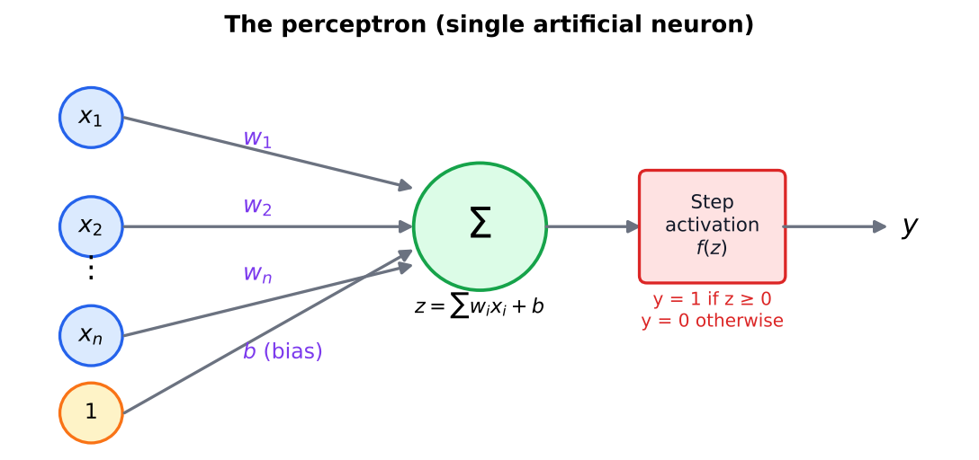
Figure 11: Structure of a perceptron.
z = w₁x₁ + w₂x₂ + … + wₙxₙ + b , y = f(z) = 1 if z ≥ 0, else 0

Perceptron learning rule
For each training example (x, t) with output y, update (η = learning rate, 0<η≤1):
wᵢ ← wᵢ + η (t − y) xᵢ , b ← b + η (t − y)
If the output is correct, (t − y) = 0 and nothing changes. If y=0 but t=1, weights move towards x; if y=1 but t=0, they move away. Perceptron convergence theorem: if the data are linearly separable, the rule converges in a finite number of steps.
Numerical 8 – Learning the AND gate
Training set: (0,0)→0, (0,1)→0, (1,0)→0, (1,1)→1. Start with w = (0,0), b = 0, η = 1, output 1 if z ≥ 0.
Epoch 1: (0,0): z=0 → y=1 but t=0 ⟹ w=(0,0), b=−1. (0,1): z=−1 → y=0 ✓. (1,0): z=−1 → y=0 ✓. (1,1): z=−1 → y=0 but t=1 ⟹ w=(1,1), b=0.
Epoch 2: (0,0): z=0 → y=1 ✗ ⟹ b=−1. (0,1): z=0 → y=1 ✗ ⟹ w=(1,0), b=−2. (1,0): z=−1 → 0 ✓. (1,1): z=−1 → 0 ✗ ⟹ w=(2,1), b=−1.
Continuing in the same way (weights at the end of each epoch are tabulated below), the process stops in epoch 6 with no changes:

End of epoch | 1 | 2 | 3 | 4 | 5 | 6
w₁, w₂ | (1, 1) | (2, 1) | (2, 1) | (2, 2) | (2, 1) | (2, 1)
b | 0 | −1 | −2 | −2 | −3 | −3
Errors in epoch | 2 | 3 | 3 | 2 | 1 | 0

Final answer: w = (2, 1), b = −3, i.e. the boundary 2x₁ + x₂ − 3 = 0. Check: (1,1) → 2+1−3 = 0 ≥ 0 → 1 ✓; (1,0) → −1 → 0 ✓; (0,1) → −2 → 0 ✓; (0,0) → −3 → 0 ✓. (Any other valid starting order may give a different but equally correct separator.)
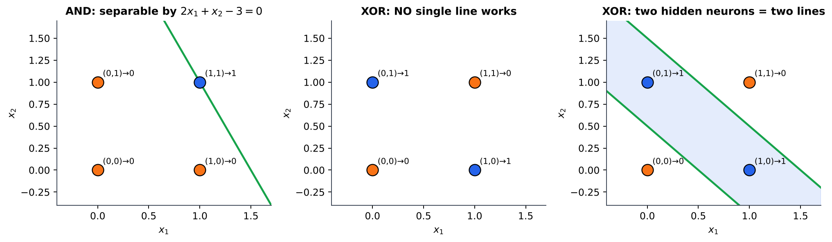
Figure 12: AND is linearly separable (left); XOR is not (centre), but two lines – i.e. two hidden neurons – solve it (right).
Limitation: a single perceptron can only learn linearly separable functions; it cannot represent XOR (Minsky & Papert, 1969). The cure is to stack neurons in layers.

4.2 Multilayer feed-forward network (MLP)
An MLP has an input layer, one or more hidden layers and an output layer. Every neuron is connected to all neurons of the next layer (fully connected) and information flows only forward (feed-forward, no loops). Hidden neurons learn intermediate features.
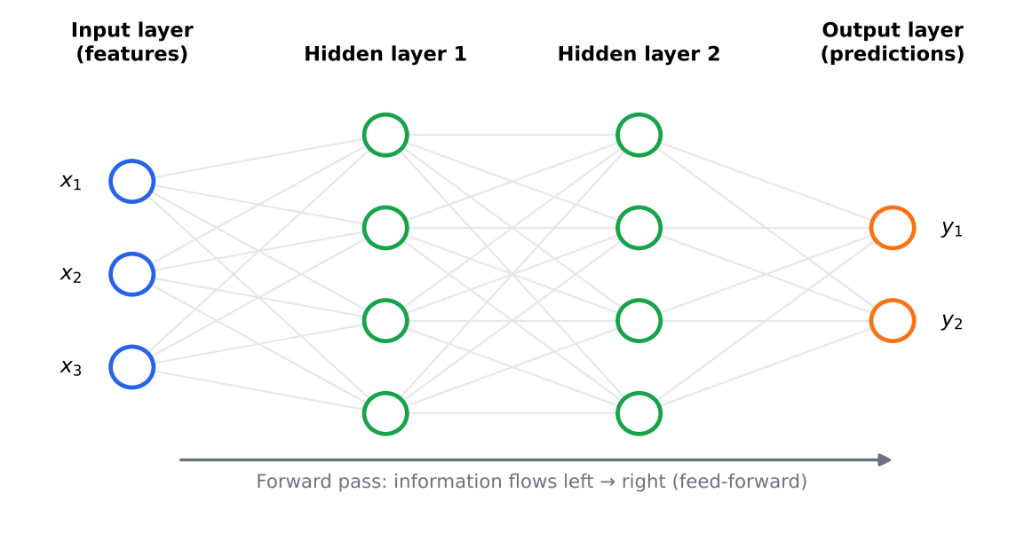
Figure 13: A fully-connected feed-forward network: 3 inputs, two hidden layers of 4 neurons and 2 outputs.
Forward pass. For layer l: a⁽ˡ⁾ = f( W⁽ˡ⁾ a⁽ˡ⁻¹⁾ + b⁽ˡ⁾ ), with a⁽⁰⁾ = x. The final activation gives the prediction (sigmoid for binary output, softmax for multi-class, linear for regression).
Universal approximation: an MLP with a single hidden layer of enough non-linear neurons can approximate any continuous function to arbitrary accuracy (Bishop Ch. 4).
Solving XOR with a 2-2-1 network of step neurons
Hidden: h₁ = step(x₁ + x₂ − 0.5) (acts as OR), h₂ = step(x₁ + x₂ − 1.5) (acts as AND). Output: y = step(h₁ − h₂ − 0.5).

x₁ | x₂ | h₁ (OR) | h₂ (AND) | z = h₁ − h₂ − 0.5 | y | XOR target
0 | 0 | 0 | 0 | −0.5 | 0 | 0
0 | 1 | 1 | 0 | +0.5 | 1 | 1
1 | 0 | 1 | 0 | +0.5 | 1 | 1
1 | 1 | 1 | 1 | −0.5 | 0 | 0

4.3 Activation functions
If every neuron were linear, any depth of layers would collapse into one linear map (W₂(W₁x) = (W₂W₁)x). Non-linear activation functions are what give a deep network its power. Back-propagation also needs them to be differentiable (almost everywhere).
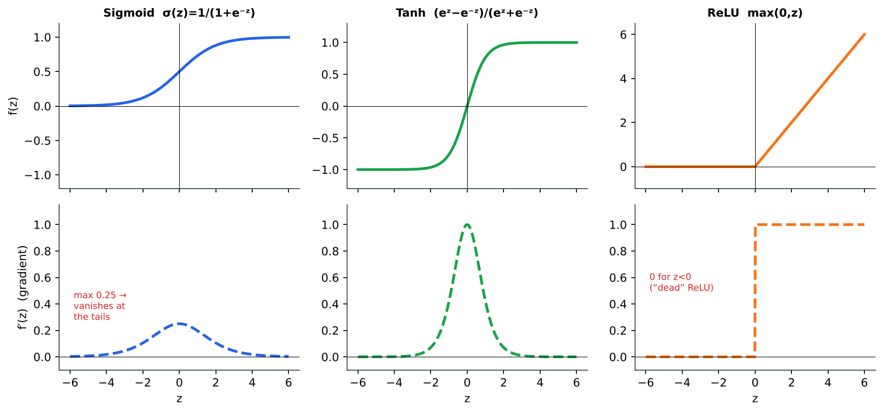
Figure 14: Sigmoid, tanh and ReLU (top) and their derivatives (bottom).
Function | Formula | Range | Derivative | Pros / cons
Sigmoid | σ(z) = 1 / (1 + e⁻ᶻ) | (0, 1) | σ(z)(1 − σ(z)), max 0.25 | Probability-like output, good for output layer of binary problems. Vanishing gradient at the tails; not zero-centred; exp is costly.
Tanh | (eᶻ − e⁻ᶻ)/(eᶻ + e⁻ᶻ) | (−1, 1) | 1 − tanh²(z), max 1 | Zero-centred (trains faster than sigmoid) but still saturates.
ReLU | max(0, z) | [0, ∞) | 1 if z>0, else 0 | Cheap, no saturation for z>0, sparse activation; default for hidden layers. 'Dying ReLU': neurons stuck at z<0 never update (fix: Leaky ReLU).

z | σ(z) | tanh(z) | ReLU(z) | σ′(z) | tanh′(z)
−2 | 0.1192 | −0.9640 | 0 | 0.1050 | 0.0707
0 | 0.5000 | 0.0000 | 0 | 0.2500 | 1.0000
2 | 0.8808 | 0.9640 | 2 | 0.1050 | 0.0707

4.4 Back-propagation algorithm
Training an MLP means finding weights that minimise an error function, e.g. the squared error for one example E = ½ Σₖ (tₖ − oₖ)². Back-propagation computes the gradient ∂E/∂w for every weight efficiently by applying the chain rule from the output layer backwards; gradient descent then updates w ← w − η ∂E/∂w.
1. Initialise all weights with small random values.
2. Forward pass: compute the activations of every hidden layer and the outputs oₖ.
3. Output error: compute the error E and the output delta δₖ = (oₖ − tₖ)·f′(zₖ). For a sigmoid output δₖ = (oₖ − tₖ) oₖ (1 − oₖ).
4. Backward pass: for each hidden neuron j, δⱼ = f′(zⱼ) · Σₖ wⱼₖ δₖ (error propagated back through the weights). For a sigmoid hidden unit f′ = hⱼ(1 − hⱼ).
5. Gradients: ∂E/∂wᵢⱼ = δⱼ · (activation of the sending neuron i).
6. Update: wᵢⱼ ← wᵢⱼ − η ∂E/∂wᵢⱼ (biases likewise).
7. Repeat for all examples (epochs) until the error is small or validation error starts to increase.
Numerical 9 – One complete forward + backward pass
Network 2-2-1, sigmoid in hidden and output layers, no biases. Input x = (0.5, 1.0), target t = 1, η = 0.5.
Weights: x₁→h₁ = 0.4, x₁→h₂ = 0.3, x₂→h₁ = 0.2, x₂→h₂ = 0.5; h₁→o = 0.6, h₂→o = 0.7.
Forward pass
z_h1 = 0.5(0.4) + 1.0(0.2) = 0.40 ⟹ h₁ = σ(0.40) = 0.5987
z_h2 = 0.5(0.3) + 1.0(0.5) = 0.65 ⟹ h₂ = σ(0.65) = 0.6570
z_o = 0.6(0.5987) + 0.7(0.6570) = 0.3592 + 0.4599 = 0.8191 ⟹ o = σ(0.8191) = 0.6940
E = ½(1 − 0.6940)² = 0.0468
Backward pass
δ_o = (o − t)·o(1 − o) = (−0.3060)(0.6940)(0.3060) = −0.0650
δ_h1 = h₁(1 − h₁)·w_h1o·δ_o = (0.5987×0.4013)(0.6)(−0.0650) = 0.2403 × (−0.0390) = −0.0094
δ_h2 = h₂(1 − h₂)·w_h2o·δ_o = (0.6570×0.3430)(0.7)(−0.0650) = 0.2254 × (−0.0455) = −0.0102
Gradients and updates (w_new = w − η·δ·input)
h₁→o: ∂E/∂w = δ_o·h₁ = −0.0389 ⟹ 0.6 − 0.5(−0.0389) = 0.6194
h₂→o: ∂E/∂w = δ_o·h₂ = −0.0427 ⟹ 0.7 − 0.5(−0.0427) = 0.7213
x₁→h₁: δ_h1·x₁ = −0.0047 ⟹ 0.4 + 0.0023 = 0.4023; x₁→h₂: −0.0051 ⟹ 0.3 + 0.0026 = 0.3026
x₂→h₁: δ_h1·x₂ = −0.0094 ⟹ 0.2 + 0.0047 = 0.2047; x₂→h₂: −0.0102 ⟹ 0.5 + 0.0051 = 0.5051
Check: with the new weights the output rises from 0.6940 to 0.6999 and the error falls from 0.0468 to 0.0450 – one gradient step moved the network towards the target.

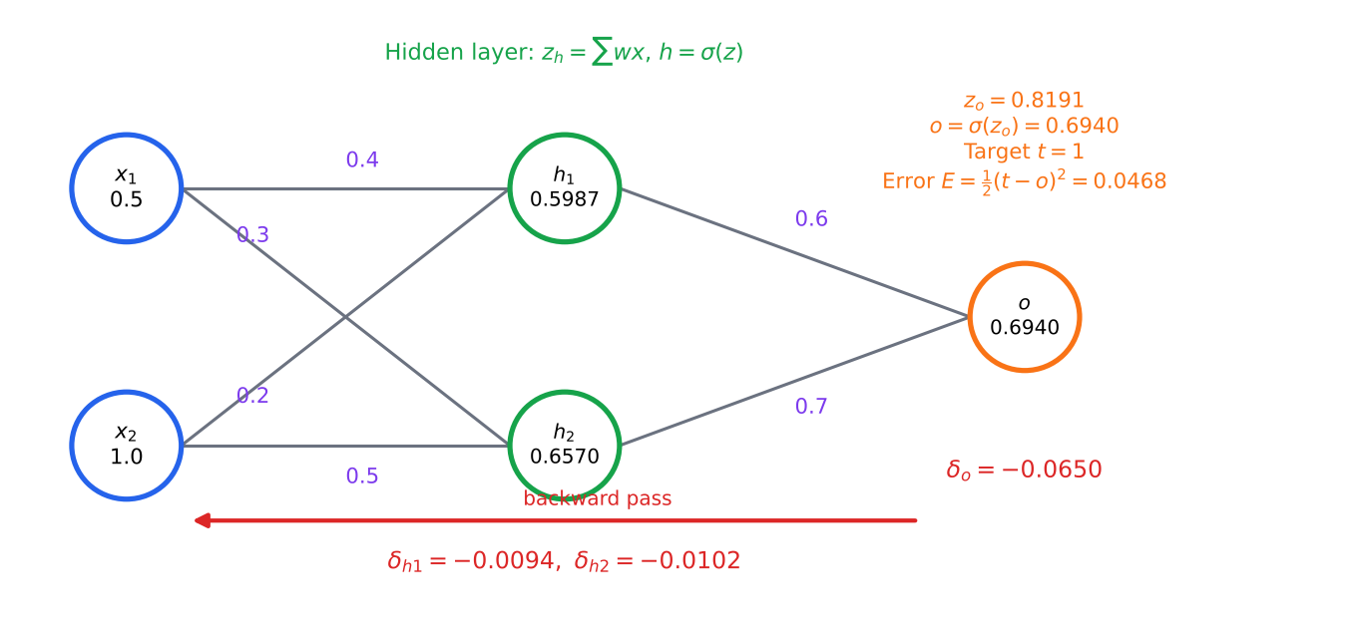
Figure 15: Numerical 9: forward activations (black) and back-propagated deltas (red).

4.5 Practical points on training neural networks
Issue | Explanation / remedy
Learning rate η | Too large → divergence/oscillation; too small → very slow. Use decay schedules or adaptive optimisers (Adam).
Batch vs stochastic | Batch GD uses all samples per update; SGD one sample; mini-batch (e.g. 32–256) is the usual compromise.
Local minima / plateaus | Error surface is non-convex; random restarts, momentum help.
Vanishing gradient | Sigmoid/tanh derivatives < 1 shrink gradients layer after layer; use ReLU, good initialisation, batch-norm.
Overfitting | Early stopping (monitor validation error), weight decay (L2 regularisation), dropout, more data.
Input scaling | Standardise features so that no input dominates; random, small, non-symmetric initial weights.

5. Quick-Revision Formula Sheet
Topic | Key formulas
Ridge / LASSO | J = Σ(y − ŷ)² + λΣw² / + λΣ|w| ; ridge: w = (XᵀX + λI)⁻¹Xᵀy
Classification metrics | Acc = (TP+TN)/N; P = TP/(TP+FP); R = TP/(TP+FN); F1 = 2PR/(P+R); FPR = FP/(FP+TN)
ROC / AUC | ROC = TPR vs FPR; AUC=1 perfect, 0.5 random
Regression metrics | MAE = Σ|e|/n; RMSE = √(Σe²/n); R² = 1 − SSE/SST
SVM | Hyperplane wᵀx+b=0; margin = 2/‖w‖; min ½‖w‖² s.t. y(wᵀx+b) ≥ 1; w = Σαyx
Kernels | Poly (xᵀz+c)ᵈ; RBF exp(−‖x−z‖²/2σ²)
Perceptron | y = step(wᵀx+b); w ← w + η(t − y)x
Activations | σ = 1/(1+e⁻ᶻ), σ′=σ(1−σ); tanh′ = 1 − tanh²; ReLU = max(0,z)
Back-propagation | δ_out = (o−t)f′(z); δ_hidden = f′(z)Σwδ; Δw = −η δ·input

6. Sample Questions
The questions below follow the pattern of the shared internal test (Part A/B with marks, CO and Bloom level) and of the end-semester pattern (Part A: 3 marks; Part B: 9 marks, up to 3 sub-divisions). The last column points to the section containing the answer.

6.1 Part A – short answer (3 marks each)
Q. | Question | BL | Answer in
1 | Differentiate between underfitting and overfitting. Mention one remedy for each. | K2 | 1.2
2 | Write the cost functions of Ridge and LASSO regression. Which one performs feature selection and why? | K2 | 1.4
3 | What is the need for a validation set in addition to a test set? | K2 | 1.3
4 | Define precision, recall and F1-score. A classifier gives TP = 30, FP = 10, FN = 20; compute precision and recall. | K3 | 2.1 (P = 0.75, R = 0.60)
5 | What is a ROC curve? What does an AUC of 0.5 indicate? | K2 | 2.2
6 | Define MAE, RMSE and R². Which is expressed in the same unit as the target? | K2 | 2.3
7 | What is a maximum-margin hyperplane? Write the expression for the margin. | K2 | 3.1
8 | What are support vectors? What is the role of the parameter C in a soft-margin SVM? | K2 | 3.1
9 | Explain the kernel trick. Write any two kernel functions. | K2 | 3.2
10 | Why can a single perceptron not solve the XOR problem? | K2 | 4.1
11 | Write the sigmoid, tanh and ReLU functions and their derivatives. | K1 | 4.3
12 | Write the perceptron weight-update rule. What does the learning rate control? | K2 | 4.1
13 | What is the vanishing-gradient problem? Name an activation function that reduces it. | K2 | 4.3 / 4.5
14 | Compare accuracy and F1-score for an imbalanced dataset with an example. | K3 | 2.1

6.2 Part B – descriptive (9 marks each, answer-any-one-of-two format)
Q. | Question | BL | Answer in
1 | (a) Explain overfitting and underfitting with suitable diagrams and list the remedies. (4)  (b) Explain Ridge and LASSO regularisation with mathematical formulations and compare them. (5) | K3 | 1.2, 1.4
2 | (a) With Ridge and LASSO, explain why LASSO yields sparse solutions (use a diagram). (4)  (b) For x = (1,2,3), y = (2,4,5) and model y = wx, find w for Ridge with λ = 2 and for LASSO with λ = 10. (5) | K3 | 1.4, Numerical 2
3 | (a) Define confusion matrix, accuracy, precision, recall and F1-score. (4)  (b) A classifier gives TP = 45, FN = 5, FP = 10, TN = 40. Compute all measures and comment on which metric is critical for cancer screening. (5) | K3 | 2.1, Numerical 3
4 | (a) Explain the ROC curve and AUC. (3)  (b) For the scores 0.95(P), 0.85(P), 0.80(N), 0.70(P), 0.60(N), 0.55(P), 0.45(N), 0.40(P), 0.30(N), 0.10(N), draw the ROC curve and compute the AUC. (6) | K3 | 2.2, Numerical 4
5 | (a) Define MAE, RMSE and R². (3)  (b) Actual = (3, 5, 2, 7), predicted = (2.5, 5.5, 2, 8). Compute the three measures and interpret R². (6) | K3 | 2.3, Numerical 5
6 | (a) Explain the concept of hyperplane and maximum-margin classification in a linear SVM. (3)  (b) Derive the optimisation problem (primal and dual) of a hard-margin SVM. (3)  (c) Find the hyperplane for support vectors (1,0)→−1, (3,1)→+1, (3,−1)→+1. (3) | K3 | 3.1, Numerical 6
7 | (a) Explain how kernels allow SVMs to learn non-linear functions. (4)  (b) Describe polynomial and RBF kernels. (2)  (c) For x=(1,2), z=(3,1) compute (xᵀz+1)² and verify it by explicit feature mapping. (3) | K3 | 3.2, Numerical 7
8 | (a) Explain the perceptron model and its learning rule. (3)  (b) Train a perceptron for the AND gate (w=0, b=0, η=1) showing at least two epochs. (4)  (c) Why does it fail for XOR? How does an MLP fix this? (2) | K3 | 4.1, 4.2, Numerical 8
9 | (a) Describe the architecture of a multilayer feed-forward network. (3)  (b) Explain the commonly used activation functions with graphs. (3)  (c) Why are non-linear activations essential? (3) | K2 | 4.2, 4.3
10 | (a) Explain the back-propagation algorithm with the necessary equations. (5)  (b) For a 2-2-1 sigmoid network with x=(0.5,1), t=1, weights as in Numerical 9, compute the output and the updated weights of the hidden→output layer for η=0.5. (4) | K3 | 4.4, Numerical 9
11 | (a) Explain training, validation and test sets. Why is a separate validation set needed? (4)  (b) Explain how early stopping and weight decay prevent overfitting in neural networks. (5) | K2 | 1.3, 4.5

6.3 Internal-test style questions (5 marks each)
Q. | Question | CO | BL
1 | Explain the concept of overfitting and underfitting with diagrams. | CO2 | L2
2 | Explain LASSO and Ridge regularisation. Compare them with mathematical formulations. | CO2 | L3
3 | Define Precision, Recall and F1-Score. When is each metric particularly important? | CO5 | L2
4 | Explain the ROC curve and AUC with a neat diagram. | CO5 | L2
5 | Explain the maximum margin hyperplane and support vectors in linear SVM. | CO2 | L2
6 | Explain the kernel trick. Compare linear, polynomial and RBF kernels. | CO2 | L3
7 | Explain the perceptron learning algorithm. Why can it not solve XOR? | CO3 | L3
8 | Explain sigmoid, tanh and ReLU activation functions with their advantages and disadvantages. | CO3 | L2
9 | Explain the back-propagation algorithm for a multilayer network. | CO3 | L3

6.4 Practice numerical problems (with answers)
Q. | Problem | Answer
1 | A classifier has TP = 70, FN = 30, FP = 20, TN = 80. Find accuracy, precision, recall and F1. | Accuracy = 0.75; precision = 70/90 = 0.778; recall = 70/100 = 0.70; F1 = 0.737
2 | Actual y = (10, 12, 14, 18), predicted ŷ = (11, 12, 13, 20). Find MAE, MSE, RMSE and R². | Errors (−1, 0, 1, −2): MAE = 1.0; MSE = 1.5; RMSE = 1.225; ȳ = 13.5, SST = 35, SSE = 6 → R² = 0.829
3 | For x = (1, 2, 3), y = (3, 5, 8), model y = wx: find the OLS, Ridge (λ = 7) and LASSO (λ = 10) weights. | Σxy = 37, Σx² = 14. OLS = 2.643; Ridge = 37/21 = 1.762; LASSO = (37 − 5)/14 = 2.286 (LASSO reaches 0 only when λ ≥ 74)
4 | A 2-D SVM has one positive support vector (3, 3) and one negative support vector (1, 1). Find w, b and the margin. | w = (0.5, 0.5), b = −2 (from 6a + b = 1, 2a + b = −1); margin = 2/‖w‖ = 2/0.707 = 2.83 (equal to the distance between the two points)
5 | Train a perceptron for the OR gate: w = 0, b = 0, η = 1, output 1 if z ≥ 0. | Epoch 1 ends with w = (0,1), b = 0; epoch 2 with (1,1), 0; epoch 3 with (1,1), −1; epoch 4 has no change. Final: x₁ + x₂ − 1 ≥ 0
6 | A neuron has inputs (1, 2), weights (0.5, −0.3) and bias 0.4. Find the output for sigmoid, tanh and ReLU. | z = 0.5 − 0.6 + 0.4 = 0.3. σ = 0.574; tanh = 0.291; ReLU = 0.3
7 | Kernel: x = (2, 1), z = (1, 3). Compute the polynomial kernel (xᵀz + 1)² and the RBF kernel with σ = 1. | xᵀz = 5 → (5+1)² = 36; ‖x−z‖² = 1 + 4 = 5 → exp(−2.5) = 0.0821

These notes are prepared from the PCCST503 syllabus and the prescribed textbooks (Alpaydin; Zaki & Meira; Bishop). Students should read the corresponding textbook chapters for proofs and additional examples.

