PCCST503 • MACHINE LEARNING • SEMESTER S5
Module 4
Unsupervised Learning, Ensembles & Resampling
Complete study notes with diagrams, worked numerical problems and exam-style questions

Syllabus topic (Module 4) | Section | Reference
Clustering – similarity measures, hierarchical (agglomerative), partitional, K-means | 1 | Zaki Ch. 13–14; Alpaydin (Clustering)
Dimensionality reduction – PCA, multidimensional scaling | 2 | Zaki Ch. 7; Alpaydin (Dimensionality Reduction)
Ensemble methods – bagging, boosting | 3 | Alpaydin (Ensemble Learning)
Resampling – bootstrapping, cross-validation | 4 | Alpaydin (Design & Analysis of ML Experiments); Zaki Ch. 22
Practical aspects – bias–variance trade-off | 5 | Alpaydin (Model Selection & Generalization)
Quick-revision formula sheet | 6 | –
Sample questions and practice problems with answers | 7 | Follows the pattern of the shared sample paper

How to use these notes
This module maps to CO4 (unsupervised learning and dimensionality reduction) and CO5 (performance evaluation / resampling). In the ESE it supplies 2 Part-A questions (3 marks each) and one 9-mark Part-B question.
Numerical problems most likely: distance / similarity values, hierarchical clustering by single/complete/average link, one or two K-means iterations, PCA on a small 2-D data set, AdaBoost weight update, and bias–variance calculation. Each is worked out below.

1. Clustering

1.1 Unsupervised learning and clustering
In unsupervised learning the data have no labels – we only observe inputs x and look for structure in them. Clustering partitions a set of objects into groups (clusters) such that objects in the same cluster are more similar to each other than to objects in other clusters (high intra-cluster similarity, low inter-cluster similarity).
Applications: customer segmentation, document / news grouping, image segmentation and colour quantisation, gene-expression analysis, anomaly detection, pre-processing for supervised learning.
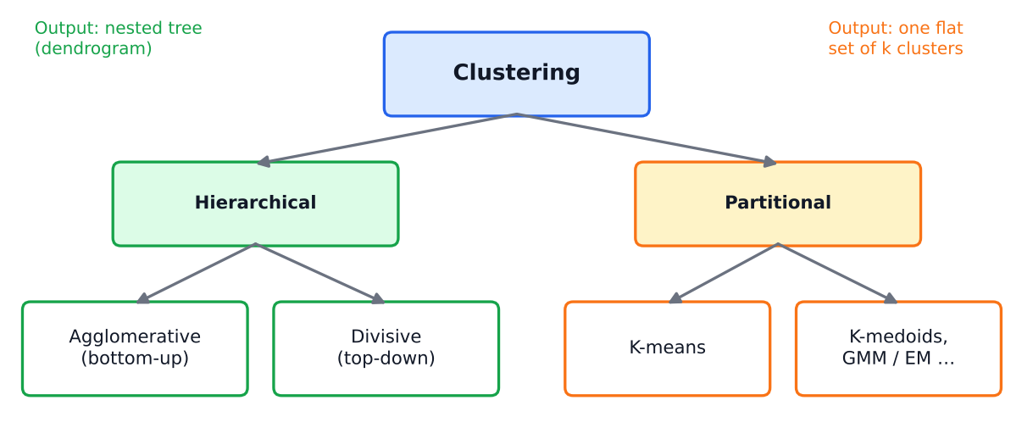
Figure 1: Main families of clustering algorithms.
 | Hierarchical | Partitional
Output | Nested clusters shown as a tree (dendrogram) | One flat partition into K clusters
K must be given? | No – choose by cutting the dendrogram | Yes (K-means needs K in advance)
Cost | O(n²)–O(n³) – poor for big data | ≈ O(n·K·d·iterations) – scales well
Decisions | Greedy, never undone | Iteratively refined

1.2 Similarity and distance measures
Clustering depends entirely on how 'closeness' is defined. For two d-dimensional points x and y:
Measure | Formula | Notes
Euclidean (L2) | d = √ Σᵢ (xᵢ − yᵢ)² | Straight-line distance; sensitive to feature scale → standardise first
Manhattan (L1, city-block) | d = Σᵢ |xᵢ − yᵢ| | Sum of axis-wise differences; less sensitive to outliers
Minkowski (Lp) | d = ( Σᵢ |xᵢ − yᵢ|ᵖ )^(1/p) | p=1 Manhattan, p=2 Euclidean, p→∞ Chebyshev
Chebyshev (L∞) | d = maxᵢ |xᵢ − yᵢ| | Largest single-coordinate difference
Cosine similarity | cos θ = (x·y) / (‖x‖ ‖y‖) | Measures angle, ignores length; popular for text. Cosine distance = 1 − cos θ
Jaccard (sets / binary) | J = |A ∩ B| / |A ∪ B| | Distance = 1 − J
Hamming (binary strings) | number of positions that differ | Categorical / binary data
Mahalanobis | d = √( (x−y)ᵀ Σ⁻¹ (x−y) ) | Accounts for correlation and scale (Σ = covariance matrix)

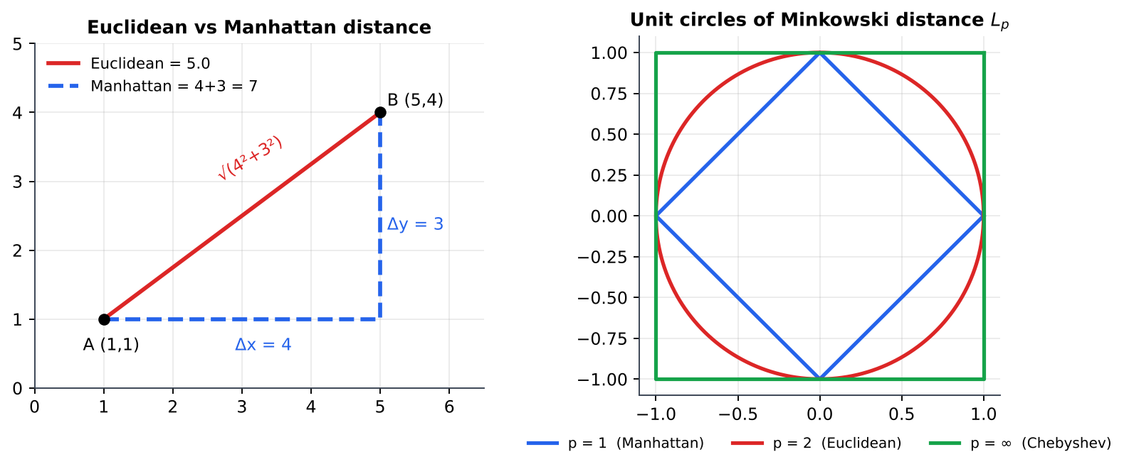
Figure 2: Left: Euclidean (diagonal) versus Manhattan (axis-parallel) path. Right: the set of points at distance 1 from the origin for p = 1, 2, ∞.
A valid distance metric satisfies: d(x,y) ≥ 0; d(x,y)=0 ⇔ x=y; symmetry d(x,y)=d(y,x); and the triangle inequality d(x,z) ≤ d(x,y)+d(y,z).
Numerical 1 – Computing similarity measures
A = (1, 2, 3), B = (4, 6, 3). Differences |A − B| = (3, 4, 0).
Euclidean = √(9 + 16 + 0) = 5
Manhattan = 3 + 4 + 0 = 7
Chebyshev = max(3, 4, 0) = 4
Minkowski (p = 3) = (27 + 64 + 0)^(1/3) = 91^(1/3) = 4.498
Cosine: A·B = 4 + 12 + 9 = 25; ‖A‖ = √14 = 3.742; ‖B‖ = √61 = 7.810 ⟹ cos θ = 25/(3.742 × 7.810) = 0.8555, cosine distance = 1 − 0.8555 = 0.1445
Jaccard: X = {a, b, c, d}, Y = {b, c, e}: |X∩Y| = 2, |X∪Y| = 5 ⟹ J = 0.4, distance = 0.6.
Hamming: 10110 vs 11100 differ in positions 2 and 4 ⟹ 2.

1.3 Hierarchical clustering – agglomerative
Agglomerative (bottom-up) clustering starts with every object as its own cluster and repeatedly merges the two closest clusters until a single cluster remains. (Divisive clustering works top-down by splitting.) The sequence of merges is drawn as a dendrogram; the height of a merge is the distance at which it happened. Cutting the dendrogram at a chosen height gives a flat clustering.

Algorithm
1. Compute the n × n proximity (distance) matrix.
2. Treat each point as a cluster.
3. Find the pair of clusters with the smallest inter-cluster distance and merge them.
4. Update the distance matrix using the chosen linkage rule.
5. Repeat steps 3–4 until one cluster is left; draw the dendrogram.
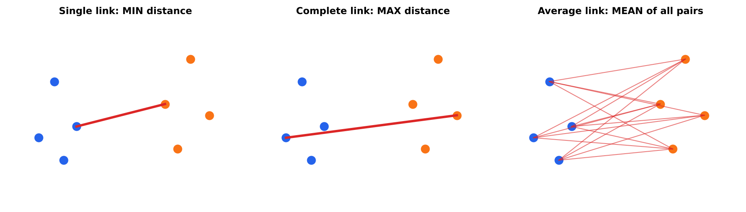
Figure 3: Linkage criteria define the distance between two clusters.
Linkage | Distance between clusters A and B | Behaviour
Single (MIN) | min d(a, b) over a∈A, b∈B | Can follow chains of points → elongated clusters; sensitive to noise ('chaining')
Complete (MAX) | max d(a, b) | Compact, roughly equal-diameter clusters; sensitive to outliers
Average (UPGMA) | mean of all |A||B| pair distances | Compromise between the two
Centroid / Ward | distance between centroids / increase in SSE after merging | Ward gives compact, variance-minimising clusters

Numerical 2 – Agglomerative clustering of five points
Points on a line: A = 1, B = 2, C = 6, D = 8, E = 15. Distance matrix (|difference|):

 | A | B | C | D | E
A | 0 | 1 | 5 | 7 | 14
B | 1 | 0 | 4 | 6 | 13
C | 5 | 4 | 0 | 2 | 9
D | 7 | 6 | 2 | 0 | 7
E | 14 | 13 | 9 | 7 | 0

Solution (single, complete and average link)
Step 1: smallest entry is d(A,B) = 1 → merge {A,B} at height 1 (all linkages).
Step 2: next smallest d(C,D) = 2 → merge {C,D} at height 2.
Step 3: distance between {A,B} and {C,D}: Single = min(5, 7, 4, 6) = 4; Complete = max(5, 7, 4, 6) = 7; Average = (5 + 7 + 4 + 6)/4 = 5.5.
Step 4: distance of E to {A,B,C,D}: Single = min(14, 13, 9, 7) = 7; Complete = max = 14; Average = (14 + 13 + 9 + 7)/4 = 10.75.
Merge heights – Single: 1, 2, 4, 7; Complete: 1, 2, 7, 14; Average: 1, 2, 5.5, 10.75.
Cutting at height 3 gives the same 3 clusters {A,B}, {C,D}, {E} for all linkages.

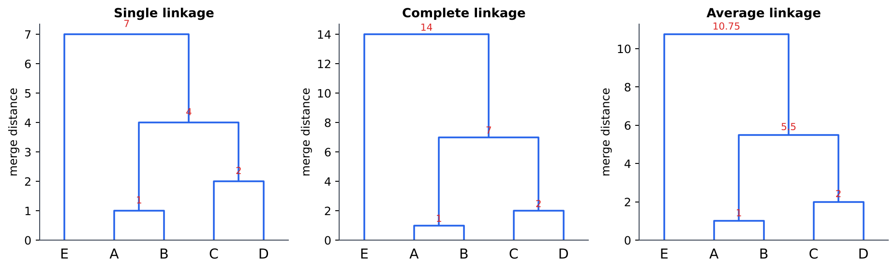
Figure 4: Dendrograms for Numerical 2 (merge heights in red).
Pros: no need to fix K in advance, dendrogram gives a multi-scale view, works with any distance. Cons: O(n²) memory and O(n³) time (naïve), merges can never be undone, choice of linkage strongly affects the result.

1.4 Partitional clustering and K-means
Partitional methods directly divide the data into K groups. K-means represents each cluster by its centroid (mean) and minimises the within-cluster sum of squared errors (SSE):
J = Σₖ Σ_{x ∈ Cₖ} ‖x − μₖ‖² , μₖ = (1/|Cₖ|) Σ_{x ∈ Cₖ} x

Algorithm (Lloyd's algorithm)
1. Choose K and initialise K centroids (e.g. K random data points).
2. Assignment step: assign each point to its nearest centroid.
3. Update step: recompute each centroid as the mean of the points assigned to it.
4. Repeat steps 2–3 until the assignments (or centroids) no longer change, or SSE stops decreasing.
Numerical 3 – K-means with K = 2
Data: P1 (1,1), P2 (1.5,2), P3 (3,4.5), P4 (5,7), P5 (3.5,5), P6 (4.5,5), P7 (3.5,4.5). Initial centroids c₁ = P1 = (1,1), c₂ = P2 = (1.5,2). Use Euclidean distance.

Point | Iter. 1  d(c₁=(1,1)) | d(c₂=(1.5,2)) | Cluster | Iter. 2  d(c₁=(1,1)) | d(c₂=(3.5,4.67)) | Cluster | Iter. 3  d(c₁=(1.25,1.5)) | d(c₂=(3.9,5.2)) | Cluster
P1 | 0.00 | 1.12 | 1 | 0.00 | 4.44 | 1 | 0.56 | 5.10 | 1
P2 | 1.12 | 0.00 | 2 | 1.12 | 3.33 | 1 | 0.56 | 4.00 | 1
P3 | 4.03 | 2.92 | 2 | 4.03 | 0.53 | 2 | 3.47 | 1.14 | 2
P4 | 7.21 | 6.10 | 2 | 7.21 | 2.77 | 2 | 6.66 | 2.11 | 2
P5 | 4.72 | 3.61 | 2 | 4.72 | 0.33 | 2 | 4.16 | 0.45 | 2
P6 | 5.32 | 4.24 | 2 | 5.32 | 1.05 | 2 | 4.78 | 0.63 | 2
P7 | 4.30 | 3.20 | 2 | 4.30 | 0.17 | 2 | 3.75 | 0.81 | 2

- After iteration 1: cluster 1 = {P1}, cluster 2 = {P2,…,P7}. New centroids: c₁ = (1, 1); c₂ = ((1.5+3+5+3.5+4.5+3.5)/6, (2+4.5+7+5+5+4.5)/6) = (3.5, 4.67).
- After iteration 2: P2 moves to cluster 1. New centroids: c₁ = ((1+1.5)/2, (1+2)/2) = (1.25, 1.5); c₂ = ((3+5+3.5+4.5+3.5)/5, (4.5+7+5+5+4.5)/5) = (3.9, 5.2).
- Iteration 3: the assignments do not change → converged. Final clusters {P1, P2} and {P3, P4, P5, P6, P7}.
- Final SSE = [0.3125 + 0.3125] + [1.30 + 4.45 + 0.20 + 0.40 + 0.65] = 0.625 + 7.00 = 7.625.
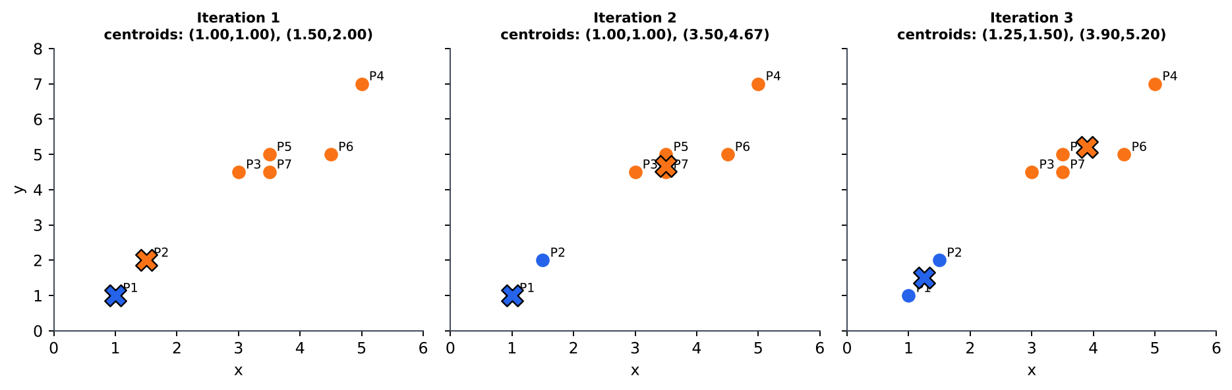
Figure 5: The three iterations of Numerical 3 (✕ = centroid).

Choosing K – the elbow method
Run K-means for K = 1, 2, 3, … and plot SSE against K. SSE always decreases as K grows; the 'elbow' where the decrease suddenly slows indicates a good K. (The silhouette score is another popular criterion.)
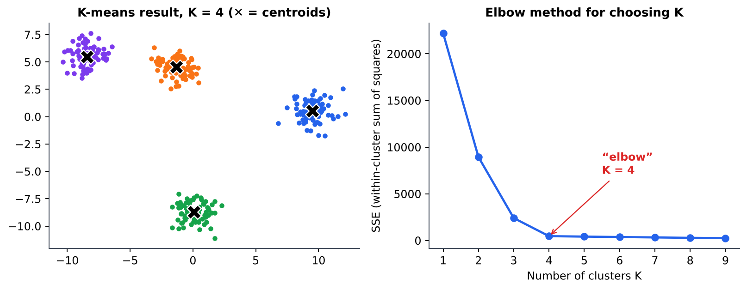
Figure 6: K-means on four natural groups (left) and its elbow plot (right).
Properties and limitations of K-means
• Always converges (SSE never increases) but only to a local minimum → run several random restarts or use K-means++ initialisation.
• Assumes roughly spherical, similarly sized clusters; fails on crescent or nested shapes.
• Sensitive to outliers (mean is not robust) → K-medoids uses an actual data point as centre.
• Needs K in advance and numeric features; scale features first.
• Time ≈ O(n·K·d·t) – efficient for large data sets.

2. Dimensionality Reduction

2.1 Why reduce dimensions?
- Curse of dimensionality: as d grows, data become sparse and distances lose meaning; more samples are needed.
- Remove redundant / correlated or noisy features; reduce storage and computation.
- Allow visualisation in 2-D or 3-D; often reduces overfitting.
Feature selection | Feature extraction
Choose a subset of the original features (filter, wrapper, embedded such as LASSO) | Create new features as combinations of the originals (PCA, MDS, LDA)

2.2 Principal Component Analysis (PCA)
PCA is an unsupervised linear technique that finds new orthogonal axes – the principal components – along which the data have the maximum variance. The first component (PC1) captures the most variance, PC2 the most of what remains and is perpendicular to PC1, and so on. Keeping only the first k components gives the best k-dimensional linear approximation in the sense of minimum squared reconstruction error.
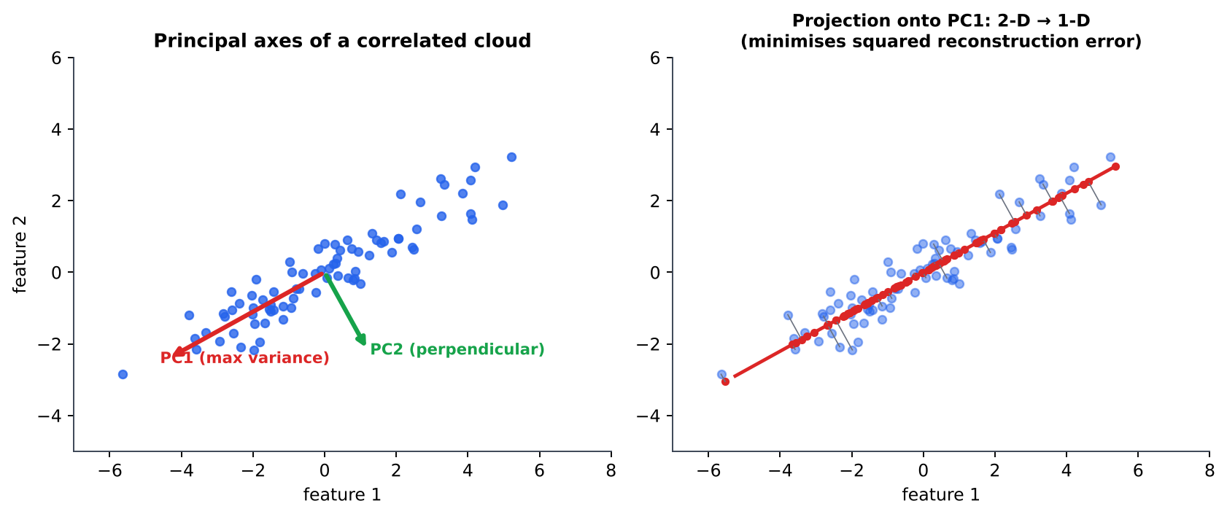
Figure 7: Left: principal axes of a correlated cloud. Right: projecting onto PC1 reduces 2-D to 1-D with little loss.

Derivation in brief
Project centred data onto a unit vector w: the variance of the projection is wᵀΣw, where Σ is the covariance matrix. Maximising wᵀΣw subject to wᵀw = 1 with a Lagrange multiplier gives the eigen-equation
Σ w = λ w
so the principal components are the eigenvectors of the covariance matrix and the variance along each is the corresponding eigenvalue λ. The eigenvector with the largest eigenvalue is PC1.

Algorithm
1. Arrange the data in an n × d matrix X. Centre each column: Z = X − μ (standardise too if features have different units).
2. Compute the covariance matrix Σ = ZᵀZ / (n − 1) (d × d).
3. Find eigenvalues λ₁ ≥ λ₂ ≥ … ≥ λ_d and eigenvectors e₁, …, e_d (from det(Σ − λI) = 0 and (Σ − λI)e = 0).
4. Choose k such that the proportion of variance (λ₁+…+λₖ)/(λ₁+…+λ_d) reaches the target (e.g. ≥ 95%), or use the scree plot elbow.
5. Project: Y = Z · [e₁ … eₖ] (n × k new data).
Numerical 4 – PCA on four 2-D points
Data: A (4, 11), B (8, 4), C (13, 5), D (7, 14). Find the first principal component and the 1-D projections.
Step 1 – Mean: μ = ((4+8+13+7)/4, (11+4+5+14)/4) = (8, 8.5). Centred data: A (−4, 2.5), B (0, −4.5), C (5, −3.5), D (−1, 5.5).
Step 2 – Covariance (divide by n−1 = 3):
var(x) = (16 + 0 + 25 + 1)/3 = 14, var(y) = (6.25 + 20.25 + 12.25 + 30.25)/3 = 23, cov(x,y) = (−10 + 0 − 17.5 − 5.5)/3 = −11
Σ = [[14, −11], [−11, 23]]
Step 3 – Eigenvalues: det(Σ − λI) = (14 − λ)(23 − λ) − 121 = λ² − 37λ + 201 = 0 ⟹ λ = (37 ± √565)/2 = (37 ± 23.77)/2 ⟹ λ₁ = 30.38, λ₂ = 6.62.
Step 4 – Eigenvector for λ₁: (14 − 30.38)a − 11b = 0 ⟹ b = −1.489a. Normalising (a² + b² = 1) gives e₁ = (−0.557, 0.830)ᵀ (sign is arbitrary; e₂ = (0.830, 0.557)ᵀ).
Step 5 – Variance explained by PC1 = 30.38/(30.38 + 6.62) = 30.38/37 = 82.1%.
Step 6 – Projection on PC1 (z·e₁): A: (−4)(−0.557) + 2.5(0.830) = 4.31; B: 0 + (−4.5)(0.830) = −3.74; C: 5(−0.557) + (−3.5)(0.830) = −5.69; D: (−1)(−0.557) + 5.5(0.830) = 5.12. (They sum to ≈ 0, as centred data must.)
The four 2-D points are now represented by four numbers while retaining 82% of the variance.

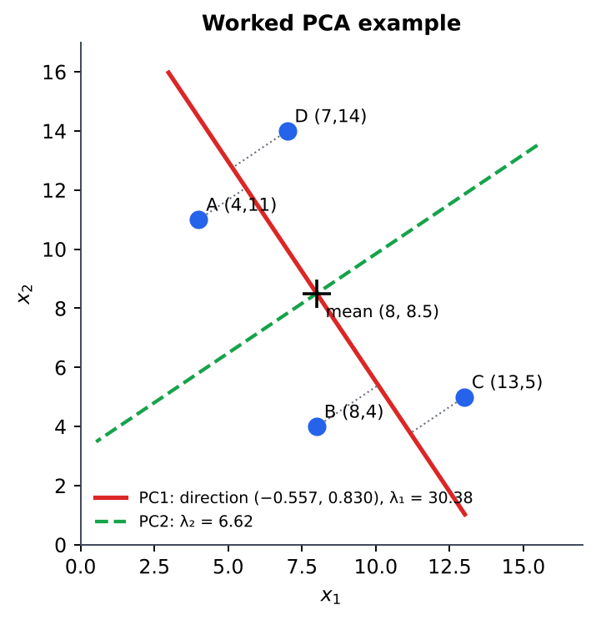
Figure 8: Numerical 4: the data, PC1 (solid red) and PC2 (dashed green); dotted lines are the projections onto PC1.
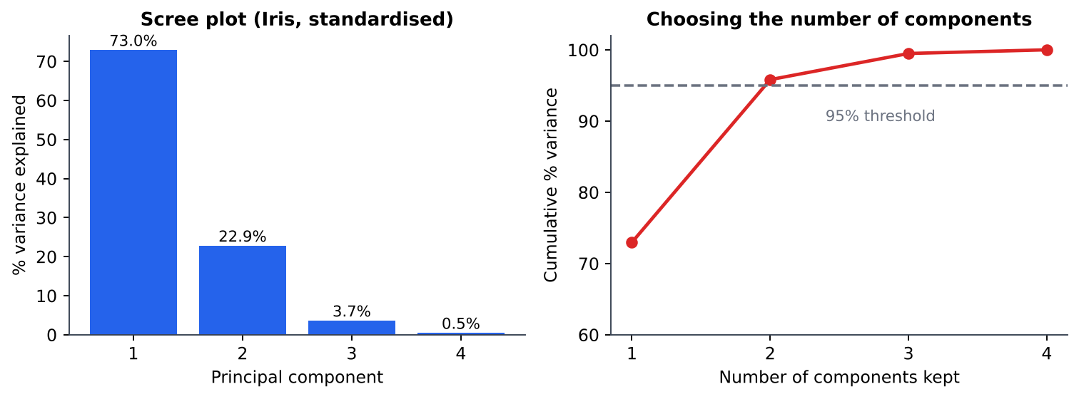
Figure 9: Scree plot and cumulative explained variance for the standardised Iris data: two components retain ≈ 96%.
PCA – points to remember
• Components are orthogonal and uncorrelated; eigenvalues sum to the total variance (trace of Σ).
• Sensitive to feature scale → standardise. Linear only (kernel PCA handles non-linear structure).
• Maximises variance, not class separation (LDA is the supervised alternative).
• Computed in practice by Singular Value Decomposition (SVD) of the centred data.

2.3 Multidimensional Scaling (MDS)
MDS takes as input only the pairwise distances (dissimilarities) δᵢⱼ between n objects – not their coordinates – and produces a low-dimensional map (usually 2-D) whose Euclidean distances dᵢⱼ approximate δᵢⱼ as closely as possible. It is used to visualise similarity data (e.g. perceived similarity of brands, distances between cities, genetic distances).
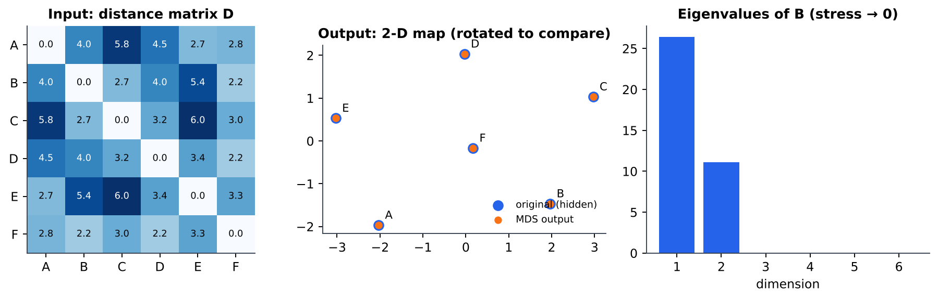
Figure 10: Classical MDS: from a distance matrix (left) to a 2-D configuration (centre) that recovers the hidden layout (up to rotation / reflection); only two eigenvalues are non-zero (right).

Classical (metric) MDS algorithm
1. Form the matrix of squared distances D² = [δᵢⱼ²].
2. Double-centre it: B = −½ J D² J, where J = I − (1/n)11ᵀ (B is the matrix of inner products).
3. Eigen-decompose B and keep the k largest positive eigenvalues λ₁…λₖ with eigenvectors v₁…vₖ.
4. Coordinates: X = [v₁ … vₖ] · diag(√λ₁, …, √λₖ).
Non-metric MDS uses only the rank order of the dissimilarities and minimises a stress function, e.g. Stress = √( Σᵢ<ⱼ (dᵢⱼ − δ̂ᵢⱼ)² / Σᵢ<ⱼ dᵢⱼ² ), by iterative optimisation (low stress = good fit). If the input distances are Euclidean, classical MDS gives the same result as PCA.
Numerical 5 – Classical MDS for three points
Given distances d₁₂ = 1, d₁₃ = 3, d₂₃ = 2, recover the configuration in 1-D.
Step 1 – squared distances: D² = [[0, 1, 9], [1, 0, 4], [9, 4, 0]]. Row means r = (10/3, 5/3, 13/3) = (3.333, 1.667, 4.333); grand mean g = 28/9 = 3.111.
Step 2 – double-centring: bᵢⱼ = −½ (d²ᵢⱼ − rᵢ − rⱼ + g). e.g. b₁₁ = −½(0 − 3.333 − 3.333 + 3.111) = 1.778; b₁₂ = −½(1 − 3.333 − 1.667 + 3.111) = 0.444; … giving
B = (1/9)·[[16, 4, −20], [4, 1, −5], [−20, −5, 25]]
Step 3 – eigen-decomposition: B has rank 1 (the points are collinear): its only non-zero eigenvalue is λ = 4.667 (= trace of B), with unit eigenvector v = (−0.617, −0.154, 0.772).
Step 4 – coordinates: x = √4.667 · v = 2.160 · v = (−1.333, −0.333, 1.667).
Check: |x₁ − x₂| = 1, |x₂ − x₃| = 2, |x₁ − x₃| = 3 ✓ – the original distances are reproduced exactly (the layout 0, 1, 3 shifted so that the mean is 0).

 | PCA | MDS
Input | Feature matrix X (n × d) | Distance / dissimilarity matrix (n × n)
Goal | Maximise retained variance | Preserve pairwise distances
Works when only distances known? | No | Yes
Eigen-decomposition of | Covariance matrix (d × d) | Double-centred distance matrix (n × n)
Relation | With Euclidean distances, classical MDS ≡ PCA scores

3. Ensemble Methods

3.1 Idea of ensembles
No single learner is best for every problem. An ensemble combines the predictions of several base learners (by voting or averaging) to obtain a model that is more accurate and more stable than any individual one – like asking a committee instead of one expert. Ensembles work when the base learners are (i) better than random guessing and (ii) diverse (make different errors).
Numerical 6a – Why majority voting helps
Three independent classifiers each have accuracy 0.7. The majority vote is correct if at least 2 of 3 are correct:
P = C(3,2)(0.7)²(0.3) + C(3,3)(0.7)³ = 3(0.49)(0.3) + 0.343 = 0.441 + 0.343 = 0.784 > 0.7.
With 5 such classifiers the accuracy is 0.837; with 11 it is 0.922. (This requires independence; correlated errors reduce the gain.)

3.2 Bagging (Bootstrap AGGregatING)
1. From the training set of N examples draw M bootstrap samples (N draws with replacement each).
2. Train one base model (typically an unpruned decision tree) on each sample, independently / in parallel.
3. Combine: majority vote for classification, average for regression.
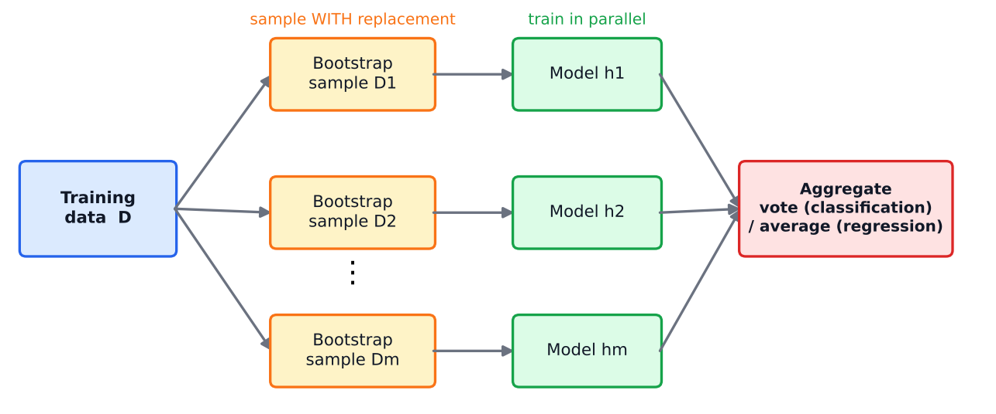
Figure 11: Bagging: parallel models on bootstrap samples, then aggregation.
- Reduces variance (not bias) – best with unstable, low-bias, high-variance learners such as deep decision trees.
- Each model sees only ≈ 63.2% distinct points; the remaining out-of-bag (OOB) points give a free estimate of test error.
- Random Forest = bagging of decision trees + at each split only a random subset of features is considered, which further de-correlates the trees.

3.3 Boosting
Boosting builds learners sequentially: each new weak learner concentrates on the examples that the previous ones got wrong. The final prediction is a weighted vote of all weak learners. Boosting mainly reduces bias (and some variance).

AdaBoost (binary labels y ∈ {−1, +1})
1. Initialise sample weights wᵢ = 1/N.
2. For t = 1…T: train weak learner hₜ on the weighted data; compute weighted error εₜ = Σ wᵢ [hₜ(xᵢ) ≠ yᵢ].
3. Compute learner weight αₜ = ½ ln((1 − εₜ)/εₜ) (more accurate learner → larger α).
4. Update weights wᵢ ← wᵢ · exp(−αₜ yᵢ hₜ(xᵢ)) / Zₜ – correctly classified points are down-weighted, misclassified points up-weighted; Zₜ normalises Σw = 1.
5. Final classifier: H(x) = sign( Σₜ αₜ hₜ(x) ).
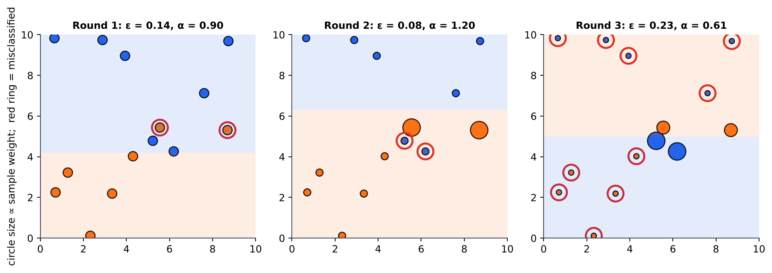
Figure 12: Three rounds of AdaBoost with decision stumps: misclassified points (red rings) grow larger and get more attention next round.
Numerical 6b – One round of AdaBoost
10 training samples, initial weights 0.1 each. The first weak learner misclassifies 3 of them.
Weighted error: ε₁ = 3 × 0.1 = 0.3.
Learner weight: α₁ = ½ ln(0.7/0.3) = ½ ln(2.333) = ½(0.8473) = 0.4236.
Multipliers: correct samples × e^(−0.4236) = × 0.6547; misclassified × e^(+0.4236) = × 1.5275.
Un-normalised weights: correct 0.1 × 0.6547 = 0.06547 (7 samples), wrong 0.1 × 1.5275 = 0.15275 (3 samples). Z₁ = 7(0.06547) + 3(0.15275) = 0.4583 + 0.4583 = 0.9165.
Normalised weights: correct 0.06547/0.9165 = 0.0714 (= 1/14), misclassified 0.15275/0.9165 = 0.1667 (= 1/6). The three hard samples now carry total weight 0.5 – half of the attention in the next round.
Final vote (if later rounds gave α₂ = 0.65, α₃ = 0.38): for a point with h₁ = +1, h₂ = −1, h₃ = +1: 0.42 − 0.65 + 0.38 = 0.15 > 0 ⟹ H(x) = +1.

 | Bagging | Boosting
Training | Parallel, independent models | Sequential, each depends on the previous
Data for each learner | Bootstrap sample (equal weights) | Whole data with adaptive weights
Combination | Simple vote / average | Weighted vote (α)
Main effect | Reduces variance | Reduces bias (and variance)
Base learners | Strong, unstable (deep trees) | Weak (stumps, shallow trees)
Noise / outliers | Robust | Sensitive (keeps boosting hard/noisy points)
Examples | Random Forest | AdaBoost, Gradient Boosting, XGBoost

Stacking (mention): the outputs of several different models are fed as inputs to a meta-learner that learns how best to combine them.

4. Resampling Methods
Resampling re-uses the single available data set many times, to estimate the performance of a model and the uncertainty of an estimate when we cannot collect new data.

4.1 Bootstrapping
A bootstrap sample is obtained by drawing n items with replacement from the n original items. Some items appear several times, others not at all. Repeating B times (B = 1000 typical) gives B pseudo-data sets, from which we compute a statistic (mean, median, accuracy …) and study its distribution – the bootstrap distribution – to get its standard error and confidence interval.
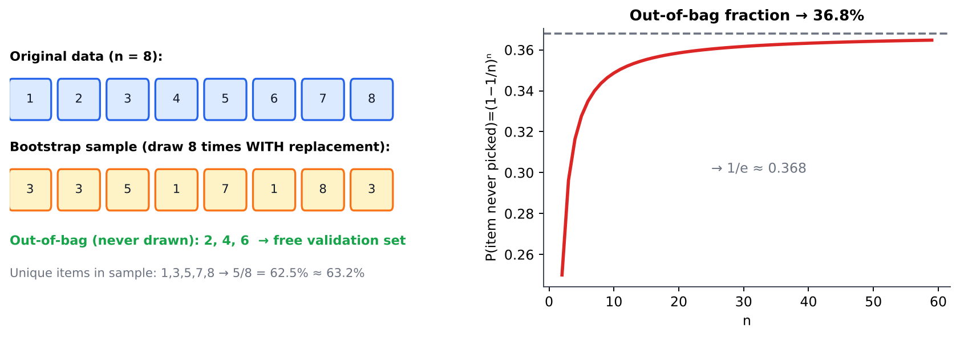
Figure 13: Left: one bootstrap sample of 8 items and its out-of-bag items. Right: the probability that an item is never chosen tends to 1/e ≈ 36.8%.
Important result
The probability that a particular item is not picked in n draws is (1 − 1/n)ⁿ → e⁻¹ ≈ 0.368. Hence a bootstrap sample contains about 63.2% distinct items and the other ≈ 36.8% are the out-of-bag (OOB) items, usable as a validation set.

n | 5 | 10 | 100 | 1000 | ∞
(1 − 1/n)ⁿ | 0.328 | 0.349 | 0.366 | 0.3677 | 0.3679
Fraction in sample | 0.672 | 0.651 | 0.634 | 0.632 | 0.632

Numerical 7 – Bootstrap estimate of a mean and its standard error
Original sample x = {2, 4, 6, 8, 10}. Three bootstrap samples (n = 5, with replacement) and their means:
B₁ = {2, 2, 6, 8, 10} → mean 5.6; B₂ = {4, 4, 6, 10, 10} → mean 6.8; B₃ = {2, 6, 6, 8, 8} → mean 6.0.
Bootstrap estimate of the mean = (5.6 + 6.8 + 6.0)/3 = 6.133.
Standard error = standard deviation of the bootstrap means = √[ ((−0.533)² + 0.667² + (−0.133)²)/(3 − 1) ] = √(0.7467/2) = √0.3733 = 0.611.
(With only 3 resamples this is rough; in practice B ≥ 1000 is used.)

4.2 Cross-validation
Cross-validation (CV) estimates generalisation error and selects hyper-parameters without wasting data on a fixed validation set.

k-fold cross-validation
1. Randomly split the data into k equal folds (k = 5 or 10 is typical).
2. For i = 1…k: train on the other k − 1 folds, test on fold i, record the score.
3. The CV estimate is the average of the k scores (the spread gives its variability).
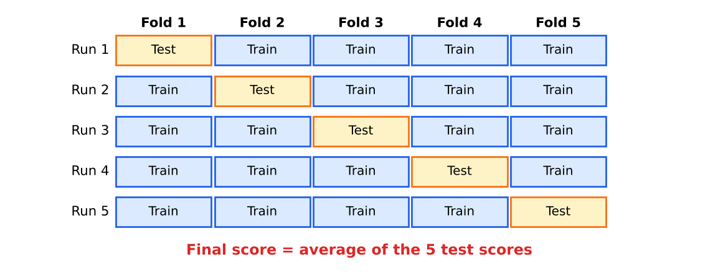
Figure 14: 5-fold cross-validation: every sample is used for testing exactly once and for training k − 1 times.
Variant | Description | Remarks
Hold-out | One fixed train/test split | Fast but high variance (depends on the split)
Stratified k-fold | Each fold keeps the class proportions | Use for classification and imbalanced data
Leave-one-out (LOOCV) | k = N: each sample is the test set once | Nearly unbiased, but N models – expensive; high variance
Repeated k-fold | k-fold repeated with different random splits | More stable estimate
Nested CV | Inner loop tunes hyper-parameters, outer loop evaluates | Gives an unbiased estimate when tuning is involved

Numerical 8 – Using k-fold CV
(a) A 5-fold CV on 20 samples gives accuracies 0.80, 0.75, 0.85, 0.90, 0.70. Each fold has 20/5 = 4 test and 16 training samples. CV accuracy = (0.80 + 0.75 + 0.85 + 0.90 + 0.70)/5 = 0.80; standard deviation (n−1) = √(0.025/4) = 0.079. LOOCV on 20 samples would need 20 trainings with 19 training samples each.
(b) Choosing a ridge parameter λ by 5-fold CV error:

λ | 0.01 | 0.1 | 1 | 10
Mean CV error | 0.30 | 0.22 | 0.18 | 0.25

The lowest CV error is at λ = 1, so λ = 1 is chosen; the final model is then re-trained on all training data with λ = 1 and evaluated once on the untouched test set.
Bootstrap | Cross-validation
Samples with replacement; ≈ 63.2% unique data per sample | Splits without replacement into disjoint folds
Gives distribution / standard error of any statistic; basis of bagging and OOB error | Gives performance estimate and model-selection criterion
Training sets overlap heavily with the original set (slightly optimistic) | Test folds are completely unseen by the model being tested

5. Practical Aspects: Bias–Variance Trade-off
Suppose the data are generated by y = f(x) + ε with noise ε of mean 0 and variance σ². We train a model f̂ on a random training set and look at its error at a fixed point x₀ averaged over all possible training sets. The expected squared error decomposes as
E[(y − f̂(x₀))²] = [ E f̂(x₀) − f(x₀) ]² + E[ ( f̂(x₀) − E f̂(x₀) )² ] + σ²
= Bias² + Variance + Irreducible noise
Term | Meaning | Large when
Bias | Systematic error: how far the average prediction (over training sets) is from the truth | Model too simple / wrong assumptions → underfitting
Variance | Sensitivity: how much the prediction changes when the training set changes | Model too flexible / too little data → overfitting
Noise σ² | Randomness in the data itself | Cannot be reduced by any model

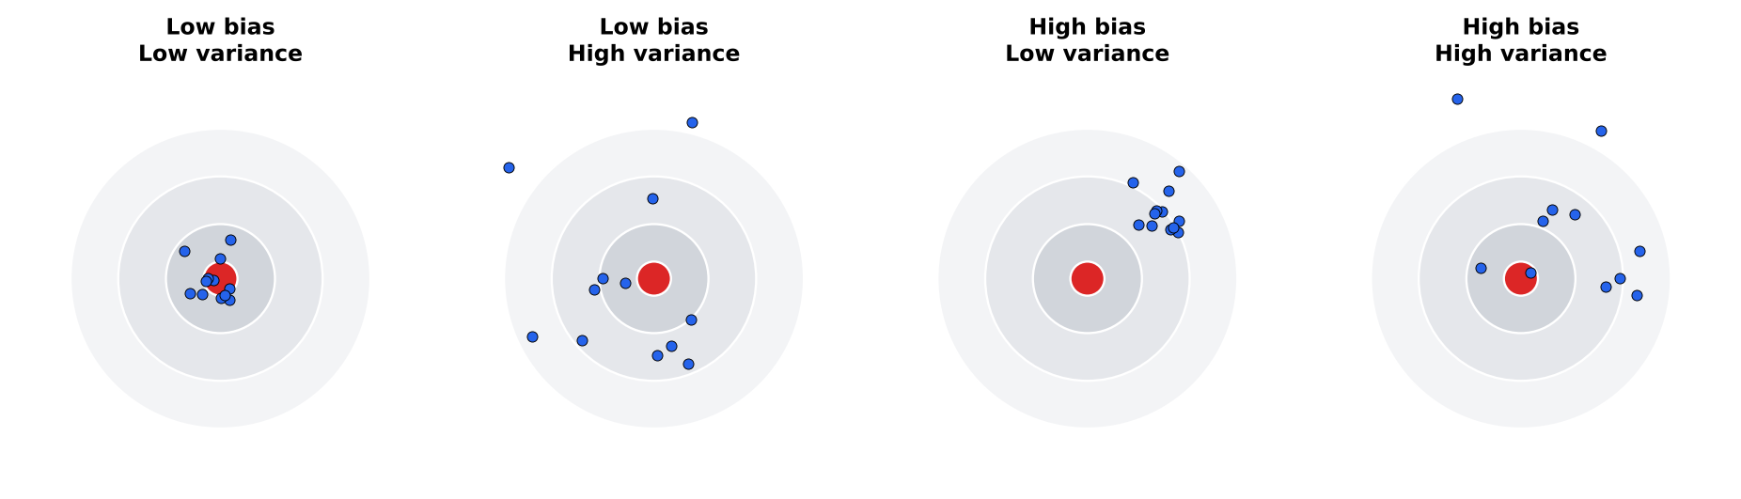
Figure 15: Dart-board view: bias = distance of the average hit from the bull's-eye, variance = scatter of the hits.
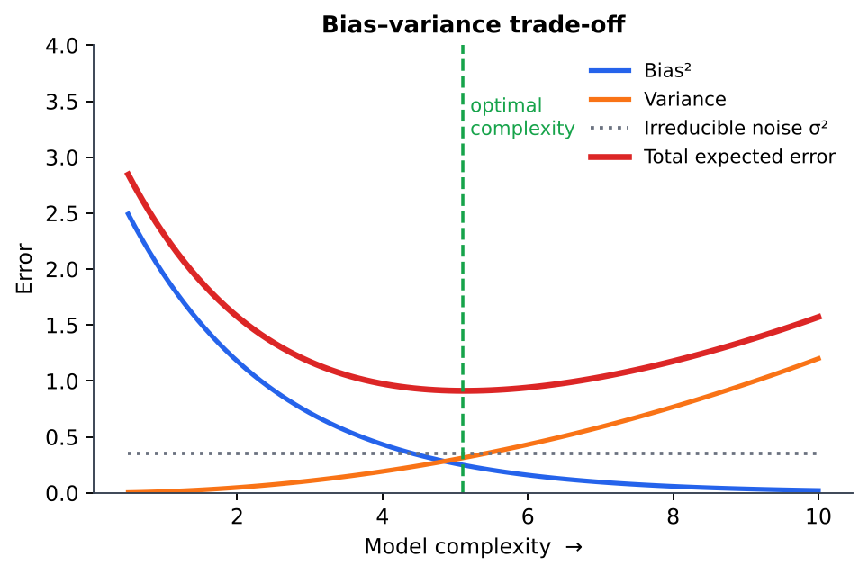
Figure 16: As model complexity increases, bias² falls but variance rises; total error is minimised at an intermediate complexity.

Diagnosing and controlling the trade-off
Symptom | Diagnosis | Remedies
Training error high, validation error high (similar) | High bias (underfitting) | More expressive model, extra features, lower regularisation λ, longer training, boosting
Training error low, validation error much higher | High variance (overfitting) | More data, simpler model, regularisation (↑λ), feature selection, dropout / early stopping, bagging / random forest, cross-validation

- Increasing regularisation λ raises bias and lowers variance; K in KNN: small K → low bias / high variance, large K → high bias / low variance; deeper trees → lower bias, higher variance.
- Bagging mainly cuts variance; boosting mainly cuts bias.
- The best model is found by minimising validation / cross-validation error – this is the practical way to sit at the sweet spot.
Numerical 9 – Computing bias² and variance
The true value at x₀ is f(x₀) = 10 and the noise variance is σ² = 0.5. Two models are trained on five different training sets; their predictions at x₀ are:
Model A (simple): 8.0, 8.2, 7.8, 8.1, 7.9; Model B (complex): 10.5, 9.0, 11.5, 8.5, 10.5.
Model A: mean = 8.0 ⟹ bias = 8.0 − 10 = −2 ⟹ Bias² = 4. Variance = [0² + 0.2² + (−0.2)² + 0.1² + (−0.1)²]/5 = 0.10/5 = 0.02. Expected error = 4 + 0.02 + 0.5 = 4.52.
Model B: mean = 10.0 ⟹ bias = 0 ⟹ Bias² = 0. Variance = [0.5² + (−1)² + 1.5² + (−1.5)² + 0.5²]/5 = (0.25 + 1 + 2.25 + 2.25 + 0.25)/5 = 6/5 = 1.2. Expected error = 0 + 1.2 + 0.5 = 1.70.
Model A is highly biased but very stable; model B is unbiased but unstable. Here B wins overall, but a model with moderate bias and moderate variance would do even better – the aim of the trade-off.

6. Quick-Revision Formula Sheet
Topic | Key formulas / facts
Distances | Euclid √Σ(x−y)²; Manhattan Σ|x−y|; Minkowski (Σ|x−y|ᵖ)^(1/p); cosine = x·y/(‖x‖‖y‖); Jaccard = |A∩B|/|A∪B|
Linkage | Single = min; Complete = max; Average = mean of all pairs
K-means | J = ΣₖΣ‖x − μₖ‖²; assign to nearest centroid → recompute means → repeat; elbow method for K
PCA | Σ = ZᵀZ/(n−1); Σe = λe; variance explained = λₖ/Σλ; Y = Z·E
MDS | B = −½ J D² J; X = V√Λ; stress = √(Σ(d−δ)²/Σd²)
Bagging | Bootstrap samples + average/vote → ↓ variance; OOB ≈ 36.8%
AdaBoost | ε = Σw[h≠y]; α = ½ ln((1−ε)/ε); w ← w e^(−α y h)/Z; H = sign(Σαh)
Bootstrap | P(not chosen) = (1−1/n)ⁿ → 0.368
k-fold CV | Score = mean of k test-fold scores; LOOCV: k = N
Bias–variance | Error = Bias² + Variance + σ²; complexity ↑ ⇒ bias ↓, variance ↑

7. Sample Questions
The questions follow the pattern of the shared internal test (Part A/B with marks, CO and Bloom level) and of the end-semester pattern (Part A: 3 marks; Part B: 9 marks, up to 3 sub-divisions). The last column points to the section containing the answer.

7.1 Part A – short answer (3 marks each)
Q. | Question | BL | Answer in
1 | Differentiate supervised and unsupervised learning. Give one example of clustering application. | K2 | 1.1
2 | Define Euclidean, Manhattan and cosine distance for two vectors. Compute the Euclidean and Manhattan distance between (2,3) and (5,7). | K3 | 1.2 (5 and 7)
3 | Differentiate single-link, complete-link and average-link in agglomerative clustering. | K2 | 1.3
4 | What is a dendrogram? How is a flat clustering obtained from it? | K2 | 1.3
5 | List the steps of the K-means algorithm. What is its objective function? | K2 | 1.4
6 | How can the value of K be chosen in K-means? Explain the elbow method. | K2 | 1.4
7 | List any three limitations of K-means. | K2 | 1.4
8 | What is the curse of dimensionality? Distinguish feature selection and feature extraction. | K2 | 2.1
9 | State the objective of PCA. How are principal components related to the covariance matrix? | K2 | 2.2
10 | How do you decide the number of principal components to retain? | K2 | 2.2
11 | What is multidimensional scaling? What input does it need? | K2 | 2.3
12 | What is an ensemble? Why does combining classifiers improve performance? | K2 | 3.1
13 | Differentiate bagging and boosting. | K2 | 3.3
14 | What is bootstrapping? What fraction of the data appears in a bootstrap sample? | K2 | 4.1
15 | Differentiate k-fold cross-validation and leave-one-out cross-validation. | K2 | 4.2
16 | What is the bias–variance trade-off? Name two ways to reduce variance. | K2 | 5

7.2 Part B – descriptive (9 marks each, answer-any-one-of-two format)
Q. | Question | BL | Answer in
1 | (a) Explain the different similarity / distance measures used in clustering. (4)  (b) Compute Euclidean, Manhattan, Chebyshev and cosine measures for A=(1,2,3), B=(4,6,3). (5) | K3 | 1.2, Numerical 1
2 | (a) Explain the agglomerative hierarchical clustering algorithm and the linkage criteria. (4)  (b) Cluster the points A=1, B=2, C=6, D=8, E=15 using single linkage and draw the dendrogram. (5) | K3 | 1.3, Numerical 2
3 | (a) Explain the K-means algorithm and its objective. (4)  (b) Apply K-means (K=2) to the points (1,1), (1.5,2), (3,4.5), (5,7), (3.5,5), (4.5,5), (3.5,4.5) with initial centroids (1,1) and (1.5,2); show two iterations. (5) | K3 | 1.4, Numerical 3
4 | (a) Compare hierarchical and partitional clustering. (3)  (b) Discuss the limitations of K-means and how they can be reduced (K-means++, restarts, elbow, K-medoids). (3)  (c) Cluster {2, 4, 10, 12, 3, 20, 30, 11, 25} into 2 clusters using K-means. (3) | K3 | 1.4, Practice 3
5 | (a) Explain the PCA algorithm with the underlying mathematics. (4)  (b) Find the first principal component of (4,11), (8,4), (13,5), (7,14) and the percentage of variance it explains. (5) | K3 | 2.2, Numerical 4
6 | (a) What is the need for dimensionality reduction? (2)  (b) Explain classical MDS and compare it with PCA. (4)  (c) Given d₁₂=1, d₁₃=3, d₂₃=2, find the 1-D configuration using classical MDS. (3) | K3 | 2.1, 2.3, Numerical 5
7 | (a) Explain bagging and Random Forest. Why does bagging reduce variance? (4)  (b) Explain AdaBoost with the weight-update equations. (5) | K2 | 3.2, 3.3
8 | (a) Explain the AdaBoost algorithm. (4)  (b) Ten samples start with equal weights; a weak learner misclassifies three of them. Compute ε, α and the updated normalised weights. (5) | K3 | 3.3, Numerical 6b
9 | (a) Explain bootstrapping and show that a bootstrap sample contains ≈ 63.2% of the original samples. (4)  (b) Estimate the mean and standard error from the bootstrap means 5.6, 6.8, 6.0. (2)  (c) Write a note on out-of-bag error. (3) | K3 | 4.1, Numerical 7
10 | (a) Explain k-fold cross-validation with a neat diagram. (4)  (b) Compare k-fold, stratified and leave-one-out CV. (3)  (c) How is CV used to select a hyper-parameter? Illustrate with an example. (2) | K3 | 4.2, Numerical 8
11 | (a) Derive the bias–variance decomposition of expected squared error. (4)  (b) Explain, with a diagram, how model complexity affects bias, variance and total error. (3)  (c) Suggest remedies for high bias and for high variance. (2) | K3 | 5
12 | (a) For true value 10 and σ² = 0.5, model A predictions (8.0, 8.2, 7.8, 8.1, 7.9) and model B predictions (10.5, 9, 11.5, 8.5, 10.5) over 5 training sets, compute bias², variance and expected error of each. (6)  (b) Which model would you prefer and why? (3) | K3 | 5, Numerical 9

7.3 Internal-test style questions (5 marks each)
Q. | Question | CO | BL
1 | Explain similarity measures used in clustering with examples. | CO4 | L2
2 | Explain agglomerative hierarchical clustering with a dendrogram. | CO4 | L3
3 | Explain the K-means algorithm. How is K selected? | CO4 | L3
4 | Explain Principal Component Analysis with steps. | CO4 | L3
5 | Explain multidimensional scaling. | CO4 | L2
6 | Compare bagging and boosting. | CO4 | L2
7 | Explain bootstrapping and cross-validation. | CO5 | L2
8 | Explain the bias–variance trade-off with a diagram. | CO5 | L2

7.4 Practice numerical problems (with answers)
Q. | Problem | Answer
1 | Find the Euclidean, Manhattan and Chebyshev distance between P = (2, 3) and Q = (5, 7). | Euclidean = √(9+16) = 5; Manhattan = 3 + 4 = 7; Chebyshev = 4
2 | Cluster the 1-D points {1, 3, 4, 9, 10} with single link and with complete link. Give the merge heights. | Single: (3,4) at 1, (9,10) at 1, {1}+{3,4} at 2, final at 5. Complete: (3,4) at 1, (9,10) at 1, {1}+{3,4} at 3, final at 9
3 | K-means, K = 2, on {2, 4, 10, 12, 3, 20, 30, 11, 25} with initial means 2 and 12. | Means (2,12) → (3,18) → (4.75,19.6) → (7,25) → stable. Clusters {2,3,4,10,11,12} (mean 7) and {20,25,30} (mean 25)
4 | Covariance matrix Σ = [[4, 2], [2, 3]]. Find the eigenvalues and the % variance of PC1. | λ² − 7λ + 8 = 0 ⟹ λ = (7 ± √17)/2 = 5.562, 1.438. PC1 variance = 5.562/7 = 79.4%. e₁ ≈ (0.788, 0.615)
5 | An AdaBoost learner has weighted error ε = 0.2 on 10 equally weighted samples. Find α and the new normalised weights. | α = ½ ln(0.8/0.2) = 0.693. Correct ×0.5, wrong ×2 ⟹ 8 × 0.05 + 2 × 0.2 = 0.8. Normalised: correct = 0.0625, wrong = 0.25
6 | For n = 10, find the probability that a given sample is absent from a bootstrap sample and the expected number of distinct samples. | (0.9)¹⁰ = 0.349; expected distinct = 10(1 − 0.349) = 6.51
7 | Predictions of a model at x₀ over 4 training sets: 4, 6, 5, 5; true value 6; σ² = 0.25. Find bias², variance, expected error. | Mean = 5 ⟹ bias² = 1; variance = (1 + 1 + 0 + 0)/4 = 0.5; error = 1 + 0.5 + 0.25 = 1.75
8 | 5-fold CV scores are 0.90, 0.85, 0.80, 0.95, 0.90. Report the CV accuracy. | (0.90+0.85+0.80+0.95+0.90)/5 = 0.88
9 | Find the cosine similarity of A = (1, 0, 1) and B = (0, 1, 1). | A·B = 1; ‖A‖ = ‖B‖ = √2 ⟹ cos θ = 1/2 = 0.5

These notes are prepared from the PCCST503 syllabus and the prescribed textbooks (Alpaydin; Zaki & Meira; Bishop). Students should read the corresponding textbook chapters for proofs and additional examples.

