Chapter 1
Introduction to Data Analytics

Contents
Contents 2
1.1 What Is Data Analytics? 3
1.2 The Analytics Process Model 4
1.2.1 Analytical Model Requirements 5
1.3 The Data Analytics Life Cycle 6
1.4 Association Between Two Variables 8
1.4.1 Association Between Two Discrete Variables 8
1.4.2 Association Between Two Ordinal Variables 9
1.4.3 Association Between Two Continuous Variables (and Ordinal-Continuous) 10
Practice Questions, Section 1.4 12
1.5 Probability Calculus 12
1.5.1 Basic Definitions 12
1.5.2 Bayes' Theorem 13
1.5.3 Random Variables and Probability Distributions 13
Practice Questions, Section 1.5 15
1.6 Hypothesis Testing, Basic Definitions 16
1.6.1 Core Definitions 16
1.6.2 Type I and Type II Errors 17
1.6.3 Steps of Hypothesis Testing 17
1.6.4 Worked Example, One-Sample z-Test 17
1.7 Proximity Measures 18
1.7.1 Data Objects and Attribute Types 18
1.7.2 Dissimilarity and Similarity, the Basic Idea 19
1.7.3 Proximity for Nominal Attributes 20
1.7.4 Proximity for Binary Attributes 20
1.7.5 Proximity for Numeric (Interval/Ratio) Attributes 21
1.7.6 Cosine Similarity (for High-Dimensional or Text Data) 22
Summary Table, Which Proximity Measure to Use 22
Practice Questions, Section 1.7 22
1.8 Programming Practice (Python) 23
Chapter Summary 24
Sources 25

Chapter 1: Introduction to Data Analytics

1.1 What Is Data Analytics?
Data analytics is the discipline of studying raw data in order to draw conclusions, uncover patterns, and support better decisions. It brings together three things at once: statistics (methods for summarising data and drawing inferences from it), computer science (techniques for storing, processing, and querying data efficiently), and knowledge of the relevant business or domain (understanding what the numbers actually mean for a real decision).
AI is the goal (machines doing tasks that seem to need human intelligence).
Machine Learning is one major way to get there (letting the system learn patterns from data rather than being explicitly programmed).
Data Mining is about digging through large datasets to find patterns nobody knew to look for.
Data Analytics is the broadest umbrella: using data (with or without ML) to answer descriptive, diagnostic, predictive, or prescriptive questions and support a decision.
A useful distinction before going further: data, information, and knowledge.
Term | Meaning | Example
Data | Raw facts that have not yet been processed | “32, 45, 28, 51” (the ages of four customers)
Information | Data that has been organised or given context | “The average customer age is 39”
Knowledge | Information used to guide an actual decision | “Customers over 40 respond better to loyalty emails, so the marketing team should target them”

Real-world example. Picture a supermarket chain that logs five million loyalty-card purchases every month. On its own this is just an enormous list of numbers (data). By studying which items are bought together, the chain might notice that shoppers who buy diapers on Friday evenings frequently also buy beer (a well-known anecdote from data-mining folklore). Moving the beer display closer to the diaper aisle on Fridays (knowledge put into action) then increases sales. That, in short, is the whole point of data analytics: turning data into decisions that create value.
Analytics work is generally grouped into four categories, arranged from the simplest to the most valuable and most difficult to carry out:
- Descriptive analytics – “What happened?” (for example, last month's total sales)
- Diagnostic analytics – “Why did it happen?” (for example, sales fell because a product went out of stock)
- Predictive analytics – “What will happen?” (for example, forecasting next month's demand)
- Prescriptive analytics – “What should we do about it?” (for example, recommending how much stock to reorder)
This chapter lays the statistical and conceptual groundwork (probability, the relationship between variables, similarity between data points, and hypothesis testing) that all four types of analytics depend on, together with the overall process used to run an analytics project from start to finish.

1.2 The Analytics Process Model
Prerequisite: none. This section covers the overall process rather than any calculations.
Doing analytics well is not a matter of loading data into a tool and reading off an answer. It is a structured process that gets repeated and refined. The version most commonly taught (closely related to the industry-standard CRISP-DM framework, short for Cross Industry Standard Process for Data Mining) breaks the work into six broad stages:
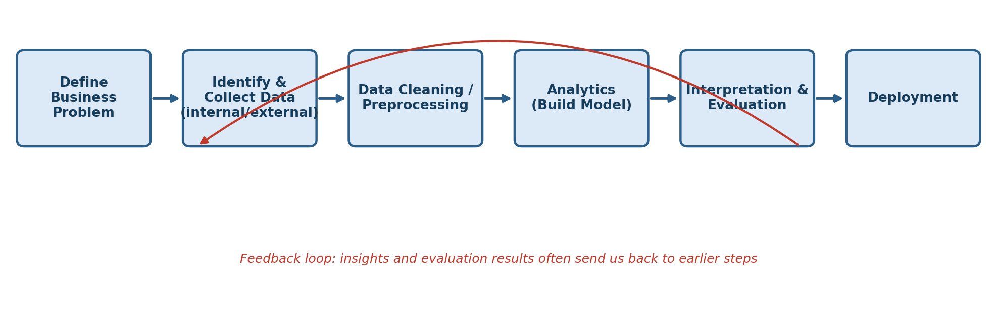
Figure 1.1: The Analytics Process Model
- Define the business problem. Every project needs to start with a specific, well-defined question, such as “which customers are likely to cancel their subscription next month?” Starting with a vague goal such as “let's do something with our data” almost always wastes the effort that follows.
- Identify and collect the data. Data can be internal (transaction records, CRM entries, sensor readings, website click logs) or external (weather records, social media activity, economic indicators, data bought from third parties, or public government datasets).
- Clean and prepare the data. Real data is rarely tidy. It contains missing values, duplicate entries, inconsistent formats, outliers, and typing errors. Industry surveys and textbooks consistently note that this stage alone can take up sixty to eighty percent of a project's total time. It is unglamorous, but it largely decides whether the rest of the project will succeed.
- Build the analytical model. Statistics, probability, and algorithms (regression, classification, clustering, association rules, and so on, covered in later modules) are applied once the data has been cleaned.
- Interpret and evaluate the results. Does the output make sense from a business standpoint? Is it statistically sound? (This is exactly where hypothesis testing, covered in Section 1.6, becomes essential.) Would a manager actually trust the result enough to act on it?
- Deploy the model. The model or insight is put into real use, for example by embedding it in a live fraud-detection system, or by presenting it as a dashboard for executives to act on.
Key idea: it is a loop, not a straight line. Evaluation often shows that the data collected was not enough, or that the business question itself needs rethinking, which sends the project back to an earlier stage. Treating analytics as a single pass from data straight to an answer is one of the most common mistakes beginners make.

1.2.1 Analytical Model Requirements
Once a model exists, how do we judge whether it is actually any good? A model that is mathematically impressive but useless in practice still counts as a failed analytics project. Six requirements are generally used to judge an analytical model:
Requirement | What it means | Example
Business relevance | The model has to answer the actual business question. | A churn model that is 99% accurate is still useless if the business needed to know which customers to target with a retention offer, not just whether churn happens at all.
Statistical performance | Accuracy or significance must be more than what chance alone would produce. This is checked using hypothesis testing and metrics such as accuracy, AUC, and RMSE (covered in later modules). | A model needs to beat a “naive” baseline, such as always predicting no churn, by a statistically meaningful margin.
Interpretability | Decision-makers need to understand why the model produced a given output. | A bank must be able to explain to a rejected loan applicant why they were turned down; a “black box” model is often not legally acceptable here.
Justifiability | The model's logic needs to align with common sense, business practice, and legal expectations, even when it is statistically valid. | A model that denies loans based on postal code (a proxy for race) may be statistically predictive, but it is not justifiable and may be illegal (a practice known as redlining).
Operational efficiency | The effort needed to collect data, score new cases, and maintain the model should be reasonable given its benefit. | A fraud-detection model that takes three minutes to score one transaction is unusable for real-time card payments, which need a decision within milliseconds.
Economic cost and compliance | The cost of building, running, and maintaining the model (data, computing, staff) must be justified by the value it creates, and it must comply with regulation. | A model that relies on data that is illegal to collect (such as certain protected attributes) cannot be deployed however good it is statistically, and must also satisfy rules such as GDPR or banking regulations like Basel.

Practice Question 1.2-A (conceptual). A data science team builds a highly complex neural network that predicts loan defaults with 96% accuracy, but the bank's compliance officer rejects it. Which requirement most likely failed, and why?
Answer: most likely interpretability and justifiability. Banking regulation typically requires a lender to explain the reasoning behind a credit decision to both the applicant and the regulator. A complex, black-box neural network cannot easily produce an explanation a person can follow, so even a highly accurate model can be rejected on these grounds. Statistical accuracy on its own is not sufficient.
Practice Question 1.2-B. Put the following actions in order according to the six stages of the analytics process model: (a) build a logistic regression model, (b) remove duplicate customer records, (c) present a dashboard to the marketing head, (d) decide the goal is “predict which customers will upgrade their plan,” (e) pull data from the CRM and web-log servers, (f) check whether the model's predictions are statistically better than random guessing.
Answer: d (stage 1, business problem) comes first, followed by e (stage 2, data collection), then b (stage 3, data cleaning), then a (stage 4, analytics), then f (stage 5, evaluation), and finally c (stage 6, deployment).

1.3 The Data Analytics Life Cycle
Prerequisite: this section builds directly on Section 1.2. Think of the process model above as the conceptual view, and the life cycle below as a more operational, project-management view of the same idea (an approach popularised by EMC²/Dell's Data Science and Big Data Analytics course and textbook).
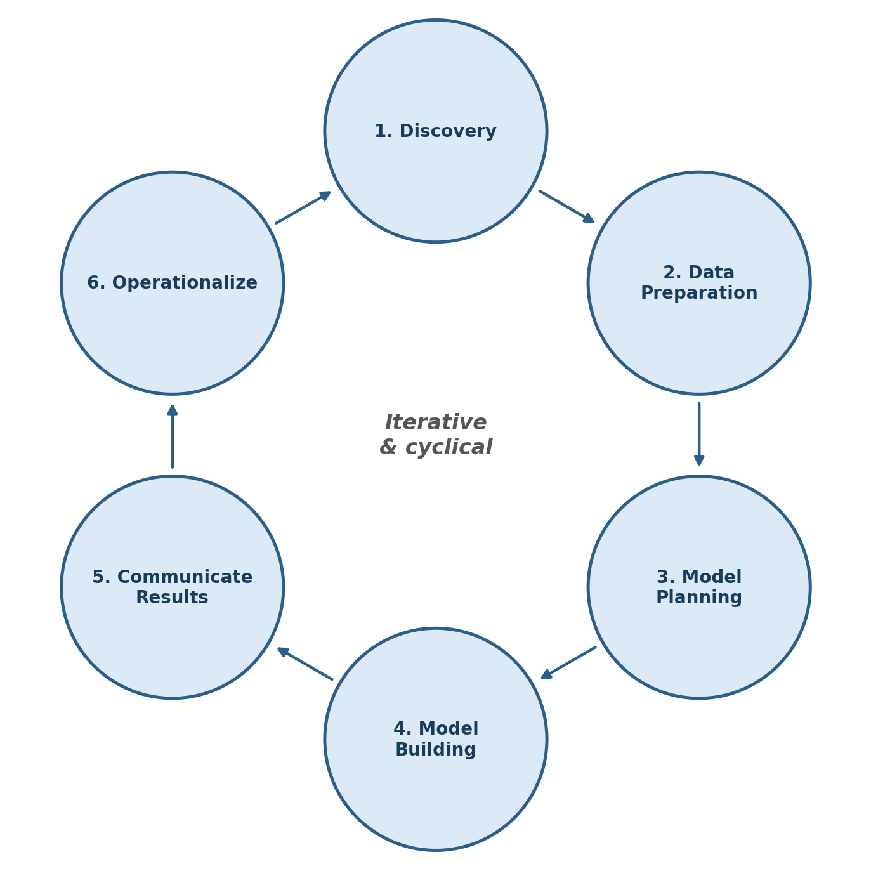
Figure 1.2: The Data Analytics Life Cycle (Six Phases)
Phase | Key activities | Telecom churn example
1. Discovery | Understand the business domain and past projects, identify available resources, and formally frame the problem as an analytics question. Identify the key stakeholders. | The telecom's head of marketing wants to reduce churn. The team learns that only three months of transaction history exist, and identifies which departments (billing, network, customer service) need to be involved.
2. Data Preparation | Set up an analytics sandbox, carry out ETL/ELT (extract, transform, load), and explore, condition, and clean the data. | Billing records, call-detail records, and support-ticket logs are merged; missing values in “monthly charges” are handled; inconsistent date formats are standardised.
3. Model Planning | Decide on methods, techniques, and workflow, and explore relationships between variables (exactly where the association techniques from Section 1.4 are used). | The team checks whether “contract type” (categorical) is associated with “churn” (categorical) using a contingency table and a chi-square test, and whether “tenure” (continuous) correlates with “monthly charges.”
4. Model Building | Develop training and testing datasets and build the actual predictive model (for example, a classification model for churn, covered in later modules). | A logistic regression model or decision tree is trained to output a churn probability for each customer.
5. Communicate Results | Compare results against the goals set during Discovery, identify key findings, quantify the business value, and shape the story for stakeholders. | The team reports that customers on month-to-month contracts are 3.2 times more likely to churn, and that offering them a 12-month contract could reduce churn by an estimated 8%.
6. Operationalize | Deliver final reports, briefings, code, and technical documentation, and run a small pilot before a full rollout. | The churn-scoring model is deployed to run weekly against the live customer database, feeding a list of at-risk customers to the retention call centre.

Why this matters for beginners: notice that building the model (stage 4) is only one of six stages. Beginners often jump straight to “let's build a model,” skipping problem framing and data preparation altogether. This is the single most common reason real-world analytics projects fail.
Practice Question 1.3-A. In which life-cycle phase would you first formally check whether “region” is statistically associated with “customer satisfaction score”? Justify your answer.
Answer: Model Planning. Exploring which variables appear related to one another happens once the data has been cleaned (Data Preparation), but before the final predictive model is actually built (Model Building).

1.4 Association Between Two Variables
Before studying association, it helps to know the four measurement scales a variable can take (these are covered in full in Section 1.7.1, but a short preview is useful here):
- Nominal (categorical, unordered): for example, blood type, gender, or city of residence.
- Ordinal (categorical, ordered): for example, a satisfaction rating of low, medium, or high, or level of education.
- Interval (numeric, no true zero): for example, temperature measured in degrees Celsius.
- Ratio (numeric, true zero): for example, income, age, or height.
For studying association, these four scales are usually grouped into two broader categories, discrete (nominal, ordinal, and integer counts) and continuous (interval and ratio), because the technique used to measure association depends on which group the variables belong to.
Why association matters. A hospital may want to know whether smoking status (yes or no) is linked to developing lung disease (yes or no): this is association between two discrete variables. A retailer may want to know whether advertising spend (continuous) is related to sales revenue (continuous): this is continuous-continuous association. An HR department may want to know whether a job-satisfaction ranking is associated with a performance ranking: this is ordinal-ordinal association. Each type of question needs a different mathematical tool, and using the wrong one can give misleading conclusions.

1.4.1 Association Between Two Discrete Variables
Contingency table (also called a cross-tabulation). This is the basic tool for two discrete variables: a table showing the joint frequency distribution of both variables together.
Worked example. A hospital records the smoking status and lung-disease status of 200 patients:
 | Lung disease: yes | Lung disease: no | Row total
Smoker | 60 | 40 | 100
Non-smoker | 20 | 80 | 100
Column total | 80 | 120 | 200

- Joint frequency distribution: the value in each individual cell, for example P(smoker and disease) = 60/200 = 0.30.
- Marginal frequency distribution: the row and column totals, found by summing across the joint distribution (called “marginal” because they traditionally sit in the margins of the table). For example, P(smoker) = 100/200 = 0.50.
- Conditional frequency distribution: the frequency of one variable given a fixed value of the other, for example P(disease given smoker) = 60/100 = 0.60.
Just from these numbers, 60% of smokers in the sample have the disease compared with only 20% of non-smokers, which strongly suggests an association. To make this rigorous rather than a visual impression, we use the chi-square test of independence.
Chi-square test, the underlying logic. If the two variables were truly independent, what count would we expect in each cell purely by chance? The expected count for a cell is found by multiplying its row total by its column total and dividing by the overall total:
Expected count (E) = (row total × column total) / grand total
We then compare the observed counts (O) against the expected counts (E) using the chi-square statistic:
χ² = Σ (O − E)² / E
Worked calculation using the table above. Applying the formula, the expected count under independence is 40 for the “smoker and disease” and “non-smoker and no disease” cells, and 60 for the “smoker and no disease” and “non-smoker and disease” cells (each found as row total × column total ÷ 200). This gives:
- (60 − 40)² / 40 = 10.00 (smoker, disease)
- (40 − 60)² / 60 = 6.67 (smoker, no disease)
- (20 − 40)² / 40 = 10.00 (non-smoker, disease)
- (80 − 60)² / 60 = 6.67 (non-smoker, no disease)
Adding these four values gives χ² = 33.33 (rounded).
Degrees of freedom for a contingency table are (number of rows − 1) × (number of columns − 1), which gives 1 for a 2×2 table. Looking up the chi-square distribution with 1 degree of freedom, a value of 33.33 corresponds to a p-value far below 0.05 (the critical value at α = 0.05 with 1 degree of freedom is only 3.84). Conclusion: we reject the hypothesis of independence, smoking and lung disease are strongly associated in this sample. (Section 1.6 explains exactly what “reject,” “p-value,” and “α” formally mean.)
Strength of association, Cramér's V. The chi-square statistic tells us whether an association exists, but not how strong it is, since it naturally grows with sample size. Cramér's V rescales it to a range between 0 and 1:
V = √[ χ² / (n × min(rows−1, columns−1)) ]
where n is the total sample size. For this example, V = √(33.33 / (200 × 1)) = √0.167 ≈ 0.41, which indicates a moderately strong association.

1.4.2 Association Between Two Ordinal Variables
Ordinal data has a meaningful order but not a meaningful distance between categories, so Pearson correlation (Section 1.4.3) cannot be applied directly to raw category values. Instead the data is converted to ranks and a rank-based correlation is used.
Spearman's rank correlation coefficient (ρ):
ρ = 1 − (6 Σ d²) / [ n(n² − 1) ]
where d is the difference between the two ranks for each pair of observations, and n is the number of pairs.
Worked example. Five employees are ranked by their manager on “communication skill” and by HR on “leadership potential” (1 = best):
Employee | Communication rank | Leadership rank | d | d²
A | 1 | 2 | −1 | 1
B | 2 | 1 | 1 | 1
C | 3 | 4 | −1 | 1
D | 4 | 3 | 1 | 1
E | 5 | 5 | 0 | 0

With Σd² = 4 and n = 5:
ρ = 1 − (6 × 4) / (5 × 24) = 1 − 24/120 = 1 − 0.2 = 0.8
A value of 0.8 indicates a strong positive association: employees who rank highly on communication also tend to rank highly on leadership potential.
(Kendall's tau is an alternative rank-correlation measure, more robust with small samples and tied ranks, but Spearman's is usually the one taught first.)

1.4.3 Association Between Two Continuous Variables (and Ordinal-Continuous)
Covariance measures whether two continuous variables tend to move together, though its size is hard to interpret on its own because it depends on the units X and Y are measured in:
Cov(X, Y) = Σ (xᵢ − x̄)(yᵢ − ȳ) / (n − 1)
Pearson's correlation coefficient (r) standardises the covariance by dividing it by the standard deviations of X and Y, giving a unit-free number that always falls strictly between −1 and +1:
r = Cov(X, Y) / (sₓ × sᵧ)
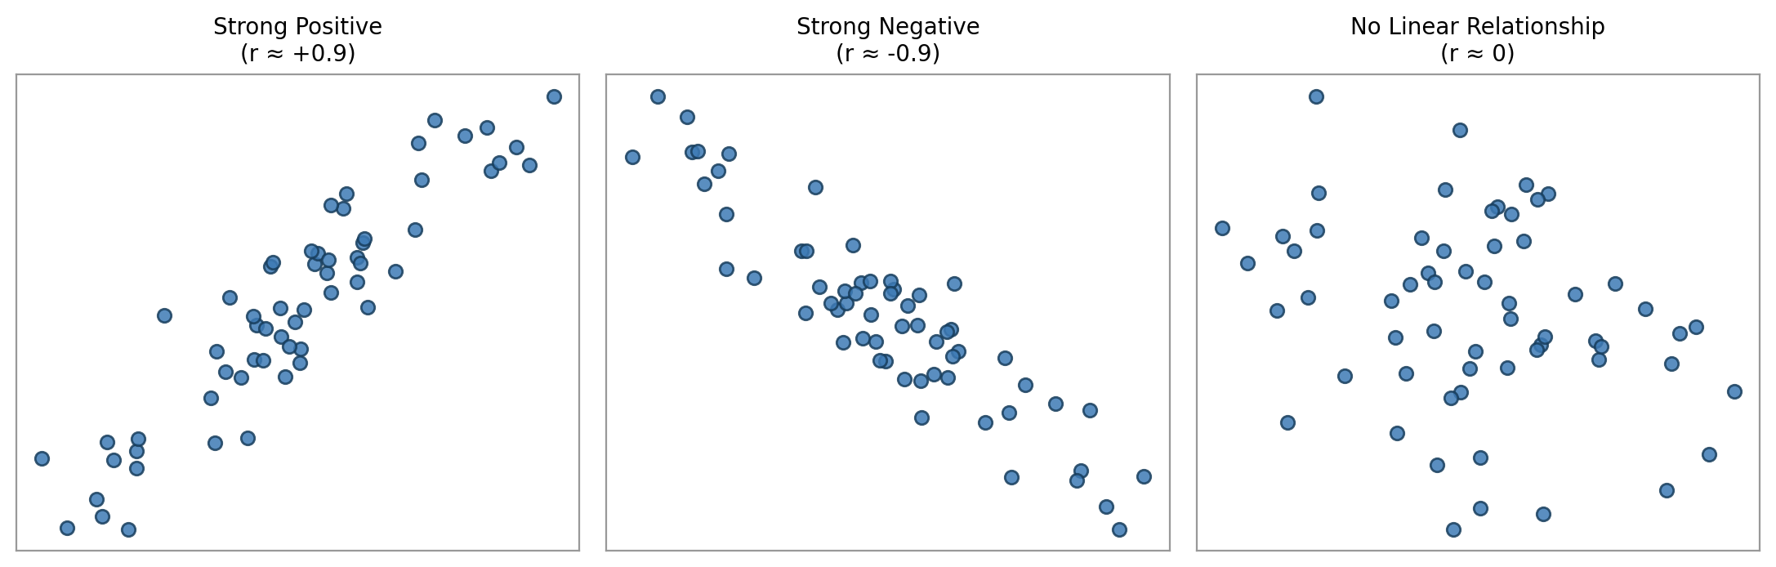
Figure 1.3: Scatterplots Illustrating Positive, Negative, and No Correlation
Interpreting r:
Range of |r| | Strength
0.0 – 0.1 | Negligible
0.1 – 0.3 | Weak
0.3 – 0.5 | Moderate
0.5 – 0.7 | Strong
0.7 – 1.0 | Very strong

Worked example. A shop records weekly advertising spend (X, in units of ₹1,000) and weekly sales (Y, in units of ₹10,000) for five weeks:
Week | X (ad spend) | Y (sales)
1 | 1 | 3
2 | 2 | 4
3 | 3 | 6
4 | 4 | 7
5 | 5 | 9

With x̄ = 3 and ȳ = 5.8:
Week | x − x̄ | y − ȳ | product | (x − x̄)² | (y − ȳ)²
1 | −2 | −2.8 | 5.6 | 4 | 7.84
2 | −1 | −1.8 | 1.8 | 1 | 3.24
3 | 0 | 0.2 | 0.0 | 0 | 0.04
4 | 1 | 1.2 | 1.2 | 1 | 1.44
5 | 2 | 3.2 | 6.4 | 4 | 10.24
Sum |  |  | 15.0 | 10 | 22.8

Adding up the columns gives Σ(x−x̄)(y−ȳ) = 15.0, Σ(x−x̄)² = 10, and Σ(y−ȳ)² = 22.8, so:
r = 15.0 / √(10 × 22.8) = 15.0 / √228 ≈ 15.0 / 15.10 ≈ 0.99
This is an extremely strong positive correlation: in this small illustrative dataset, advertising spend and sales rise together in an almost perfectly straight line.
Important caution, correlation is not causation. Ice cream sales and drowning deaths are strongly correlated across the months of the year, but eating ice cream does not cause drowning. Both are driven by a third, confounding variable: hot summer weather. Before concluding that one thing causes another, always ask whether some third factor could explain the pattern instead.
Visualising variables of different scales. Because the association technique depends on the scale of the variables, so does the best chart for displaying it:
Variable 1 | Variable 2 | Best visualisation
Nominal/Ordinal | Nominal/Ordinal | Stacked or grouped bar chart, mosaic plot
Ordinal | Continuous | Grouped boxplot (one box per ordinal category)
Continuous | Continuous | Scatter plot

Practice Questions, Section 1.4
Q1. A survey of 150 people cross-tabulates “preferred news source” (TV / online / print) with “age group” (young / old). What test would you use to check for an association, and what does the degrees-of-freedom formula give if there are 3 columns and 2 rows?
Answer: chi-square test of independence. df = (r−1)(c−1) = (2−1)(3−1) = 2.
Q2. For the smoking/lung-disease table in Section 1.4.1, what is P(smoker | no disease)?
Answer: P(smoker | no disease) = 40/120 ≈ 0.333 (33.3%).
Q3. Two variables have covariance = 45, sₓ = 5, sᵧ = 10. Compute Pearson's r and interpret its strength.
Answer: r = 45 / (5 × 10) = 0.9, a very strong positive linear association.
Q4. Why can't we compute a standard Pearson correlation directly on raw ordinal categories like “low, medium, high”?
Answer: because Pearson's r assumes the numeric distance between values is meaningful (the gap between 2 and 3 equals the gap between 3 and 4). Ordinal categories only guarantee order, not equal spacing, so we first convert them to ranks and use Spearman's rho (or Kendall's tau) instead.

1.5 Probability Calculus
Prerequisite: a basic idea of set notation (union and intersection) is helpful but not essential. Everything below is explained from first principles.

1.5.1 Basic Definitions
- Random experiment: a process whose outcome cannot be known in advance, such as tossing a coin or a customer visiting (or not visiting) a website.
- Sample space (S): the set of every possible outcome. For a single coin toss, S = {Heads, Tails}.
- Event: any subset of the sample space, for example “getting heads” is the event {Heads}.
- Probability of an event A, P(A): a number between 0 and 1 describing how likely A is. P(A) = 0 means impossible, and P(A) = 1 means certain.
The three axioms of probability (Kolmogorov's axioms):
- P(A) ≥ 0 for any event A.
- P(S) = 1 (something in the sample space is guaranteed to happen).
- If A and B are mutually exclusive (they cannot both happen at once), P(A ∪ B) = P(A) + P(B).
Key probability rules:
Rule | Formula | Real-life meaning
Complement | P(A′) = 1 − P(A) | P(it does not rain) = 1 − P(it rains)
Addition (general) | P(A ∪ B) = P(A) + P(B) − P(A ∩ B) | P(a customer buys milk or bread) must account for those who buy both
Multiplication (independent events) | P(A ∩ B) = P(A) × P(B) | P(two unrelated machines both failing today)
Conditional probability | P(A|B) = P(A ∩ B) / P(B) | P(a customer churns, given that they called support three or more times)

1.5.2 Bayes' Theorem
Bayes' theorem lets us “flip” a conditional probability, which is extremely useful because we often know P(B|A) but actually want P(A|B).
Real-life worked example (medical testing, the classic illustration of why Bayes' theorem matters). A disease affects 1% of a population. A test for the disease is 95% accurate for people who have it (sensitivity) and 90% accurate for people who don't (specificity, so a false-positive rate of 10%). If a random person tests positive, what is the probability they actually have the disease?
Let D = has the disease, T = tests positive.
- P(D) = 0.01, so P(D′) = 0.99
- P(T|D) = 0.95 (sensitivity)
- P(T|D′) = 0.10 (false-positive rate = 1 − specificity)
By the law of total probability:
P(T) = P(T|D)P(D) + P(T|D′)P(D′) = (0.95 × 0.01) + (0.10 × 0.99) = 0.0095 + 0.099 = 0.1085
P(D|T) = P(T|D)P(D) / P(T) = 0.0095 / 0.1085 ≈ 0.088
This is the famous, counter-intuitive result: even after testing positive, the person only has about an 8.8% chance of actually having the disease. This happens because the disease is rare, so the false positives from the other 99% of (healthy) people outnumber the true positives. This is exactly why doctors run a second, different confirmatory test before diagnosing rare diseases, and it is a core reasoning tool in spam filtering, fraud detection, and medical diagnostics.

1.5.3 Random Variables and Probability Distributions
A random variable is a variable whose value is the numerical outcome of a random experiment.
- Discrete random variable: takes countable values (0, 1, 2, …), for example the number of defective items in a batch.
- Continuous random variable: takes any value in an interval, for example the exact weight of a manufactured part.
A probability distribution describes how probability is spread across the possible values of a random variable.
A. The Binomial Distribution (discrete)
Models the number of “successes” in n independent identical trials, each with success probability p.
Mean = np; Variance = np(1 − p)
Real-life example. A call centre closes 30% of the calls it handles as a sale (p = 0.3). Out of 10 calls today (n = 10), what is the probability that exactly 3 result in a sale?
P(X=3) = C(10,3) × 0.3³ × 0.7⁷ = 120 × 0.027 × 0.0824 ≈ 0.267 (about 26.7%)
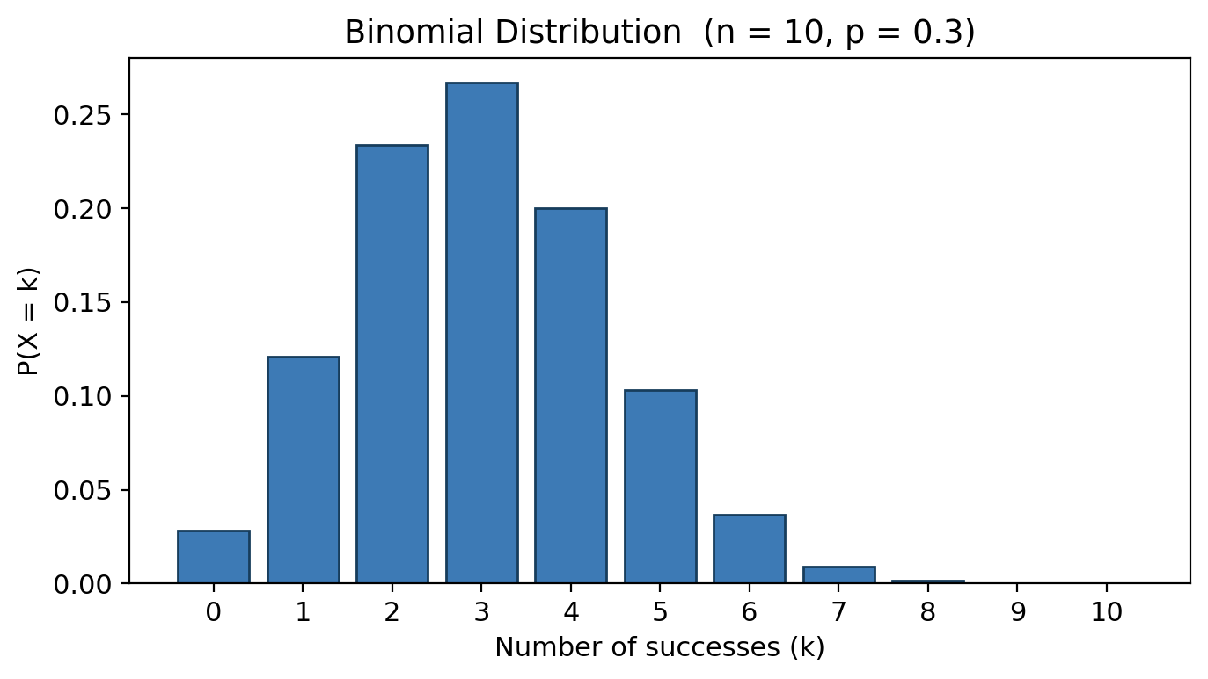
Figure 1.4: Binomial Distribution (n = 10, p = 0.3)
B. The Poisson Distribution (discrete)
Models the number of events occurring in a fixed interval of time or space, given a known average rate λ, when events happen independently of one another.
Real-life example. A website receives, on average, 3 server errors per hour (λ = 3). The probability of exactly 2 errors in the next hour is:
P(X=2) = (e⁻λ λ²) / 2! = (e⁻³ × 9) / 2 ≈ 0.224 (about 22.4%)
C. The Normal (Gaussian) Distribution (continuous)
The single most important continuous distribution: many natural and business quantities (heights, measurement errors, IQ scores, sums of many small effects) approximately follow it. It is fully described by its mean μ and standard deviation σ.
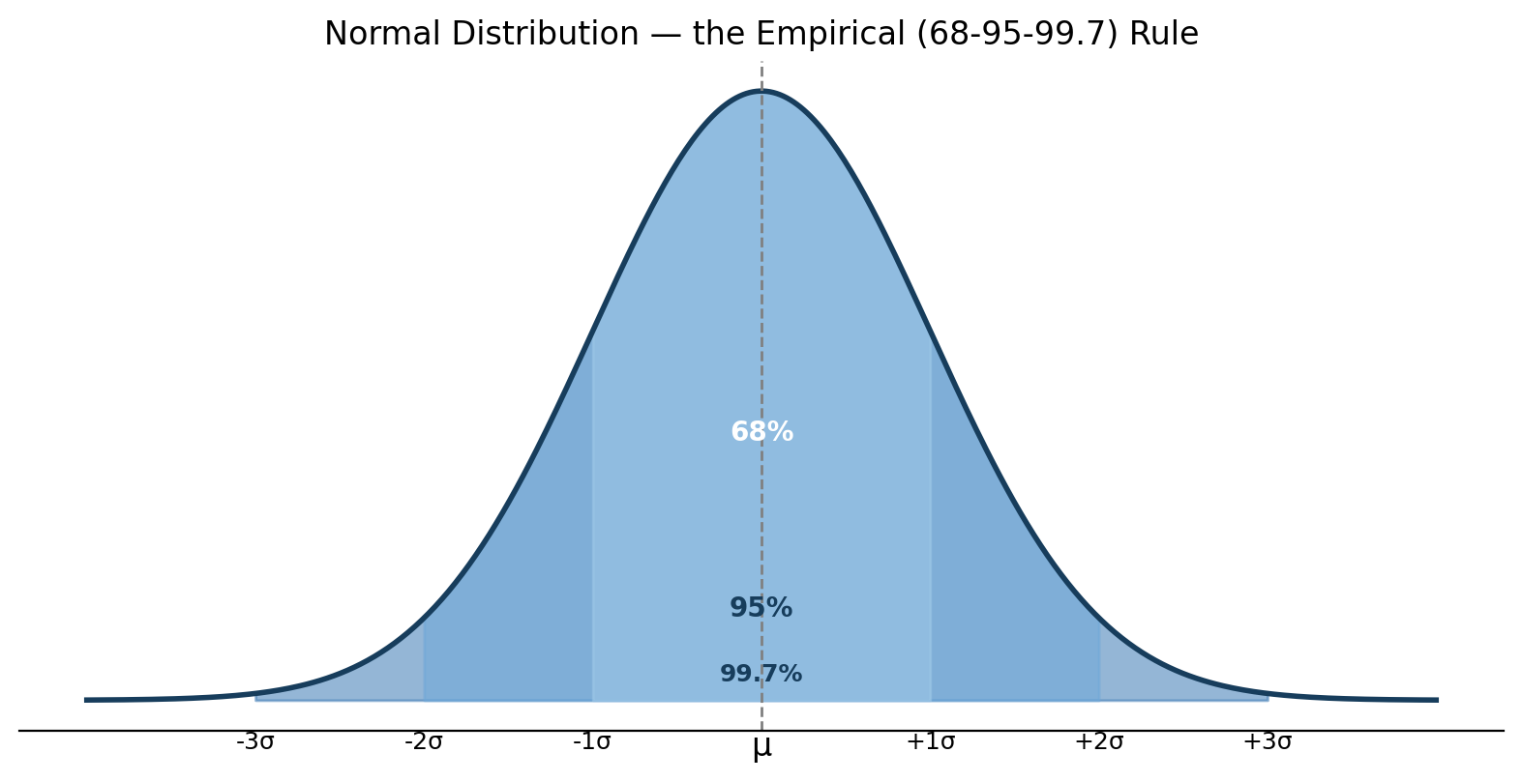
Figure 1.5: The Normal Distribution and the Empirical (68-95-99.7) Rule
The Empirical Rule (68-95-99.7 rule): about 68% of values lie within 1 standard deviation of the mean, 95% lie within 2 standard deviations, and 99.7% lie within 3 standard deviations.
Real-life example. Adult male heights in a population are approximately normal with μ = 170 cm and σ = 7 cm. What percentage of men are taller than 184 cm? Since (184 − 170)/7 = 2, 184 cm sits exactly 2 standard deviations above the mean. Because about 95% of values lie within 2 standard deviations of the mean, the remaining 5% is split evenly between the two tails, so roughly 2.5% of men are taller than 184 cm.
Why the Normal distribution keeps appearing, the Central Limit Theorem (a preview). The Central Limit Theorem states that the sampling distribution of the mean of a large number of independent, identically distributed random variables approaches a normal distribution, regardless of the shape of the original distribution. This is exactly why the hypothesis tests in Section 1.6 (which are built on sample means) can rely on the normal or t-distribution even when the underlying raw data is not perfectly normal.

Practice Questions, Section 1.5
Q1. A fair six-sided die is rolled once. What is P(rolling an even number OR a number greater than 4)?
Answer: even = {2,4,6}; greater than 4 = {5,6}. Their union is {2,4,5,6}, so P = 4/6 ≈ 0.667. (Using the addition rule: P(even) + P(>4) − P(even and >4) = 3/6 + 2/6 − 1/6 = 4/6.)
Q2. In a factory, machine A produces 60% of all items and machine B produces 40%. 5% of machine A's items are defective, and 8% of machine B's items are defective. If an item is picked at random and found defective, what is the probability it came from machine B? (Bayes' theorem)
Answer: P(B|defective) = [P(defective|B)P(B)] / [P(defective|A)P(A) + P(defective|B)P(B)] = (0.08×0.4) / [(0.05×0.6) + (0.08×0.4)] = 0.032 / (0.03 + 0.032) = 0.032/0.062 ≈ 0.516 (about 51.6%).
Q3. X follows a Binomial distribution with n = 8, p = 0.5. Find P(X = 4).
Answer: P(X=4) = C(8,4)(0.5)⁴(0.5)⁴ = 70 × 0.0625 × 0.0625 = 70 × 0.00391 ≈ 0.2734.
Q4. Exam scores are normally distributed with mean 70 and standard deviation 10. Using the empirical rule, between what two scores do approximately 95% of students fall?
Answer: μ ± 2σ = 70 ± 20, that is, between 50 and 90.

1.6 Hypothesis Testing, Basic Definitions
Prerequisite: understanding the Normal distribution and the idea of a “sample mean” (Section 1.5.3) is needed, since most tests are built on these ideas.
Why we need hypothesis testing (real-life motivation). Suppose a factory currently produces light bulbs with an average life of 1000 hours. After changing suppliers, a sample of 40 new bulbs shows an average life of 1015 hours. Is this a real improvement, or could it simply be random sampling variation, meaning another sample of 40 bulbs might just as easily show 990 hours? Hypothesis testing gives us a rigorous, quantitative way to answer “is this difference real, or just noise?”

1.6.1 Core Definitions
Term | Meaning
Null hypothesis (H₀) | The “status quo” or “no effect/no difference” statement assumed true until evidence says otherwise. Example: H₀: μ = 1000 (the new bulbs are no different).
Alternative hypothesis (H₁ or Hₐ) | What we suspect might actually be true, and what we look for evidence in favour of. Example: H₁: μ > 1000 (the new bulbs last longer).
Test statistic | A single number computed from sample data (such as a z-score or t-score) that measures how far the sample result is from what H₀ predicts.
Significance level (α) | The threshold probability (commonly 0.05 or 0.01) chosen before the test, representing how much risk of a wrong “reject H₀” decision we are willing to accept.
p-value | The probability of observing a result at least as extreme as what we actually got, assuming H₀ is true. A small p-value means the data would be very unusual if H₀ were true, casting doubt on H₀.
Decision rule | If p-value ≤ α: reject H₀ (the result is “statistically significant”). If p-value > α: fail to reject H₀ (not enough evidence, which is not the same as “proving H₀ true”).

One-tailed vs. two-tailed tests. A one-tailed test checks for a difference in one specific direction (H₁: μ > μ₀ or H₁: μ < μ₀), while a two-tailed test checks for a difference in either direction (H₁: μ ≠ μ₀). The choice depends on the business question and must be decided before looking at the data.

1.6.2 Type I and Type II Errors
Because we make a decision under uncertainty from a sample, rather than the whole population, two kinds of mistakes are possible:
 | H₀ is actually true | H₀ is actually false
We reject H₀ | Type I error (false alarm), probability = α | Correct decision (true positive)
We fail to reject H₀ | Correct decision (true negative) | Type II error (missed effect), probability = β

Real-life analogy, a courtroom trial. H₀ is “the defendant is innocent.” A Type I error is convicting an innocent person (rejecting a true H₀). A Type II error is letting a guilty person go free (failing to reject a false H₀). Just as courts try to keep the Type I error rate very low (guilt “beyond reasonable doubt”), analysts pick a small α (typically 0.05) to control the false-alarm rate. There is generally a trade-off: reducing α (fewer false alarms) tends to increase β (more missed real effects) for a fixed sample size. The only way to reduce both is to collect more data. Statistical power (1 − β) is the probability of correctly detecting a real effect when one exists.

1.6.3 Steps of Hypothesis Testing
- State H₀ and H₁.
- Choose the significance level α.
- Choose the appropriate test and compute the test statistic from the sample.
- Compute the p-value (or compare the test statistic to a critical value).
- Make a decision: reject or fail to reject H₀.
- State the conclusion in the context of the original business or research question.

1.6.4 Worked Example, One-Sample z-Test
Back to the light-bulb example. The population is assumed to have a known standard deviation of σ = 60 hours (from long historical records). A sample of n = 40 new bulbs has a mean of x̄ = 1015 hours. Test at α = 0.05 whether the new bulbs last longer (a one-tailed test).
Step 1: H₀: μ = 1000, H₁: μ > 1000
Step 2: α = 0.05
Step 3: test statistic (z-test, since σ is known and n is reasonably large):
z = (x̄ − μ) / (σ/√n) = (1015 − 1000) / (60/√40) = 15 / 9.49 ≈ 1.58
Step 4: for a one-tailed test at α = 0.05, the critical z-value is 1.645. Our computed z (1.58) is slightly less than this critical value. The corresponding p-value is approximately 0.057.
Step 5: since the p-value (0.057) is greater than α (0.05), we fail to reject H₀.
Step 6: conclusion: at the 5% significance level, there is not quite enough statistical evidence to conclude the new bulbs last longer than 1000 hours on average. The observed improvement could plausibly be due to sampling variation alone. (Notice how close this result was; a slightly larger sample size might well have produced a significant result. This illustrates why “fail to reject” is a cautious conclusion, not a negative one.)
(When the population standard deviation is unknown, which is far more common in practice, we use the sample standard deviation instead and run a t-test with n − 1 degrees of freedom. The logic and steps are otherwise identical.)

Practice Questions, Section 1.6
Q1. A pharmaceutical company claims a new painkiller relieves pain in an average of 30 minutes. A sample of 36 patients gives a mean of 27 minutes with sample standard deviation s = 9. Test H₀: μ = 30 against H₁: μ ≠ 30 at α = 0.05 using a t-test. (The critical t at df = 35, two-tailed, α = 0.05, is approximately 2.03.)
Answer: t = (27 − 30) / (9/√36) = −3 / 1.5 = −2.0. Since |t| = 2.0 < 2.03 (the critical value), we fail to reject H₀; there is not enough evidence that the true average differs from 30 minutes.
Q2. True or false: “Failing to reject H₀ proves that H₀ is true.” Explain.
Answer: false. It only means the sample did not provide enough evidence to reject H₀ at the chosen significance level. H₀ might still be false, but the data or sample size was not powerful enough to detect it (a Type II error is possible, or the effect may genuinely not exist; a single test cannot fully distinguish between these two possibilities).
Q3. A quality control manager wants to be very cautious about a Type I error (wrongly stopping a good production line). Should they choose a smaller or larger α?
Answer: a smaller α. A smaller α makes it harder to reject H₀, which reduces the chance of a false alarm (Type I error).

1.7 Proximity Measures
Prerequisite: basic algebra (squares, square roots, sums). This topic is the mathematical foundation for later modules on clustering and classification (k-means, k-nearest neighbours, hierarchical clustering, and so on), so mastering it now pays off later.
Motivating real-life question: a streaming service wants to recommend shows based on other users who are “similar” to you. A hospital wants to group patients into clusters with “similar” symptom profiles. An e-commerce site wants to detect whether two product listings are actually duplicates. All of these require a numerical way of describing how similar or dissimilar two data objects are, which is exactly what proximity measures provide.

1.7.1 Data Objects and Attribute Types
A data object (also called a record, sample, instance, or data point) represents one entity being described, for example one customer, one patient, or one product. It is described by a set of attributes (also called features, fields, or variables), for example age, income, or product category.
The four attribute types (expanding on the preview given in Section 1.4):
Type | Definition | Valid operations | Examples
Nominal | Categories with no inherent order; values are simply distinct labels | =, ≠ (equality only) | Blood type (A, B, AB, O), marital status, ZIP code
Ordinal | Categories with a meaningful order, but the differences between values are not meaningful or measurable | =, ≠, <, > | Movie rating (1–5 stars), education level (high school < bachelor's < master's)
Interval | Numeric; order and equal-sized differences are meaningful, but there is no true zero (zero does not mean “absence of the quantity”) | =, ≠, <, >, +, − | Temperature in °C or °F (0°C does not mean “no temperature”), calendar year
Ratio | Numeric; order, equal differences, and a true zero are all meaningful, so ratios such as “twice as much” make sense | =, ≠, <, >, +, −, ×, ÷ | Height, weight, age, income, number of purchases (0 means literally none)

A special, very common case, binary attributes (a nominal attribute with only two states, 0/1):
- Symmetric binary: both outcomes are equally important, for example “gender: male/female,” where neither state is more “significant” than the other.
- Asymmetric binary: one outcome is rarer or more important than the other, for example “has disease: yes/no” or “bought product: yes/no.” A “1” (rare, positive) usually matters far more than a “0,” and two people who both do not have a rare disease tells us little about how similar they are.
Practice Question 1.7-A. Classify each attribute as nominal, ordinal, interval, or ratio: (a) customer satisfaction (poor/fair/good/excellent), (b) number of children, (c) temperature in Kelvin, (d) postal/ZIP code, (e) annual income.
Answer: (a) ordinal; (b) ratio; (c) ratio, note that Kelvin does have a true zero (absolute zero means no thermal energy at all), unlike Celsius, which is a classic trick question; (d) nominal, since ZIP codes are just labels and arithmetic on them is meaningless even though they look numeric; (e) ratio.

1.7.2 Dissimilarity and Similarity, the Basic Idea
- Similarity, sim(i,j): a numerical measure of how alike two objects i and j are, usually scaled to [0,1], with 1 meaning identical.
- Dissimilarity or distance, d(i,j): a numerical measure of how different two objects are, usually d ≥ 0, with 0 meaning identical, and larger values meaning more different.
A valid distance metric should satisfy:
- d(i,j) ≥ 0, and d(i,i) = 0 (non-negativity, identity)
- d(i,j) = d(j,i) (symmetry)
- d(i,j) ≤ d(i,k) + d(k,j) (triangle inequality: going directly is never longer than taking a detour)

1.7.3 Proximity for Nominal Attributes
For a single nominal attribute, the simplest dissimilarity is:
d(i,j) = (p − m) / p
where p is the total number of attributes compared, and m is the number of attributes that match exactly.
Worked example. Two customers are described by three nominal attributes (favourite colour, city, membership tier):
 | Colour | City | Tier
Customer 1 | Blue | Delhi | Gold
Customer 2 | Blue | Mumbai | Gold

Colour and tier match, so m = 2 out of p = 3 attributes. d(i,j) = (3 − 2)/3 ≈ 0.33.

1.7.4 Proximity for Binary Attributes
Given two objects described by binary attributes, we build a 2×2 contingency table:
 | Object j = 1 | Object j = 0
Object i = 1 | q | r
Object i = 0 | s | t

Simple Matching Coefficient (for symmetric binary attributes), counts both matches (1-1 and 0-0) as informative:
SMC = (q + t) / (q + r + s + t)
Jaccard Coefficient (for asymmetric binary attributes), ignores 0-0 matches since they carry no real information (two patients both not having a rare disease tells us little):
J = q / (q + r + s)
Worked example. Two patients are tested for 5 symptoms (1 = present, 0 = absent). Patient A: [1, 0, 1, 0, 0]; Patient B: [1, 0, 1, 1, 0].
Comparing position by position: positions 1 and 3 are 1-1 matches (q = 2), position 2 and position 5 are 0-0 matches (t = 2), and position 4 is a mismatch (A = 0, B = 1, contributing to r or s, giving r + s = 1).
J = q / (q + r + s) = 2 / (2 + 1) ≈ 0.667
Since the symptoms are asymmetric (presence is rare and important, absence is not informative), the Jaccard similarity of 0.667 is the appropriate measure. The Simple Matching Coefficient would give (q+t)/5 = 4/5 = 0.8, which would be misleadingly inflated by counting the “both healthy” symptom as meaningful agreement.

1.7.5 Proximity for Numeric (Interval/Ratio) Attributes
Euclidean distance (a straight-line, “as the crow flies” distance) is the most commonly used distance measure:
d(i,j) = √[ Σ (xᵢₖ − xⱼₖ)² ]
Manhattan distance (also called city-block distance, like navigating a grid of city streets where diagonal shortcuts are not possible):
d(i,j) = Σ |xᵢₖ − xⱼₖ|
Minkowski distance is the general form, of which Euclidean and Manhattan are special cases:
d(i,j) = [ Σ |xᵢₖ − xⱼₖ|ᵠ ]^(1/q)
Setting q = 1 gives Manhattan distance, q = 2 gives Euclidean distance, and q → ∞ gives the Chebyshev distance (the single largest attribute-wise difference).
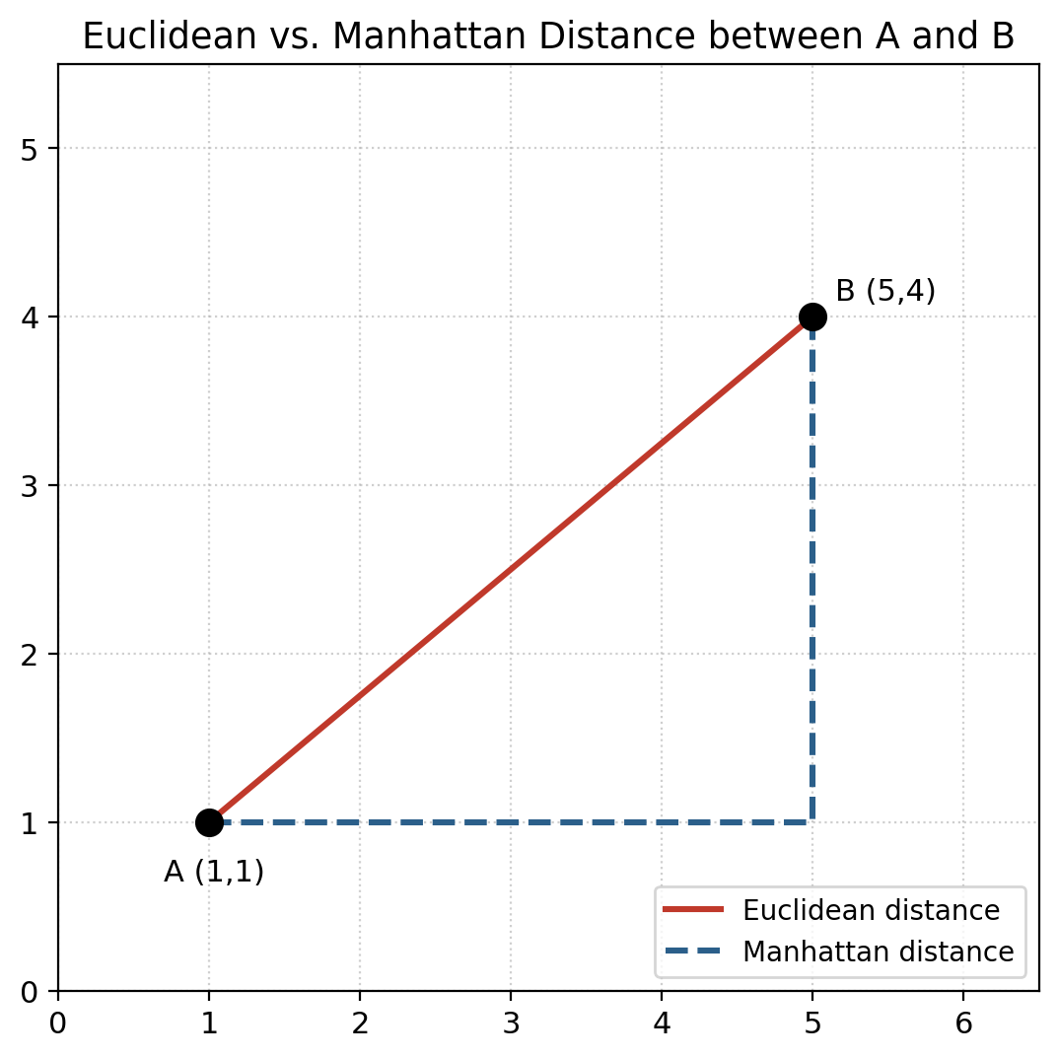
Figure 1.6: Euclidean vs. Manhattan Distance Between Two Points
Worked example. Two customers are described by (age, annual income in ₹ lakhs): A = (25, 4), B = (35, 10).
- Euclidean: d = √[(35−25)² + (10−4)²] = √(100 + 36) = √136 ≈ 11.66
- Manhattan: d = |35−25| + |10−4| = 10 + 6 = 16
Critical practical point, normalisation or standardisation is required before computing distances. Notice that “age” roughly ranges from 0 to 100, while “income in lakhs” might range from 0 to 500. An attribute with a naturally larger numeric range will dominate the distance calculation even if it isn't actually more important. Before computing any of these distances in practice, attributes are typically standardised (z-score, z = (x − μ)/σ) or min-max normalised to a common scale such as [0,1].

1.7.6 Cosine Similarity (for High-Dimensional or Text Data)
When data objects are very high-dimensional and sparse (for example, documents represented as word-count vectors), Euclidean distance behaves poorly because it ends up dominated by document length rather than content. Cosine similarity instead measures the angle between two vectors, ignoring their magnitude:
cos(X,Y) = (X · Y) / (‖X‖ × ‖Y‖)
The value ranges from −1 to 1 for general vectors, but for non-negative data such as word counts it ranges from 0 to 1, with 1 meaning the vectors point in exactly the same direction (the same relative word usage, regardless of document length).
Worked example. Two short documents are represented as word-count vectors over the vocabulary {data, science, fun}: Doc1 = (2, 1, 0), Doc2 = (4, 2, 1).
X · Y = (2×4)+(1×2)+(0×1) = 10; ‖X‖ = √5 ≈ 2.24; ‖Y‖ = √21 ≈ 4.58
cos(X,Y) = 10 / (2.24 × 4.58) ≈ 0.976
A cosine similarity of 0.976 (very close to 1) shows the two documents have very similar word-usage patterns, even though Doc2 is roughly twice as long as Doc1. This length-independence is exactly what makes cosine similarity so useful for text.

Summary Table, Which Proximity Measure to Use
Attribute type | Recommended measure
Nominal | Simple matching (proportion of mismatches)
Symmetric binary | Simple Matching Coefficient
Asymmetric binary | Jaccard Coefficient
Numeric (low-dimensional, dense) | Euclidean, Manhattan, or Minkowski distance (after normalisation)
High-dimensional or sparse (text, market-basket) | Cosine similarity, Jaccard (for sets)
Mixed attribute types | Gower's general similarity coefficient (combines the above, weighted per attribute type)

Practice Questions, Section 1.7
Q1. Two objects have binary attributes: Object X = [1,1,0,0,1], Object Y = [1,0,0,0,1] (asymmetric, “1” = rare/positive). Compute the Jaccard similarity.
Answer: matches where both = 1 (q): positions 1 and 5, so q = 2. Mismatches (one is 1, the other 0): position 2, so r+s = 1. Both-zero: positions 3 and 4 (not counted). J = q/(q+r+s) = 2/(2+1) ≈ 0.667.
Q2. Compute the Euclidean and Manhattan distances between P = (2,3,5) and Q = (7,4,1).
Answer: differences are 5, 1, and 4. Euclidean = √(25+1+16) = √42 ≈ 6.48. Manhattan = 5+1+4 = 10.
Q3. Why must numeric attributes usually be standardised before computing Euclidean distance in a real dataset with attributes like “salary” (in rupees) and “age” (in years)?
Answer: because salary naturally has a much larger numeric range than age, unstandardised Euclidean distance would be driven almost entirely by differences in salary, effectively making age irrelevant to the result even if age is equally or more important for the analysis. Standardising (z-scores) or min-max normalising puts both attributes on a comparable scale.
Q4. Would you use Euclidean distance or cosine similarity to compare two customers' purchase-frequency vectors across 10,000 products, where each customer has bought only a handful of items (a very sparse, high-dimensional vector)? Why?
Answer: cosine similarity, because it is designed for high-dimensional, sparse data. It correctly ignores irrelevant “both never bought this product” agreement and instead focuses on the pattern or direction of purchases, rather than being dominated by the sheer number of items bought, unlike Euclidean distance.

1.8 Programming Practice (Python)
Try writing each of these on your own before checking any solution online. A short hint is given for each; use pandas, numpy, scipy.stats, and matplotlib.
- Contingency table and chi-square. Recreate the smoking/lung-disease table from Section 1.4.1 as a numpy 2×2 array. Use scipy.stats.chi2_contingency() to verify the chi-square statistic and p-value calculated by hand.
- Pearson and Spearman correlation. Load or create a small dataset with an advertising-spend column and a sales column. Compute Pearson's r using numpy.corrcoef() and Spearman's rho using scipy.stats.spearmanr(). Compare the two: do they agree when the relationship is perfectly linear versus monotonic but curved?
- Simulate the Central Limit Theorem. Generate 10,000 samples from a heavily skewed distribution (for example numpy.random.exponential). For each of 1,000 repetitions, draw a sample of size 30 and record its mean. Plot a histogram of these 1,000 sample means and observe that it looks approximately normal even though the original distribution is not.
- Bayes' theorem simulation. Simulate the medical-testing scenario from Section 1.5.2: generate 100,000 simulated people, 1% of them with the disease. Apply the sensitivity and specificity rules to simulate test results, then compute the empirical P(disease | positive test) from the simulated data and check that it matches the roughly 8.8% computed by hand.
- One-sample t-test. Using scipy.stats.ttest_1samp(), test the light-bulb example from Section 1.6.4 (adapted to a t-test using a sample standard deviation), and confirm the computed t-statistic and p-value.
- Type I and Type II error simulation. Simulate 1,000 experiments where H₀ is actually true (for example, draw samples from a Normal(0,1) distribution) and run a hypothesis test on each at α = 0.05. What fraction of the 1,000 tests incorrectly reject H₀? (It should be close to 5%, which demonstrates what α really means in practice.)
- Distance metrics from scratch. Write your own Python functions euclidean(a, b), manhattan(a, b), and jaccard(a, b) (for binary vectors) without using any library function, then check each one against scipy.spatial.distance.euclidean, .cityblock, and .jaccard.
- Effect of normalisation on distance. Using the age/income example from Section 1.7.5, compute Euclidean distance for several customer pairs (a) on raw data and (b) after applying sklearn.preprocessing.StandardScaler. Discuss how much the nearest and farthest pairs change between (a) and (b).
- Cosine similarity for text. Take three short sentences, convert them to word-count vectors using sklearn.feature_extraction.text.CountVectorizer, and compute pairwise cosine similarity using sklearn.metrics.pairwise.cosine_similarity. Which two sentences are most similar, and does that match your intuition?
- End-to-end mini pipeline. Pick any small public dataset (for example the Titanic or Iris dataset). (a) Build a contingency table between a categorical column and the target, and run a chi-square test. (b) Compute the Pearson correlation matrix for the numeric columns and display it as a heatmap. (c) Pick two numeric columns and compute their pairwise Euclidean distance matrix for the first 10 rows using scipy.spatial.distance.cdist. This exercise ties together every concept in this chapter.

Chapter Summary
- Analytics is a structured, iterative process (business problem → data → cleaning → modelling → evaluation → deployment), not a single algorithm call. A model must satisfy business relevance, statistical performance, interpretability, justifiability, operational efficiency, and cost/compliance requirements to be genuinely useful.
- The Data Analytics Life Cycle (Discovery, Data Preparation, Model Planning, Model Building, Communicate Results, Operationalize) gives a project-management view of the same overall process.
- Association between two variables depends on their scales: contingency tables and the chi-square test (discrete-discrete), Spearman's rho (ordinal-ordinal), and Pearson's r (continuous-continuous). Always remember: correlation is not causation.
- Probability calculus (the axioms, conditional probability, Bayes' theorem, and the Binomial, Poisson, and Normal distributions) forms the mathematical backbone for every statistical technique that follows.
- Hypothesis testing provides a rigorous way to decide whether an observed effect is “real” or just sampling noise, using α, p-values, β, and an awareness of Type I and Type II errors.
- Proximity measures (Euclidean, Manhattan, Jaccard, and cosine similarity, chosen according to attribute type) let us quantify “how similar are two data objects,” which underpins clustering, recommendation, and nearest-neighbour classification covered in later modules.

Sources
This chapter draws on standard, widely used academic references for data analytics and data mining. Consult these directly for deeper reading:
- Baesens, B. (2014). Analytics in a Big Data World: The Essential Guide to Data Science and Its Applications. Wiley. (Source for the Analytics Process Model and Analytical Model Requirements.)
- Han, J., Kamber, M., & Pei, J. (2011). Data Mining: Concepts and Techniques (3rd ed.). Morgan Kaufmann. (Source for data objects, attribute types, and proximity/dissimilarity measures.)
- Tan, P.-N., Steinbach, M., & Kumar, V. (2018). Introduction to Data Mining (2nd ed.). Pearson. (Source for similarity/dissimilarity measures and association analysis.)
- EMC Education Services (2015). Data Science and Big Data Analytics: Discovering, Analyzing, Visualizing and Presenting Data. Wiley. (Source for the six-phase Data Analytics Life Cycle.)
- Chapman, P. et al. (2000). CRISP-DM 1.0: Step-by-step Data Mining Guide. SPSS Inc. (Original definition of the CRISP-DM process referenced in Section 1.2.)
- Montgomery, D. C., & Runger, G. C. (2018). Applied Statistics and Probability for Engineers (7th ed.). Wiley. (Source for probability axioms, distributions, and hypothesis-testing fundamentals.)
- NIST/SEMATECH (2012). e-Handbook of Statistical Methods. National Institute of Standards and Technology. Available at https://www.itl.nist.gov/div898/handbook/ (An authoritative public reference for hypothesis testing definitions, Type I/II errors, and correlation.)
- Field, A. (2013). Discovering Statistics Using IBM SPSS Statistics (4th ed.). Sage. (Source for Spearman's rank correlation and chi-square test conventions.)
The diagrams and charts in this chapter (the process model, the life cycle, the distributions, the correlation scatterplots, and the distance diagram) were generated originally for this document using Python and Matplotlib, to keep them accurate and free of copyright issues with third-party textbook images. The underlying formulas and conventions follow the sources listed above.

