形式语言与自动机理论 随堂练习
院(系) 班级 学号 姓名
- （CFL和非CFL）
  - Let C = {x#y | x, y ∈ {0, 1}* and x != y}. Show that C is a context-free language.
  - Use the pumping lemma to show that the following languages are not context free.
{x₁#x₂# · · · #x_{k}| k ≥ 2, each x_{i}∈ {a, b}* , and for some i ≠j, x_{i}=x_{j}}

- A string is in the language C = {x#y | x, y ∈ {0, 1} and x ≠ y} if and only if |x| ≠ |y|, or for some i, the ith bit of x is different with the ith bit of y. Accordingly, we design a CFG for C, thus showing that C is context-free:
S → M | N1A | P 0A
M → XMX | U
X → 0 | 1
U → #0A | #1A | A0# | A1#
A → 0A | 1A | ε
N → XNX | 0A#
P → XP X | 1A#

Assume that the language is context-free. Let p be the pumping length. Consider the string
s = 0^{p}1^{p}#0^{p}1^{p} which is in the form x₁#x₁. Thus, s is in the language, and also with length at least p.

Suppose that s is partitioned into s = uvxyz with |vxy| ≤ p and |vy| > 0.
There are two cases:(i) One of v or y contains # (ii) Both v and y does not contain #
For case (i), the string uxz must not be in the language, since it does not contain #.
For case (ii), since v and y are within p characters, deleting v and y will not delete the same characters in the corresponding portions of x₁ in s. As a result, the string uxz must not be in the language. Thus, we find a string in the language which does not satisfy the pumping lemma. Contradiction occurs, so that we conclude the language is not context-free.

- (可解问题分析) Let S = { M | M is a DFA that accepts w whenever it accepts the reverse of w}. Show that S is decidable.

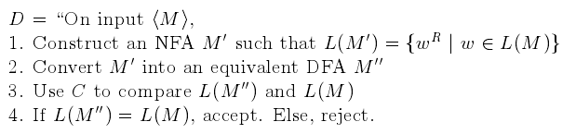
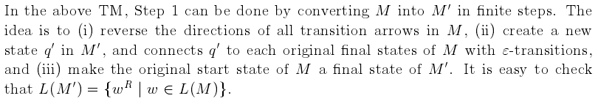
Also, both Step 2 and Step 3 can be done in finite steps, as we learnt from the lectures. So, D runs in finite steps and is thus a decider.

