Panel and Page Comic Shop Management System
Relational Database Project
Project detail | Value
Prepared by | Duane Harris
Presentation date | November 19, 2026
Project repository | https://github.com/duaneX1504/bookstore-management-system

Project overview
Panel and Page is an inventory and order manager for a comic shop. It tracks comic editions by title, series, issue or collected range, publisher, lead creator, genre, format, condition, store price, and stock. The dashboard helps staff maintain the catalog, check low-stock editions, search and filter inventory, export a CSV, and review recent orders.
The seeded catalog contains real Marvel and DC titles, including The Amazing Spider-Man, X-Men: Days of Future Past, Batman: Year One, and Watchmen. Store prices, inventory amounts, condition grades, and catalog codes are fictional practice values.

Languages and tools
Layer | Technology
Frontend | HTML, CSS, JavaScript
Backend | PHP 8 with PDO
Relational database | MySQL 8 or MariaDB
Local environment | XAMPP: Apache and MySQL
API | REST-style HTTP requests with JSON responses

Database design
The database has seven related tables. Publishers, creators, and genres are stored once and referenced from comic records. Each record identifies one lead creator to keep this class model manageable. Customers place orders, and order_items connects orders with comic editions using a composite primary key.
Table | Primary key | Main fields and relationships
publishers | publisher_id | publisher_name (unique)
creators | creator_id | creator_name (unique)
genres | genre_id | genre_name (unique)
comics | comic_id | catalog_code, title, series_title, issue_number, publisher_id FK, creator_id FK, genre_id FK, format, condition_grade, price, stock_qty
customers | customer_id | full_name, email (unique), phone
orders | order_id | customer_id FK, order_date, status
order_items | order_id + comic_id | both columns are foreign keys; quantity and unit_price

Foreign keys protect related data. Unique constraints prevent duplicate publisher, creator, genre, catalog-code, and customer-email values. Price and stock cannot be negative. The order API checks stock and saves an order, its lines, and the stock deduction in one transaction. A cancellation restores reserved copies. Each order line stores its unit price so prior orders keep the price charged at checkout.
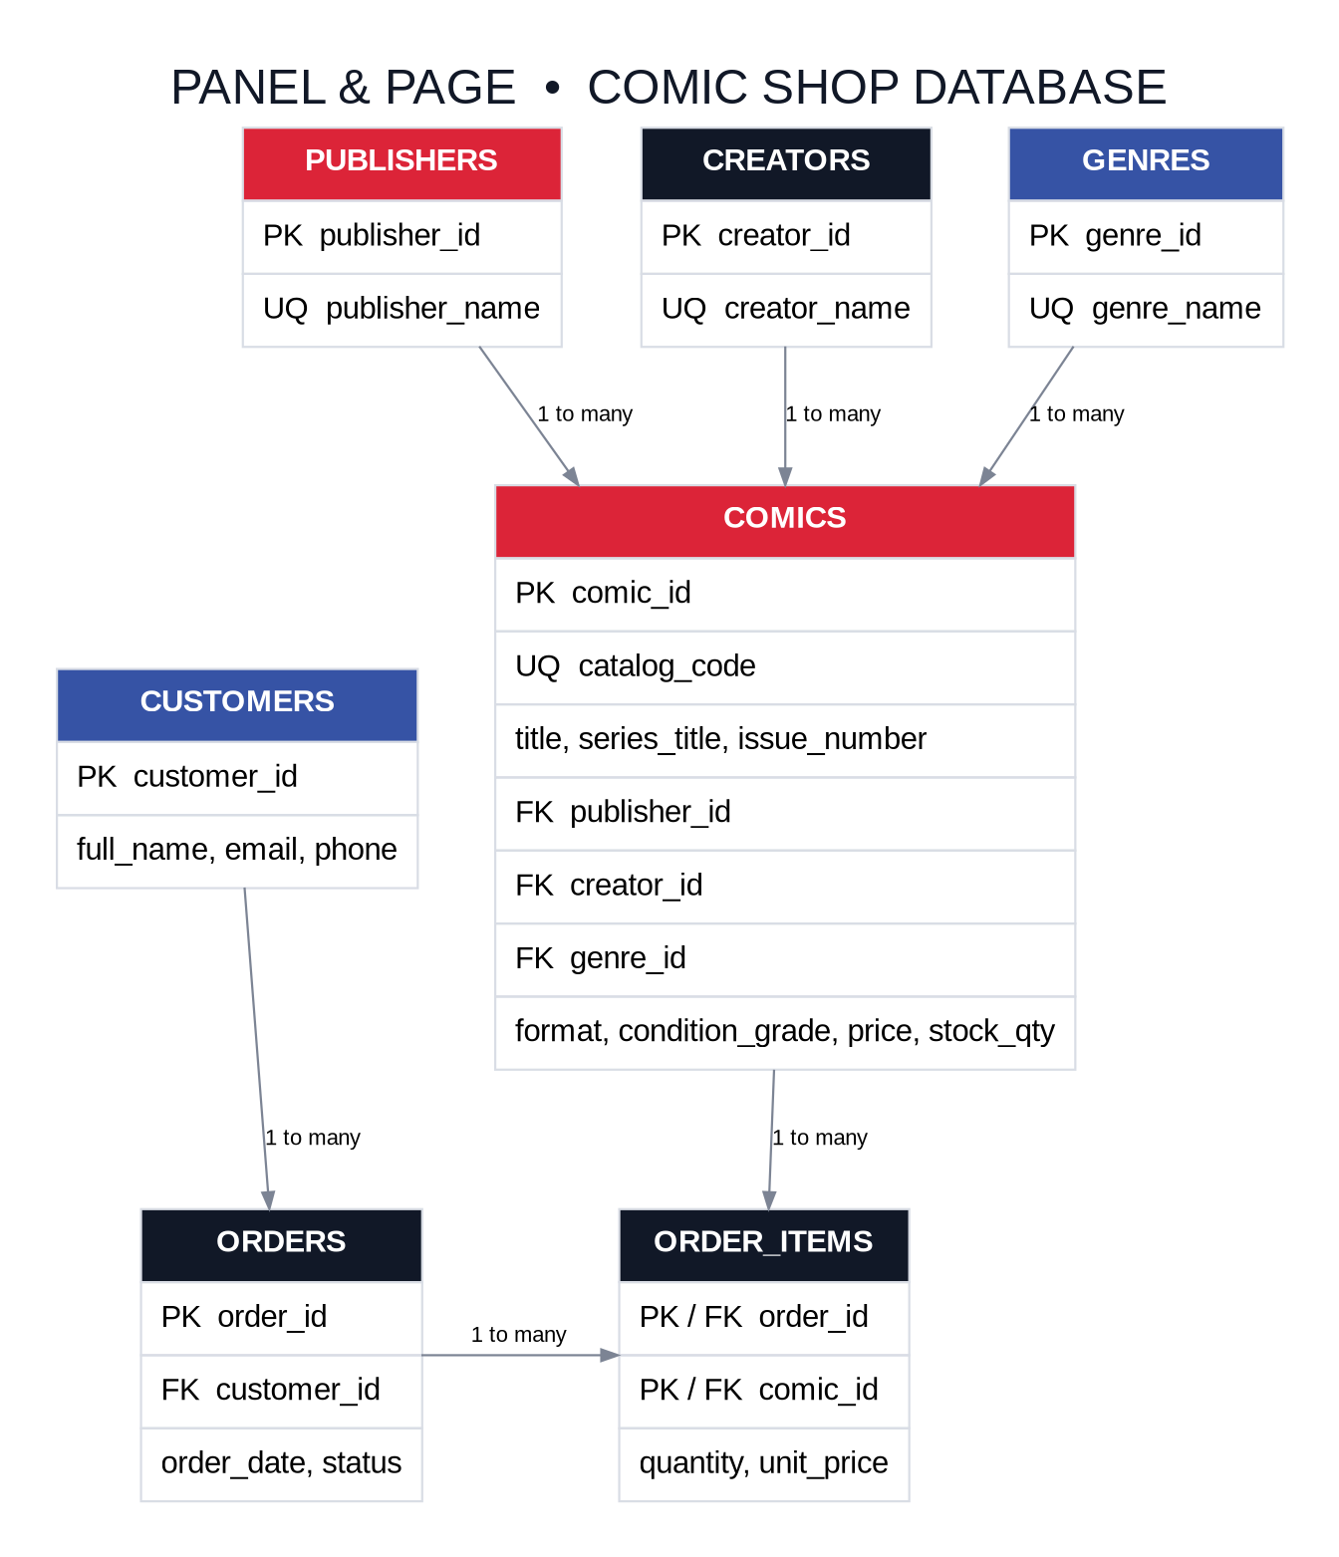
Figure 1. Comic shop relational database

Frontend and API
The dashboard summarizes the number of comic editions, available copies, open orders, and low-stock editions. Staff can create, read, update, and delete comic records. The form stores comic metadata and store inventory information. Search includes title, series, issue range, creator, and catalog code. A publisher filter narrows the catalog, while CSV export downloads the current inventory. Sidebar links open dedicated Orders, Publishers, and Creators sections. Publishers and creators can be added, renamed, or deleted when they are not referenced by a comic.
The Orders section can place orders for existing customers, show each order's comic lines and total, change its status, cancel it, or delete it. Cancelling or deleting an active order returns reserved copies to stock. Order lines and sale prices stay fixed after checkout to preserve the sale record; correct an order by cancelling or deleting it and creating a replacement.
The PHP API uses prepared PDO statements and validates incoming values. Comics, publishers, creators, genres, and customers support GET, POST, PUT/PATCH, and DELETE requests. Orders support reads, creation with stock deduction, status changes, and deletion with stock restoration. Responses use JSON and HTTP status codes for success, invalid input, missing records, and related-record conflicts.

Dashboard screenshot
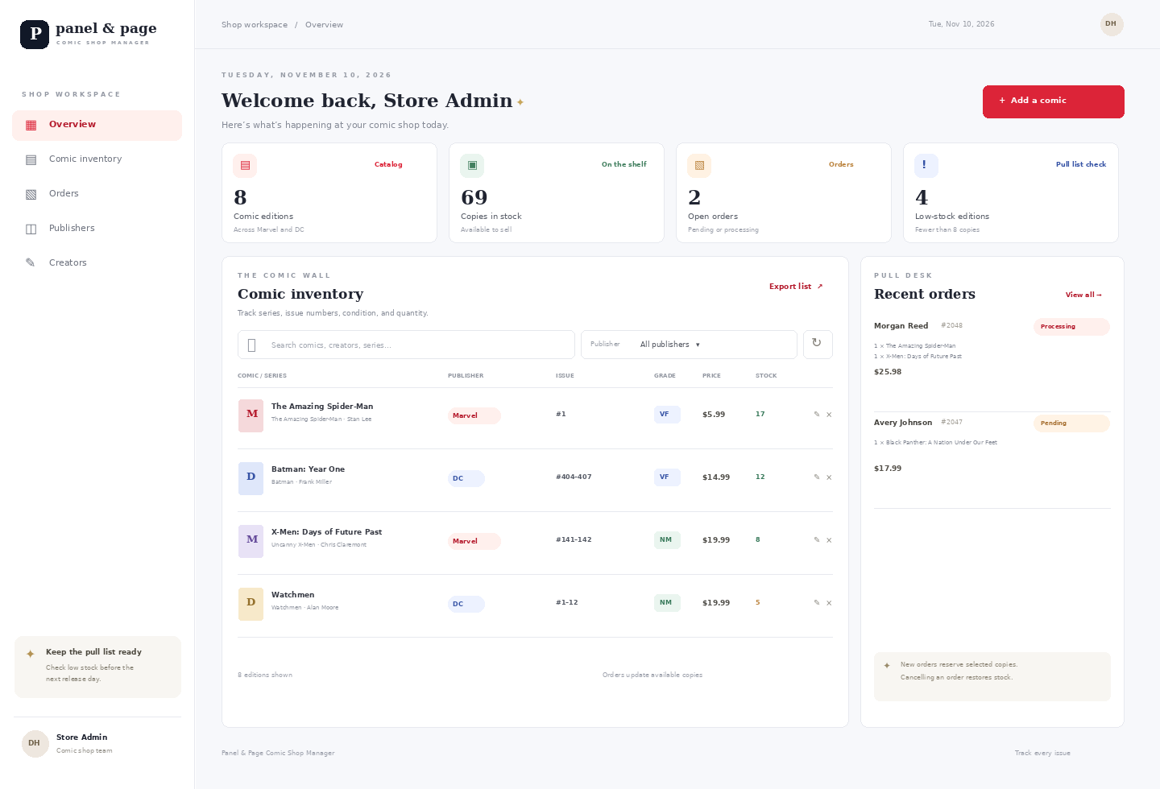
Figure 2. Panel and Page comic shop dashboard preview

Comic entry form
The form records a title and series, issue or collected range, store catalog code, publisher, lead creator, genre, format, condition grade, price, and stock quantity.
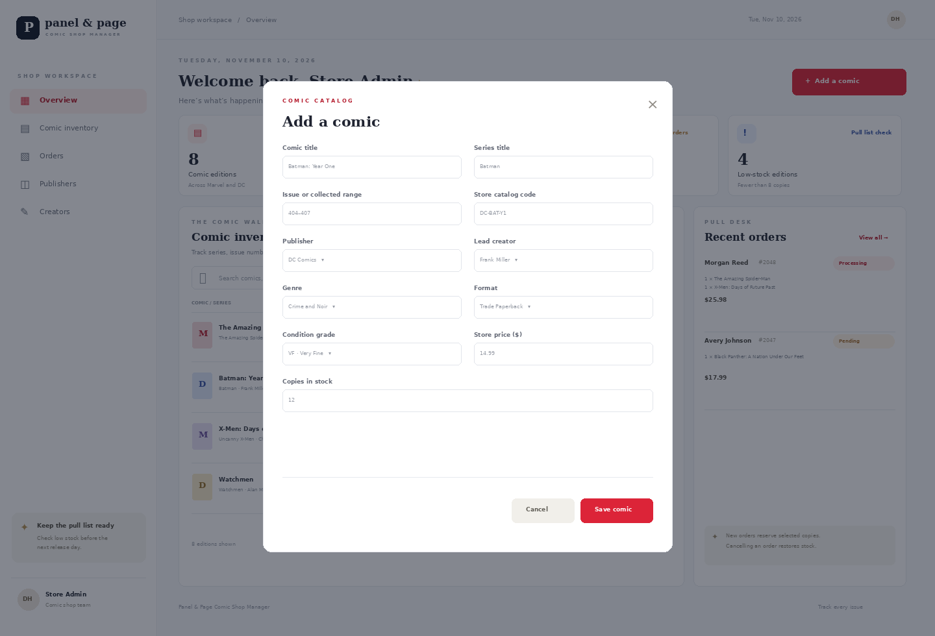
Figure 3. Add-comic form preview

Publisher and creator management
The sidebar opens separate management screens for publishers and creators. Staff can add new records, rename existing records, or delete records that are not referenced by a comic. The relational database rejects a delete if a comic still depends on that publisher or creator.
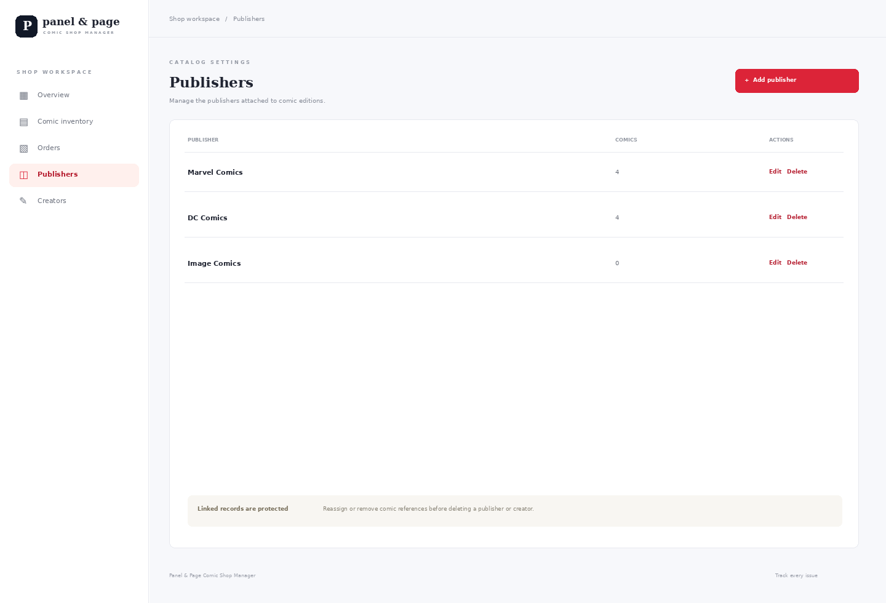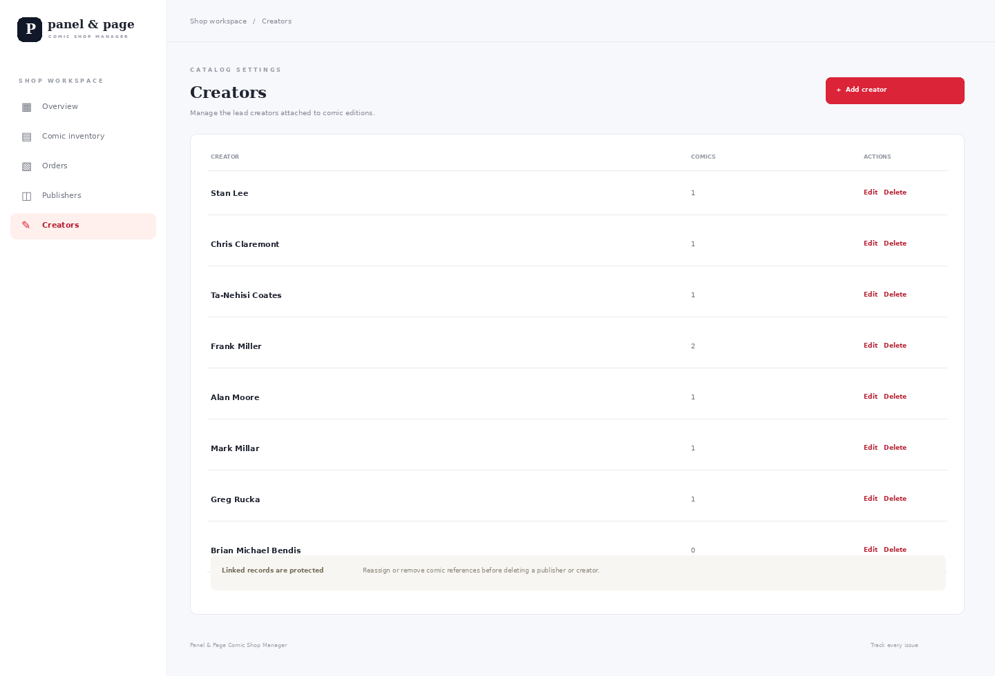
Figure 4. Publisher and creator management screens

Order management
The Orders section lets staff place an order for a customer, select comics and quantities, review line items and totals, and change an order's status. Cancelling or deleting an active order restores reserved stock. The charged prices and comic lines are fixed after checkout so the original sale record remains accurate.
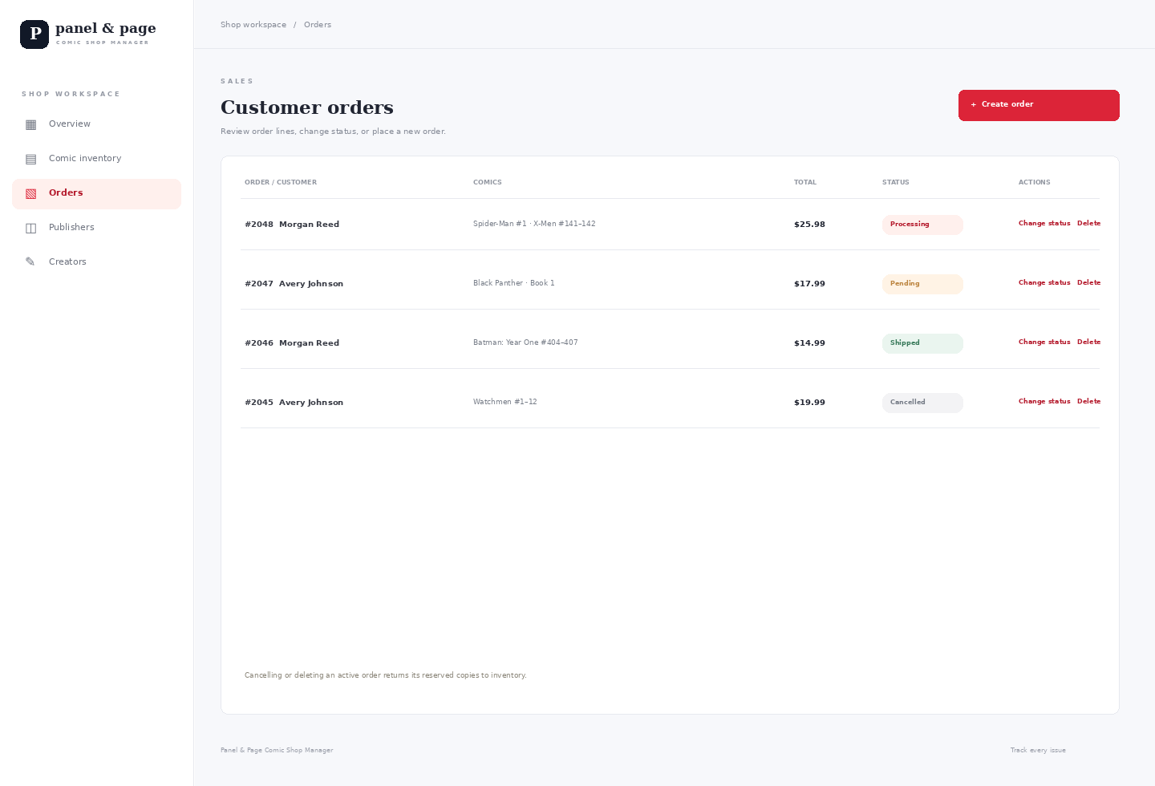
Figure 5. Order management with status and delete actions

Setup and class demonstration
To recreate the project, place the folder in C:\xampp\htdocs, start Apache and MySQL, import database/schema.sql through phpMyAdmin, copy config.example.php to config.php, and open http://localhost/bookstore-management-system/. The SQL file creates comic_store_db and seeds sample records.
- Show the Marvel and DC sample editions, then create or edit a temporary comic record.
- Add a publisher or creator and show that linked records cannot be deleted while comics use them.
- Create an order in the Orders section, update its status, then cancel it and show stock return.
- Explain the foreign keys, order_items composite key, prepared statements, and transaction rollback.

Project repository and title references
GitHub: https://github.com/duaneX1504/bookstore-management-system
Official Marvel and DC catalog links for the sample titles are included in the repository README.
Scope: classroom demonstration without logins, payment processing, shipping, or barcode scanning.

