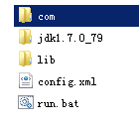



@echo on

set java_home="D:\TestJar\jdk1.7.0_79"

setlocal enabledelayedexpansion

set classpath=.

for %%c in (lib\*.jar) do set classpath=!classpath!;%%c

set classpath=%classpath%;./config;

java com.socket.NioServer