MySQL数据库中如何修改root用户的密码呢？下面总结了修改root用户密码的一些方法

**1： 使用set password语句修改**

[?](http://www.jb51.net/article/69761.htm)

|  |  |
| --- | --- |
| 1  2  3  4  5  6  7  8  9  10  11  12  13  14  15 | mysql> select user();  +----------------+  | user()  |  +----------------+  | root@localhost |  +----------------+  1 row in set (0.08 sec)    mysql> set password=password('123456');  Query OK, 0 rows affected (0.00 sec)    mysql> flush privileges;  Query OK, 0 rows affected (0.00 sec)    mysql> exit |

[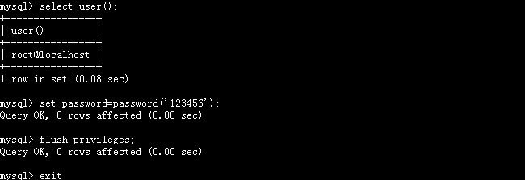](http://files.jb51.net/file_images/article/201507/201507211028147.png)

**2: 更新mysql数据库的user表**

[?](http://www.jb51.net/article/69761.htm)

|  |  |
| --- | --- |
| 1  2  3  4  5  6  7  8  9  10  11  12  13 | mysql> use mysql;  Reading table information for completion of table and column names  You can turn off this feature to get a quicker startup with -A    Database changed  mysql> update user set password=PASSWORD('QwE123') where user='root';  Query OK, 4 rows affected (0.03 sec)  Rows matched: 4 Changed: 4 Warnings: 0    mysql> flush privileges;  Query OK, 0 rows affected (0.00 sec)    mysql> quit |

[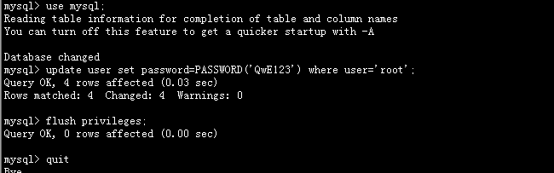](http://files.jb51.net/file_images/article/201507/201507211028148.png)

**3：使用mysqladmin命令修改**

命令一般为 mysqladmin -u root -p'oldpassword' password newpass 如下所示：

[?](http://www.jb51.net/article/69761.htm)

|  |  |
| --- | --- |
| 1  2 | [root@DB-Server ~]# mysqladmin -u root -p'123456' password 'Qwe123'  Warning: Using a password on the command line interface can be insecure. |

验证root密码修改是否成功

[?](http://www.jb51.net/article/69761.htm)

|  |  |
| --- | --- |
| 1  2 | [root@DB-Server ~]# mysqladmin -u root -p'123456' password 'Qwe123'  Warning: Using a password on the command line interface can be insecure. |

上面都是在知道root密码的情况下修改root密码，如果忘记了root密码，如何修改root的密码呢？

**1：首先停掉MySQL服务**

[?](http://www.jb51.net/article/69761.htm)

|  |  |
| --- | --- |
| 1  2  3 | [root@DB-Server ~]# service mysql stop  Shutting down MySQL..[ OK ]  [root@DB-Server ~]# |

或

[?](http://www.jb51.net/article/69761.htm)

|  |  |
| --- | --- |
| 1  2 | [root@DB-Server ~]# /etc/rc.d/init.d/mysql stop  Shutting down MySQL..[ OK ] |

**2：然后使用mysqld_safe命令启动mysql，更新root账号的密码**

    --skip-grant-tables：不启动grant-tables(授权表),跳过权限控制。

    --skip-networking ：跳过TCP/IP协议，只在本机访问(这个选项不是必须的。可以不用)是可以不用

[?](http://www.jb51.net/article/69761.htm)

|  |  |
| --- | --- |
| 1  2  3  4  5  6  7  8  9  10  11  12  13  14  15  16  17  18  19  20  21  22  23  24  25  26  27  28  29  30  31  32  33  34  35  36  37  38  39  40  41  42  43  44 | [root@DB-Server ~]# mysqld_safe --user=mysql --skip-grant-tables --skip-networking &  [1] 5145  You have new mail in /var/spool/mail/root  [root@DB-Server ~]# 150709 14:10:53 mysqld_safe Logging to '/var/lib/mysql/DB-Server.localdomain.err'.  150709 14:10:53 mysqld_safe Starting mysqld daemon with databases from /var/lib/mysql    [root@DB-Server ~]# mysql -u root mysql  Reading table information for completion of table and column names  You can turn off this feature to get a quicker startup with -A    Welcome to the MySQL monitor. Commands end with ; or \g.  Your MySQL connection id is 1  Server version: 5.6.20-enterprise-commercial-advanced MySQL Enterprise Server - Advanced Edition (Commercial)    Copyright (c) 2000, 2014, Oracle and/or its affiliates. All rights reserved.    Oracle is a registered trademark of Oracle Corporation and/or its  affiliates. Other names may be trademarks of their respective  owners.    Type 'help;' or '\h' for help. Type '\c' to clear the current input statement.    mysql> show databases;  +--------------------+  | Database  |  +--------------------+  | information_schema |  | mysql  |  | performance_schema |  | test  |  +--------------------+  4 rows in set (0.00 sec)    mysql> use mysql  Database changed  mysql> UPDATE user SET password=PASSWORD("Qwe123") WHERE user='root';  Query OK, 4 rows affected (0.01 sec)  Rows matched: 4 Changed: 4 Warnings: 0    mysql> flush privileges;  Query OK, 0 rows affected (0.00 sec)    mysql> exit  Bye |

**3：重新启动MySQL服务。**