CASS-Q User Guide

Contents
For respondents 3
Download the client application 3
For researchers 3
Go to the CASS administrator webpage 3
Login 3
Help at any time 4
Create a new user 4
Create a new Research 5
Data collection methods 6
CREATING, EDITING QUERIES TO RESEARCH 10
Add a new query 10
Edit query question 11
Add respondents to the research 13
Getting answers from the research 15
Downloading information 15
Lock the research 15

For respondents

Download the client application

Method 1: Open Play Store in your phone, search: cass-q. Install and open
Method 2: Use your phones barcode scanner which connects you directly to CASS-Q client. Install and open



For researchers

Go to the CASS administrator webpage
http://ec2-23-23-93-172.compute-1.amazonaws.com/cass/content/index.php

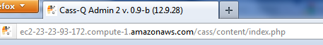

Login
Login to CASS with your research administrator credentials.
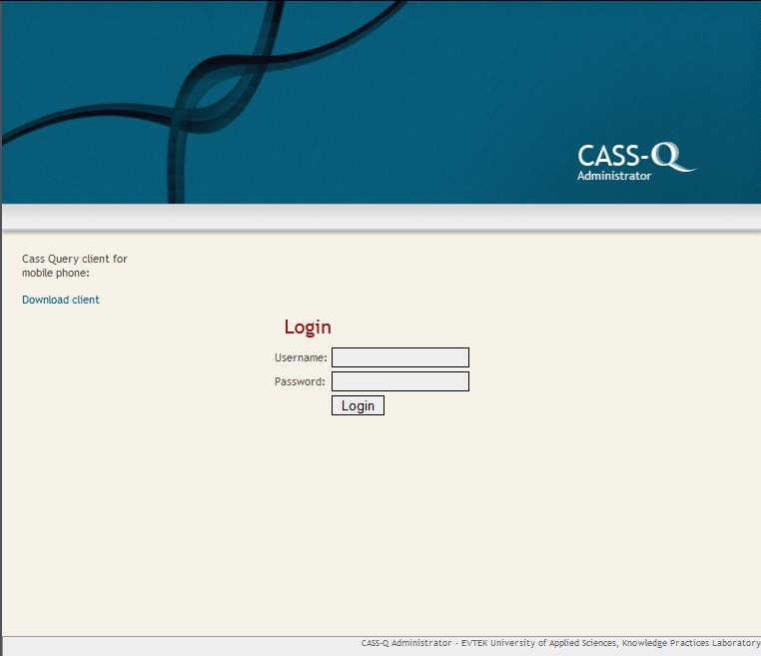

Help at any time
Whenever you see this sign you can get more explanations about CASS.

Create a new user
Only if you want to create a researcher administrator (who has the right to create new users and researches). The research administrator can login into the page. This is not an option to create new respondents for a research. It should be done through the research’s main page.

>> Add a new user
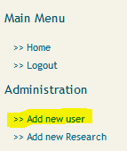

Fill name and password*. Then check: Research Administrator.
*They can be both changed afterwards by the research administrator.

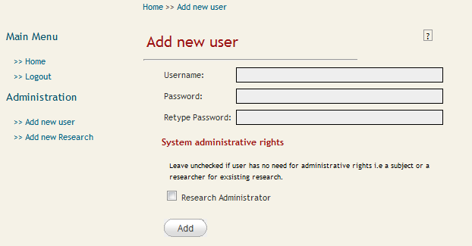

Output: 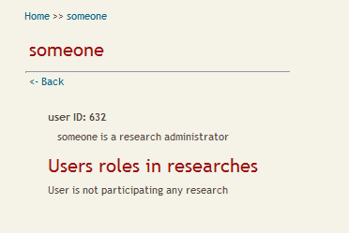

Create a new Research
>> Add new Research
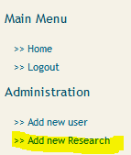
Fill in all the fields
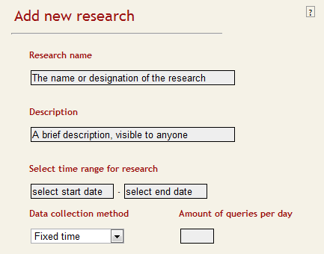

Data collection methods
Fixed time –data collection method: In this method an amount of exact times are set when a query(s) is(are) sent. For each time a different query can be sent. Also, the same query can be sent many times a day too. Respondents have time to answer the sent query until next pre-set time kicks in. During this interval the respondent can answer the query only once.

When you select certain amount of queries per day (is required) you will have to set at what time in the day the queries are going to be sent.
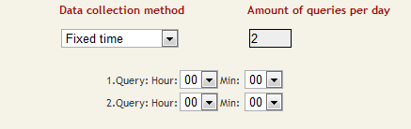
Last thing Add new Research:

Fixed Interval –data collection method: In this method a time is set for the first query of the days, after that the first query can be answered any time. Also, there needs to be set an interval. The respondent can answer the next query after the interval has passed. In fixed interval also many different queries can be sent.

When you select certain amount of queries per day (is required) you will have to set at what time in the day the first query will be sent and the interval between one query and the next.
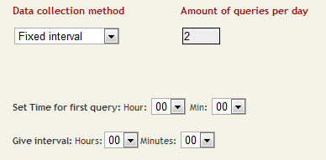
Last thing Add new Research:

Event contingent - data collection method: Only one query is sent and it can be answered as many times as the respondent wants to answer it a day.
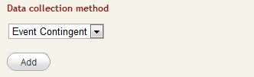
You only need to Add new Research:

When you add a new research you will be redirected to the Research Main page. Important links that you may use, are in the circled areas. Research, Actions and Information menu relates to that specific
research.
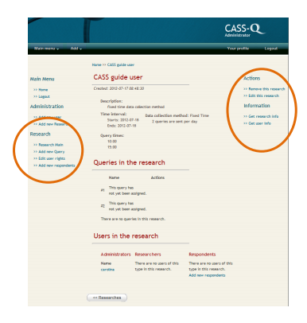
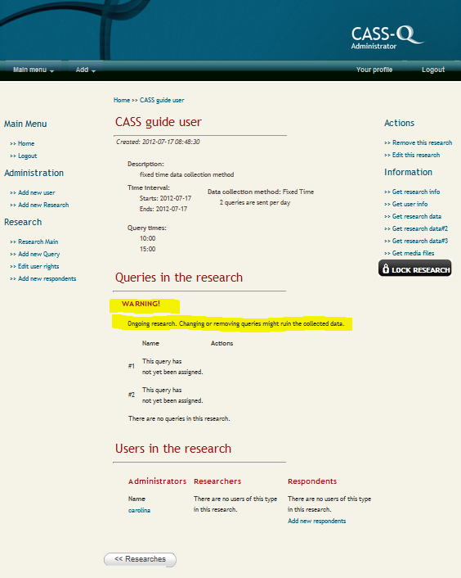
*This is a ongoing research that is why: WARNING! Ongoing research. Changing or removing queries might ruin the collected data.

You should NOT change any data when the research is going on, it may ruin the research data and respondents might not be able to answer it anymore. You can get the research answers or research information. Also, visualize the queries one by one.

CREATING, EDITING QUERIES TO RESEARCH

Add a new query
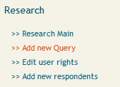
a) Case: Fixed time
Give the query a name and assign it either to all the fixed times. Click create query.
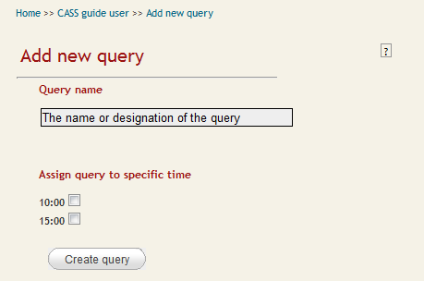

b) Case: Fixed interval.
Select at what point the query should be sent. Click create query.
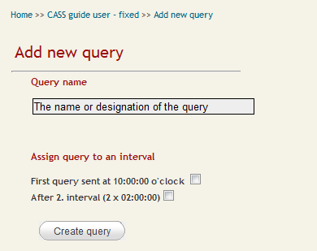

c) Case: Event contingent
Only one query can be sent in Event Contingent type of Research. Click create query.
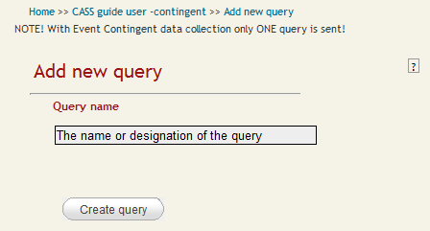

Edit query question
Editing the questions happens on the panels that you can see in the picture below. The left panel is for editing the Question list and the right panel is meant for editing, copying existing questions in other researches and adding new questions. These functionalities are marked on the tabs: Edit, Copy and Add.

In a research there can be 9 types of questions and comments. Each of these questions has different behaviour and the types also define what kind of respond the respondents can give to the questions. Here comes a list with the names of the different question types, their behaviours and settings:
- Open text: respondent can insert text up to 1000 characters.
- Open number: this has minimum and maximum values and the respondent can answer something between them.
- Sound: respondent can record sound. Also has a possibility to answer by text. The maximum file size that can be sent is usually 2 MB but it depends on the settings of the server. This file size is enough to record a 4-5 minutes long voice file.
- Multiple choice – one answer: respondent can choose one option from the given options.
- Multiple choice – multiple answer: this is basically a subversion of the Multiple choice question. To save this kind of question, tick the multi ans. checkbox.
- Super question: in this the respondent can choose one option, like in multiple choice – one answer. In this question type the answer affects the whole query by showing additional questions based on the answer. On the mobile phone questions, with category number 0 (default), are shown always and bigger than that are shown only if a super questions option with that category number is chosen. Category number can be set for every question in the query. Be careful when you make the super questions! There can be many super questions in the query but a super question should not point to another super question because the mobile client cannot handle the second super questions. It can cause problem in the presentation of the query. In other words a super questions category number cannot be anything else then 0. In addition, it is advisable that the questions which a super question effects should appear after the super question.
- Comment: a comment text in the phone, nothing can be answered to these.
- Picture: respondent can take a picture. The size of the picture usually does not exceed the limit that is allowed by the system (450MB).
- Video: respondent can take video recordings. The maximum file size that can be sent is usually 2 MB but it depends on the settings of the server. This file size is enough to record a 4-5 minutes long video file.
- Slider: basically the same as open number but it is shown graphically in the phone. Slider has minimum value label, minimum value, maximum value label, maximum value. The step between these values is 1. Minimum label is the text shown in the left side of the slider and maximum label is in the right side. The values tell the maximum and minimum values in the slider.

Note 1: The following characters should not be used in the questions: “ # ¤ & +. They cause problems during copying, editing or showing the questions on the mobile phone.

Note 2: In a query there should not be two or more questions with the exact same question text because that can cause problems later on when downloading the research data because of the way how the data is sorted during the download process. If you want to use the same question in a query you can add a number in front of the question, thus differentiate the questions.
After adding all the questions and you are satisfied with the order of the questions, press the Finished button.

Note 3: After a research has started, the order of the questions should not be changed, you should not add new a question or remove one, it can cause problem when retrieving the data. In general it is a good practice to make a pilot research with pilot queries and when you are satisfied with it, create a new research and copy the queries in it.

Add respondents to the research
a. Add new respondents to the research from Research Main page.
Each respondent will get a token, an access key which they can introduce in the mobile device in order to get the queries.

>>Add new respondents
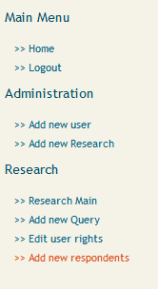

First, select how many new respondents you want to create and then click create.

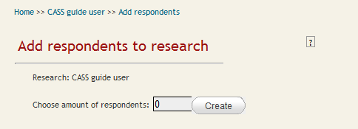

A list of possible users and tokens will be generated. Only username and password are editable. . Only username and password are editable.!Username should not be the same than a previous one, it would cause errors.
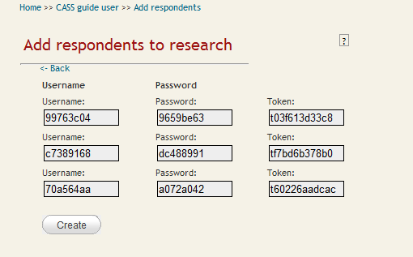

Click create, the respondents will be stored this time in CASS. You may download the list of usernames and passwords because it will not be available afterwards. You will get a doc file. Click Research Main to go back to the Research page.

The token with the usernames can be downloaded later on as well from Main Research page, in the link Get User Info or when you download Get research info (in the bottom of the doc document).
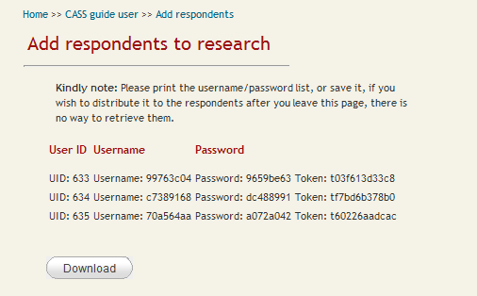

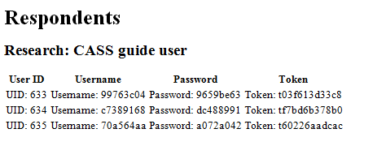

Getting answers from the research
From the right menu, you can get the research data
- Get research data will output an excel file
- Get media files in a zipped file.

Downloading information
- Get research info. This you can get while the research has not started.
- Get user info: downloads a file with the usernames and tokens. It is suggested to print it in order to give the respondents their token. When analyzing the data also, it will be useful to know
which token relates to whom –in case any of the respondents looses it-.

Lock the research
If it is a ongoing research you will be able to see:
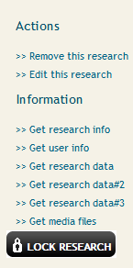
After pressing this button you cannot edit the research anymore. This locks the research permanently; the users will not be able to edit the research further.

