COMP3322 Modern Technologies on World Wide Web
Assignment 2 (12%)
[Learning Outcomes 2, 3]
Due by: 23:55, Sunday Nov 6 2016
Overview
In this assignment, you are going to develop a simple web-based news feed application using PHP, Javascript/jQuery, AJAX, HTML and CSS. The application implements a few simplified functionalities, including displaying news lists, switching between different news list pages, searching news headlines, displaying a news entry, displaying comments posted to a piece of news, and posting comments on a piece of news after login.

Prepare database tables
Prepare the following database tables in your database in the server sophia.cs.hku.hk
1. Create a database table users, which stores information of registered user in the news feed application. Each user entry in the table must contain the following attributes:
- userID – The unique ID of the user, which is an integer starting from 1.
- name – The registered name of the user (less than or equal to 20 characters).
- password – The registered password of the user (less than or equal to 20 characters).
- icon – The path (which can be absolute or relative path) to the file of the icon used to represent that user (e.g., a photo of the user). The path should be less than or equal to 255 characters.

For your reference, the following SQL statement creates the users table.
CREATE TABLE users (
userID int(11) NOT NULL,
name varchar(20) NOT NULL,
password varchar(20) NOT NULL,
icon varchar(255) NOT NULL,
PRIMARY KEY (userID)
)
The following SQL statement inserts a user entry into the users table.
INSERT INTO users( userID, name, password, icon)
VALUES (
'1',
'Jacky',
'12345',
'images/jacky.jpg'
);

Insert at least two user entries into the users table, for testing your program.

2. Create a database table news. Each news entry in the table must contain the following attributes:
- newsID – The unique ID for each piece of news, which is an integer starting from 1.
- headline – The headline of the news (less than or equal to 150 characters).
- content – The textual content of the news.
- time – The time when the news was posted (less than or equal to 30 characters).
For your reference, the following SQL statement creates the news table.
CREATE TABLE news (
newsID int(11) NOT NULL,
headline varchar(150) NOT NULL,
content longtext NOT NULL,
time varchar(30) NOT NULL,
PRIMARY KEY (newsID)
)

The following SQL statement inserts a news entry into the news table.
INSERT INTO news(newsID , headline, content, time)
VALUES (
'1',
'Toni Kroos: Real Madrid midfielder signs new contract',
'Germany midfielder Toni Kroos has extended his Real Madrid contract until 2022.
Spanish newspaper AS claims the new deal will earn him £346,000 a week.',
'Oct 10 2016'
);

Insert at least 15 news entries into the news table, for testing your program. In this assignment, we assume the news entries are inserted into the news table in chronological order, i.e., the oldest news has a newsID of 1 and the latest news has the largest newsID in the table.

3. Create a database table comments. Each comment entry in the table must contain the following attributes:
- commentID – The unique ID for each comment, which is an integer starting from 1.
- newsID – The newsID identifying which news this comment is posted on.
- userID – The userID identifying who posted this comment.
- content – The textual content of the comment.
- time – The time when the comment was posted (less than or equal to 30 characters).
For your reference, the following SQL statement creates the comments table.
CREATE TABLE comments (
commentID int(11) NOT NULL,
newsID int(11) NOT NULL,
userID int(11) NOT NULL,
content longtext NOT NULL,
time varchar(30) NOT NULL,
PRIMARY KEY (commentID)
)

The following SQL statement inserts a comment into the comments table.
INSERT INTO comments(commentID, newsID , userID, content, time)
VALUES (
'1',
'5',
'2',
'Fantastic!',
'Oct 13 2016'
);

You can insert some comment entries into the comments table for testing purpose, or you can insert comments later through the web page you have developed. We assume the comments are inserted into the comments table in chronological order, i.e., a smaller commentID corresponds to an older comment.

Task 1 (40 marks) Implement the news list display page (index.html and handleListDisplay.php)
Index.html and handleListDisplay.php collectively create the news list display page as shown in Fig. 1.
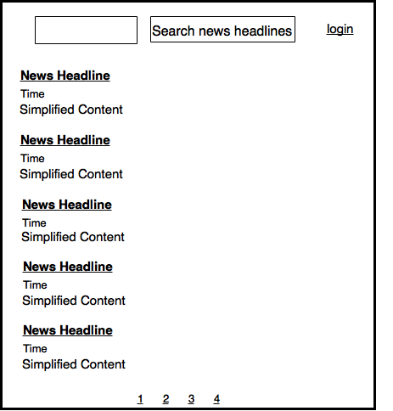
Fig. 1 The news list display page.

1. Index.html should implement the following:

(1) It contains 3 divisions: (i) <div id=“header”>, containing a search input textbox, a button showing “Search news headlines”, and a login or logout link; (ii) <div id=“news”>, to display the news entries; (iii) <div id=“pageindex”>, to contain page indices for navigating to other news list pages. Create the search input textbox and the search button in the “header” division.

5 marks for correctly implementing the index.html, including:
1. 1 mark for creating a search input textbox
2. 1 mark for creating a button showing search news headlines
3. 1 mark for creating a login or logout link
4. 1 mark for creating a <div id=”news”> element.
5. 1 mark for creating a <div id=”pageindex”> element.

(2) The “login” or “logout” link in the “header” division, the news entries in the “news” division, and the page indices in the “pageindex” division are dynamically generated in a Javascript function loadNewsList(pageindex). The function should be invoked when index.html is loaded for the first time, when the “Search news headlines” button is clicked, and when a page index is clicked. In the first and the second cases, loadNewsList(1) is called; in the third case, loadNewsList(pageindex) is invoked, where pageindex is the page index that the user clicks.

In loadNewsList(pageindex), the search string that the user enters in the search input textbox is retrieved. If the search input box is empty, the search string should be “”. An AJAX request is sent to retrieve handleListDisplay.php, carrying pageindex and the search string. It will obtain the following information from the server: (a) the total number of news entries in the database, whose headlines contain the search string; (b) newsID, headline, time and simplified content of 5 pieces of news (or less if the page is the last page) among the news entries whose headlines contain the search string, according to the pageindex; (c) the login status of the user.

With the responded data, it creates the HTML content on the page as follows:

(a) Display “login” or “logout” in the “header” division. If the login status is 0, “login” is displayed; if the login status is 1, “logout” is displayed. “login” should be a hyperlink linking to the URL “login.php?newsID=0”. “logout” should not link to any URL, but an event handler function logout() should be registered with its “onclick” event (how to implement logout() will be described in Task 3).

(b) Create or replace the news entries in the “news” division with the received news entries. The news entries are ordered in reverse chronological order, i.e., the latest news are displayed at the top. Each news headline is a hyperlink, linking to displayNewsEntry.php?newsID=xx, where xx should be the newsID value of the corresponding news entry.

(c) Produce the page indices in the “pageindex” division. The page indices are created according to the overall number of news entries in the database whose headlines contain the search string – the number received from the server. We display 5 news entries per page. For example, if the overall number is 17, we need 4 pages — 5 entries on pages “1”, “2”, “3”, and 2 entries on page “4”. The index of the page current being displayed should be displayed in a highlight color, different from the color of the other page indices.

You should use proper HTML elements and styling rules at your choice to implement the page display, following the layout sketch given in Fig. 1.

20 marks for correctly implementing loadNewsList(pageIndex) function, including:
1. 2 marks, loadNewsList(1) should be invoked when the webpage is loaded for the first time or when the search news headlines button is clicked.
2. 2 marks for generating a HTTP request to handleListDisplay.php, carrying pageIndex and searchString as parameters.
3. 2 marks for correctly displaying login or logout link.
4. 3 marks for correctly sorting the news in reverse chronological order.
5. 4 marks for correctly displaying the news under <div id=”news”>.
6. 4 marks for correctly displaying all the page indexes.
7. 3 marks for adding an underline to the current page index.

2. handleListDisplay.php obtains the total number of entries in the news table in the database whose headlines contain the search string sent in the request (Hint: You may find the SQL like operator http://www.w3schools.com/Sql/sql_like.asp useful). It then retrieves a number of news entries according to the pageindex and the total number of entries obtained above. In addition, it checks whether a “userID” cookie has been set for the user (which is set after the user has successfully logged in, to be implemented in Task 3): if so, it sets the login status to be 1; otherwise, it sets the login status to be 0.

handleListDisplay.php returns all the data to the user using a JSON string: (1) you should design the concrete format of the JSON string and parse it accordingly in loadNewsList(pageindex); (2) only the first 10 words of the content of a news entry should be sent to the user as the “simplified content”, instead of the complete news content (refer to http://www.w3schools.com/php/php_ref_string.asp for PHP string functions that you may use).

15 marks for correctly implementing handleListDisplay.php, including:
1. 3 marks correctly calculating the total number of news containing the search string from the database.
2. 3 marks for correctly retrieving all the news containing the search string on the current page index.
3. 3 marks for correctly extracting the first 10 words of the content of a news entry.
4. 3 marks for correctly setting up the login status of the user.
5. 3 marks for correctly returning a JSON string containing all the information required by the loadNewsList function.

Task 2 (30 marks) Implement the news entry display page (displayNewsEntry.php and handlePostComment.php)
After a user clicks a news headline on the news list display page shown in Fig. 1, displayNewsEntry.php is retrieved, which generates a page as shown in Fig. 2: if the user has not logged in before, he sees Fig. 2(a); if the user has successfully logged in, he sees Fig. 2 (b).

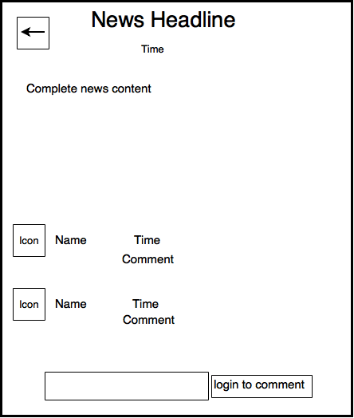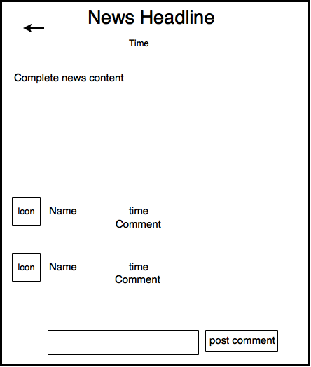
(a) (b)

Fig. 2 The news entry display page.

1. displayNewsEntry.php implements the following:

(1) Retrieve the news entry from the news table in the database according to the newsID carried in the request. It then retrieves all the comments posted on this news from the comments table based on the “newsID” as well. For each comment, it further retrieves the name and the icon of the user who posted the comment from the users table according to the “userID”.

(2) Create appropriate HTML elements and styling rules to display the news information and comments according to the layout sketch in Fig. 2. The comments should be displayed in reverse chronological order with the newest comments at the top.

(3) Create a button displaying an arrow in the top-left corner of the page, which links back to index.html.

(4) Create a comment input textbox and a button besides it at the bottom of the page. If the current user has not logged in (by checking if the “userID” cookie has been set), the comment input textbox should be disabled (Hint: use the disabled attribute http://www.w3schools.com/tags/att_input_disabled.asp), and “login to comment” should be displayed on the button; otherwise, the comment input textbox should be enabled, and “post comment” should be displayed on the button.

(5) The “login to comment” button should link to the URL “login.php?newsID=xx”, where xx should be the newsID value of the news entry displayed on the current page.

(6) The “post comment” button does not link to a URL. Instead, an event handler function postComment() is registered with its “onclick” event.

In postComment(), the comment that the user has entered in the comment input text box is obtained. If the comment input textbox is empty, an alert box will pop up, showing “No comment has been entered”, and then the function exists.

Otherwise, an AJAX request is sent to retrieve handlePostComment.php, carrying the comment that the user has entered in the comment input textbox, the newsID, the commentID of the newest comment that is displayed on the page, and the current time. You only need to include date, month and year in the time string to be sent in the request (Hint: use JavaScript Date object to obtain date, month and year http://www.w3schools.com/jsref/jsref_obj_date.asp). Upon receiving the latest comments (that the current page has not displayed) returned by handlePostComment.php, update the comments display part of the page by inserting these latest comments at the top, and empty the comment input textbox.

10 marks for correctly implementing displayNewsEntry.php, including:
1. 2 marks for correctly displaying the headline, time and content of the news, as well as a back arrow linking to “index.html”.
2. 2 marks for correctly retrieving all the comments posted on the displayed news.
3. 2 marks for sorting the news in reverse chronological order.
4. 1 marks for retrieving the information of the user who posted the comment.
5. 1 marks for correctly displaying all the comments on the webpage.
6. 2 marks for correctly displaying an input box and a button depending on the login status of the user.

2. handlePostComment.php inserts the comment posted by the user into the comments table (Hint: you can obtain userID from the “userID” cookie, and set the commentID to be 1+ total number of comments in comments table). It then retrieves all the latest comments on the news entry from the comments table, that have not been displayed on the user’s news entry display page. For each comment, it further retrieves the name and the icon of the user who posted the comment from the users table. The retrieved data should be returned to the user in a JSON string. You should design the format of the JSON string and parse it accordingly in postComment().

10 marks for correctly implementing handlePostComment.php, including:
1. 3 marks for correctly calculating the commentID of the new comment.
2. 3 marks for correctly inserting the comment into the database.
3. 4 marks for returning all the comments that are not displayed on user’s web page back to the user in a JSON string.

10 marks for correctly implementing the postComment() function, including:
1. 1 mark for correctly generating an alert when input box is empty.
2. 1 mark for correctly retrieving the ID of the news that the comment is posted on.
3. 2 marks for correctly retrieving the ID of the newest comment that is being displayed on the webpage.
4. 2 marks for correctly calculating the time when the new comment is posted.
5. 2 marks for sorting the new comments in reverse chronological order.
6. 2 marks for correctly displaying the new comments.
Task 3 (20 marks) Implement login and logout pages (login.php, handleLogin.php and handleLogout.php)
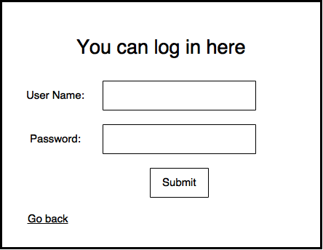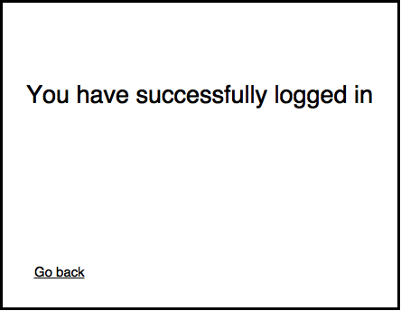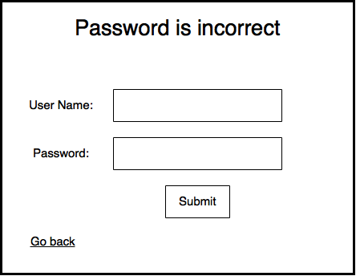
(a) (b) (c)

Fig. 3 The login page.

1. When the “login” link in index.html (Fig. 1) is clicked, or when the “login to post comment” button is clicked on a news entry display page (Fig. 2), login.php is retrieved. login.php implements the following:

(1) Generate an HTML page (Fig. 3(a)) containing (1) a login form with a username input textbox, a password input textbox, and a submit button, (2) a heading on top of the form which initially displays a message such as “You can login here”, and (3) a hyperlink “Go back” at the bottom of the page. The hyperlink should link to index.html, if the newsID value carried in the request for login.php is 0, or link to displayNewsEntry.php?newsID=xx, if the newID value carried in the request is larger than 0 (xx should be replaced by this newsID value).

(2) Register an event handler function login() with the “onclick” event of the submit button.

In login(), retrieve the input username and password in the respective input textboxes. If either username or password input is empty, an alert box pops up, displaying “Please enter username and password”, and the function exists.

Otherwise, send an AJAX request to retrieve handleLogin.php, carrying the input username and password. If the string returned by handleLogin.php is “login success”, replace the heading and the login form on the page by a heading “You have successfully logged in” (Fig. 3(b)); otherwise, replace the heading on the page by the error message received (e.g., Fig. 3(c)).

2. handleLogin.php checks whether the input username and password match those of any user entry in the users table. If so, it sets a cookie “userID” for the user, and returns the string “login success”; otherwise, it returns an error message such as “Username is incorrect” or “Password is incorrect”.

3. When “logout” in index.html (Fig. 1) is clicked, the event handler function logout() in index.html is invoked. In logout(), send an AJAX request to retrieve handleLogout.php. When the response message is received from the server, change the “logout” link to the “login” link in the “header” division in index.html.

4. handleLogout.php unsets the “userID” cookie for the user, and returns a string “logout success”.

4 marks for correctly implementing the login.php file, including:
1. 2 marks for correctly displaying a header, 2 input boxes for entering user name and password and a submit button.
2. 2 marks for correctly displaying a Go back link according to the newsID parameter carried in the HTTP request.

6 marks for correctly implementing the login() function, including:
1. 2 marks for correctly generating an alert when input boxes are empty.
2. 2 marks for generating an HTTP request to handleLogin.php, carrying correct parameters.
3. 2 marks for correctly modifying the layout of login.php to render a web page like fig 3 (b) or (c) in the response handler.

6 marks for correctly implementing the handleLogin.php file, including:
1. 2 marks for correctly retrieving the user record from the database according to the user name and password.
2. 2 marks correctly setting up the cookie if the user name and password are valid.
3. 2 marks for generating warning messages when user name and password are not valid.

4 marks for correctly implementing logout() function and handleLogout.php file.
1. 2 marks for changing the login link on index.html to logout link in logout() function when the HTTP response is received.
2. 2 marks for unsetting the cookie associated with the user in handleLogout.php.
Notes:
- In this handout, we may not have described all the implementation details of the pages. Other than what we described, you should decide other implementation details to achieve the stated functionalities. You can add more functions or files if deemed necessary.
- You can use either basic JavaScript or jQuery to implement client side scripting.

Other marking criteria:
- (5 marks) Style all your pages nicely using CSS rules in a style.css
2. (5 marks) Maintain a good programming style: avoid redundant code; the code should be easy to understand and maintain. Please provide a readme.txt file to let us know more about your program.

Testing:
You should carefully test all the functionalities stated in this handout. When testing comment posting, you can launch two browsers and log in as two users to post comments to the same news. We will check your assignment submission in a similar fashion when marking.

Submission:
You should submit the following files:
index.html
handleListDisplay.php
displayNewsEntry.php
handlePostComment.php
login.php
handleLogin.php
handleLogout.php
style.css
readme.txt
any additional file(s), in case you add them

Please compress all the files in a .zip file and submit it on Moodle:

- Login Moodle.
- Find “Assignments” in the left column and click “Assignment 2”.
- Click “Add submission”, browse your .zip file and save it. Done.
- You will receive an automatic confirmation email, if the submission was successful.
- You can “Edit submission” to your already submitted file, but ONLY before the deadline.

