# 2022.3.29

特征选择：无, 随机生成结果

方法选择：无, 随机生成结果

F1-score: 0.495618

# 2022.4.1

特征选择：特征选择方法1

方法选择：解决策略1

F1-score: 0.593073

# 2022.4.2

特征选择：特征选择方法1. num_of_feature=20

Features: 33个

方法选择：解决策略4

初始

F1-score: 0.63662

# 2022.4.3

特征选择：特征选择方法2. num_of_feature=20

Features: ['battery_total_Min', 'tenure', 'memory_total_Max', 'manufacturer', 'number_upgrades', 'voice_minutes', 'battery_available_Max', 'battery_available_Avg', 'total_redemptions', 'total_kb', 'SuspensionsDay_Sum', 'last_plan_name_coded', 'hotspot_kb', 'total_quantity', 'battery_total_Max', 'total_sms', 'memory_total_Avg', 'memory_available_Max', 'battery_total_Avg', 'memory_treshold_Max', 'memory_total_Min', 'battery_available_Min', 'memory_available_Avg', 'memory_available_Min']

24个

方法选择：解决策略4

# 2022.4.4

# 估算训练集真实的分布

特征选择：

Features: ['total_quantity', 'memory_treshold_Min', 'battery_available_Avg', 'bluetooth_on', 'manufacturer', 'battery_available_Max', 'NotCompleted', 'tenure', 'total_kb', 'battery_total_Max', 'memory_treshold_Avg', 'memory_available_Max', 'memory_treshold_Max', 'battery_available_Min', 'data_roaming_false', 'memory_total_Avg', 'memory_available_Min', 'memory_total_Min', 'battery_total_Min', 'memory_total_Max', 'SuspensionsDay_Sum', 'memory_available_Avg', 'battery_total_Avg', 'voice_minutes', 'data_roaming_true', 'total_sms', 'hotspot_kb', 'bluetooth_off']

Number of Features 28

方法选择：解决策略4

# 固定featurethreshold=FeatureThresholdList[14]//0.75分位

FeatureThreshold 401.5242

1.

init_num = 5000 # solid negative

2022-04-04_v1.csv

Number of one in train 86002

Number of zero in train 12310

Number of one in eval 17410

Number of zero in eval 2421

2.

init_num = 10000 # solid negative

2022-04-04_v2.csv

Number of one in train 77864

Number of zero in train 20448

Number of one in eval 15918

Number of zero in eval 3913

3.

init_num = 15000 # solid negative

2022-04-04_v3.csv

Number of one in train 75839

Number of zero in train 22473

Number of one in eval 11970

Number of zero in eval 7861

4.

init_num = 20000 # solid negative

2022-04-04_v4.csv

Number of one in train 70024

Number of zero in train 28288

Number of one in eval 13683

Number of zero in eval 6148

5.

init_num = 25000

Number of one in train 62811

Number of zero in train 35501

Number of one in eval 11328

Number of zero in eval 8503

6.

**init_num = 30000**

Number of one in train 65293

Number of zero in train 33019

Number of one in eval 11053

Number of zero in eval 8778

**F1_score best: 2022-04-04_v1 0.638498**

# 2022.4.5

# 固定init_num = 5000

# 更高的**Threshold（更少的Feature）会不会使F1score更好（得到更真实的训练集label）**

**## 调整feature Threshold**

**1.** **FeatureThreshold = FeatureThresholdList[15] # 0.80**

**2022-04-05_v1.csv**

Features: ['memory_treshold_Max', 'battery_total_Avg', 'memory_total_Min', 'battery_total_Max', 'total_sms', 'battery_available_Avg', 'memory_available_Avg', 'memory_available_Max', 'memory_total_Max', 'voice_minutes', 'total_kb', 'battery_available_Max', 'total_quantity', 'memory_treshold_Avg', 'SuspensionsDay_Sum', 'memory_total_Avg', 'battery_total_Min', 'battery_available_Min', 'memory_available_Min', 'tenure', 'memory_treshold_Min', 'hotspot_kb']

Number of Features 22

Number of one in train 90836

Number of zero in train 7476

Number of one in eval 17828

Number of zero in eval 2003

**2.** **FeatureThreshold = FeatureThresholdList[16] # 0.85**

**2022-04-05_v2.csv**

Features: ['battery_available_Min', 'memory_total_Avg', 'tenure', 'battery_total_Min', 'memory_available_Avg', 'memory_total_Max', 'battery_available_Avg', 'memory_available_Max', 'hotspot_kb', 'total_quantity', 'battery_available_Max', 'battery_total_Avg', 'total_kb', 'total_sms', 'memory_total_Min', 'voice_minutes', 'battery_total_Max']

Number of Features 17

Number of one in train 91668

Number of zero in train 6644

Number of one in eval 17659

Number of zero in eval 2172

**3.** FeatureThreshold = FeatureThresholdList[15] # 0.85

**2022-04-05_v3.csv**

**init_num = 7500**

Number of one in train 89827

Number of zero in train 8485

Number of one in eval 17534

Number of zero in eval 2297

## 以下实验

# # 固定featurethreshold=FeatureThresholdList[14]//0.75分位

## 固定init_num = 5000

**4.2022-04-05_model1.csv**

**5.2022-04-05_model2.csv**

**6.2022-04-05_model3.csv**

**7.2022-04-05_model4.csv**

**8.2022-04-05_model5.csv**

**9.2022-04-05_model6.csv**

# 2022.4.6

# 使用**SolidNegative1_TwoStepMethod(score_sampleBased).py**

# # 固定featurethreshold=FeatureThresholdList[14]//0.75分位

# 调整init_score_samples初始化不同大小label为0的数据

0.

2022-04-06_v0.csv

init_score_samples = quantile_df[0]

trainset_with_label_zero (4909, 30)

Iterative 28 times

Number of one in train 92061

Number of zero in train 6328

Number of one in eval 18209

Number of zero in eval 1640

**0.687516**

1

2022-04-06_v1.csv

init_score_samples = quantile_df[1]

init_score_samples: -0.4741648684378971

trainset_with_label_zero (7363, 30)

Iterative 37

Number of one in train 90362

Number of zero in train 8027

Number of one in eval 17833

Number of zero in eval 2016

**0.689122**

2.

2022-04-06_v2.csv

init_score_samples = quantile_df[2]

init_score_samples: -0.4357340686839713

trainset_with_label_zero (9817, 30)

Iterative 29

Number of one in train 69778

Number of zero in train 28611

Number of one in eval 16899

Number of zero in eval 2950

**0.705698**

3.

2022-04-06_v3.csv

init_score_samples = quantile_df[3]

trainset_with_label_zero (12271, 30)

Iterative 10

Number of one in train 84270

Number of zero in train 14119

Number of one in eval 16713

Number of zero in eval 3136

**0.695662**

4.

2022-04-06_v4.csv

init_score_samples = quantile_df[4]

init_score_samples: -0.383744958845647

trainset_with_label_zero (14725, 30)

Iterative 6

Number of one in train 82717

Number of zero in train 15672

Number of one in eval 16906

Number of zero in eval 2943

**0.704169**

5.

2022-04-06_v5.csv

init_score_samples = quantile_df[5]

init_score_samples: -0.35089269002407664

trainset_with_label_zero (19633, 30)

Number of one in train 65565

Number of zero in train 32824

Number of one in eval 13184

Number of zero in eval 6665

**0.730586**

6.

2022-04-06_v6.csv

init_score_samples = quantile_df[6]

init_score_samples: -0.34167647310373805

trainset_with_label_zero (24541, 30)

Iterative 64

Number of one in train 60085

Number of zero in train 38304

Number of one in eval 14811

Number of zero in eval 5038

**0.73688**

7.

2022-04-06_v7.csv

init_score_samples = quantile_df[7]

init_score_samples: -0.32448376589523104

trainset_with_label_zero (36811, 30)

Number of one in train 54883

Number of zero in train 43506

Number of one in eval 12545

Number of zero in eval 7304

**F1 0.765517**

# 2022.4.7

# 使用**SolidNegative1_TwoStepMethod(score_sampleBased).py**

# # 固定featurethreshold=FeatureThresholdList[14]//0.75分位

# 调整init_score_samples初始化不同大小label为0的数据

0.

2022-04-07_v0.csv

init_score_samples = quantile_df[8] # 0.8

init_score_samples: -0.3229153713165517

trainset_with_label_zero (39264, 30)

Number of one in train 55785

Number of zero in train 42604

Number of one in eval 11746

Number of zero in eval 8103

**0.74801**

1.

2022-04-07_v1.csv

init_score_samples = quantile_df[9]

init_score_samples: -0.32380935714170356

trainset_with_label_zero (41719, 30)

Number of one in train 50682

Number of zero in train 47707

Number of one in eval 12093

Number of zero in eval 7756

**0.765518**

# FeatureThreshold = FeatureThresholdList[16]

# 2-4是SolidNegative1_TwoStepMethod(score_sampleBased_SVMiter_IFfindsolid)

2.

2022-04-07_v2.csv

init_score_samples = quantile_df[7]

init_score_samples: -0.36428061679593615

trainset_with_label_zero (36811, 28)

Number of one in train 58148

Number of zero in train 40241

Number of one in eval 5649

Number of zero in eval 14200

**0.727812**

**3.**

**2022-04-07_v3.csv**

init_score_samples = quantile_df[1]

init_score_samples: -0.506531203055561

trainset_with_label_zero (7363, 28)

Number of one in train 70755

Number of zero in train 27634

Number of one in eval 8194

Number of zero in eval 11655

***0.906645***

4.

2022-04-07_v4.csv

init_score_samples = quantile_df[2]

init_score_samples: -0.4827595618263261

trainset_with_label_zero (9817, 28)

Number of one in train 69571

Number of zero in train 28818

Number of one in eval 7776

Number of zero in eval 12073

**0.880626**

# 5-9是randomforest based

5.

2022-04-07_v5.csv

init_score_samples = quantile_df[1]

init_score_samples: -0.4984900563146844

trainset_with_label_zero (7363, 28)

Number of one in train 88462

Number of zero in train 9927

Number of one in eval 14029

Number of zero in eval 5820

6.

2022-04-07_v6.csv

init_score_samples = quantile_df[2]

init_score_samples: -0.4865831003459168

trainset_with_label_zero (9817, 28)

Number of one in train 87405

Number of zero in train 10984

Number of one in eval 14336

Number of zero in eval 5513

7.

2022-04-07_v7.csv

init_score_samples = quantile_df[3]

Number of one in train 85943

Number of zero in train 12446

Number of one in eval 14226

Number of zero in eval 5623

8.

2022-04-07_v8.csv

init_score_samples = quantile_df[4]

init_score_samples: -0.43999847387411034

trainset_with_label_zero (14725, 28)

Number of one in train 83664

Number of zero in train 14725

Number of one in eval 14549

Number of zero in eval 5300

9.

2022-04-07_v9.csv

init_score_samples = quantile_df[5]

init_score_samples: -0.41140272805375877

trainset_with_label_zero (19587, 28

Number of one in train 78802

Number of zero in train 19587

Number of one in eval 15092

Number of zero in eval 4757

# 2022.4.8

# FeatureThreshold = FeatureThresholdList[16] # 0.85

**1.**

**2022-04-08_v0.csv**

init_score_samples: -0.536503476716969

trainset_with_label_zero (4909, 28)

Number of one in train 72940

Number of zero in train 25449

Number of one in eval 8503

Number of zero in eval 11346

**0.924057**

**# FeatureSelection加入PCA**

**1-4**

**固定：**

**FeatureThreshold = FeatureThresholdList[16]**

**init_score_samples = quantile_df[0]**

调整PCA的n_component (即数据经过主成分分析后留下n_component个特征)

**2022-04-08_v1.csv**

pca = PCA(n_components=10)

Number of one in train 72438

Number of zero in train 25951

Number of one in eval 8437

Number of zero in eval 11412

**0.911545**

**2022-04-08_v2.csv**

pca = PCA(n_components=20)

Number of one in train 74613

Number of zero in train 23776

Number of one in eval 7831

Number of zero in eval 12018

**2022-04-08_v3.csv**

pca = PCA(n_components=15)

**Number of one in train 71663**

**Number of zero in train 26726**

**Number of one in eval 8272**

**Number of zero in eval 11577**

**0.910464**

**2022-04-08_v4.csv**

pca = PCA(n_components=13)

**Number of one in train 72427**

**Number of zero in train 25962**

**Number of one in eval 8204**

**Number of zero in eval 11645**

**0.907914**

### 5-9是imblearn之后的

**2022-04-08_v5.csv**

**Iter_SVM**

**Number of one in eval 7603**

**Number of zero in eval 12246**

**日历

**

**0.869998**

**2022-04-08_v6.csv**

**Mlp**

**model = MLPClassifier(hidden_layer_sizes=(100, 50),max_iter=1000)**

**Predict Eval Set:**

**Number of one in eval 6003**

**Number of zero in eval 13846**

**2022-04-08_v7.csv**

**model = MLPClassifier(hidden_layer_sizes=(50, 50, 50), max_iter=1000)**

**Number of one in eval 6824**

**Number of zero in eval 13025**

**0.910295**

**2022-04-08_v8.csv**

model = MLPClassifier(hidden_layer_sizes=(128, 256, 512), max_iter=1000)

Number of one in eval 7095

Number of zero in eval 12754

日历

**0.831908**

**2022-04-08_v9.csv**

model = MLPClassifier(hidden_layer_sizes=(128, 256, 128, 256), max_iter=1000)

Number of one in eval 6868

Number of zero in eval 12981

**0.815824**

# 2022.4.9

# n_component = 20

**2022-04-08_v0.csv**

init_score_samples: -0.4818367247107601

trainset_with_label_zero (4909, 22)

Number of one in train 71535

Number of zero in train 26854

Number of one in eval 8404

Number of zero in eval 11445

0.91965

**2022-04-08_v1.csv**

**Kfold**

# Model 7

params = {'C': 100, 'kernel': 'rbf', 'degree': 3, 'gamma': 'auto'}

Number of one in eval 9326

Number of zero in eval 10523

文本

0.846775

**2022-04-08_v2.csv**

# Model 7

params = {'C': 1000, 'kernel': 'rbf', 'degree': 3, 'gamma': 'auto'}

Number of one in eval 12727

Number of zero in eval 7122

**2022-04-08_v3.csv**

# Model 7

params = {'C': 500, 'kernel': 'rbf', 'degree': 3, 'gamma': 'auto'}

Number of one in eval 12759

Number of zero in eval 7090

**2022-04-08_v4.csv**

# Model 7

params = {'C': 5000, 'kernel': 'rbf', 'degree': 3, 'gamma': 'auto'}

**2022-04-08_v5.csv**

params = {'C': 250, 'kernel': 'rbf', 'degree': 3, 'gamma': 'auto'}

**2022-04-08_v6.csv**

params = {'C': 50, 'kernel': 'rbf', 'degree': 3, 'gamma': 'auto'}

**2022-04-08_v7.csv**

params = {'C': 150, 'kernel': 'rbf', 'degree': 3, 'gamma': 'auto'}

**2022-04-08_v8.csv**

params = {'C': 200, 'kernel': 'rbf', 'degree': 3, 'gamma': 'auto'}

# 2022.4.10

# without PCA

FeatureThreshold = FeatureThresholdList[16] # 0.85

Slow iter

**2022-04-10_v0.csv**

**0.924174**

**2022-04-10_v1.csv**

**Voting SVM LAST 5**

0.914477

**2022-04-10_v2.csv**

**Voting SVM LAST 3**

0.914597

**2022-04-10_v3.csv**

**model = SVC(probability=True, degree=4)**

**0.923596**

**2022-04-10_v4.csv**

**Voting SVM（from 3） LAST 5**

0.91405

**2022-04-10_v5.csv**

**Voting SVM（from 3） LAST 3**

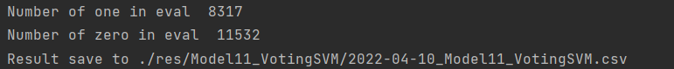

0.913931

**# 以下FeatureThreshold = FeatureThresholdList[15]**

**2022-04-10_6.csv**

Itersvm

0.939595

**2022-04-10_7.csv**

Slow svm

model = SVC(probability=True,degree=4)

**0.939749**

**2022-04-10_8.csv**

**Voting SVM（from 7） LAST 5**

**0.938575**

**2022-04-10_9.csv**

**Voting SVM（from 7） LAST 3**

**背景图案

**

**2022-04-10_9.csv**

**Catboost**

**0.740666**

# 2022.4.11

FeatureThreshold = FeatureThresholdList[15]

**2022-04-11_0.csv**

model = SVC(probability=True, **degree=5**)

文本

0.932593

**2022-04-11_1.csv**

**Voting SVM（from 0） LAST 3**

0.930867

**2022-04-11_2.csv**

**Voting SVM（from 0） LAST 3**

**文本

**

0.930203

**2022-04-11_3.csv**

**Voting SVM（from 8） LAST 5**

**文本

**

0.937173

**2022-04-11_4.csv**

**固定 FeatureThreshold = FeatureThresholdList[13]**

**（同2022-04-12_v0.csv）**

model = SVC(probability=True, degree=4)

**0.941538**

**以下 FeatureThreshold = FeatureThresholdList[14]**

**2022-04-11_v5.csv**

model = SVC(probability=True, **degree=4**)

0.939027

**2022-04-11_v6.csv**

**Voting SVM（from 5） LAST 3**

0.935251

**2022-04-11_v7.csv**

**Voting SVM（from 5） LAST 5**

0.935728

**2022-04-11_v8.csv**

model = SVC(probability=True, degree=5)

0.940168

**2022-04-11_v9.csv**

**Voting SVM（from 8） LAST 3**

文本

0.9368

# 2022.4.12

以下都是Catboost

**固定 FeatureThreshold = FeatureThresholdList[15] # Number of Features 34**

**2022-04-12_v0.csv**

文本

**0.975042**

**2022-04-12_v1.csv**

**From v0 fit all**

0.972786

**2022-04-12_v2.csv**

**FeatureThreshold = FeatureThresholdList[16] #**  **Number of Features 26**

**

**2022-04-12_v3.csv**

**FeatureThreshold = FeatureThresholdList[16] #**  **Number of Features 26**

model = CatBoostClassifier(iterations=2000, verbose=500, eval_metric='F1')

**一些文字和图片的手机截图

**

0.9611

**2022-04-12_v4.csv**

**Iter_Cat**

0.972526

**2022-04-12_v5.csv**

**固定 FeatureThreshold = FeatureThresholdList[15] # Number of Features 34**

**model = CatBoostClassifier(iterations=3000, verbose=1000, eval_metric='F1', depth=7, l2_leaf_reg=5)**

0.972452

**2022-04-12_v6.csv**

**固定 FeatureThreshold = FeatureThresholdList[15] # Number of Features 34**

**model = CatBoostClassifier(iterations=3000, verbose=1000, eval_metric='F1', depth=7, l2_leaf_reg=5)**

**GridSearch**

**SMOTE balance**

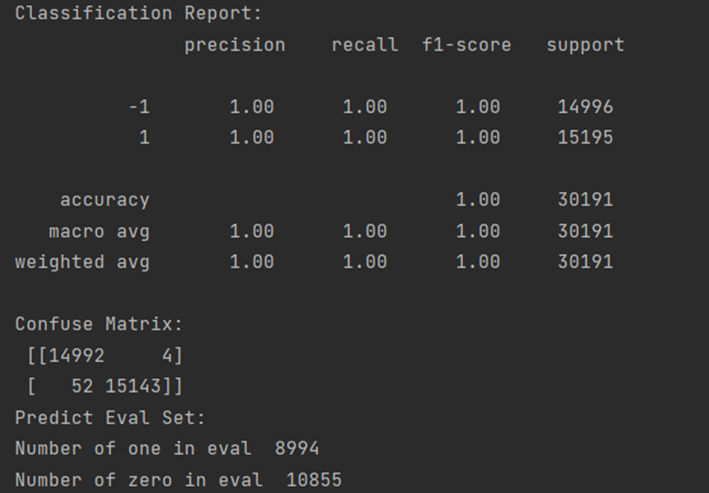

{'params': {'depth': 6, 'l2_leaf_reg': 1, 'learning_rate': 0.1}

0.927147

**2022-04-12_v7.csv**

**固定 FeatureThreshold = FeatureThresholdList[15] # Number of Features 34**

**model = CatBoostClassifier(iterations=3000, verbose=1000, eval_metric='F1', depth=7, l2_leaf_reg=5)**

**GridSearch**

Without balancing

'params': {'depth': 7, 'l2_leaf_reg': 7, 'learning_rate': 0.4

0.971481

**2022-04-12_v8.csv**

**No GridSearch** No balancing

model = CatBoostClassifier(iterations=10000, verbose=1000, eval_metric='F1', depth=7, l2_leaf_reg=5, learning_rate=0.4)

0.971815

**2022-04-12_v9.csv**

**No GridSearch** No balancing

model = CatBoostClassifier(iterations=10000, verbose=1000, eval_metric='F1', depth=7, l2_leaf_reg=5, learning_rate=0.4)

# 2022.4.13

**2022-04-13_v0.csv**

**FeatureThreshold = FeatureThresholdList[16] #**  **Number of Features 26**

**model = CatBoostClassifier(iterations=3000, verbose=1000, eval_metric='F1', depth=7, l2_leaf_reg=5)**

**手机屏幕截图

**

**0.96017**

**2022-04-13_v1.csv**

model=CatBoostClassifier(iterations=50000, verbose=10000, eval_metric='F1', depth=7, l2_leaf_reg=5, learning_rate=0.4)

if len(trainset_with_label) - len_trainset_with_label <= 5:

**2022-04-13_v2.csv**

**Params = {'task_type':'GPU','iterations':50000, 'verbose':10000, 'eval_metric':'F1', 'depth':7, 'l2_leaf_reg':5, 'learning_rate':0.3}**

**文本

**

**0.971597**

**2022-04-13_v3.csv**

**Params = {'task_type':'GPU','iterations':10000, 'verbose':5000, 'eval_metric':'F1', 'depth':7, 'l2_leaf_reg':7, 'learning_rate':0.3}**

**文本

**

0.972564

**2022-04-13_v4.csv**

**Params = {'task_type':'GPU','iterations':10000, 'verbose':5000, 'eval_metric':'F1', 'depth':7, 'l2_leaf_reg':10, 'learning_rate':0.3}**

0.972306

**2022-04-13_v5.csv**

Params = {'task_type':'GPU','iterations':20000, 'verbose':5000, 'eval_metric':'F1', 'depth':9, 'l2_leaf_reg':10, 'learning_rate':0.3}

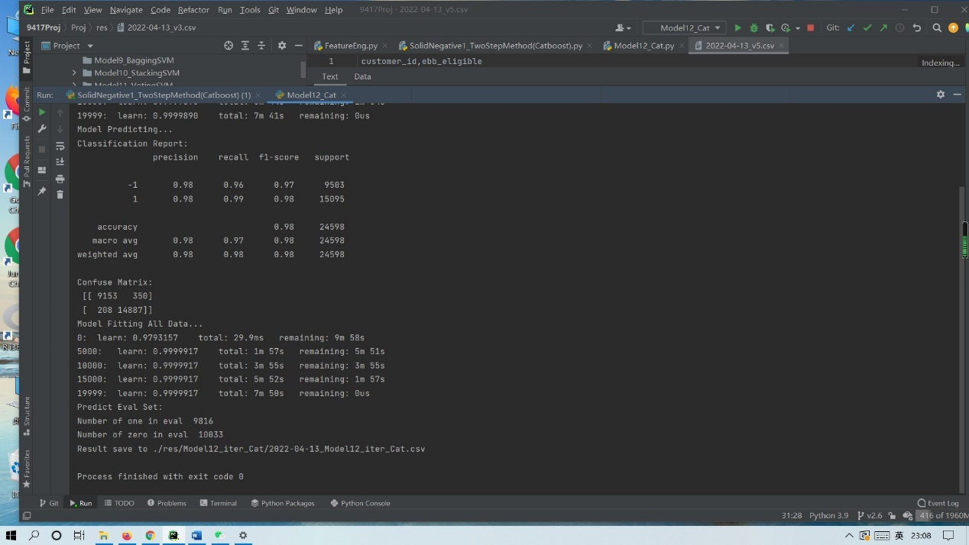

# 2022.4.14(be baned)

# 2022.4.15（解禁） v6best

**2022-04-15_v0.csv**

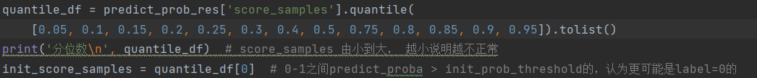

model = CatBoostClassifier(iterations=5000, verbose=2500, eval_metric='F1', depth=7, l2_leaf_reg=7, learning_rate=0.1)

0.974136

**2022-04-15_v1.csv**

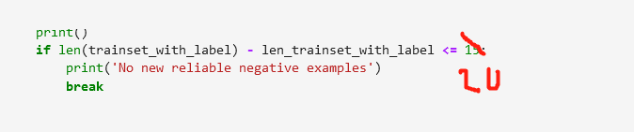

**0.980804**

**2022-04-15_v2.csv**

Params = {'iterations':10000, 'verbose':1000, 'eval_metric':'F1', 'depth':7, 'l2_leaf_reg':7, 'learning_rate':0.07675896435626739}

model.set_params(**Params)

**0.980908**

**2022-04-15_v3.csv**

Params = {'iterations':10000, 'verbose':1000, 'eval_metric':'F1', 'depth':7, 'l2_leaf_reg':7, 'learning_rate':0.07675896435626739}

model.set_params(**Params)

0.974595

**2022-04-15_v4.csv**

Params = {'iterations':5000, 'verbose':1000, 'eval_metric':'F1', 'bootstrap_type':'Bernoulli','depth': 6, 'l2_leaf_reg': 17,

'learning_rate': 0.29134132907050203, 'random_strength':0.8877203622059868}

0.980144

**2022-04-15_v5.csv**

与v4相同，但是在本地运行结果

0.972864

**2022-04-15_v6.csv**

其余和v1相同

徽标

**0.981968**

**2022-04-15_v7.csv**

其余和v1相同

**0.981235**

# 2022.4.16

**2022-04-17_v0.csv**

FeatureThreshold = FeatureThresholdList[16]

**2022-04-17_v1.csv**

FeatureThreshold = FeatureThresholdList[15]

**2022-04-17_v2.csv**

FeatureThreshold = FeatureThresholdList[15]

