static err_t http_find_file(struct http_state *hs, const char *uri, int is_09)函数是发现index的网页

const default_filename g_psDefaultFilenames[] = {

{"/index.shtml", true },

{"/index.ssi", true },

{"/index.shtm", true },

{"/index.html", false },

{"/index.htm", false }

};

改成这个

const default_filename g_psDefaultFilenames[] = {

{"/STM32_LED_OFF_BEEP_OFF.shtml", true },

{"/STM32_LED_OFF_BEEP_OFF.ssi", true },

{"/STM32_LED_OFF_BEEP_OFF.shtm", true },

{"/STM32_LED_OFF_BEEP_OFF.html", false },

{"/STM32_LED_OFF_BEEP_OFF.htm", false }

};

则当192.168.1.103后进入的就是STM32_LED_OFF_BEEP_OFF.shtml这个网页



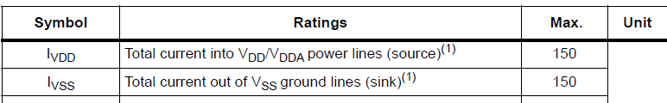

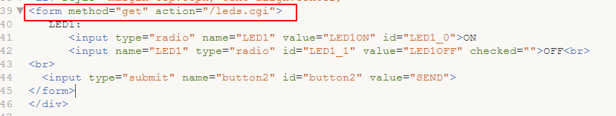

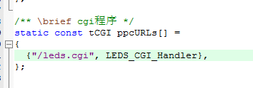

这个必须是/led.cgi,如果改为其他的，则网页中也要写成/leds.cgi