University of Missouri, Columbia
Department of Electrical and Computer Engineering
ECE 4330 Introduction to Mechatronics and Robotic Vision
Fall, 2014

Prediction Based Approach to Minimize Distance Traveled while Tracking Objects in Mobile Robotic Navigation

Chris Arnold
crag47@mail.missouri.edu

Dallas Fletchall
djfrmd@mail.missouri.edu

Abstract
This project explores the effect of linear Kalman filtering on sensor input of tracking robots and how it affects distance traveled. The noise reduction and predictive aspects of the filter are explored as well as the filter's pertinence in the presented situation.

Introduction
The ultimate objective of this project was to explore the effect of the Kalman filter on mobile robotic tracking. The guiding hypothesis was that passing sensor data through a Kalman filter would improve a robotic tracking system by reducing the total distance traveled. It was discovered that the effect of filtering sensor data on the distance traveled was highly dependent upon the shape of the path traversed by the target. A number of different shaped paths were tested, some which supported our initial hypothesis and some which contradicted it.

Objective
The objective of this project is to reduce the path length of a tracking mobile robot by filtering the data read from its sensors using a Kalman filter. MobileSim is used in conjunction with the ARIA library (Advanced Robot Interface for Applications) to simulate the mobile robots moving in an open environment. The path of the first robot may be defined by the user, after which a second robot will track the first robot as it moves. During the first traversal of the path, the tracking robot alters its course based on raw sensor data in order to follow the first robot. During the second traversal, the tracking robot filters the sensor data using a Kalman filter. During each traversal, the tracking robot periodically records its pose with respect to the global frame of the MobileSim environment so that the final path results of the tracking robots may be compared.

Background
In order to implement mobile robot tracking, a tracking robot must know where its target is located with respect to the tracking robot's coordinate frame to know how to set its heading and speed to reach the target. A laser sensor can provide a robot with this information in the form of a position with respect to the laser. This is an effective means of providing an instantaneous snapshot of the target's position with a reasonably small uncertainty. In order to track the target, a tracking robot may sample this laser data and adjust its speed and heading at each sample acquisition.

All sensors contain a certain amount of noise coupled with their readings. Filtering this noise from these measurements would provide a more accurate determination of the actual value of the measurement. In this case, the laser sensor returned the distance and angle between the objects, and the noise was embedded in these sensor readings. Using the Kalman filter allows this noise to be reduced or removed while using the measurement.

Noisy measurements aside, while a laser sensor provides valuable position information, each datum is only an instantaneous value of the target's position. In order to better track the target using this information, a predictive algorithm should be used in conjunction. One such algorithm is the Kalman Filter.

The linear Kalman filter is a recursive predictor that uses current measurements along with previous predictions in order to make a more accurate estimation of the true state of the system. A single iteration of the filter performs two high level actions, namely, prediction and update. The following equations are associated with the two actions [4]:

Prediction
(1.1) Project the state ahead
(1.2) Project the error covariance ahead

Update
(1.3) Compute the Kalman gain
(1.4) Update estimate with measurement z_{k}
(1.5) Update the error covariance

where
- a priori state estimate at step k given knowledge of the process prior to step k
- a posteriori state estimate at step k given measurement z_{k}
- actual measurement
- a priori estimate error covariance
- a posteriori estimate error covariance
- the gain that minimizes the a posteriori error covariance equation
- relates the state at the previous time step k-1 to the state at the current step k
- relates the optional control input u to the state x
- relates the state to the measurement z_{k}
- process noise covariance
- measurement noise covariance

At a high level, the prediction stage projects the current state estimate ahead in time and the update stage adjusts the projected estimate, using the measured values from the sensor. The a posteriori state estimate, , contains the newly estimated state which is a function of the a priori state estimate, the measurement, and the error covariance. The predictive quality of the Kalman filter comes in part from its projection of historical error covariance onto the new state.

Procedure
This section outlines the implementation of the robot tracking simulation and the Kalman filter.

Robot Setup
Four programs were made to model the robot tracking system. Two programs model the target robot and the remaining two model the different tracking robots. When the object program is run, it uses keyboard input to move the robot and it record its path as it moves in the environment. The wander program then acts as the target robot and follows this prerecorded path. Finally, the reactive and kalman programs model the two tracking robots. The reactive program models the tracking robot that uses only raw sensor input, and the kalman program models the tracking robot that uses filtered sensor input.

As an initial test of the simulation, the object program was run to map out a user-defined path. Following this, the wander program was run to ensure that it duplicated the defined path. The duplicated path, as shown in Figure 1 against the original path traced by the object program, was sufficient to give the user a relatively fine degree of control over path creation, which allowed proceeding with further tests.
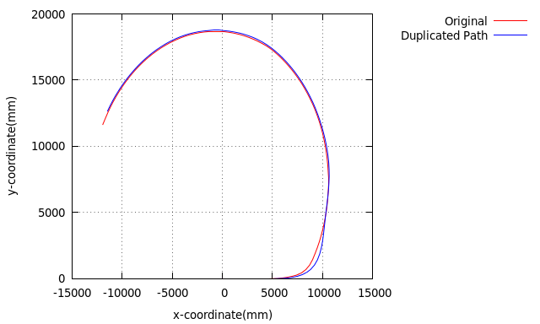Figure 1: Original user-defined path shown against the path duplicated by the wander program

In addition to the mobile tracking programs, a static tracking program, called “Sensor”, was created to measure the noise produced by the sensor when the target was not moving. This provided data that demonstrated two aspects of the filter; first its ability to smooth out noise, and second, its ability to correct its prediction in the event of an invalid initial state.

Kalman Filter Setup
A Kalman filter was modeled to filter distance and angle measurements from the robot's laser sensor. Referring to Equation 1.1 of the Kalman filter equations, it was assumed (and later invalidated) that identity matrices would adequately define the state transition model.

Tests and Results
In order to test the effectiveness of the filter at removing noise, the sensor program was used to sample the distance, shown in Figure 2, and the angle, shown in Figure 3, of a static target with respect to the motionless tracking robot.
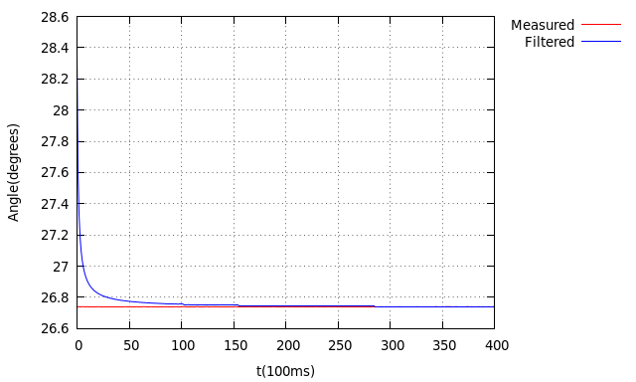Figure 2: Measured and filtered angles between tracking robot and target.
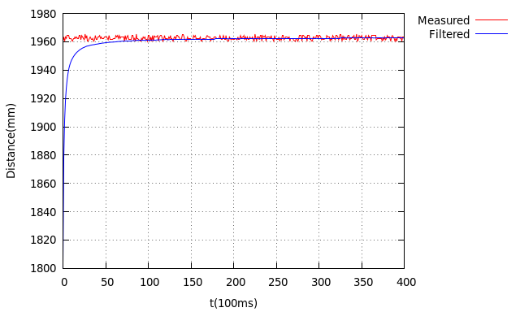Figure 3: Measured and filtered distances between tracking robot and target.
A path with a single wide turn was used to test the case in which the difference between the measured state and the a priori state estimate consistently had the same sign. The position data sample rate was set to 1/3000ms, or one sample every 3s. Figure 4 shows the paths taken by the unfiltered tracking robot (reactive), the filtered tracking robot (kalman), and the target (object). Figure 5 shows the total distance traveled by each robot.
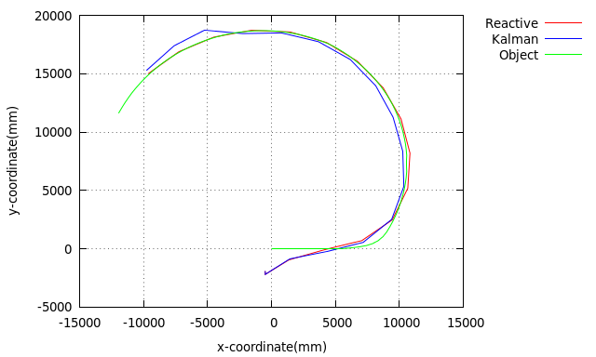Figure 4: Traversed paths of filtered and unfiltered tracking robots and target robot at 1/3000ms sample rate.

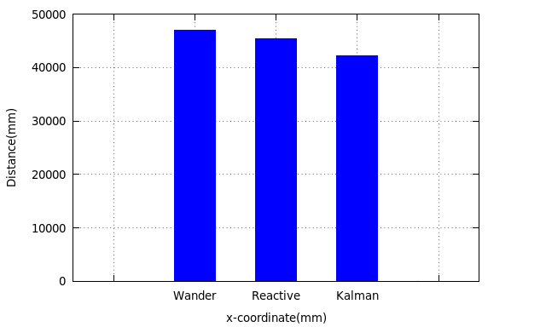Figure 5: Total distance traversed by filtered and unfiltered tracking robots and target robot at 1/3000ms sample rate.
Using the same path, the sample rate was increase to 1/500ms, or 2 samples per second. Figure 6 shows the paths taken by each robot and Figure 7 shows the total distance traveled by each robot.

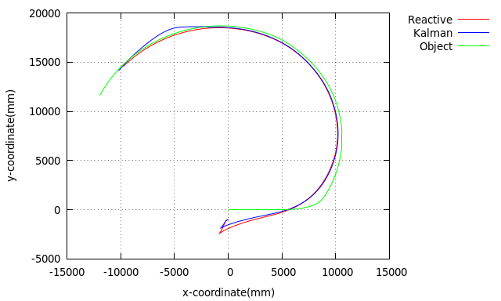Figure 6: Traversed paths of filtered and unfiltered tracking robots and target robot at 1/500ms sample rate.
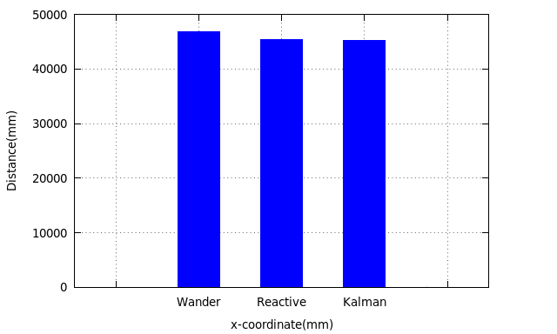Figure 7: Total distance traversed by filtered and unfiltered tracking robots and target robot at 1/500ms sample rate.
A straight path was tested. Figure 8 shows the paths taken by each robot and Figure 9 shows the total distance traveled by each robot.
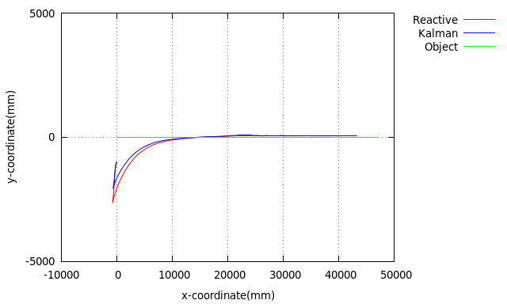Figure 8: Traversed paths of filtered and unfiltered tracking robots and target robot at 1/500ms sample rate.
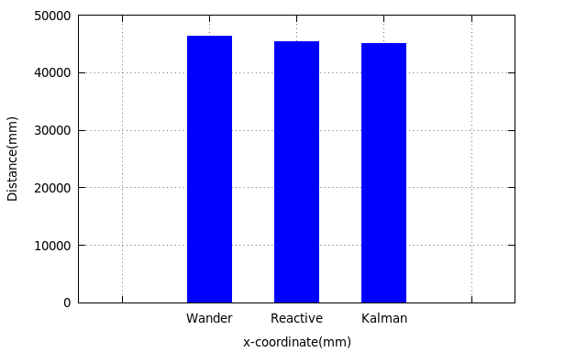Figure 9: Total distance traversed by filtered and unfiltered tracking robots and target robot at 1/500ms sample rate.
An oscillating path was tested. Figure 10 shows the paths taken by each robot and Figure 11 shows the total distance traveled by each robot.
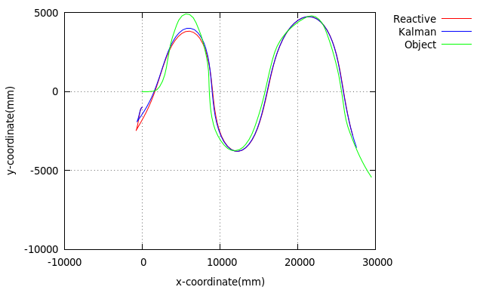Figure 10: Traversed paths of filtered and unfiltered tracking robots and target robot at 1/500ms sample rate.
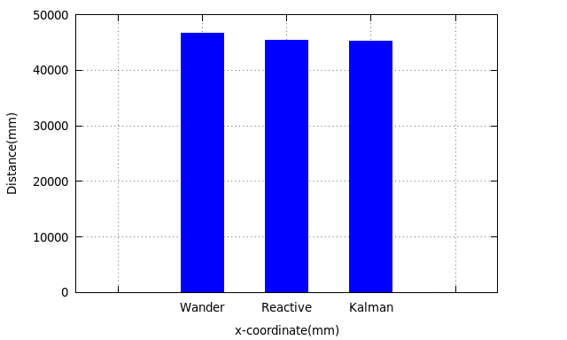Figure 11: Total distance traversed by filtered and unfiltered tracking robots and target robot at 1/500ms sample rate.

Conclusion
Our hypothesis that filtering the sensor data with a Kalman filter would reduce the distance traveled by the tracking robot could not be validated by our results. While there were situations that yielded a shorter path when the data was filtered, we were not able to consistently reduce the distance. Even when there was a difference in the distances traveled, the difference was small.

For nonlinear paths, the robot's trajectory would have been better modeled using an Extended Kalman Filter. The Extended Kalman Filter is able to transform nonlinear models into linear systems of equations, so long as the modeling equations are differentiable. Because the linear Kalman filter that was implemented assumed linear state transitions, its predictions weren't representative of the actual conditions. Upon first inspection, the results appeared to show that the effectiveness of the filter was predicated on the shape of the path. In a sense this is true, in that the state transition model of the filter was linear, so nonlinear paths did not see reduced path length as a result of using Kalman filtering. The difference in path lengths in many of these cases is likely due to extraneous implementation differences between the kalman and reactive programs. In the case where a straight line path was used (Figures 8 and 9), there was little difference in the paths of the filtering and non-filtering robots. If there had been greater sensor noise, particularly of the angle measurement, perhaps a greater difference in the path lengths would have been observed.

While the nonlinear trajectories in our implementation may have made it an inappropriate application for relying on the predictive capabilities of the linear Kalman Filter, the filter still proved beneficial for smoothing out sensor noise. When the tracking robot held perfectly still and took readings of a target 1.962 m away, the noise in the distance measurement from the laser sensor was about +/- 2 mm. From Figure 3 it is clear that the Kalman filter was quite effective at removing this noise. While the reading fluctuates between 1.960 m and 1.964 m, the filtered result steadies around 1.962 m. Noise filtering of the angle readings from the laser sensor can be seen in Figure 2. The filtering is much less prominent here because the noise from this reading was very small to begin with.

The Kalman filter was able to quickly correct from an incorrect initial value. This can be seen in Figure 2 and Figure 3, where an arbitrary initial value was provided for the initial distance and angle of the target with respect to the sensor robot. The initial distance value was 0.964 m away from the actual distance, but was able to correct to within 0.020 m in about 0.8 s.

Changing the sampling rate affected the distances traveled by the filtering and non-filtering robots, although, this is likely coincidental. A comparison of sampling rate on path and total distance traveled can be seen by comparing Figures 4 and 5 with Figures 6 and 7. In both cases, the same path was followed by the target robot. In Figures 4 and 5, the sampling period was set to 3000ms and in Figures 6 and 7 the sampling period was set to 500ms. When the sampling rate decreased, the filtered robot's path length was typically shorter than that of the unfiltered robot. Initially it was speculated that this was a result of the filtered robot acting on a prediction, however, after further exploration of the Kalman filter, this was likely just coincidental. For a nonlinear path, the linear Kalman filter does not have the proper state transition model to make an accurate prediction of the target's trajectory.

Over the course of the project, much was learned about the execution of the Kalman filter. For the implementation in this project the Kalman filter was under utilized, nevertheless, it provided valuable insight about the operation of the filter and its relevance to certain situations.

Future Work
For this project to provide more conclusive results, it could be implemented using an Extended Kalman Filter and a fixed robot path. This would allow using data to find a state transition matrix for nonlinear paths and would ensure an accurate state transition model for the filter. It would also be beneficial to place additional robots and static obstacles in the map to fully explore the power of the Kalman filter.

Works Cited
[1] Oxford University Press. (2014). Oxford Dictionaries [Online]. Available: http://www.oxforddictionaries.com/us/definition/american_english/navigation?searchDictCode=all. [Accessed: 2014, Nov. 24].

[2] DeSouza, G. (Unknown). Lecture 22: Mobile Robotics [Online]. Available: http://vigir.ee.missouri.edu/~gdesouza/ece4330/Lecture_Notes/Lecture22.pdf. [Accessed: 2014, Nov. 24].

[3] Gnuplot. (2014, Nov.). Gnuplot Homepage [Online]. Available: http://gnuplot.info. [Accessed: 2014, Nov. 24].

[4] G. Welch and G. Bishop, “An Introduction to the Kalman Filter,” Dept. Comp. Sci., University of North Carolina at Chapel Hill, North Carolina, 2001, 20-24

