Part 1:
A) F1_score=0.6553468208092486(TrainSet)
B) F1_score=0.6508108108108108(TestSet)

C)
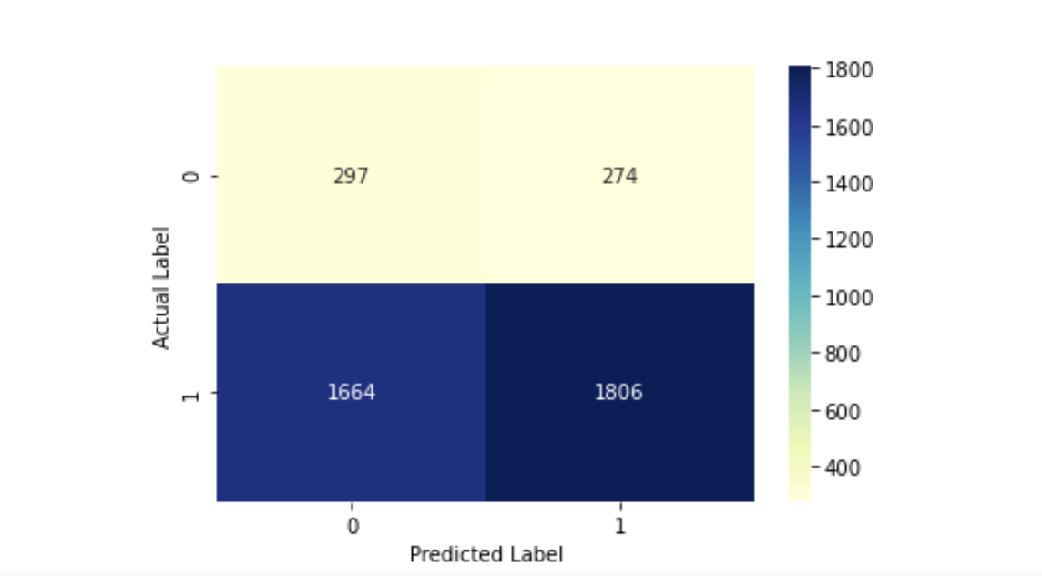

Part 2:

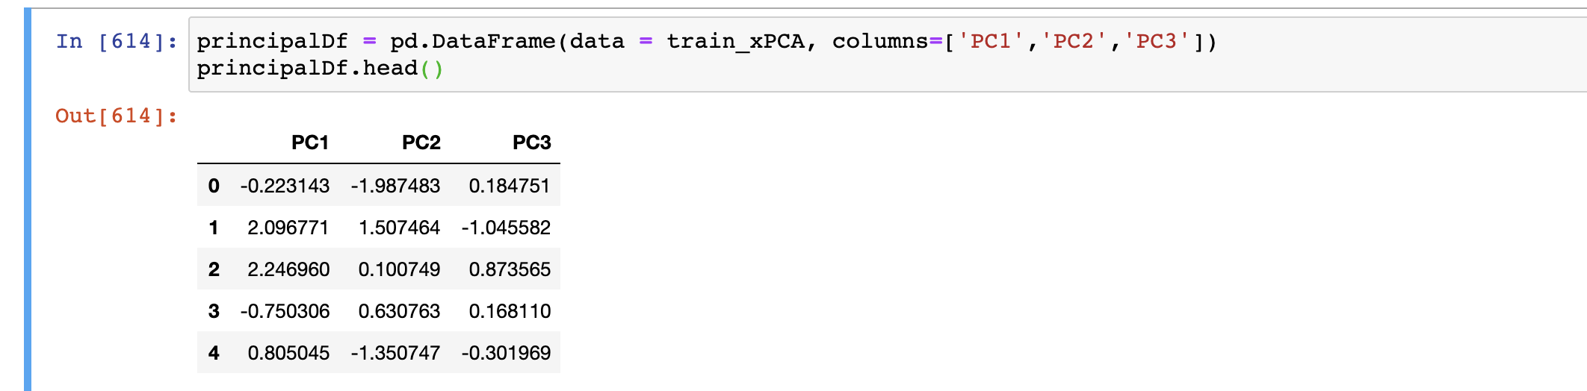

Applied PCA(3 components)

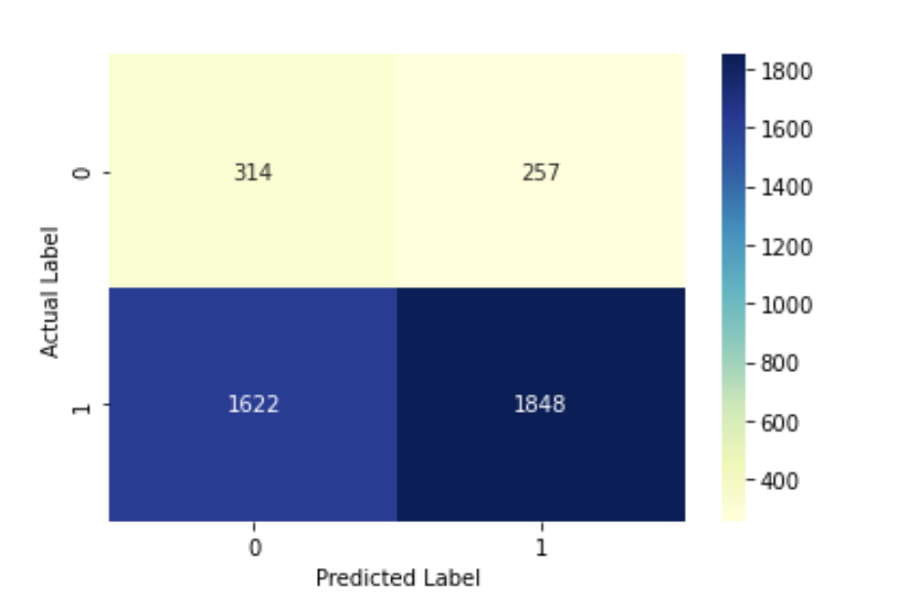

- Applied PCA(1 components)

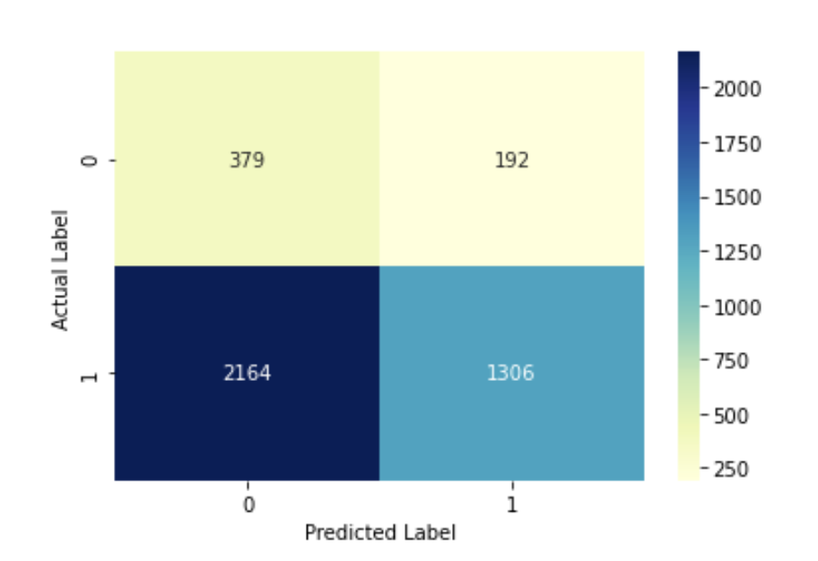

- After applying the PCA(3 components),False negative decrease 42(1664-1622), True negative increase 17 (314-297), Ture positive increase 42(1848-1806), False positive decrease 17 (274-257). In the context of the bank credit card score, PCA(3 components) optimize the logistic regression result. However, the PCA(1 component) may not be an optimized choice. The True negative increases. The False Negative increase a lot, which means the plan to reduce the unbanked people may not work because a lot people will be rejected. True positive decreases. False Positive decrease, which is good. But the PCA(1 component) makes the credit score assessment too strict.

