1. 取得每个部门最高薪水的人员名称

Step1：取得每个部门的最高薪水，按照部门分组求最大值

SELECT deptno,max(sal) as maxsal

FROM emp

GROUP BY deptno;

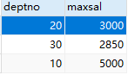

Step2:将以上结果作为一个临时表t(deptno,maxsal)

SELECT e.deptno,e.ename,e.sal,t.maxsal

from emp e join

(

SELECT deptno,max(sal) as maxsal

FROM emp

GROUP BY deptno

)t

on e.deptno=t.deptno

where e.sal=t.maxsal

order by e.deptno;

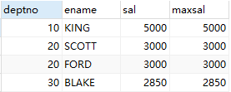

1. 哪些人的薪水在部门平均薪水之上

Step1：取得每个部门的平均薪水，按部门分组求平均

select deptno,AVG(sal) as avgsal

from emp

GROUP BY deptno;

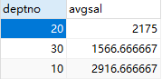

Step2：将以上结果作为一个临时表t(deptno,avgsal)

select e.deptno,e.ename

from

(select deptno,AVG(sal) as avgsal

from emp

GROUP BY deptno)

t

join emp e

on e.deptno=t.deptno

where e.sal>t.avgsal

order by e.deptno;

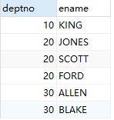

1. 取得部门中（所有人的）平均薪水等级

第一种语义：取得部门中所有人的平均薪水的等级

Step：

第二种语义：取得部门中所有人的平均的薪水等级

1. 不准用组函数MAX，取得最高薪水（给出两种解决方案）

方案一：

select sal

from emp

order by sal desc

limit 1;



方案二：（取出sal作为临时表a,b；a,b进行交叉连接，只要a表中的sal只要存在b表中sal小的值，那么该sal就不是最大sal）

select sal

from emp

where sal not in(select DISTINCT a.sal

from (select sal

from emp)a

join (select sal

from emp)b

where a.sal<b.sal);



1. 取得平均薪水最高的部门的部门编号

Setp1：取得部门平均最高薪水

select deptno,avg(sal) as avgsal

from emp

group by deptno;

Setp2：将以上查询结果作为临时表t(deptno,avgsal)求出最大平均薪水值

select max(t.avgsal) as max_avgsal

from (select deptno,avg(sal) as avgsal

from emp

group by deptno)t;



Setp3:对分组后的值进行条件选择having

select deptno,avg(sal) as avgsal

from emp

group by deptno

having avgsal = (select max(t.avgsal) as max_avgsal

from (select deptno,avg(sal) as avgsal

from emp

group by deptno)t);



1. 取得平均薪水最高的部门的部门名称

将6题结果取过来进行修改：

select e.deptno,d.dname,avg(e.sal) as avgsal

from emp e

join dept d

on e.deptno = d.deptno

group by e.deptno,d.dname

having avgsal = (select max(t.avgsal) as max_avgsal

from (select deptno,avg(sal) as avgsal

from emp

group by deptno)t);



1. 求平均薪水等级最低的部门的部门名称

Step1：每个部门的平均薪水

Step2：以上结果作为临时表t(deptno,avgsal)与salgrade进行表连接，求解出来每个部门的平均薪水等级t.avgsal between s.losal and s.hisal

select t.deptno,t.dname,s.grade

from salgrade s

join (

select e.deptno,d.dname,avg(sal) as avgsal

from emp e

join dept d

on e.deptno = d.deptno

group by e.deptno,d.dname

)t

on t.avgsal between s.losal and s.hisal;

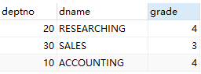

Step3：将以上查询结果作为临时表t select min(grade) as mingrade from t求出最低等级

select min(t.grade) as mingrade

from (select t.deptno,t.dname,s.grade

from salgrade s

join (

select e.deptno,d.dname,avg(sal) as avgsal

from emp e

join dept d

on e.deptno = d.deptno

group by e.deptno,d.dname

)t

on t.avgsal between s.losal and s.hisal)t;



Step4：对step2中的结果使用where按照step4求出的结果[最低等级]进行过滤

select t.deptno,t.dname,s.grade

from salgrade s

join (

select e.deptno,d.dname,avg(sal) as avgsal

from emp e

join dept d

on e.deptno = d.deptno

group by e.deptno,d.dname

)t

on t.avgsal between s.losal and s.hisal

where s.grade = 3;



1. 取得比普通员工（员工代码没有在mgr出现的）的最高薪水还要高的经理人姓名

【in 会自动忽略NULL 而not in 不会忽略NULL】

Setp1：找出普通员工（即员工代码没有出现在mgr上的）的最高薪水

select max(sal) as maxsal

from emp

where empno not in(

select DISTINCT mgr

from emp

where mgr is not NULL);



Step2：利用上面的取值进行where条件的过滤

select ename

from emp

where sal >(

select max(sal) as maxsal

from emp

where empno not in(

select DISTINCT mgr

from emp

where mgr is not NULL));

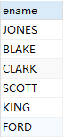

1. 取得薪水最高的前五名员工

【limit前一个参数表示起始下标，第二个参数表示截取几条数据】

select *

from emp

order by sal desc

limit 0,5;

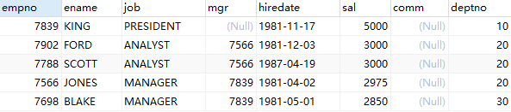

1. 取得薪水最高的第6到第10名员工

select *

from emp

order by sal desc

limit 5,5;

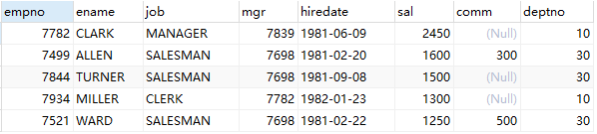

1. 取得最后入职的5名员工

【order by不仅可以排数字也可以排日期类型的数据】

select *

from emp

order by hiredate desc

limit 0,5;

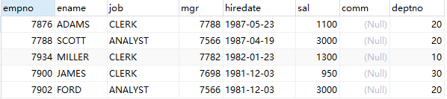

1. 取得每个薪水等级有多少员工

Step1:查询每个员工的薪水等级

select e.empno,e.sal,s.grade

from emp e

join salgrade s

on e.sal BETWEEN s.losal and s.hisal;

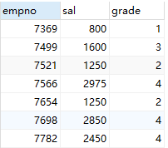

Setp2：将以上结果作为临时表t(empno,sal,grade),按薪水等级分组计数count()

select t.grade,count(t.empno) as totalEmp

from (

select e.empno,e.sal,s.grade

from emp e

join salgrade s

on e.sal BETWEEN s.losal and hisal

)

t

group by t.grade

order by t.grade;

