Worksheet 01.03 - Coordinates

|  |  |
| --- | --- |
| Name | **.................................................................................** |
| Class | **.................................................................................** |

****Using the grid on the next page, follow the instructions below…

|  |  |
| --- | --- |
| 1. Draw a line between (0, 80) and (400, 80) 2. Draw a line between (100, 80) and (100, 250) 3. ​​Draw a line between (300, 80) and (300, 250) 4. Draw a line between (80, 250) and (320, 250) 5. Draw a line between (80, 250) and (200, 320) 6. Draw a line between (320, 250) and (200, 320) 7. Draw a point at (120, 180), then a square with width 50 and height 50 - the bottom left corner should be at the point (120, 180) 8. Draw a point at (220, 80), then a rectangle with width 50 and height 100 - the bottom left corner should be at the point (220, 80)   Can you improve this?  HINT: Steps 2 and 3 can be done in one line! So can Steps 4, 5 and 6 |  |

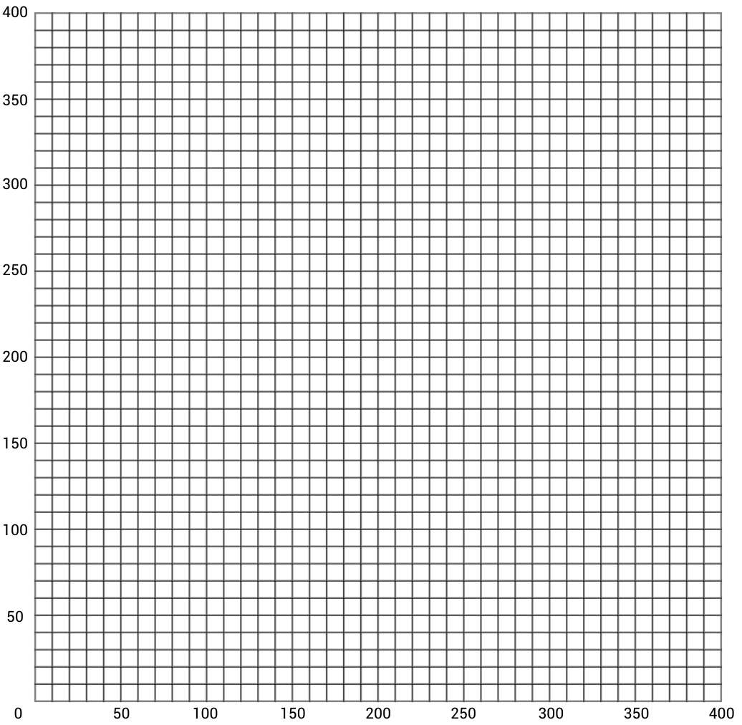

**License Information**This material was created by the team at [CS in Schools](https://csinschools.io/). It is licensed under a [Creative Commons Attribution-ShareAlike 4.0 International License](https://creativecommons.org/licenses/by-sa/4.0/).