Worksheet 03.01 Multiple Choices Trivia

|  |  |
| --- | --- |
| Name | **.................................................................................** |
| Class | **.................................................................................** |

You can find the code for this flowchart [here](https://replit.com/@ricproenca/0301d-Academy-Awards).

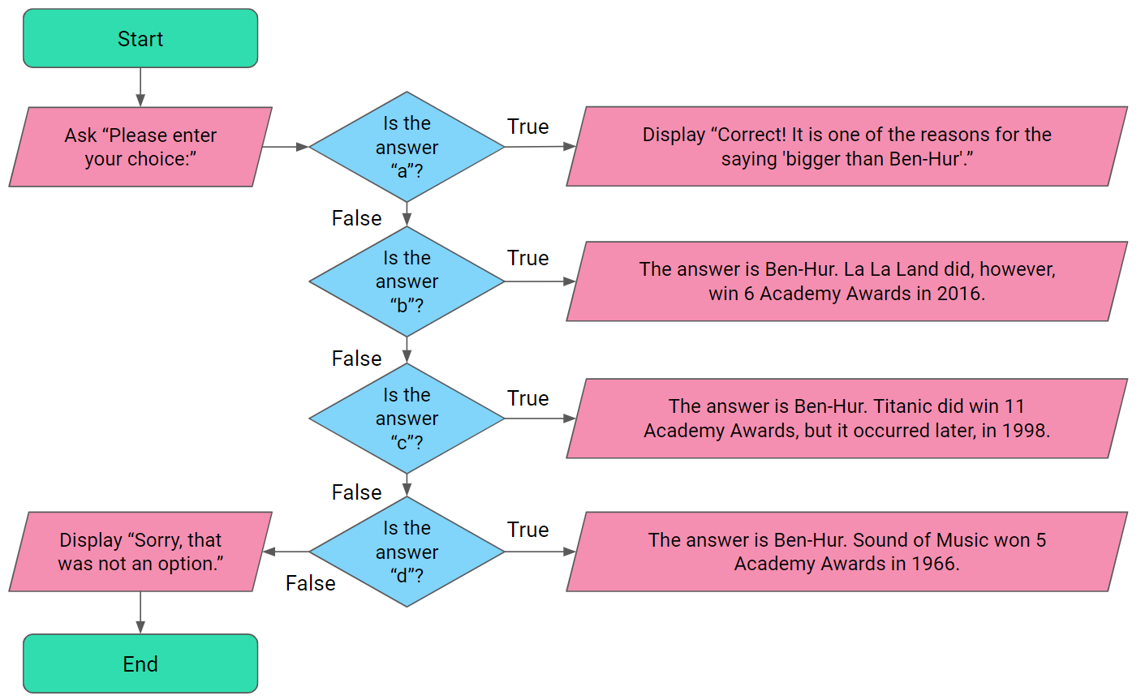

**License Information**

These [CS in Schools](http://csinschools.io/) lessons plans, worksheets, and other materials were created by Toan Huynh and Hugh Williams. They are licensed under a [Creative Commons Attribution-ShareAlike 4.0 International License](https://creativecommons.org/licenses/by-sa/4.0/).