05.01 Guess My Height Flowchart

|  |  |
| --- | --- |
| Name | **.................................................................................** |
| Class | **.................................................................................** |

Complete the flowchart below for a program which lets the user guess the computer’s height.

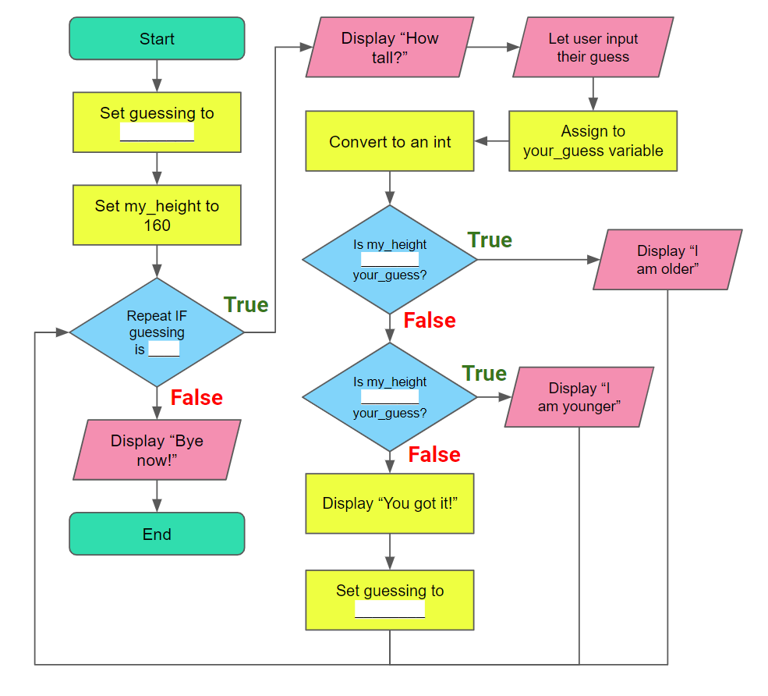

**License Information**

These [CS in Schools](https://csinschools.com/) lessons plans, worksheets, and other materials were created by Toan Huynh and Hugh Williams. They are licensed under a [Creative Commons Attribution-ShareAlike 4.0 International License](https://creativecommons.org/licenses/by-sa/4.0/).