Lesson 2: Our First Web Page

|  |  |  |  |
| --- | --- | --- | --- |
| **Name:** | **................................................................................................................** | **Class:** | **.............** |

## Extension Task: My Favourite...

Your task is to design and develop your own web page about something you really love. You will find some ideas in the table below, or you can choose something yourself.

|  |  |
| --- | --- |
| **My Favourite...** | |
| 1. Holiday Destination 2. Sport 3. School Subject 4. Food 5. Car | 1. Music/Artist 2. Celebrity/Person 3. Computer Game 4. Animal 5. ...anything else you are interested in! |

|  |  |
| --- | --- |
| * Open Replit | <https://replit.com/> |
| * Click on |  |
| * On the first drop down menu select: HTML, CSS, JS (this is the set of languages we will be coding in) * On the second drop down menu, give your Repl a name “My Favourite…” * Click “Create repl” |  |

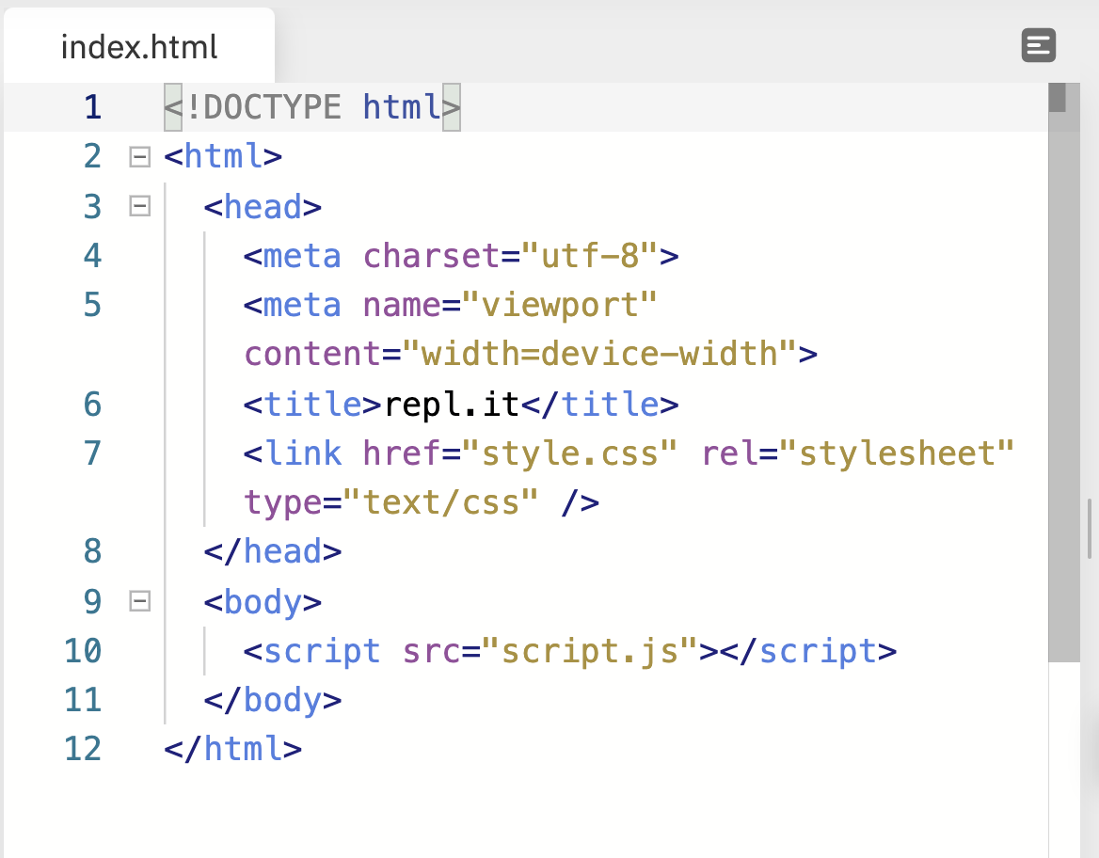

## Web Page Considerations - What to include

### <title></title>

Change the title of your webpage: “My Favourite…”

### <body></body>

Add information about your topic between these tags including:

* **Headings**

Include at least **2** different sized headings on your webpage

**<h1>**This is the LARGEST Heading**</h1>**

**<h6>**This is the SMALLEST Heading**</h6>**

* **Paragraphs**

**<p>**Order your information into **3** paragraphs**</p>**

**<p>**Paragraph 1**</p>**

**<p>**Paragraph 2**</p>**

**<p>**Paragraph 3**</p>**

* **Images**

Include at least **2** images of your chosen topic

**<img src="MyFavourite.jpg" alt="My Favourite..."/>**

* **Line Break**

**<hr />**

Organise the information on your webpage by using at least **1** horizontal rule