Lesson 6: Software Engineering

|  |  |  |  |
| --- | --- | --- | --- |
| **Name:** | **................................................................................................................** | **Class:** | **.............** |

Part 1 - Preparation

Now it’s time to begin developing some prototypes for the website we will build. Remember, our user story is:

“As a **student** I want to **be able to view the classes I have on a selected day on my phone** so that I can **pack my bags with the required books and textbooks before I travel to school**.”

Follow the steps below to complete this task:

1. Get 3 sheets of paper, as well as pencils, pens, texters - different colours too if you can! Or alternatively, you can use this [worksheet](Worksheet-06.03-Paper-Prototype.pptx).

Part 2 - Main page

1. Label one sheet ‘main page’. Sketch a few rectangles that are roughly the same size and shape as your phone.
2. Have a look at the designs below and think about what makes them good, or what makes them bad.

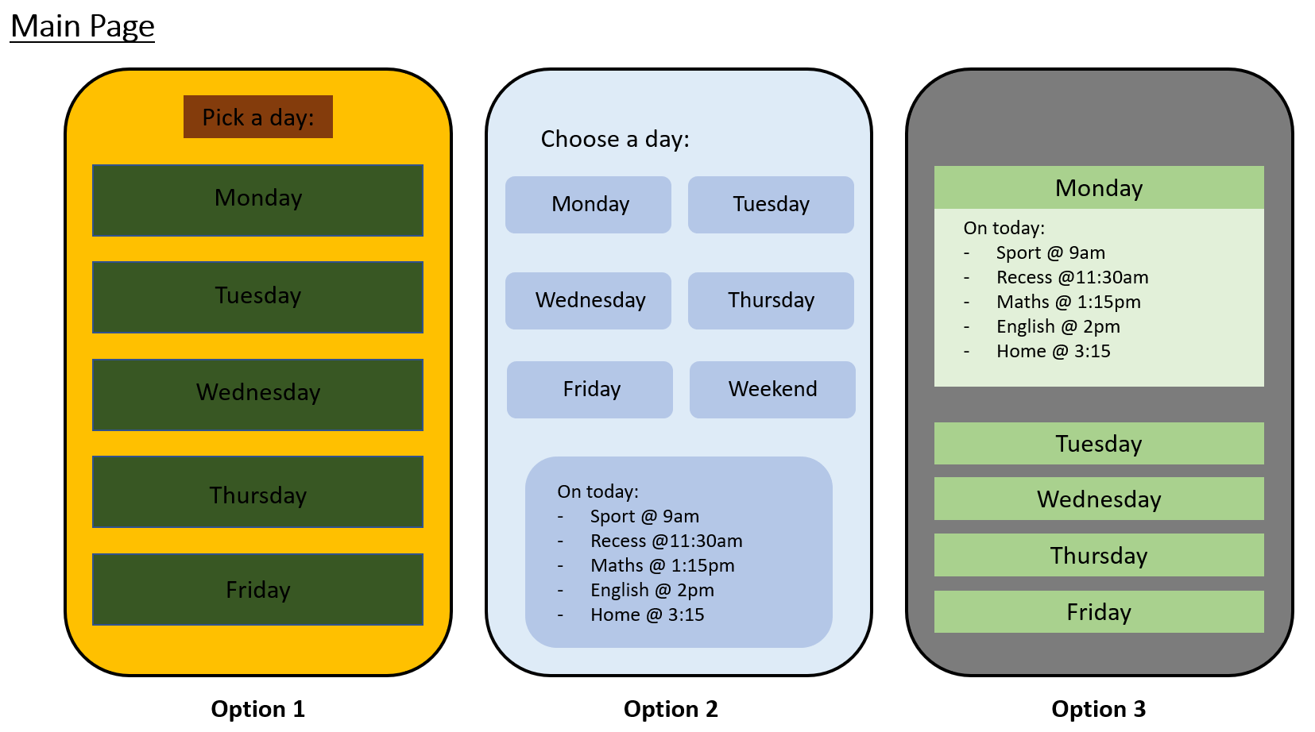

1. Draw some ideas of how your main page could look on your own ‘main page’. Refer back to lesson 4 and the colour wheel to help you make colour choices!

Part 3 - Day page

1. Label the next sheet as ‘day page’. Sketch a few rectangles that are roughly the same size and shape as your phone, as we did before
2. Have a look at the designs below and think about what makes them good, or what makes them bad.

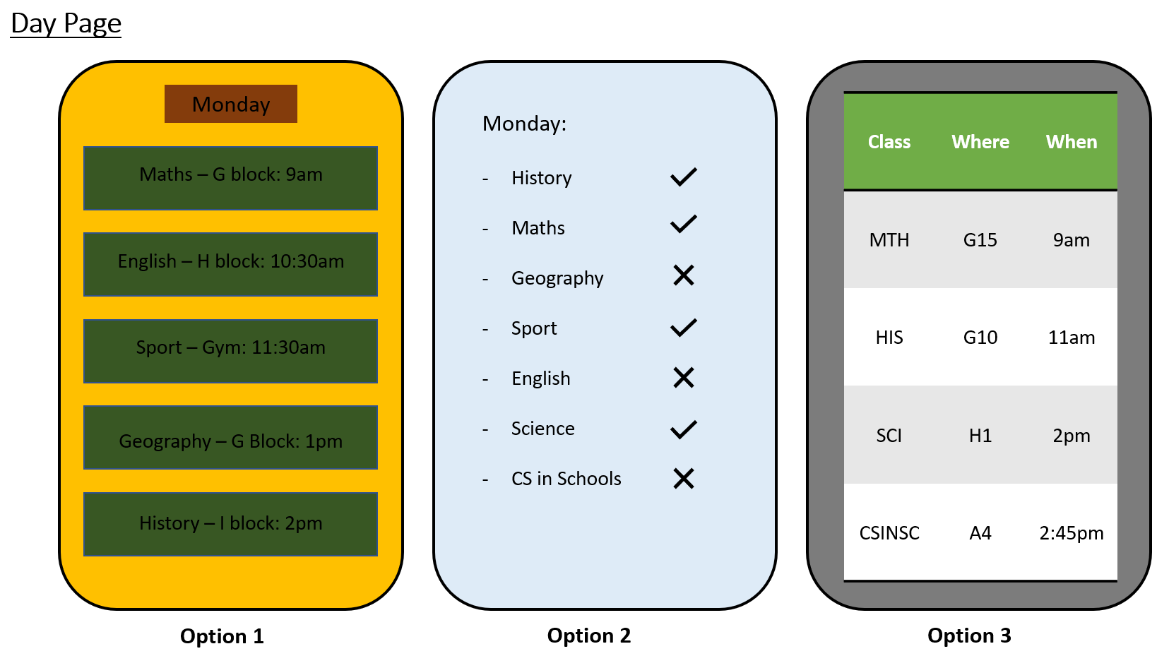

1. Draw some ideas of how your day page could look on your own day page’. Refer back to lesson 4 and the colour wheel to help you make colour choices!

Part 4 - Final steps

1. Use the last sheet of paper to write down any notes or considerations you think of during steps 1 to 3.
2. Keep your designs nearby, as we will be using them for the next activity.