Assignment Worksheet 1 - Timetable Website

|  |  |  |  |  |  |
| --- | --- | --- | --- | --- | --- |
| **Name:** |  | **Class:** |  | **URL:** |  |

**Recommended working duration:** 2-4 weeks

Your task is to develop a basic timetable website based on the following:

**USER STORY:**

|  |
| --- |
| *As a* ***principal*** *I want* ***my students to be able to view their classes on a selected day on their phones*** *so that* ***they can attend class on time and prepared, with the correct books.*** |

|  |  |
| --- | --- |
|  |  |

**Here is a partial example:**

* [Timetable Template](https://replit.com/@ricproenca/0701-Timetable-Template-Code) - Note: Monday and about are the only working links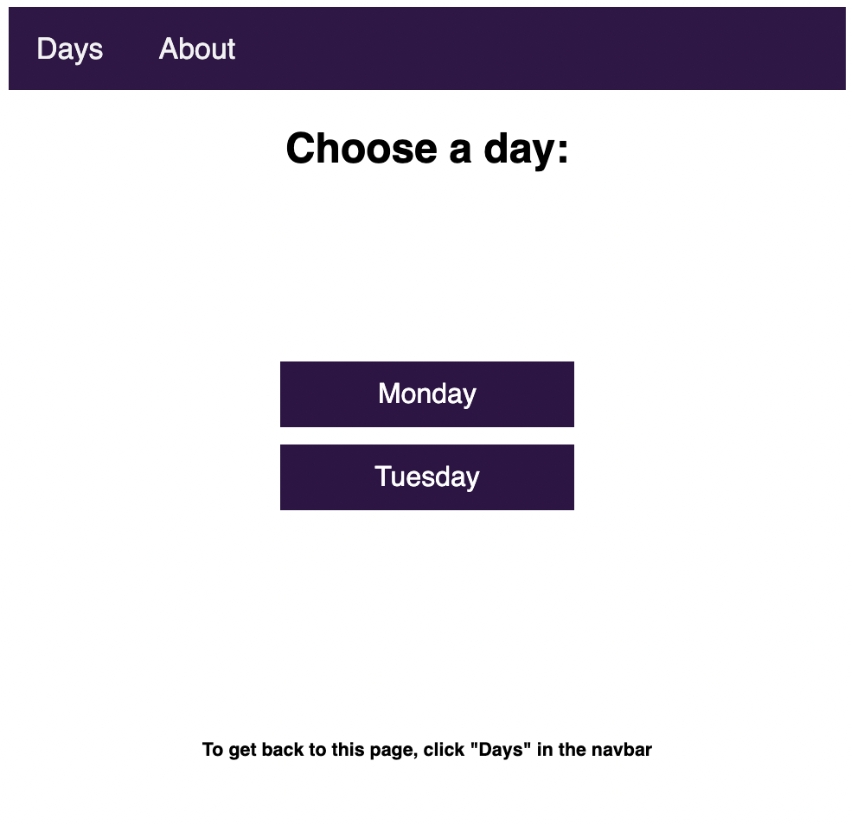

Assessment Areas

You will be assessed on the following areas:

### **Paper Prototype**

You need to submit a paper prototype of your website

### **User Story**

Your website must fulfil the requirements identified by the user story.

### **HTML**

You must include the following HTML tags: **<title>**, **<h1>**, **<h2>**, **<p>**, **<img>**, and **<a>**.

### **CSS**

You must utilise simple selectors, **id** selectors, and **class** selectors

### **Colour**

You must utilise colours based on the colour wheel

### **CSS Layout**

You must use the following CSS properties to style your web pages: **margin**, **padding**, **border**

### **About Page**

You must provide explanations as to how you met the user story, how you chose the colours for the site, and a reflection on the project and your efforts.

In addition, you will need to include an **about.html** page that has the following sections:

* **Functionality**
  + Detail how your website meets the user story
* **Colour Selection**
  + Detail the colours used and how you selected them
* **Developers**
  + Include a picture of an avatar you have created
* **Reflection**
  + Reflect on the project and your efforts

Please refer to the [Web Fundamentals Timetable Website: Assessment Rubric](Assignment-Rubric-Timetable-Website.docx) for how you will be assessed on this task.



**Getting Started:**

Access this [step-by-step guide](Assignment-Guide-Timetable-Website.docx) that walks you through the process of creating your timetable!