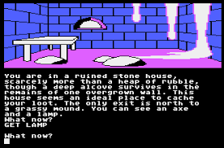Assignment - A Simple Text Adventure Game

|  |  |
| --- | --- |
| Name | **.................................................................................** |
| Class | **.................................................................................** |

**Recommended working duration:** 2 weeks

Your task is to program a simple text adventure game similar to these two examples:

* [City of Gold](https://replit.com/@ricproenca/0701d-City-of-Gold)
* 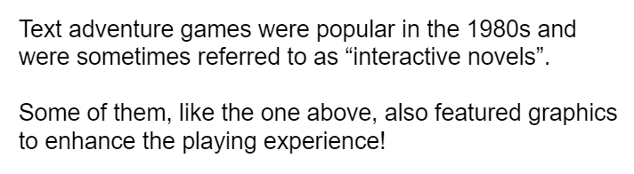[Your Spirit Animal](https://replit.com/@ricproenca/0702d-Your-Spirit-Animal)

Your game needs to contain at least **five scenes** with at least **two choices** in each scene. Example scenes could be rooms, locations, battles, situations, questions, and so on.

More than one choice from different scenes can lead to the same scene.

**You must be able to finish the game!**

Using colours in your game is encouraged. You could also optionally draw graphics, clear the screen, and use other visual ideas to make your game appealing.

Please see the above two games as examples.

There is also [some starting template code](https://replit.com/@ricproenca/0704-Text-Adventure-Game) that you might find helpful.

Assessment Areas

You will be assessed on the following areas.

### **Number of Scenes**

Your game needs to have at least five scenes

### **Number of Choices**

Your five scenes must allow the user to make at least two choices.

### **Game Completion**

We must be able to complete your game without any errors.

### **Creativity - Storyline**

You will be awarded marks for creativity in the story.

### **Creativity - Presentation**

You will be awarded marks for creativity in your layout and presentation (use of colours, special characters, screen clearing, and so on).

## 

Marking Rubric

|  |  |  |  |  |
| --- | --- | --- | --- | --- |
|  | **High (3)** | **Medium (2)** | **Low (1)** | **Not Shown (0)** |
| **Number of Scenes** | More than 5 scenes were demonstrated | 5 scenes were demonstrated | Less than 5 scenes were demonstrated | The game did not run |
| **Number of Choices** | At least 5 scenes had at least 2 choices | Between 2 and 4 scenes had at least 2 choices | Only 1 or no scenes had choices | The game did not run |
| **Game Completion** | The game can be completed successfully without any bugs | The game can be completed with some bugs | The game can be completed with a lot of bugs | The game cannot be completed |
| **Creativity Storyline** | A highly creative and original story or game was built | A standard but workable game and storyline | The storyline was difficult to understand | The game did not run |
| **Creativity - Presentation** | Colours and screen effects were used and were suited to the game | Some colours and screen effects were used but more would have been appropriate | The game did not use colour or other effects at all | The game did not run |

**License Information**

These [CS in Schools](https://csinschools.com/) lessons plans, worksheets, and other materials were created by Toan Huynh and Hugh Williams. They are licensed under a [Creative Commons Attribution-ShareAlike 4.0 International License](https://creativecommons.org/licenses/by-sa/4.0/).