Worksheet 01.01 - Introduction to CS in Schools

|  |  |
| --- | --- |
| Name | **.................................................................................** |
| Class | **.................................................................................** |

|  |
| --- |
| **Out of a scale of 1 to 5, how much programming have you done before?**  **(5 = I program often in my spare time, 1 = what is programming??)** |
|  |

|  |
| --- |
| **Write down 3 areas where computers make an impact on your life.** |
| 1)  2)  3) |

|  |
| --- |
| **If you could make computers do anything you want, write down 3 things that you would like them to do.** |
| 1)  2)  3) |

Continued on the next page…

Introduction to Coding: Scavenger Hunt

* Using your preferred search engine, respond in full sentences and complete the following activity
* Once complete, share your answers with the class

PART 1: Technology & Life

|  |  |
| --- | --- |
| **Identify 1 way technology impacts the following areas of our daily lives. Include a specific example for each:** | |
| 1. Around the home | 1. |
| 1. Health | 2. |
| 1. Communication | 3. |
| 1. Appliances and devices | 4. |
| 1. Travel | 5. |
| 1. Entertainment | 6. |



PART 2: Digital Detective (A)

* Using your preferred search engine, fill in the table below with full sentences.
* You can fill out this table, or jump onto the next page to complete the case file - if you would prefer!

|  |  |
| --- | --- |
| **Questions** | **Answers** |
| In what year was the Python programming language formally released? |  |
| Who is the person credited with developing Python? |  |
| What is this person's age? |  |
| How many siblings do they have? |  |
| Upload a picture of this person. |  |









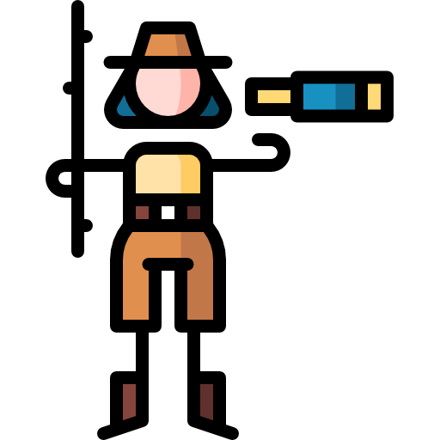

PART 2: Digital Detective [b]

* Using your preferred search engine, fill in the case file below:
  + **“<YEAR OF CREATION>”** - replaced with the year Python was invented by double clicking on it
  + **“DETAILS ABOUT CREATOR”** - fill in all the blanks by double clicking on them
  + **“IMAGE OF CREATOR”** - cover the box with an image of the creator of Python language



Details about creator

Name:

Age:

Location:

Number of Siblings:

IMAGE OF CREATOR

Python: <Year of Creation>

PART 3: Communicating with Python

* Using your preferred search engine, fill in the table below with full sentences.

|  |  |
| --- | --- |
| **Questions** | **Answers** |
| Provide 2 reasons why Python is a popular coding language today. |  |
| What does the word syntax mean (in reference to computers)? |  |
| Why is syntax important when coding? |  |





print(“sss”)



Hello

**License Information**This material was created by the team at [CS in Schools](https://csinschools.io/). It is licensed under a [Creative Commons Attribution-ShareAlike 4.0 International License](https://creativecommons.org/licenses/by-sa/4.0/).