Sonic Hub World - Mid April Report

This document is the mid april report required for the ICG class for the Sonic Hub World Project, made by Duarte Branco (nº 119253).

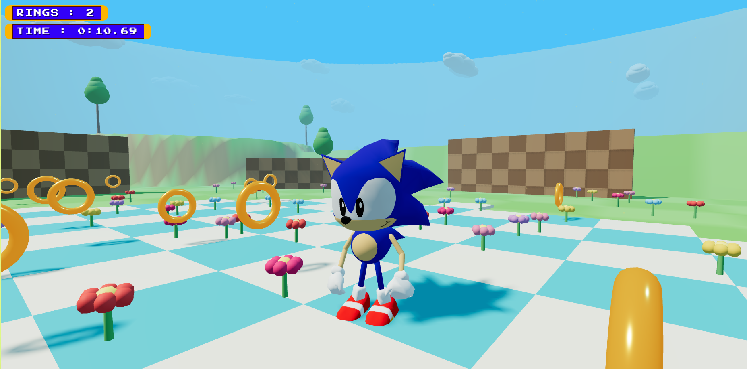

repo: https://github.com/duartebranco/sonic-hub-world
site: https://duartebranco.github.io/sonic-hub-world/

Objectives

Recreate the Sonic Jam’s (1997, Sega Saturn) hub world as a modern, browser-based 3D game built with three.js. Sonic Jam was one of the first Sonic compilations and its standout feature was a free-roaming open world where the player could explore, collect rings, and race around the map. This project reimplements that concept, with some of my own preference design choices.

What Is Already Done

Player and Physics:
- Full momentum physics: tangential-drag turning, slope acceleration, surface-normal jumping, air inertia and variable jump height.
- Speed tiers: WALK, RUN and MAX.
- Spin-dash: hold Shift/X to charge, release to launch at TOP_SPEED (bigger than MAX).
- Ground dust particles emitted at run speed and above.

Animation System:
- Three authored animations: idle, walk, and run - each crafted with the custom `animator.html` tool.

World:
- Procedural terrain using layered functions.
- Map features: plateaus, ramps, lakes, trenches, a bridge, cliffs, trees, flowers, clouds and a water surface.
- Checkerboard path tiles along the intended route.
- 22 collectible rings with proximity detection (0.9 units), sparkle particles and HUD counter (ring counter).
- Badnik mob meshes placed in the world (patrol AI not yet implemented).

Camera and HUD (heads up display):

- Third-person camera with mouse drag / pointer lock and scroll zoom.
- HUD: ring counter, race timer, spin-dash charge bar, speed-lines effect at high speed, Sonic-style font and tittle/loading screen.

What Still Needs to Be Done

Animations:
- Jump animation.
- Animation of Sonic being hit by a mob.
- Death animation.
- Give use of the different facial expressions on those new animations.

World and Game Logic:
- Deliberate track layout - the current path is placeholder checkerboard tiles with no intentional design.
- Water zone with buoyancy or wading physics; currently the water surface is purely visual.
- Enemy interaction: player should take damage on contact with MotoBugs (ring loss, brief invincibility frames) and be able to kill them with a spin attack.
- Player hit/death and respawn: hit detection, check if player has rings, and respawn at the last checkpoint.
- Checkpoint system to save progress along the route.
- Different checkpoints that refer the start and finish line of the track (for the

Sound:
- Have a complete soundtrack and use it.
- Have sound effects relating to the world and to the actual player (sonic).

