**Application description**

Build an anime recommender system and predictor using the concepts of object oriented programming. The application will recommend new and experienced users anime titles, movies and tv shows, and predict whether a user will like an anime or not.

**Requirements**

Functional requirements:

* The application must recommend users an anime title
* The application must provide users information on a recommended title
* The application must predict if a user will like a new item

Non-functional requirements:

* The application should allow a user to specify criteria for recommendations
* The application should track whether a user provided a positive review to the recommendation
* The application should track whether a prediction had a positive review by the user
* The application should specify why a user would not like a title or not
* The application should ask for users initial tastes in anime

**Use Cases**

1. Title: Provide recommendation

Primary Actor: User

Success Scenario: User asks for a recommendation. User specifies criteria for recommendation. Recommender analyzes the user and decides which recommendation method to use. Recommender provides user the recommendation. User watches the anime and likes the recommendation. Recommender will track if the user liked the recommendation.

2. Title: Provide prediction

Primary Actor: User

Success Scenario: User asks for a prediction on an anime title. User specifies the anime. Predictor will retrieve data on the anime title. The model will generate a prediction. The model will be different whether the anime title is a movie or a tv show. The model will return a prediction and identify why the user did not like the title.

**Classes**

1. User
2. Anime
   1. Movie
   2. TV Show
3. Recommender
4. Predictor

**Responsibility Diagram**

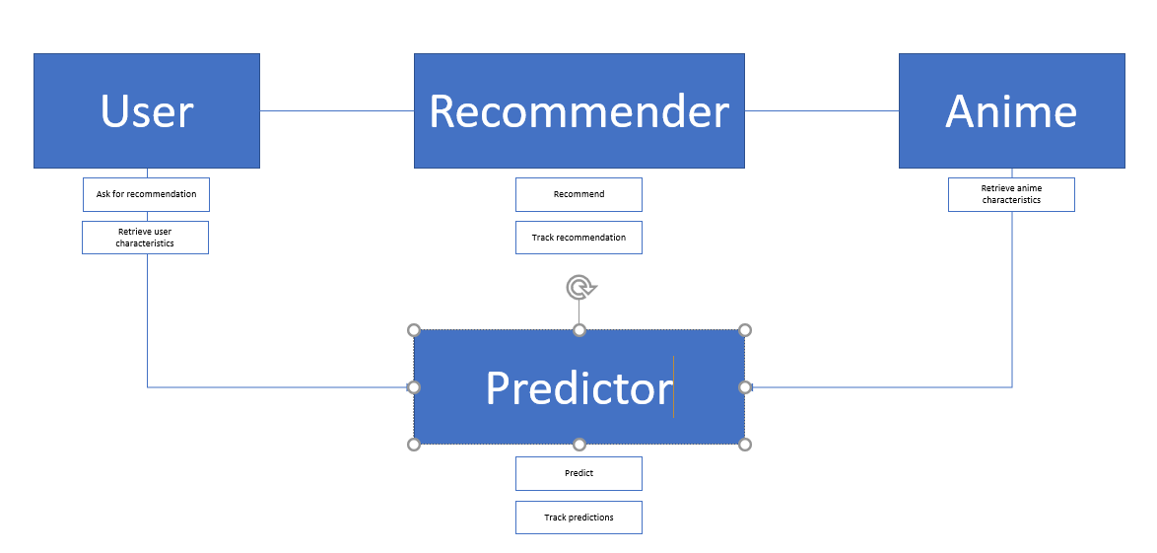

**Class Diagrams**

|  |
| --- |
| **User** |
| * User ID: Int * User Gender: Boolean * Birth Date: Datetime * Join Date: Datetime * Mean_score: Float * Episode_stats: List * Animes_watched: List |
| + getUserStats  - getRecommendation  - getPrediction |

|  |
| --- |
| **Anime** |
| * Anime ID: Int * Title: Boolean * Source: Str * Status: Str * Aired: Datetime * Rating: Str * Score: Float * Rank: Int * Popularity: Float * Popularity: Members * Favorites: Int * Genre: List |
| + getAnimeAttr |

|  |
| --- |
| **Movie** |
| * Duration: Float |

|  |
| --- |
| **TV Show** |
| * Seasons: Int * Episodes: Float * Avg_ep: Float |

|  |
| --- |
| **Recommender** |
| * Type: Str * Tracker: pd.DataFrame |
| + recommendAnime  - trackRecommendation |

|  |
| --- |
| **Predictor** |
| * Type: Str * Model: Pickle * Tracker: pd.DataFrame |
| + predictAnime  - trackPrediction |