chatInn (a simple chatting app)

MEMBERS:

DUA KHAN (22/IT/2K17)
ISBAH IQBAL (35/IT/2K17)
SAHAR MUBASHIR (78/IT/2K17)

Implemented in node.js

STEPS TO RUN THIS APP

- open cmd
- go to folder path where this chatapp folder place either on desktop or anywhere else.
- and run command "npm run dev"
- wait for a while.
- then go to browser on search bar write "localhost:1234" because its run on port 1234
- first prompt up and ask for username
- then you strt doing messagaes.If you press enter then message send

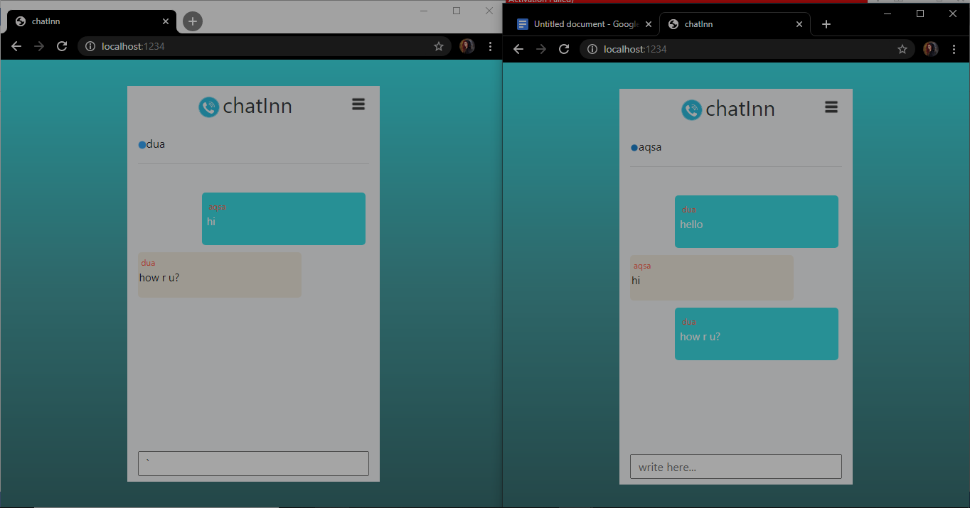
Online users
Message area
Username show
Text area
Different browser window

Index.html

<!DOCTYPE html>
<html lang="en">
<head>
<meta charset="UTF-8">
<meta name="viewport" content="width=device-width, initial-scale=1.0">
<title>chatInn</title>
<link href="/style.css" rel="stylesheet">
<link href="https://stackpath.bootstrapcdn.com/bootstrap/4.5.0/css/bootstrap.min.css" rel="stylesheet">
</head>

<body>
<div class="wrapper ">

<div class="container logo bg-light w-50">

<div class="mt-1 text-center">
<img class="img-fluid ml-2 mb-2 " src="/icon.png" width="30px" height="30px">
<span id="lg" class="text-dark"> chatInn</span>
<img onclick="user()" ondblclick="userout()" src="user-icon.png" class="img-fluid user" width="30px" height="30px">
<p id="para"></p>

</div>

<!--online users-->

<div>
<span class="onln_users pt-2 pb-2 " id="online"><img src="/source.gif" width="12px" height="12px"></span>
</div>
<hr>

<!--msg area-->
<div class="msg_area pt-4">

</div>

<!--Typing area-->
<div class="type_area pb-2 pt-2 text-center">
<input id="type_area" class="area text-dark" placeholder="write here..." type="text">

</div>
</div>

</div>

<script src="https://stackpath.bootstrapcdn.com/bootstrap/4.5.0/js/bootstrap.min.js"></script>
<script src="https://stackpath.bootstrapcdn.com/bootstrap/4.5.0/js/bootstrap.bundle.min.js"></script>

<script src="/socket.io/socket.io.js"></script>
<script src="/client.js"></script>

</body>

</html>

Server.js

const express = require('express')

const app = express()

const http = require('http').createServer(app)

app.use(express.static(__dirname + '/public'))

const port=process.env.port || 1234

http.listen(port, ()=>{

console.log(`listening on port ${port}`)

})

app.get('/', (req, res) => {
res.sendFile(__dirname + '/index.html')
})

//socketio

const io = require('socket.io')(http)

io.on('connection', socket => {
console.log('connected...')

socket.on('srvr_msg',(msg)=>{
socket.broadcast.emit('srvr_msg',msg)
})
})

Client.js

let name;
let type_area=document.querySelector('#type_area')
let msg_area=document.querySelector('.msg_area');

do{
name= prompt('enter username');
}while(!name)

function user(){
document.getElementById("para").innerHTML="username: "+name;

}

function userout(){
document.getElementById("para").innerHTML="";

}

const socket = io();

type_area.addEventListener('keyup', (e) =>{
if(e.key==='Enter'){
outgoingMsg(e.target.value)
}
})

function outgoingMsg(message){
let msg={
user: name,
usermsg:message
}

appendMsg(msg,'send_msg_clr')
type_area.value=''
scrollBottom()

socket.emit('srvr_msg', msg)
}

function appendMsg(msg , type){
let msgdiv= document.createElement('div');
let Classname=type;
msgdiv.classList.add(Classname , 'msg');

let pattrn=`
<p><span id='user__nme'>${msg.user}</span><br> ${msg.usermsg}</p>
`

msgdiv.innerHTML=pattrn;
msg_area.appendChild(msgdiv);

}

function scrollBottom(){
msg_area.scrollTop = msg_area.scrollHeight;
}

// incoming messages

socket.on('srvr_msg',(msg)=>{
user=msg.user;
document.getElementById('online').innerHTML += user+' ';

appendMsg(msg,'rec_msg_clr')
scrollBottom();

})

