Problem link: https://leetcode.com/problems/palindrome-number/

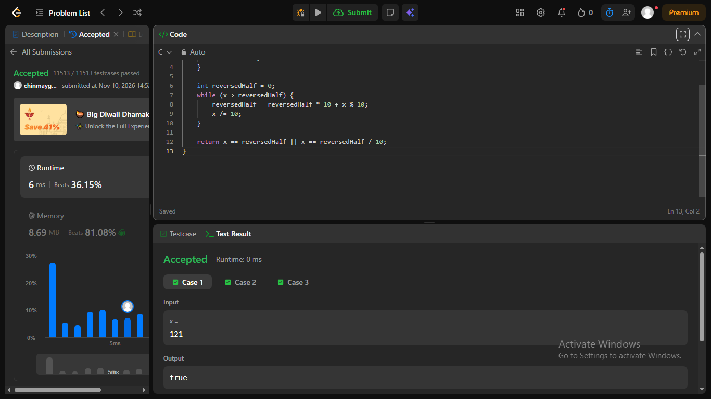n

