**BELIZE 11 DAY**

**By: Tran Nhat Duat**

**Fri, Jul 2: New York - Belize**

**You can stay here for 1 night if the flight makes you tired**

I would recommend Sea Breeze hotel in Belize city . I only recommend this place if you are looking for the cheapest possible hotel accommodation. The place is also surrounded by a barbed wire fence - great for security I guess. All for $50BZD / £20 per night.

**Afternoon in Belize City Old Town**

You could spend the afternoon in the Old Town in Belize, or looking round the shops in the new. Either grab some street food in town for your dinner, or try out the Smokey Mermaid Restaurant and Bar by the beach.

**if ok then you can move to San Ignacio**

Here I would like to recommend **Venus Hotel**, it is suitable for 2 people and has a shuttle service from the airport.

**Price      :** ~$42

**Address:** 29 Burns Avenue, 00011 San Ignacio, Belize

**Venus Hotel:** <http://venushotelbelize.com/> or <https://bit.ly/3iPTPyP>

**More:**

**Mariposa Jungle Lodge:** <https://bit.ly/2RRhOCw>

**Rumors Resort Hotel:** <https://bit.ly/3zlG3tm>

**Sat, Jul 3: San Ignacio**

You can rent a car or take a bus or taxi as you like. but I suggest renting a car if you have enough money, otherwise the bus here is also very convenient.

**10:00am - 12:30pm**

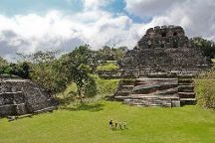

**Xunantunich Mayan Ruins**, Cayo

Observe the unbelievable ancient structures at Xunantunich Mayan Ruins, a site of ancient Mayan civilization and commerce. Contemplate the site's largest structure, a pyramid standing at a staggering 40 m (130 ft) tall, and climb to its summit for amazing vistas across the jungle. Consider taking a guided tour for for a more illuminating visit, helping you to absorb extra knowledge about the fascinating Mayan civilization. Don’t forget your camera and sunscreen, and keep you ears open for the sound of howler monkeys bellowing from the jungle canopy.

**Link map:**  <https://bit.ly/2U4Z833>

**1:30pm - 2:00pm**

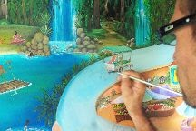

**Creek Art Walter Castillo Home Art Gallery**

**Link map:** <https://bit.ly/3zjLER1>

**2:30pm - 5:00pm**

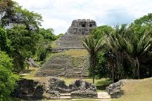

**Cahal Pech**

Journey back in time at Cahal Pech, one of the oldest Mayan sites in Belize. Consisting of over 30 structures, the ruins once served as the hilltop home of an elite Mayan ruling family. Wander freely through the site's many tunnels, climbing the buildings and exploring their nooks and crannies. Check out the visitor centre, where artists’ impressions of the settlement in its heyday give you sense of what life was once like here. Make sure to bring plenty of water, sunscreen, and bug spray.

**Link map:**   <https://bit.ly/3viF6in>

**5:30pm - 6:00pm**



**Cappello's Art Gallery**

**Link map:** <https://bit.ly/35gbK9A>

**Sun, Jul 4: Tunichil Muknal**

**10:00am - 11:00am**

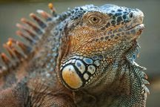

**Green Iguana Conservation Project**

Visit the San Ignacio Hotel to meet the lizards of Green Iguana Conservation Project. Set in a lush part of jungle near the Macal River, the hotel houses a project for conservation and protection of green iguanas. The program serves to educate people about the animals and prevent them from being hunted for food. Take the short, scenic trail down to the iguana center with the hotel guide, spot medicinal herbs and trees, or try eating termites from a termite mound. Meet the resident iguanas, learn about their behavior, feed and hold them, or take a photo with them as a souvenir.

**Link map:** <https://bit.ly/35aXCP5>

**12:00pm - 5:00pm**

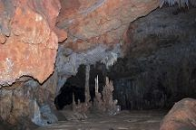

**ATM Cave Belize- Actun Tunichil Muknal**, Cayo

Embark on an adventurous hike through ATM Cave Belize- Actun Tunichil Muknal, a cave brimming with Mayan history. Be aware that traversing the cave requires a decent level of fitness, as you'll find yourself climbing, squeezing through tight spaces, and in rare cases swimming to explore the sites. The cave system spreads through about 4.8 km (3 mi) with a river flowing through it for approximately 3.2 km (2 mi). Be on the lookout for large spiders, freshwater crabs, and lots of bats. The highlight for most visitors is the undisturbed skeletal remains and pottery of Mayan origin, such as the "crystal maiden," whose calcified bones give off a crystalized, sparkly appearance.

**Link map:** <https://bit.ly/3wls1G8>

**Mon, Jul 5: Cave**

**10:30am -  12:00pm**

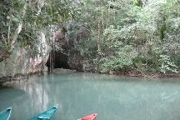

**Barton Creek Cave**, Cayo

Paddle through and explore the mystical Barton Creek Cave, an ancient site used by the Mayans for burial and ceremonial purposes. The jade-colored water runs for 6.4 km (4 mi) inside the caves surrounded by stalactites and stalagmites. You can spend time paddling for more than an hour with a spotlight discovering rock flows and cathedral chambers. Observe Mayan pottery shards and the bone remains of more than 28 humans dating back to 200 CE. Watch for bats inside the caves as well.

**Link map:** <https://bit.ly/3ixOuMg>

**1:00pm -  5:00pm**

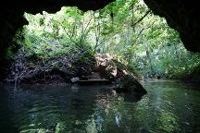

**Guanacaste National Park**, Belmopan

Explore the jungle, caves, and beautiful natural pools in Guanacaste National Park while keeping an eye out for rare animals. The park gets its name from the natural jungle pool, the Guanacaste National Park, which boasts a bright blue color to the water. Nearby the pool are two cave systems, where you can explore the underground. See over 200 species of birds throughout the park, including many rare species such as the piratic flycatcher. Keep an eye out for large cats as well, as ocelots and jaguars have been seen in the park.

**Link map:** <https://bit.ly/3vgCvWe>

**Tue, Jul 6: San Ignacio to San Pedro**

**5:00am:  Depart from San Ignacio**

**San Ignacio — Belize City**

**Belize City — Belize City Municipal**

**Belize City Municipal  — San Pedro**

**9:30am: Arrive in San Pedro**

**Hotel:**

**Drift Inn:**  <https://bit.ly/3cDcfyH>

**Ambergris Sunset Hotel:**  <https://bit.ly/2RPhmEJ>

**Ocean Tide Beach Resort:** <https://bit.ly/3wjQUlv>

**10:00am - 10:30am**

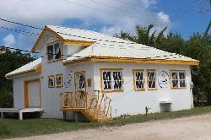

**Caye Coffee Roasting Co.**

**11:00am - 4:00pm**

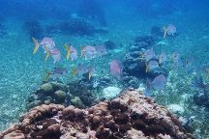

**Hol Chan Marine Reserve**

Belize's top snorkeling and diving site, Hol Chan Marine Reserve dazzles with its impressive coral formations and diverse marine life. Its reefs shelter a dizzying variety of creatures, including 40 types of coral and 160 different species of fish. This thriving underwater kingdom also provides a home for several mammals, including pantropical spotted dolphins and short-beaked common dolphins. The marine reserve encompasses mangroves and beds of sea grass, which ensure a safe habitat for southern stingrays and nurse sharks. You can get up close to both of these species, as they're quite used to visiting tour boats.

**4:30pm - 6:00pm**

**Skydiving: Link map:** [**https://bit.ly/2RSNqHY**](https://bit.ly/2RSNqHY)

**Wed, Jul 7**

**10:00am - 10:30am**

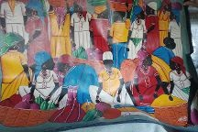

**Belizean Arts**

**11:00am - 1:30pm**

**Scuba & Snorkeling**

**2:00pm - 4:30pm**



**The Gallery of San Pedro**

Browse the extensive selection of artisanal handicrafts at The Gallery of San Pedro. The gallery displays and sells works exclusively made by local residents, encompassing a number of styles including Mayan, Caribbean, and Garifuna. Choose from sculptures, wood carvings, masks, blankets, fabrics, historical maps, and hammocks. The gallery also offers a painting refitting service in case you find a piece that you love but can't fit in your home space.

**Thu, Jul 8: Caye Caulker**

**San Ignacio to Caye Caulker:** you can take a bus or taxi to belize city harbor and then take a boat to Caye Caulker

There are a lot of great hotels here with different price ranges. I introduce here  **Weezie's Ocean Front Hotel and Garden Cottages.** it is a good hotel, suitable for 2 people, close to the sea and has its own beach and has a shuttle.

**Price      :** ~$100

**Address:** Playa Asuncion, Caye Caulker, Belize

**Link book:** <https://bit.ly/3pQXMVo>

**More:**

**Blu Zen:** <https://bit.ly/3xdZlPB>

**Jan's Hotel:** <https://bit.ly/2SmCjaB>

**10:00am - 11:30am**



**Spas**

**12:00pm - 12:30pm**

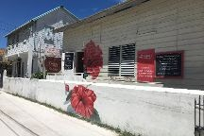

**Red Flower Gallery**

**1:00pm - 3:30pm**

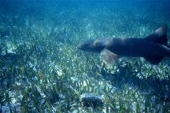

**Shark Ray Alley**, Ambergris Caye

Swim with sharks at Shark Ray Alley. Take a boat ride to the area, and watch the nurse sharks and rays approach the boat. Snorkel, swim, or dive in the shallow waters, while the sharks and rays swim in circles around you. The guides will often feed the sharks as you explore the reef, observe the fish, or take memorable photographs with an underwater camera.

**4:00pm - 5:30pm**



**The Estuary of Caye Caulker**

**Fri, Jul 9: Diving Caye Caulker**

**10:00am - 2:00pm**

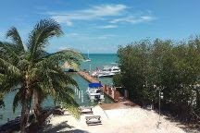

**Belize Diving Services**, Ambergris Caye

**Map:** <https://bit.ly/3giWD5Q>

**Sat, Jul 10: Relax**

**10:00am - 12:30pm**

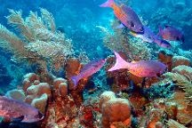

**Turneffe Reef**

Discover flourishing coral life as you head beneath the water at Turneffe Reef, one of the largest and most biologically diverse reefs in Belize. Find schools of fish, sharks, large rays, turtles, and eels lurking around the coral. Several steep drop-offs and a high range of visibility make this one of the best dive spots in the local area. Appropriate for both novice and experienced divers, the reef features shallower dives suitable for beginners and snorkelling, as well as deeper dives with stronger currents for the more experienced.

**Link map:** <https://bit.ly/3cCNaUr>

**5:30pm - 6:00pm**

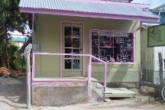

**Osprey Silver Jewelry & Boutique**

**Sun, Jul 11: Placencia**

Here I would like to introduce you to **Hotel Belizean Nirvana.**

**Address:** Beachfront Placencia, Westby Way, 50432 Placencia Village, Belize

**Hotel Belizean Nirvana:** <https://bit.ly/3iHaqEH>

**More:**

**Maya Beach Hotel:** <https://bit.ly/35ewWNh>

**Inn The Trees Cabañas:** <https://bit.ly/3iCuZ5l>

**6:30am** **Depart from Caye Caulker**

Caye Caulker — Placencia

Duration: 1 h 15 min via TZA

**9:30am Arrive in Placencia**

**10:00am - 2:00pm**

**Scuba & Snorkeling**

**3:00pm - 5:30pm**

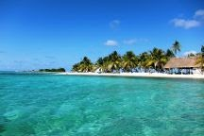

**Laughing Bird Caye National Park**

Laughing Bird Caye National Park represents a distinctive island that sits on an unusually narrow ridge of reef. Named after a bird which used to breed here, the park is home to an abundance of coral habitats and marine life. The tropical island features white sand and palm trees, and is surrounded by coral reefs. This allows visitors to mix snorkeling, diving, and island exploration into their visit, but you must rent a boat and guide out of Placencia. Lunch can be organized through your guide, with possibilities for a picnic or a beach barbeque.

**Mon, Jul 12: Go Home**

**Placencia to Belize City**

Today is the day of return. I will not recommend hotels to you anymore, but I will introduce some more places to play in this city for you.

-See amazing marine wildlife by snorkeling the Hol Chan Marine Reserve and Shark Ray Alley

-In Cate Caulker, explore the many colorful shops and end the day at the “The Split”. If you are in SanPedro, indulge in the many amazing restaurants and then go bar hopping

-Choose a more relaxing tour and go Manatee spotting

**Any questions contact me:**

**Facebook:** https://www.facebook.com/trannhatduat/

**Instagram:** https://www.instagram.com/dua3t3rn2h/

**Fiverr:** https://www.fiverr.com/sijzkby3?up_rollout=true

**Mail:** [18lynnxx@gmail.com](mailto:18lynnxx@gmail.com)

**Thank you for your trust**