STM32F4 Discovery Custom Bootloader Specification
- Introduction
Bootloader is something cool when you work with Embedded System. This project is about creating a custom bootloader for STM32F4 Discovery. The main task of this custom bootloader is to update the application.

- Memory outline
Below figure shows the memory outline of STM32F4 Discovery.
- The Main memory block is the place to store the application. STM32F4 Discovery has its bootloader in the System memory block and we will not not this bootloader in this project.

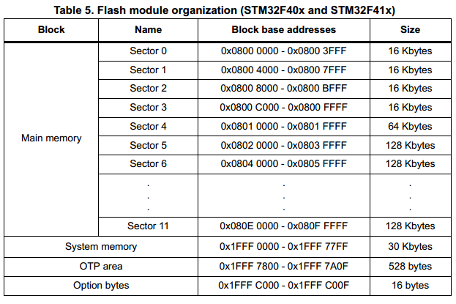

- For this Custom Bootloader project, we will split the Main memory block into 2 areas: the Bootloader and the Application. The memory outline as show as below.

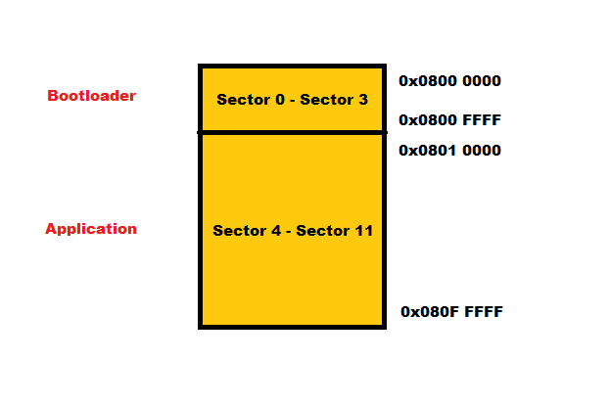
- Main activity diagram
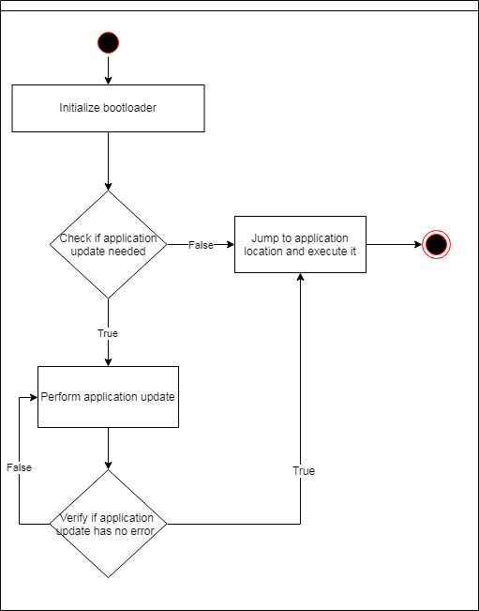

- Initialize bootloader
Configure needed peripherals that are used in bootloader.

- Check if application needed
This project has a delay of 10 seconds after the bootloader completing its initialization. If user want to update the application, just press the button (blue button) on STM32F4 within 10 seconds.

- Jump to Application

- Perform Application Update
Application update is perform after the bootloader get all the binary data.
a. Sending binary (Host)
Here is the way that Host (PC) send the binary to STM32F4
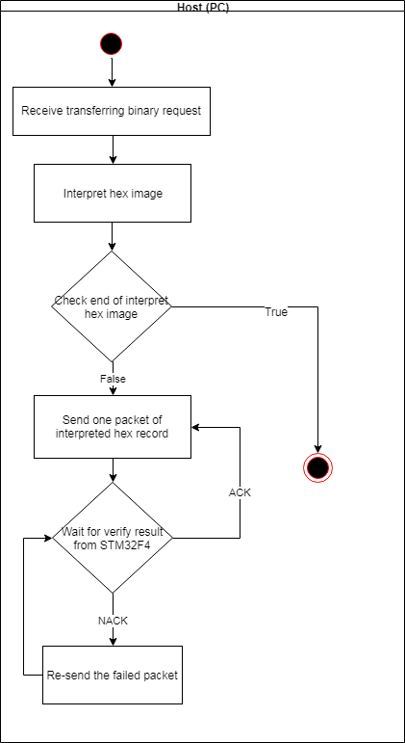

- After receiving the transferring binary request, Host read the content of a Intel hex file and interpret it before sending it to STM32F4. The hex file must have no corruption.
- Please refer to http://www.keil.com/support/docs/1584/ to get knowledge about the Intel hex format.
- This is the format of each packet which is sent to STM32F4:

b. Receiving binary (STM32F4)
STM32F4 activity diagram of receiving binary is described as below.
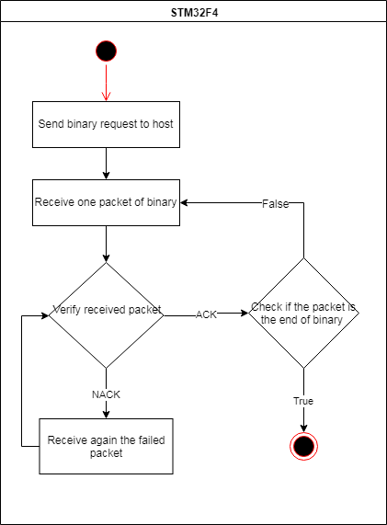

- The checksum byte of the hex image is sent to STM32F4. When STM32F4 receive all data of one packet, it calculate the checksum and compare with the received checksum byte.
+ If the the calculated checksum and received checksum are the same, then STM32F4 send an ACK byte to tell the Host to send next packet.
+ When two checksums are different, STM32F4 will send an NACK byte to request the Host re-send the failed packet.

- Verify application update
Verify the programmed application using the CRC32.
- References
http://www.keil.com/support/docs/1584/
http://marcelojo.org/marcelojoeng/2015/09/bootloader-on-stm32f0.html
http://aimagin.com/blog/bootloader-waijung-blockset/
https://en.wikibooks.org/wiki/Serial_Programming/Error_Correction_Methods
http://wiki.csie.ncku.edu.tw/embedded/Flash

