Monitoring the Change Process of Banana Freshness by GoogLeNet

In this paper author is applying GoogLeNet prebuilt model to predict freshness in banana fruit and this model is developed by Google developer and available in KERAS package as InceptionV3 model. To predict freshness in banana we are using transfer learning concept which also us to concatenate our own custom model in GoogLeNet model.

To concatenate custom banana freshness model we have used dataset which contains 3 different types of images such as RIPE, GREEN and OVER RIPE and this dataset available inside ‘Dataset/train’ folder and below screen shot showing dataset folder contents

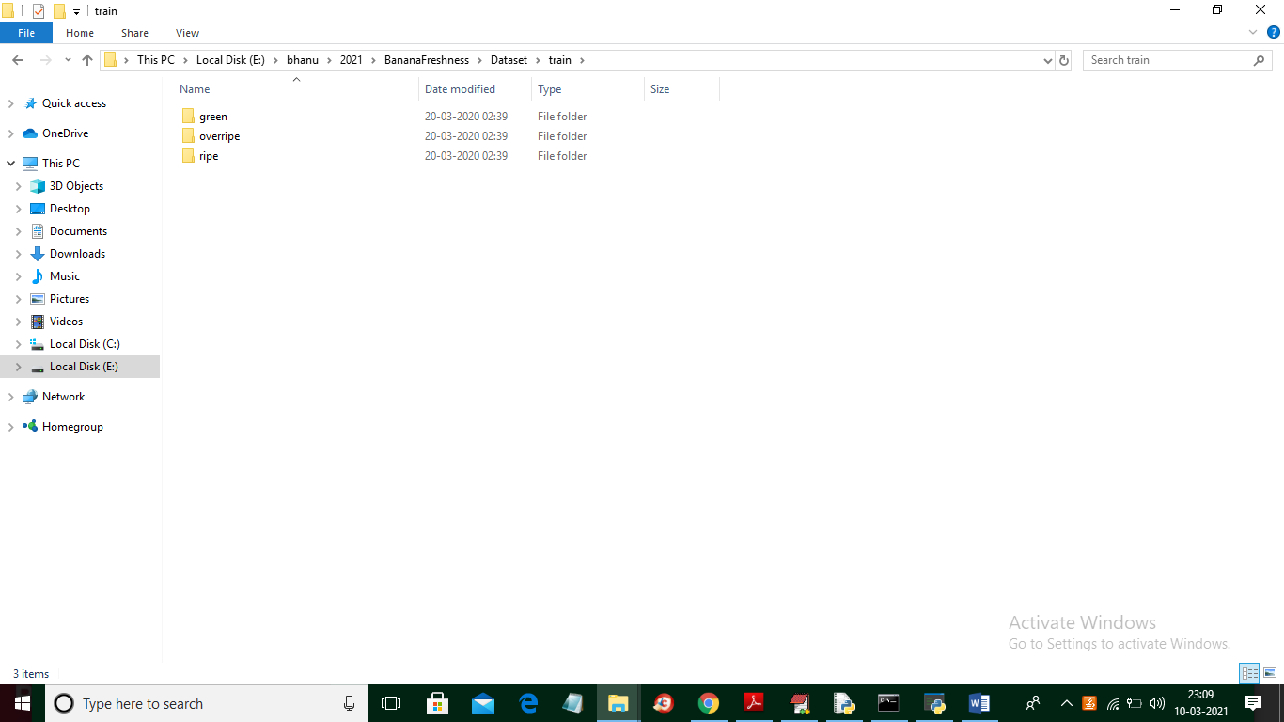

In above screen we have 3 different folders and each folder contains its own images and just go inside any folder to view images like below screen

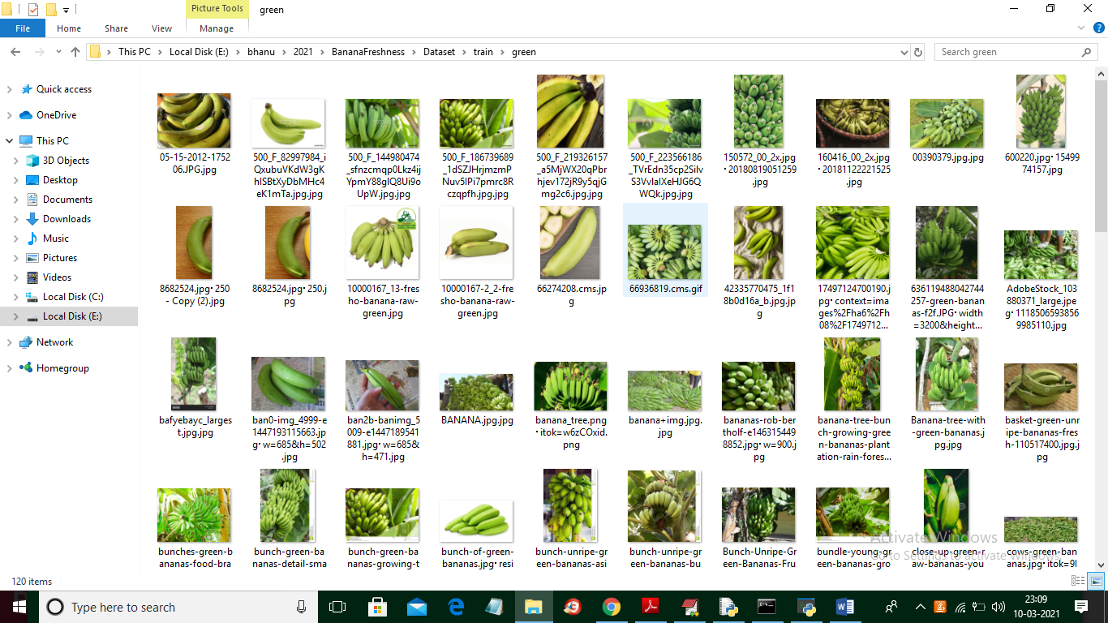

In above screen we can see images from GREEN folder. Below code screen shots showing how we are concatenate banana model in GoogLeNet

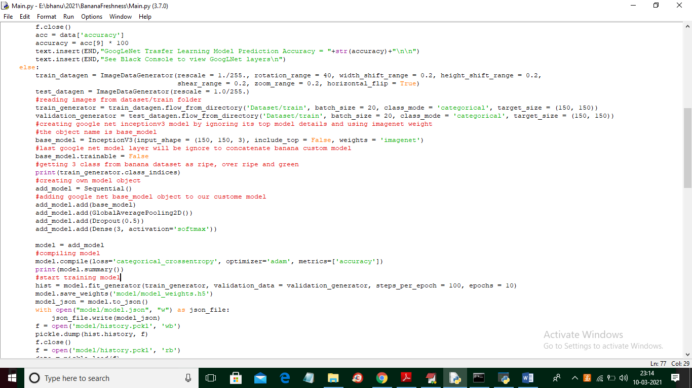

In above screen shots you can read red colour comments to know how we are using GoogLeNet model.

SCREEN SHOTS

To run project double click on ‘run.bat’ file to get below screen

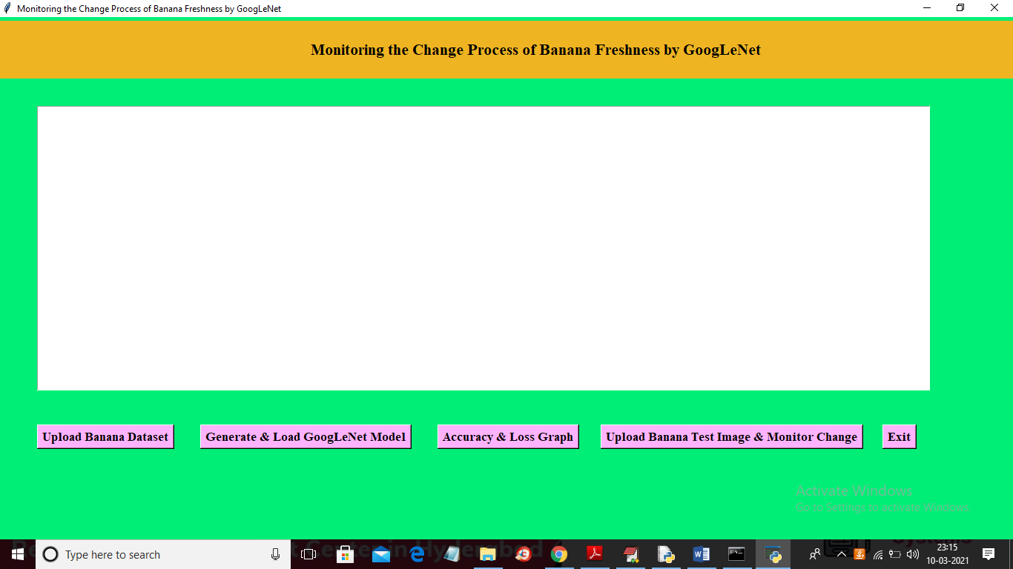

In above screen click on ‘Upload Banana Dataset’ button to upload dataset and to get below screen

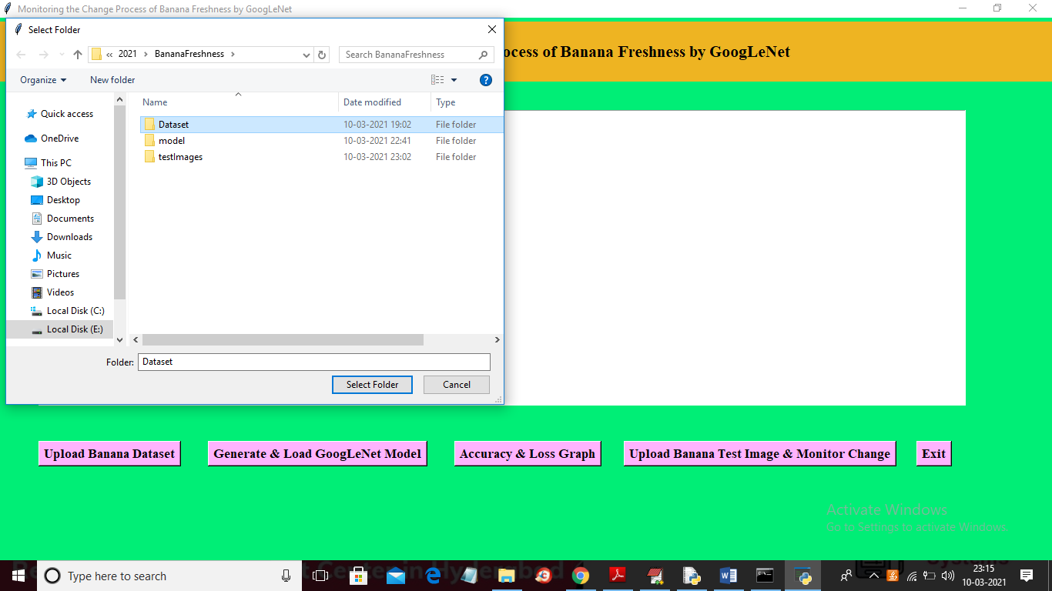

In above screen selecting and uploading ‘Dataset’ folder and then click on ‘Select Folder’ button to load dataset and to get below screen

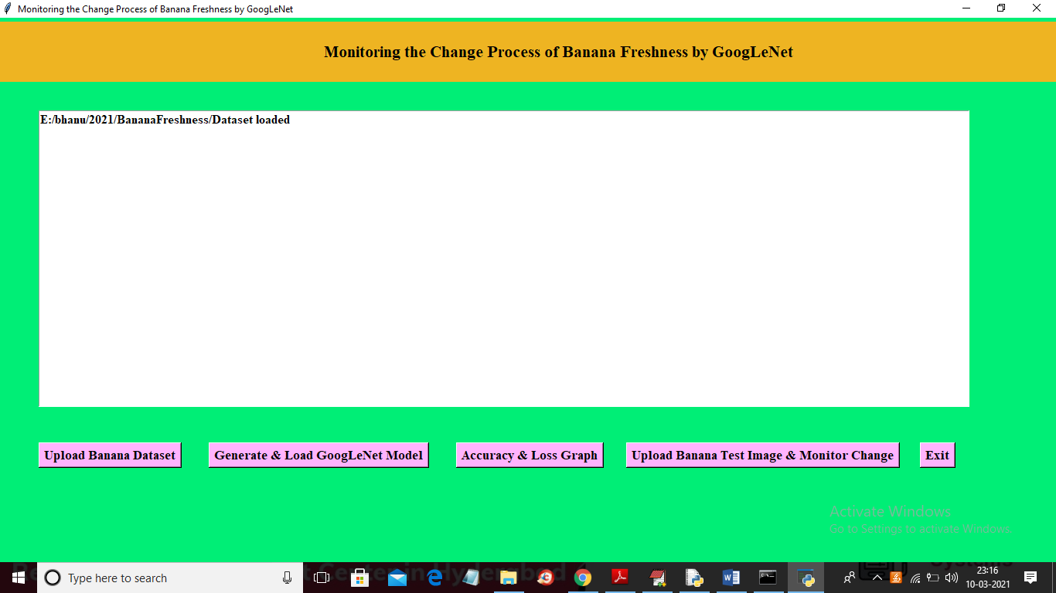

In above screen dataset loaded and now click on ‘Generate & Load GoogLeNet Model’ to build model on loaded dataset and then calculate accuracy and loss of the model. The higher the accuracy the better is the model and loss should be less.

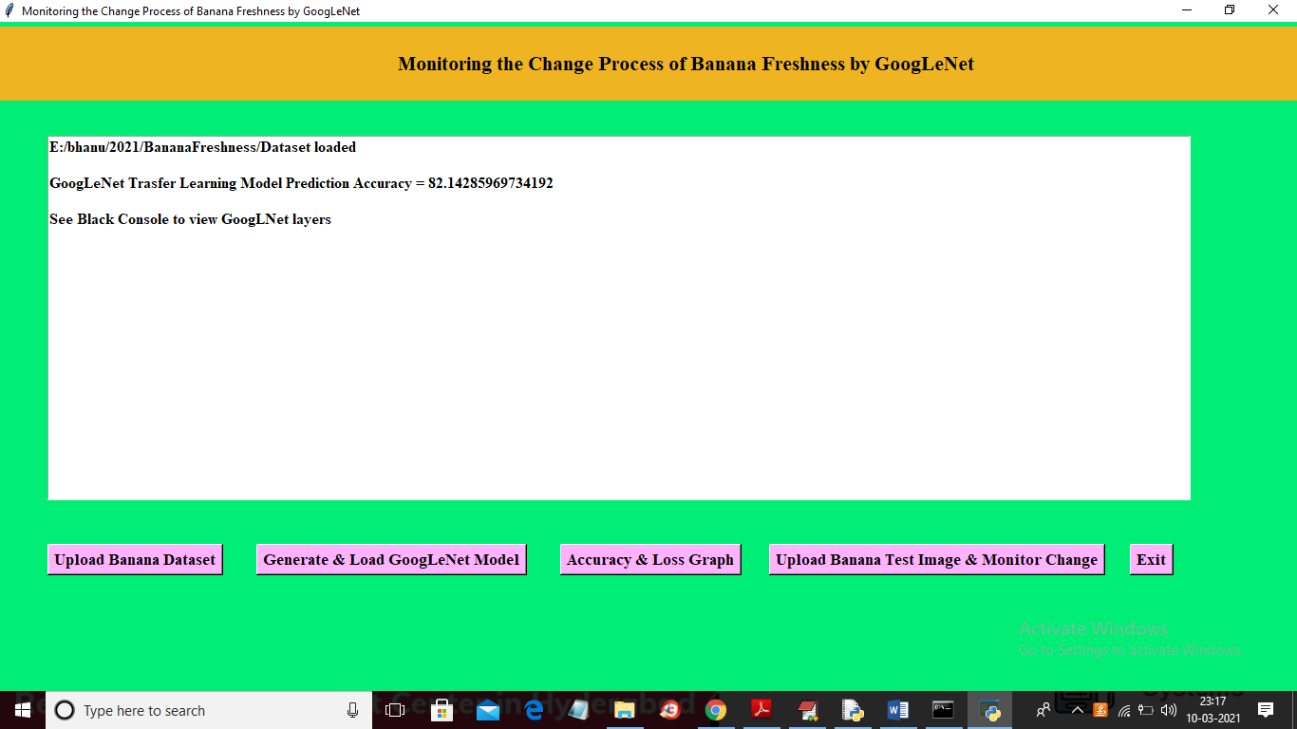

In above screen Model generate with accuracy of 82% and if we use more dataset size then accuracy will be more but model building time will go in hours so I used limited dataset size. We can see below console screen to see GoogLeNet Layers

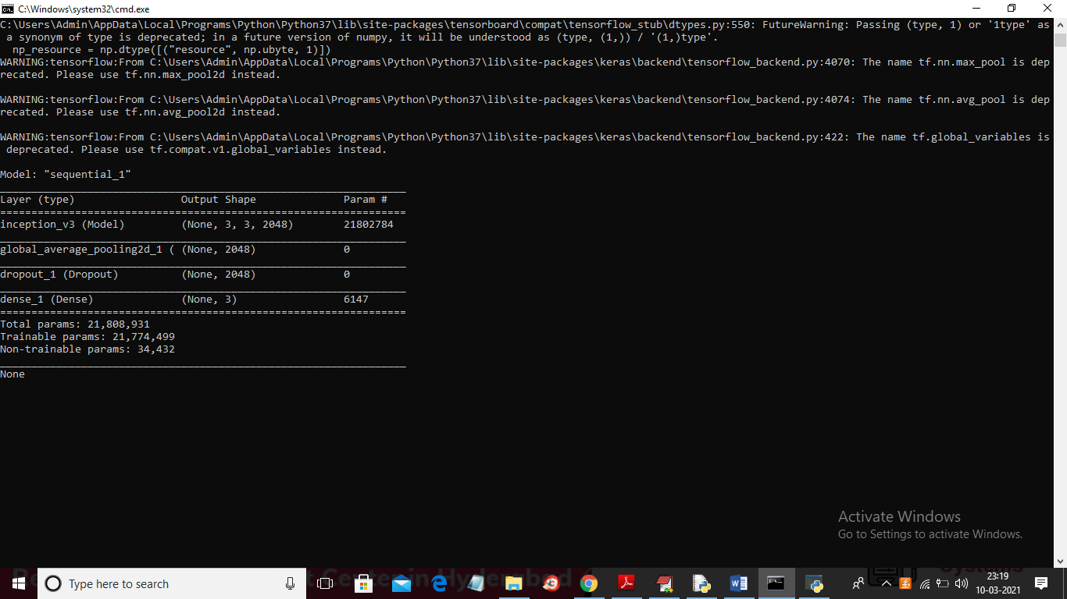

In above screen we can see GoogLeNet inception model generated and loaded and now click on ‘Accuracy & Loss Graph’ button to get below graph

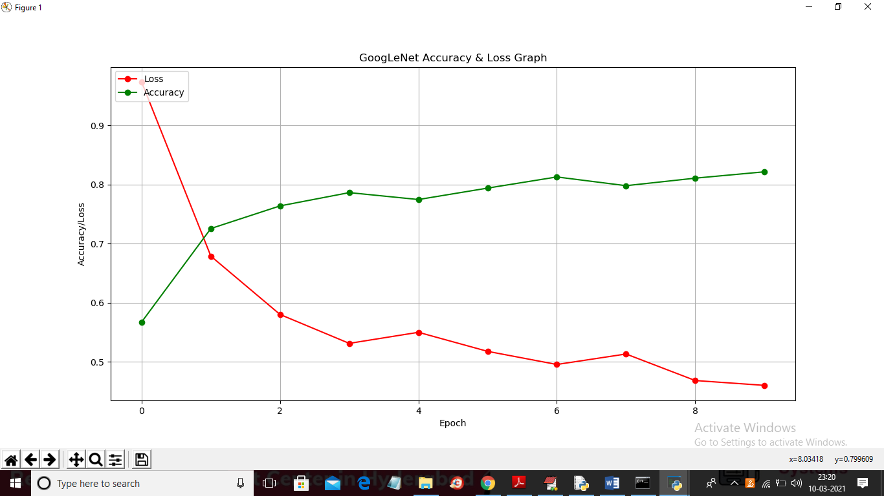

In above graph x-axis represents EPOCH and I took 10 epoch or iterations and y-axis represents ACCURACY and LOSS. In above graph we can see with each increasing epoch accuracy get increase and loss get decrease. Now model is ready and now click on ‘Upload Banana Test Image & Monitor Change’ button and upload test image and then model will predicts it changes

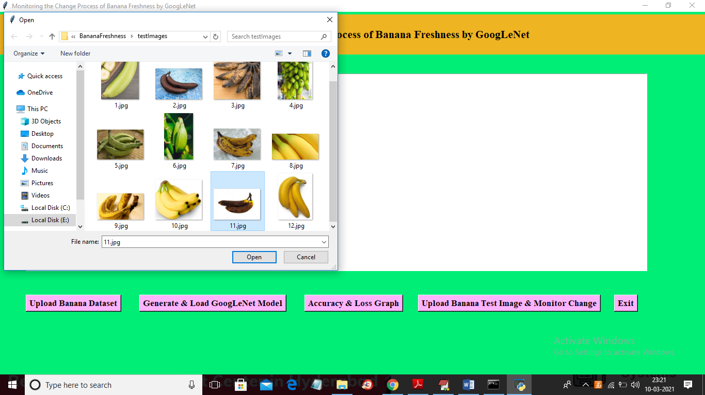

In above screen selecting and uploading ’11.jpg’ file and below is the prediction result

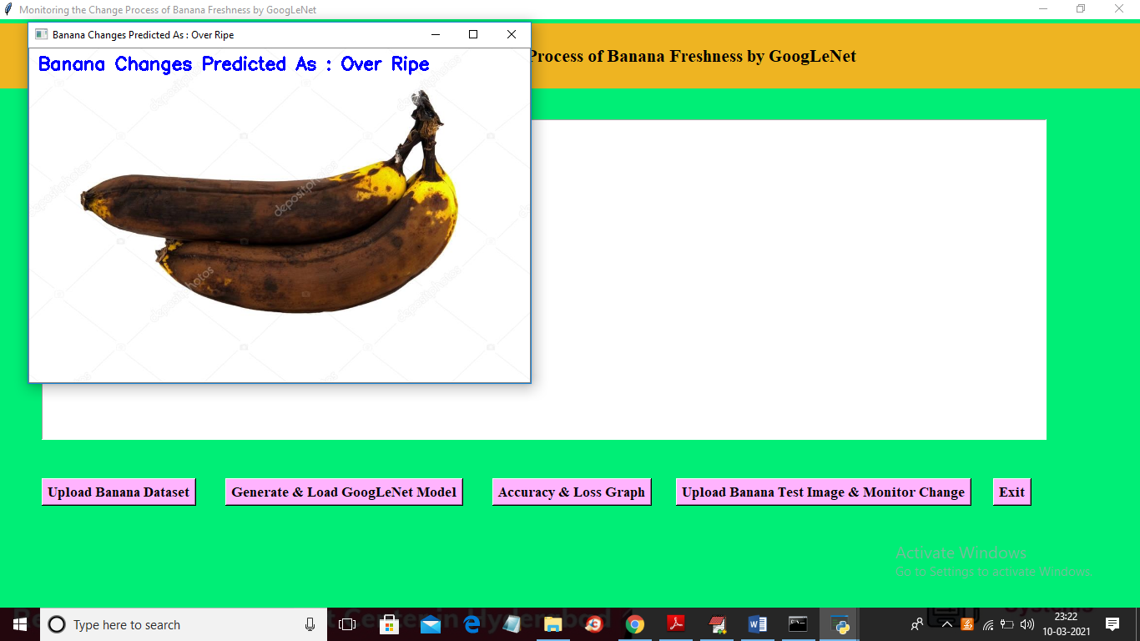

In above screen banana changes in image predicted as ‘OVER RIPE’ and similarly upload other image and test

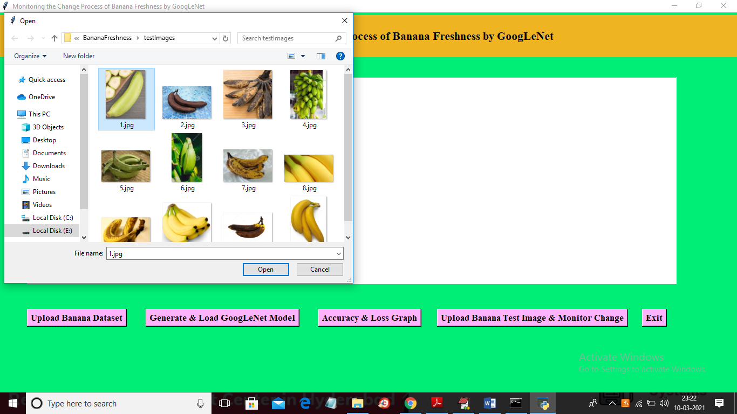

In above screen 1.jpg is uploading and below is the result

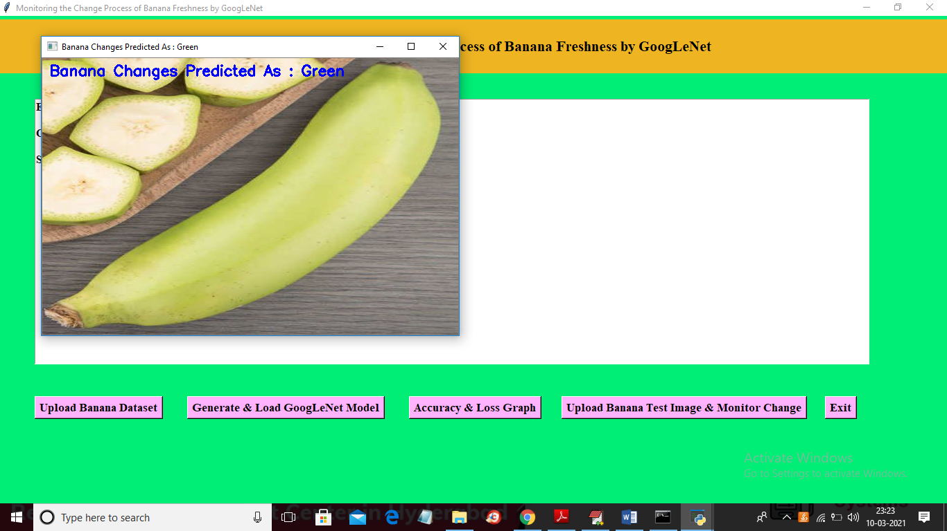

Another image we can test

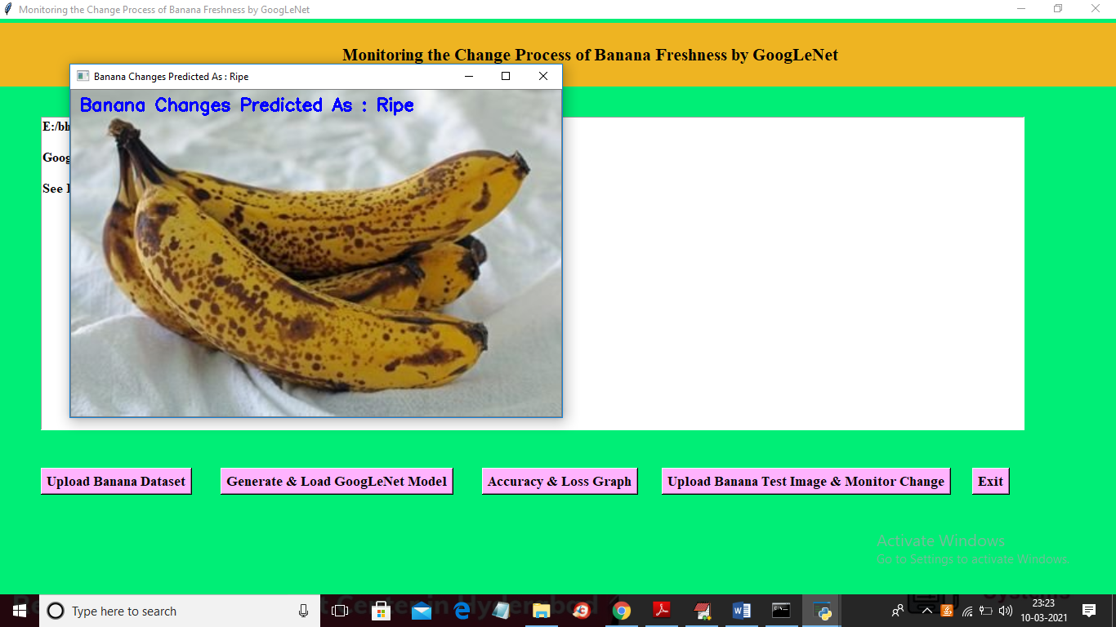

Similarly you can upload other images and test

